Product Specification
8GFC SFP+ LR Dual LC Transceivers

PRODUCT FEATURES
- 8GFC(8.5Gb/s) serial optical interface
- Up to 20km transmission distance
- Wide operating temperature(0°C~70°C)
- Low power consumption <1W
- Fibre Channel FC-PI-6 compliant high speed interface
--3200-M5-SN-S, 3200-M5E-SN-I, 3200-M5F-SN-I

Application
- Fibre Channel switches (director, stand alone, blade)
- Fibre Channel Host Bus Adapters
- Fibre Channel RAID controllers
- Fibre Channel tape drive
- Port side connections
- Inter-switch or inter-chassis aggregated links
Ordering information
Part Number | Product Description
JH-8G-SFP+-LR20 | 8GFC SFP+ LR Transceivers, C-TEMP

DESCRIPTION
The 8GFC SFP+ LR Transceiver is intended for 20km reach service 8.5Gb/s Multi-mode high-speed communications equipment where low-cost, extraordinary performance and reliability are essential. It consumes low power, operates base on 3.3V DC power supply and is offered in the commercial temperature range. They are compliant with SFP+ MSA, SFF-8431 and SFF-8432. High speed electrical and optical specifications are compliant with ANSI Fibre Channel FC-PI-6.

The 8GFC SFP+ is a multi-rate transceiver which ensures compliance with 8GFC specifications. Per the requirements of 8GFC, internal clock and data recovery circuits (CDRs) are present on both electrical input and electrical output of this transceiver for low jitter compliance.

ABSOLUTE MAXIMUM RATINGS
Parameter | Symbol | Conditions | Min. | Max. | Unit
Storage Temperature | T_{Storage} |  | -40 | +85 | °C
Relative Humidity | RH |  | 0 | +85 | %

RECOMMENDED OPERATING CONDITIONS (T=25°C, unless noted)
Parameter | Symbol | Conditions | Min. | Typ. | Max. | Unit
Case Temperature | T_{C} |  | 0 |  | 70 | °C
Power Supply Voltage | V_{CC} |  | 3.15 | 3.3 | 3.45 | V
Signaling Rate each Channel |  |  |  | 8.5 |  | Gbps

ELECTRICAL CHARACTERISTICS (T=25°C, unless noted)
Parameter | Symbol | Conditions | Min. | Typ. | Max. | Unit
Power Consumption |  |  |  |  | 1 | W
Supply Current | Icc |  |  |  | 300 | mA

TRANSMITTER CHARACTERISTICS (T=25°C, unless noted)
Parameter | Symbol | Conditions | Min. | Typ. | Max. | Unit
Center wavelength | λ |  | 1300 | 1310 | 1320 | nm
RMS spectral width | Pm |  |  |  | 0.6 | nm
Average optical power | Pavg |  | -8.4 |  | 2.4 | dBm
Optical modulation amplitude | OMA |  | -6.4 |  | 3 | dBm
Average launch power of OFF transmitter | Poff |  |  |  | -30 | dBm
Extinction ratio | ER |  | 2 |  |  | dB
Optical return loss tolerance |  |  |  |  | 12 | dB

RECEIVER CHARACTERISTICS (T=25°C, unless noted)
Parameter | Symbol | Conditions | Min. | Typ. | Max. | Unit
Center wavelength | λ |  | 1300 | 1310 | 1320 | nm
Damage threshold |  |  | 3.4 |  |  | dBm
Receive power overload |  |  | 2.4 |  |  | dBm
Receiver reflectance |  |  |  |  | -12 | dB
Receiver sensitivity | SENS |  |  |  | -10 | dBm
LOS Assert | LOS_{A} |  | -30 |  |  | dBm
LOS De-Assert | LOS_{D} |  |  |  | -13 | dBm
LOS Hysteresis | LOSH |  | 0.5 |  |  | dB

PIN ASSIGNMENT

PIN DESCRIPTION

Recommended Interface Circuit
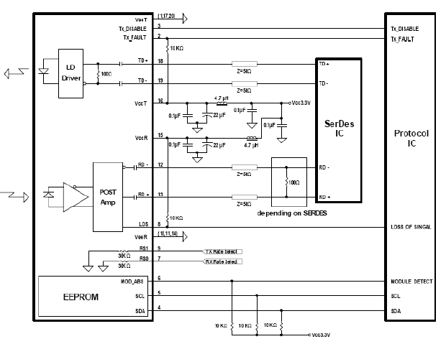
Figure 2. Typical application circuit

Mechanical Dimensions
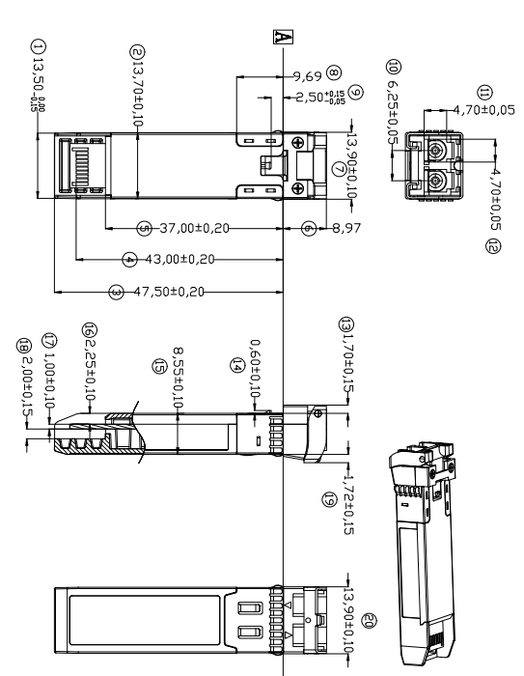
Figure 3. Module Mechanical Dimensions

Digital Diagnostics Functions
As defined by the SFF-8472, Our SFP+ transceivers provide digital diagnostic functions via a 2-wire serial interface, which allows real-time access to the following operating parameters:
- Transceiver temperature
- Laser bias current
- Transmitted optical power
- Received optical power
- Transceiver supply voltage
It also provides a sophisticated system of alarm and warning flags, which may be used to alert end-users when particular operating parameters are outside of a factory-set normal range. The operating and diagnostics information is monitored and reported by a Digital Diagnostics Transceiver Controller (DDTC) inside the transceiver, which is accessed through the 2-wire serial interface. The memories are organized as a series of 8-bit data words that can be addressed individually or sequentially. The 2-wire serial interface provides sequential or random access to the 8 bit parameters, addressed from 0x00h to the maximum address of the memory. For more detailed information, including memory map definitions, please refer the SFF-8472 documentation.

Digital Diagnostic Monitor Accuracy
The following characteristics are defined over recommended operating conditions

Parameter | Accuracy | Unit
Internally measured transceiver temperature | +/-3 | deg.C
Internally measured transceiver supply voltage | +/-3 | %
Measured Tx bias current | +/-10 | %
Measured Tx output power | +/-3 | dB
Measured Rx received average optical power | +/-3 | dB

Contact:
Wuhan Jiuhong Optics Technology Co., Ltd.
TEL: 86-13476016116
E-mail：grace@jh-optics.com
Web：www.jh-optics.com
Address：Building 1, 4th Floor, Yunqi Free Trade Innovation Port, Donghu Comprehensive Bonded Zone,Donghu High-tech Zone, Wuhan City

