Product Specification
10Gb/s 80Km SFP+ BIDI Transceivers
Features
- Compliant to SFP+ MSA
- Fully RoHS Compliant
- All metal housing for superior EMI performance
- Operating data rate up to 11.3Gbps
- 1550nm/1490nm Laser
- High sensitivity Pin photodiode and TIA
- LC single connector
- Hot pluggable 20pin connector
- Low power consumption <1W
- 0℃ to 70℃ operating wide temperature range
- Single +3.3V±5% power supply
- Digital Monitoring SFF-8472 Rev 10.2 compliant

Applications
- 10GBASE-LR/LW
- 10G Fiber Channel
- SFP+ MSA (SFF-8472)
- IEEE802.3ae

The laser based 10Gigabit SFP+ Transceiver is designed to transmit and receive serial optical data over single mode optical fiber with 80Km.
They are compliant with SFF-8431,SFF-8432, 10GFC Rev 4.0,. The transmitter converts serial CML electrical data into serial optical data compliant with the IEEE 802.3ae standard. The receiver converts serial optical data into serial CML electrical data.Digital diagnostics functions are available via a 2-wire serial interface, as specified in SFF-8472.

Part No. | Specifications |  |  |  |  |  |  |  |  | Application
Part No. | Package | Data rate | Laser | Optical Power | Detector | Sensitivity | Temp | Reach | Other | Application
JH-10G-WDM  -B-80L-54 | SFP+ | Up to 11.3G | 1550nm/ 1490nm | 0~4dBm | PIN | < -23dBm | 0~70℃ | 80km | DDM | 10GBASE-LR/LW

Pin function definitions
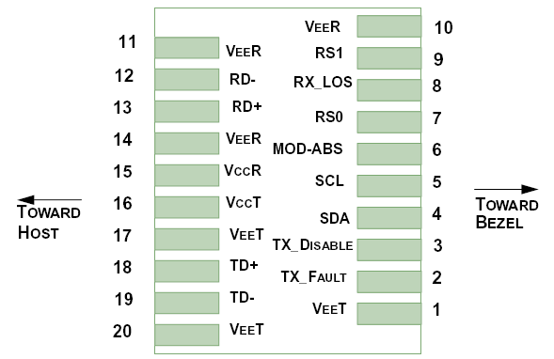
Figure 1.Pin function definitions
Table 1: Transceiver pin descriptions
Pin Number | Symbol | Name | Description
1,17,20 | VeeT | Transmitter Signal Ground | These pins should be connected to signal ground on the host board.
2 | TX Fault | Transmitter Fault Out (OC) | Logic “1” Output = Laser Fault (Laser off before t_fault)  Logic “0” Output = Normal Operation  This pin is open collector compatible, and should be pulled up to Host Vcc with a 10kΩ resistor.
3 | TX Disable | Transmitter Disable In (LVTTL) | Logic “1” Input (or no connection) = Laser off  Logic “0” Input = Laser on  This pin is internally pulled up to VccT with a 10 kΩ resistor.
4 | SDA | Module Definition Identifiers | Serial ID with SFF 8472 Diagnostics  Module Definition pins should be pulled up to Host Vcc with 10 kΩ resistors.
5 | SCL | Module Definition Identifiers
6 | MOD-ABS | Module Definition Identifiers
7 | RS0 | Receiver Rate Select (LVTTL) Transmitter Rate Select (LVTTL) | These pins have an internal 30kΩ pull-down to ground. A signal on either of these pins will not affect module performance.
9 | RS1 | Receiver Rate Select (LVTTL) Transmitter Rate Select (LVTTL)
8 | LOS | Loss of Signal Out (OC) | Sufficient optical signal for potential  BER < 1x10⁻¹² = Logic “0”  Insufficient optical signal for potential  BER < 1x10⁻¹² = Logic “1”  This pin is open collector compatible, and should be pulled up to Host Vcc with a 10kΩ resistor.
10,11,14 | VeeR | Receiver Signal Ground | These pins should be connected to signal ground on the host board.
12 | RD- | Receiver Negative DATA Out (CML) | Light on = Logic “0” Output Receiver DATA output is internally AC coupled and series terminated with a 50Ω resistor.
13 | RD+ | Receiver Positive DATA Out (CML) | Light on = Logic “1” Output Receiver DATA output is internally AC coupled and series terminated with a 50Ω resistor.
15 | VccR | Receiver Power Supply | This pin should be connected to a filtered +3.3V power supply on the host board. See Figure 3.Recommended power supply filter
16 | VccT | Transmitter Power Supply | This pin should be connected to a filtered +3.3V power supply on the host board. See Figure 3.Recommended power supply filter
18 | TD+ | Transmitter Positive DATA In (CML) | Logic “1” Input = Light on Transmitter DATA inputs are internally AC coupled and terminated with a differential 100Ω resistor.
19 | TD- | Transmitter Negative DATA In (CML) | Logic “0” Input = Light on Transmitter DATA inputs are internally AC coupled and terminated with a differential 100Ω resistor.

Absolute Maximum Ratings
Parameter | Symbol | Unit | Min | Max
Storage Temperature Range | Ts | ºC | -40 | 85
Relative Humidity | RH | % | 0 | 95
Maximum Supply Voltage | Vcc3 | V | -0.5 | 3.6

General Specifications
Parameter | Symbol | Min | Typ | Max | Units | Ref.
Bit Rate | BR |  |  | 11.3 | Gb/s | 1
Bit Error Ratio | BER |  |  | 10E-12 |  | 2
Max. Supported Link Length | LMAX |  |  | 80 | km | 1
Notes:
1. 10GBASE-LR, 10GBASE-LW, 1200-SM-LL-L 10GFC.
2. Tested with a 2³¹-1 PRBS.

Recommended Operating Conditions
Parameter | Symbol | Unit | Min | Typ | Max
Operating Case Temperature Range | Tc | ºC | 0 |  | 70
Power Supply Voltage | Vcc | V | 3.14 | 3.3 | 3.46
Bit Rate | BR | Gb/s |  |  | 11.3
Bit Error Ratio | BER |  |  |  | 10⁻¹²
Max Supported Link Length | L | Km |  |  | 80

Electric Ports Definition
Parameter | Symbol | Unit | Min | Typ | Max | Note
Supply Voltage | V_{CC} | V | 3.14 | 3.3 | 3.46
Module Power | Icc | mW |  |  | 1000
Transmitter
Input Differential Impedance | R_{IN} | Ω | 80 | 100 | 120
Differential Data Input | V_{IN} | mVp-p | 180 |  | 700
Transmit Disable Voltage | V_{DIS} | V | 2 |  | V_{CCHOST}
Transmit Enable Voltage | V_{EN} | V | V_{EE} |  | V_{EE}+0.8
Transmit Fault Assert Voltage | V_{FA} | V | 2 |  | V_{CCHOST}
Transmit Fault De-Assert Voltage | V_{FDA} | V | V_{EE} |  | V_{EE}+0.4
Receiver
Differential Data Output | V_{OD} | mVp-p | 300 |  | 850
Output Rise Time | t_{RISE} | pS | 25
Output Fall Time | t_{FALL} | pS | 25
LOS Fault | V_{LOSFT} | V | 2 |  | V_{CCHOST}
LOS Normal | V_{LOSNR} | V | V_{EE} |  | V_{EE}+0.4

Parameter | Symbol | Min | Typ | Max | Note | Unit
Optical Transmitter Characteristics
Nominal Wavelength (FLS10C411S) | λ_{C} | 1540 | 1550 | 1560 |  | nm
Nominal Wavelength (FLS10C412S) | λ_{C} | 1480 | 1490 | 1500 |  | nm
Optical Output Power | Pav | 0 |  | 4 |  | dBm
Extinction Ratio | ER | 3.5 |  |  |  | dB
Average Launch Power of OFF Transmitter | POFF |  |  | -35 |  | dBm
Relative Intensity Noise | RIN |  |  | -128 |  | dB/Hz
Optical Receiver Characteristics
Center Wavelength (FLS10C411S) | λ_{C} | 1480 | 1490 | 1500 |  | nm
Center Wavelength (FLS10C412S) | λ_{C} | 1540 | 1550 | 1560 |  | nm
Receiver Sensitivity@10.3Gb/s | RSENSE |  |  | -23 | 1 | dBm
Receiver Overload |  | 0.5 |  |  |  | dBm
Optical Return Loss |  | 27 |  | - |  | dB
LOS Assert | LOSA | -30 |  |  |  | dBm
LOS De-Assert LOS | LOSD |  |  | -17 |  | dBm
LOS Hysteresis |  | 0.5 |  |  |  | dB
Optical Characteristics (Tc=0 ºC to 70 ºC and Vcc= 3.14 to 3.46)
Note1: Measured at 10.3125Gbps,ER>3.5dBm, PRBS 2³¹-1 and BER better than or equal to 10E-12;

Typical Application Circuit
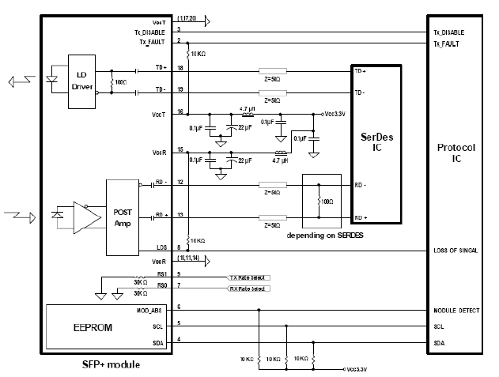
Figure 2. Typical application circuit

Mechanical Dimensions
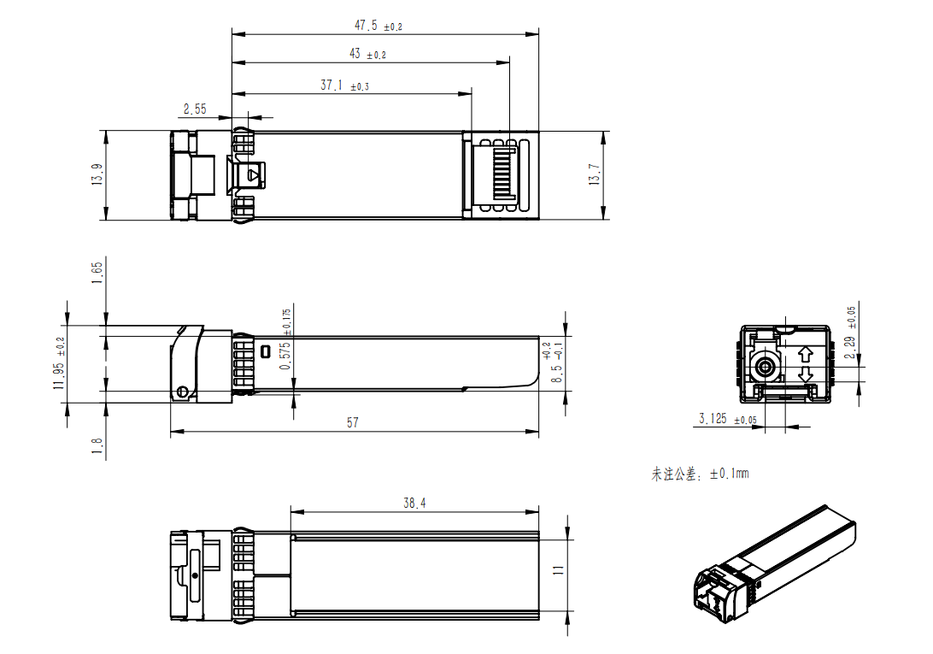
Figure 3. Module Mechanical Dimensions
Digital Diagnostics Functions
As defined by the SFF-8472, Our SFP+ transceivers provide digital diagnostic functions via a 2-wire serial interface, which allows real-time access to the following operating parameters:
- Transceiver temperature
- Laser bias current
- Transmitted optical power
- Received optical power
- Transceiver supply voltage
It also provides a sophisticated system of alarm and warning flags, which may be used to alert end-users when particular operating parameters are outside of a factory-set normal range. The operating and diagnostics information is monitored and reported by a Digital Diagnostics Transceiver Controller (DDTC) inside the transceiver, which is accessed through the 2-wire serial interface. When the serial protocol is activated, the serial clock signal (SCL pin) is generated by the host. The positive edge clocks data into the SFP+ transceiver into those segments of its memory map that are not write-protected. The negative edge clocks data from the SFP+ transceiver. The serial data signal (SDA pin) is bi-directional for serial data transfer. The host uses SDA in conjunction with SCL to mark the start and end of serial protocol activation. The memories are organized as a series of 8-bit data words that can be addressed individually or sequentially. The 2-wire serial interface provides sequential or random access to the 8 bit parameters, addressed from 000h to the maximum address of the memory.For more detailed information, including memory map definitions, please see the SFF-8472 documentation1.

