10Gb/s 120KM SFP+ 1550nm Transceivers

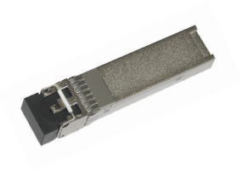

Features

The 1550nm cooled EML laser based 10Gigabit SFP+ Transceiver is designed to transmit and receive serial optical data over single mode optical fiber with 120KM.
They are compliant with SFF-8431,SFF-8432, 10GFC Rev 4.0, and 10GBASE-ZR. The transmitter converts serial CML electrical data into serial optical data compliant with the IEEE 802.3ae standard. The receiver converts serial optical data into serial CML electrical data.Digital diagnostics functions are available via a 2-wire serial interface, as specified in SFF-8472.

l Compliant to SFP+ MSA
l Fully RoHS Compliant
l All metal housing for
superior EMI performance
l Operating data rate up to 11.3Gbps
l Cooled EML DFB Laser
l High sensitivity APD photodiode and TIA
l LC duplex connector
l Hot pluggable 20pin connector
l Low power consumption <1.8 W
l -5℃ to 70℃ operating wide temperature range
l Single +3.3V±5% power supply
l Digital Monitoring
SFF-8472 Rev 10.2 compliant
l Real time monitoring of： Transmitted optical power Received optical power
Laser bias current

Applications
l 10GBASE-ZR
l 10G Fiber Channel

Specifications
(Tc=-5 ℃ to 70 ℃ and Vcc= 3.14 to 3.46V)

Parameter | Symbol | Unit | Min | Typ | Max | Note
Transmitter
Nominal Wavelength | λ | nm | 1530 |  | 1565
Side Mode Suppression Ratio | SMSR | dB | 30
Spectral Width(-20dB) | Δλ | nm |  |  | 0.3
Optical Output Power | Pav | dBm | 0 |  | 5
Extinction Ratio | ER | dB | 8.2
Average Launch Power of OFF Transmitter | POFF | dBm |  |  | -30
Relative Intensity Noise | RIN | dB/Hz |  |  | -128
Receiver
Center Wavelength | λC | nm | 1260 |  | 1620
Receiver  Sensitivity@10.3125Gb/s | RSENSE | dBm |  |  | -31 | 1
Receiver Sensitivity at  1600ps/nm @ 10.3125Gb/s | RSENSE | dBm |  |  | -22 | 1.2
Overload |  | dBm | -7
Optical Return Loss |  | dB | 27 |  | -
LOS Assert | LOSA | dBm | -36
LOS De-Assert LOS | LOSD | dBm |  |  | -27
LOS Hysteresis |  | dB | 0.5 |  | 6

Note 1: Measured at 1528-1600nm,ER>8.2dBm, PRBS 231-1 and BER better than or equal to 10E-12;
2: loopback using 120KM fiber (SMF-28).

Ordering Information

Part No. | Specifications |  |  |  |  |  | Application
Part No. | Package | Laser | Optical Power | Detector | Sensitivity | Temp | Reach | Other
JH-10G-ZR+-100 | SFP+ | 1550nm EML | 0 ~+5dBm | APD | < -31dBm | -5~70℃ | 120KM | DDM | 10GBASE-ZR/ZW 10G Fiber  Channel

Block diagram
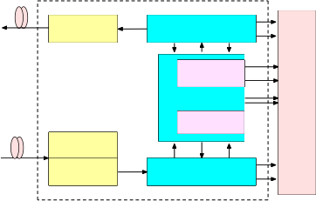
Laser Driver

Controller
MCU
FLASH

Post Amplifier
TOSA

ROSA
TIA
S F P
+ C O N N E C T O R

Figure 1.Transceiver functional diagram

Absolute Maximum Ratings

Parameter | Symbol | Unit | Min | Max
Storage Temperature Range | Ts | oC | -40 | 85
Relative Humidity | RH | % | 0 | 95
Recommended Operating Conditions
Parameter | Symbol | Unit Min | Typ | Max
Operating Case Temperature Range | Tc | oC -5 |  | 70
Power Supply Voltage | Vcc | V 3.14 | 3.3 | 3.46
Bit Rate | BR | Gb/s |  | 11.3
Bit Error Ratio | BER |  |  | 10-12
Max Supported Link Length | L | Km |  | 120

Electric Ports Definition

Parameter | Symbol | Unit | Min | Typ | Max Note
Supply Voltage | VCC | V | 3.14 | 3.3 | 3.46
Power consumption | Por | W |  |  | 1.8
Transmitter
Input Differential Impedance | RIN | Ω | 80 | 100 | 120
Differential Data Input | VIN | mVp-p | 180 |  | 700
Transmit Disable Voltage | VDIS | V | 2 |  | VCCHOST
Transmit Enable Voltage | VEN | V | VEE |  | VEE+0.8
Transmit Fault Assert Voltage | VFA | V | 2 |  | VCCHOST
Transmit Fault De-Assert Voltage | VFDA | V | VEE |  | VEE+0.4
Receiver
Differential Data Output | VOD | mVp-p | 300 |  | 850
Output Rise Time | tRISE | pS | 25
Output Fall Time | tFALL | pS | 25
LOS Fault | VLOSFT | V | 2 |  | VCCHOST
LOS Normal | VLOSNR | V | VEE |  | VEE+0.4

Pin function definitions

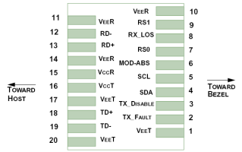

Figure 2.Pin function definitions

Table 1: Transceiver pin descriptions

Pin  Number | Symbol | Name | Description
1,17,20 | VeeT | Transmitter Signal Ground | These pins should be connected to signal ground on the host board.
2 | TX Fault | Transmitter Fault Out (OC) | Logic “1” Output = Laser Fault (Laser off before t_fault) Logic “0” Output = Normal Operation

This pin is open collector compatible, and should be pulled
up to Host Vcc with a 10kΩ resistor.
3 | TX  Disable | Transmitter Disable In  (LVTTL) | Logic “1” Input (or no connection) = Laser off Logic “0” Input = Laser on  This pin is internally pulled up to VccT with a 10 kΩ resistor.
4 | SDA | Module Definition Identifiers | Serial ID with SFF 8472 Diagnostics  Module Definition pins should be pulled up to Host Vcc with 10 kΩ resistors.
5 | SCL | Module Definition Identifiers
6 | MOD-ABS | Module Definition Identifiers
7 | RS0 | Receiver Rate Select (LVTTL) Transmitter Rate Select  (LVTTL) | These pins have an internal 30kΩ pull-down to ground. A signal on either of these pins will not affect module performance.
9 | RS1
8 | LOS | Loss of Signal Out (OC) | Sufficient optical signal for potential BER < 1x10- 12 = Logic “0”  Insufficient optical signal for potential BER < 1x10- 12 = Logic “1”  This pin is open collector compatible, and should be pulled up to Host Vcc with a 10kΩ resistor.
10,11,14 | VeeR | Receiver Signal Ground | These pins should be connected to signal ground on the host board.
12 | RD- | Receiver Negative DATA Out  (CML) | Light on = Logic “0” Output Receiver DATA output is internally AC coupled and series terminated with a 50Ω resistor.
13 | RD+ | Receiver Positive DATA Out  (CML) | Light on = Logic “1” Output Receiver DATA output is internally AC coupled and series terminated with a 50Ω resistor.
15 | VccR | Receiver Power Supply | This pin should be connected to a filtered +3.3V power supply on the host board. See Figure 3.Recommended power supply filter
16 | VccT | Transmitter Power Supply | This pin should be connected to a filtered +3.3V power supply on the host board. See Figure 3.Recommended power supply filter
18 | TD+ | Transmitter Positive DATA In  (CML) | Logic “1” Input = Light on Transmitter DATA inputs are internally AC coupled and terminated with a differential 100Ω resistor.
19 | TD- | Transmitter Negative DATA In  (CML) | Logic “0” Input = Light on Transmitter DATA inputs are internally AC coupled and terminated with a differential 100Ω resistor.

Typical Application Circuit
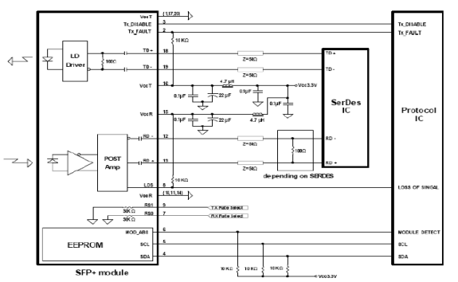

Package Outline

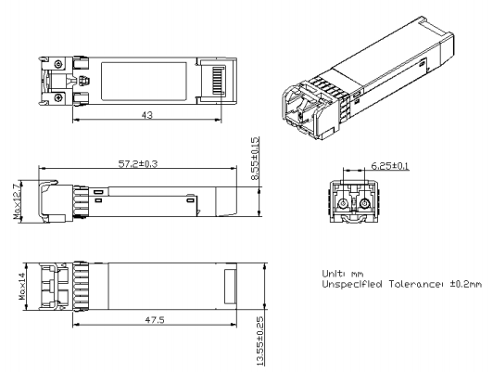

Regulatory Compliance

Feature | Test Method | Performance
Electrostatic Discharge (ESD) to the Electrical Pins | MIL-STD-883C Method  3015.7 | Class 1 (> 1500 Volts)
Electrostatic Discharge (ESD) to the Duplex LC Receptacle | Variation of IEC 61000-4-2 | Typically, no damage occurs with 15 kV when the duplex LC connector receptacle is contacted by a Human Body Model probe.
Electrostatic Interference (EMI) | CISPR22 ITE Class B  EN55022 Class B  FCC Class B | Compliant with standards
Immunity | IEC61000-4-3 Class 2  EN55024 | Typically show no measurable effect from a 3V/m field swept from 80 to 1000MHz applied to the transceiver without a chassis enclosure.
RoHS Compliance |  | Less than 1000 ppm of cadmium, lead, mercury, hexavalent chromium, polybrominated biphenyls, and polybrominated biphenyl ethers.

