1.25G SFP 1550nm 80KM LC DDM

Features：
■Up to 1.25Gbps data rate
■Duplex LC receptacle optical interface compliant
■Single +3.3V power supply
■DDM function implemented
■External calibration
■Hot-pluggable
■Receiver Loss of Signal Output
■AC coupling of PECL signals
■Serial ID module on MOD(0-2)
■International Class 1 laser safety certified
■Transmitter disable input
■Operating temperature range: 0℃~+70℃ or -40~85℃
■CWDM module Operating temperature range:0℃~+70℃
■RoHS Compliant

Applications：
■Gigabit Ethernet
■Gigabit Fiber Channel
■Switch to switch interface
■Switched backplane applications

Standard:
■Compliant with SFP MSA (INF-8074i)
■Compliant with SFF-8472 v9.3
■Compliant with IEEE802.3z Gigabit Ethernet
■Compliant with ITU-T G.695
■Compliant with FC-PI v2.0

Absolute Maximum Ratings
Parameter | Symbol | Uint. | Min | Max
Storage Temperature Range | Ts | °C | -40 | +85
Relative Humidity | RH | % | 5 | 95
Power supply Voltage | V_{cc} | V | -0.5 | 4

Recommended Operating Conditions
Parameter | Symbol | Uint | Min | Typ | Max
OperatingTemperature | Tc | °C | 0/-40 |  | 70/85
Power Supply Voltage | Vcc | V | 3.135 | 3.3 | 3.465
Data Rate | - | Gb/s | - | 1.25/1.0625 | -

Specifications (tested under recommended operating conditions, unless otherwise noted)
Parameter |  |  | Symbol | Uint | Min | Typ | Max | Notes
Electrical Characteristics
Supply Current |  | Tx Section | Icc | mA | - | - | 300 | 1
 |  | Rx Section
Single Ended Data Input Swing |  |  |  | mV | 150 |  | 1100
Single Ended Data Output Swing |  |  |  | mV | 300 |  | 600
TX_fault /LOS output (TTL) |  |  | VOH | V | 2.0 |  | Vcc
 |  |  | VOL | V | 0 |  | 0.8
TX_disable input (TTL) |  |  | VOH | V | 2.0 |  | Vcc
 |  |  | VOL | V | 0 |  | 0.8
Optical transmitter Characteristics
Launch Optical Power |  |  | Po | dBm | -2 | 0 | 3 | 80km 1550nm DFB-LD
Center Wavelength Range |  |  | λc | nm | 1530 | 1550 | 1570 | DFB-LD
Extinction Ratio |  |  | EX | dB | 9
Spectral Width |  |  | ∆λ | nm |  |  | 4 | DFB-LD
Side Mode Suppression Ratio |  |  | SMSR | dB | 30 |  |  | DFB-LD
Contributed Total Jitter  added at TP2 |  |  | TJ | UI |  |  | 0.284 | 3
Relative Intensity Noise |  |  | RIN | dB/H z |  |  | -120 | 4
Eye Diagram |  |  | Complies with IEEE802.3z eye masks when filtered
Dispersion Penalty |  |  |  | dB |  |  | 1
 |  |  |  | dB |  |  | 2 | CWDM
Optical Rise/Fall Time |  |  | Trise/Tfal | PS |  |  | 260 | 5
Optical receiver Characteristics
Receiver Sensitivity |  |  | S | dBm |  |  | -26 | 1550nm 80km
Overload Input Optical Power |  |  | P in | dBm | -3 |  |  | 80km
LOS | Optical Dessert |  |  | dB |  |  | S
LOS | Optical Assert |  |  | dB | -35
LOS |  |  |  | dB | -45
LOS Hysteresis |  |  |  | dB | 0.5 | 3 | 5
Note1. The supply current includes SFP module’s supply current and test board working current.
Note2. The CWDM transmitter center wavelengths “λ”are: 1471, 1491, 1511, 1531, 1551, 1571, 1591, 1611nm
Note3. TP refers to the compliance point specified in IEEE802.3z, section 38.2.1.
Note4. RIN is the laser noise, integrated over a specified bandwidth, measured relative to average optical power with 12dB
return loss. For multimode application, the RIN is better than -117dB/Hz.
Note5. Optical transition time is the time interval required for the rising or falling edge of an optical pulse to transition
between the 20% and 80% amplitudes relative to the logical 1 and 0 levels
Note6. Measured with a PRBS 2 23 -1 test pattern, @1.25Gb/s, EX=10dB, BER<10 -12 .
Note7. The LOS Hysteresis to minimize “chatter” on the output line. In principle, Hysteresis alone does
not guarantee chatter-free operation

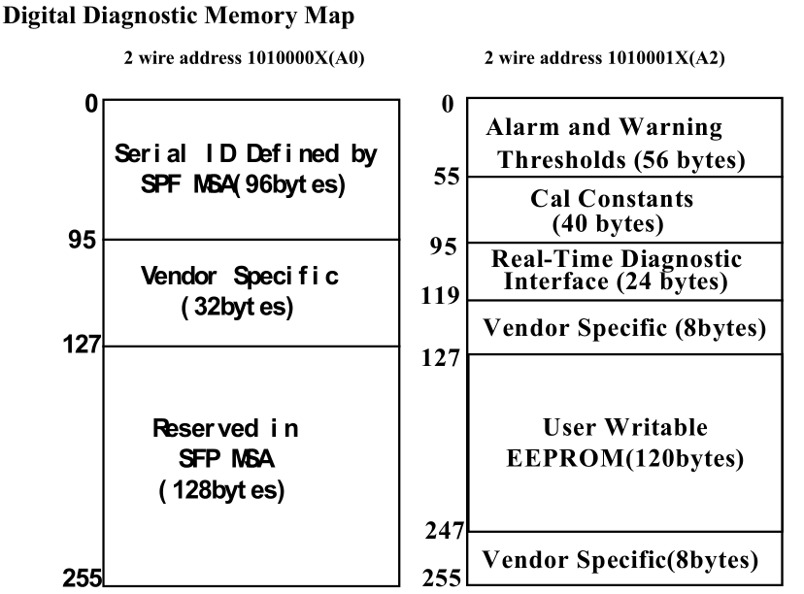

EEPROM Serial ID Memory Contents
Accessing Serial ID Memory uses the 2 wire address 1010000X(A0). Memory Contents of Serial ID areshown in Table 2
Table 2Serial ID Memory Contents
Data  Address | Size  (Bytes) | Name of Field | Contents(Hex) | Description
BASE ID FIELDS
0 | 1 | Identifier | 03 | SFP
1 | 1 | Ext. Identifier | 04 | SFP function is defined by serial ID only
2 | 1 | Connector | 07 | LC Connector
3~10 | 8 | Transceiver |  | Transceiver Codes
11 | 1 | Encoding | 03 | NRZ
12 | 1 | BR, Nominal | 0C | 1.25Gbit/s
13 | 1 | Reserved | 00
14 | 1 | Length (9µm) km |  | Transceiver transmit distance
15  16 | 1 | Length (9µm) 100m |  | Transceiver transmit distance
16 | 1 | Length (50µm) 10m |  | Transceiver transmit distance
17 | 1 | Length(62.5µm)10m |  | Transceiver transmit distance
18 | 1 | Length (Copper) | 00 | Not compliant
19 | 1 | Reserved | 00
20~35 | 16 | Vendor name |  | (ASCII)
36 | 1 | Reserved | 00
37~39 | 3 | Vendor OUI | 00 00 00
40~55 | 16 | Vendor PN |  | Transceiver part number
56~59 | 4 | Vendor rev | 20 20 20 20
60~61 | 2 | Wavelength |  | Transceiver wavelength
62 | 1 | Reserved | 00
63 | 1 | CC_BASE | Check Sum (Variable) | Check code for Base ID Fields
EXTENDED ID FIELDS
64~65 | 2 | Options | 00 1A | TX_DISABLE, TX_FAULT and  Loss of Signal implemented.
66 | 1 | BR,max | 00
67 | 1 | BR,min | 00
68~83 | 16 | Vendor SN | 42 30 30 39 38 32 32 20  20 20 20 20 20 20 20 20 | Serial Number of transceiver  (ASCII).For example“B009822”
84~91 | 8 | Date code | 30 32 31 30 30 35 20 20 | Manufactory date code. For  example “021005”.
92 | 1 | Diagnostic  Monitoring Type | 58 | Digital diagnostic monitoring  implemented, “externally calibrated” isimplemented,  RX measurement type is  “Average Power”.
93 | 1 | Enhanced Options | B0 | Optional Alarm/Warning flags  implemented for all monitored  quantities, Optional Soft TX_FAULT  monitoring implemented, Optional Soft  RX_LOS monitoring implemented.
94 | 1 | SFF_8472  Compliance | 01 | Includes functionality described in  Rev9.3 SFF-8472.
95 | 1 | CC_EXT | Check Sum (Variable) | Check sum for Extended ID Field
VENDOR SPECIFIC ID FIELDS
96~127 | 32 | Vendor Specific | Read only | Depends on customer information
128~25555 | 128 | Reserved | Read only | Filled by zero

Diagnostic Monitor Functions
Diagnostic Monitor Functions interface uses the 2 wire address 1010001X (A2). Memory contents ofDiagnostic Monitor Functions are shown in Table 3
Table 3 Memory contents of Diagnostic Monitor Function

Data  Address | Field Size  (bytes) | Name | Contents and Description
Alarm and Warning Thresholds
00-01 | 2 | Temperature High Alarm | Set to 85 o C
02-03 | 2 | Temperature Low Alarm | Set to -5 o C
04-05 | 2 | Temperature High Warning | Set to 75 o C
06-07 | 2 | Temperature Low Warning | Set to 0 o C
08-09 | 2 | Vcc High Alarm | Set to 3.6 V
10-11 | 2 | Vcc Low Alarm | Set to 3.0 V
12-13 | 2 | Vcc High Warning | Set to 3.5 V
14-15 | 2 | Vcc Low Warning | Set to 3.1 V
16-17 | 2 | Bias High Alarm | 2×IBias (25 o C ) +20
18-19 | 2 | Bias Low Alarm | 25%×IBias (25 o C)
20-21 | 2 | Bias High Warning | 2×IBias (25 o C ) +10
22-23 | 2 | Bias Low Warning | 50%×IBias (25 o C
24-25 | 2 | TX Power High Alarm | Manufacture measurement plus 2dB
26-27 | 2 | TX Power Low Alarm | Manufacture measurement minus 2dB
28-29 | 2 | TX Power High Warning | Manufacture measurement plus 1dB
30-31 | 2 | TX Power Low Warning | Manufacture measurement minus 1 dB
32-33 | 2 | RX Power High Alarm | Maximum input optical power
34-35 | 2 | RX Power Low Alarm | Minimum input optical power
36-37 | 2 | RX Power High Warning | Maximum input power minus 3dB
38-39 | 2 | RX Power Low Warning | Manufacture measurement plus 3dB
40-55 | 16 | Reserved
Calibration Constants
56-59 | 4 | RX Power Calibration Data4 | Single precision floating-point numbers (variousvalues at each device)
60-63 | 4 | RX Power Calibration Data3
64-67 | 4 | RX Power Calibration Data2 | Single precision floating-point numbers (variousvalues at each device)
68-71 | 4 | RX Power Calibration Data1
72-75 | 4 | RX Power Calibration Data0
76-77 | 2 | Bias Calibration Data1 | 00 01 (fixed)
78-79 | 2 | Bias Calibration Data0 | 00 00 (fixed)
80-81 | 2 | TX Power Calibration Data1 | 00 01 (fixed)
82-83 | 2 | TX Power Calibration Data0 | 00 00 (fixed)
84-85 | 2 | Temperature Calibration Data1 | 00 01 (fixed)
86-87 | 2 | Temperature Calibration Data0 | 00 00 (fixed)
88-89 | 2 | Vcc Calibration Data1 | 00 01 (fixed)
90-91 | 2 | Vcc Calibration Data0 | 00 00 (fixed)
92-94 | 3 | Reserved | 00 00 00 (fixed)
95 | 1 | Check Sum | Checksum of bytes 0-94
Real Time Diagnostic Monitor Interface
96-97 | 2 | Measured Temperature | Yield to a 16-bit A/D value (see Table 3.1)
98-99 | 2 | Measured Vcc | Yield a 16-bit A/D value (see Table 3.1)
100-101 | 2 | Measured Bias | Yield a 16-bit A/D value (see Table 3.1)
102-103 | 2 | Measured TX Power | Yield a 16-bit A/D value (see Table 3.1)
104-105 | 2 | Measured RX Power | Yield a 16-bit A/D value (see Table 3.1)
106-109 | 4 | Reserved
110 | 1 | Logic Status | See Table 3.2
111 | 1 | AD Conversion Updates | See Table 3.2
112-129 | 8 | Alarm and Warning Flags | See Table 3.3
Vendor Specific
120-127 | 8 | Vendor Specific | Don’t Access
128-247 | 120 | User writable EEPROM
245-255 | 8 | Vendor Specific | Don’t Access
The measured values located at bytes 96-105(in the 2 wire address 0xA2) are raw A/D values (16-bit
integers) of transceiver temperature, supply voltage, laser bias current, laser optical output power and
received power. All the measured values are “Externally Calibrated”, and then it is necessary to convert raw
A/D values to real world units by the manner as shown in Table 3.1

Table 3.1 Real Time Diagnostic Monitor Values
Byte | Name | Description
96 | Temperature MSB | Internally measured transceiver temperature. Comply with ExternalCalibration of SFF-8472.
97 | Temperature LSB
98 | Vcc MSB | Internally measured supply voltage. Comply with External Calibration ofSFF-8472
99 | Vcc LSB
100 | Laser Bias MSB | Measured Laser bias current. Comply with External Calibration ofSFF-8472
101 | Laser Bias LSB
102 | Tx Power MSB | Measured Tx power. Comply with External Calibration of SFF-8472.
103 | Tx Power LSB
104 | Rx Power MSB | Measured Tx power. Comply with External Calibration of SFF-8472
105 | Rx Power LSB

This transceiver implements two optional status bytes, “Logic States” at byte 110(0xA2)” and “A/D
Updated” at byte 111(0xA2) as shown in Table 3.2. “A/D Updated” status bits allow the user to verify if an
update from the analog-digital conversion has occurred of the measured values, temperature, Vcc, laser bias,
Tx power and Rx power. The user writes the byte to 0x00. Once a conversion is completed for a given value,
its bit will change to ‘1’.

Table 3.2 Logic Status and AD Conversion Updates
Byte | Bit | Name | Description
110 | 7 | Tx Disable State | Optional digital State of the Tx Disable input pin.
110 | 6 | Soft Tx Disable Control | Not supported (set to 0).
110 | 5 | Reserved | Set to 0.
110 | 4 | Rx Rate Select State | Not supported (set to 1).
110 | 3 | Soft Rate Select Control | Not supported (set to 0).
110 | 2 | Tx Fault | Optional digital state of the Tx Fault output pin
110 | 1 | LOS | Optional digital state of the LOS output pin
110 | 0 | Power on Logic | Bit will be 0 when the analog monitoring is active
111 | 7 | Temp A/D Valid | Indicates A/D value in Bytes 96/97 is valid.
111 | 6 | Vcc A/D Valid | Indicates A/D value in Bytes 98/99 is valid.
111 | 5 | Laser Bias A/D Valid | Indicates A/D value in Bytes 100/101 is valid.
111 | 4 | Tx Power A/D Valid | Indicates A/D value in Bytes 102/103 is valid.
111 | 3 | Rx Power A/D Valid | Indicates A/D value in Bytes 104/105 is valid.
111 | 2 | Reserved | Set to 0
111 | 1 | Reserved | Set to 0
111 | 0 | Reserved | Set to 0
Each of the measured values has a corresponding high alarm, low alarm, high warning and low warning
threshold level at location 00-39(x0A2) written as the data format of a corresponding valued shown in Table
3.3.Alarm and warning flags at bytes 112-119(0xA2) are defined as follows.
(1) Alarm flags indicate conditions likely to result (or have resulted) in link failure and cause for
immediate action.
(2) Warning flags indicate conditions outside the guaranteed operating specification of transceiver but not
necessarily causes of immediate link failures

Table 3.3 Alarm and Warning Flags
Byte | Bit | Name | Description
112 | 7 | Temperature High Alarm | Set when temperature monitor value exceeds high alarmlevel.
112 | 6 | Temperature Low Alarm | Set when temperature monitor value exceeds low alarm level
112 | 5 | Vcc High Alarm | Set when Vcc monitor value exceeds high alarm level.
112 | 4 | Vcc Low Alarm | Set when Vcc monitor value exceeds Low alarm level
112 | 3 | Laser Bias High Alarm | Set when laser bias monitor value exceeds high alarm level.
112 | 2 | Laser Bias Low Alarm | Set when laser bias monitor value exceeds low alarm level.
112 | 1 | Tx Power High Alarm | Set when Tx power monitor value exceeds high alarm level
112 | 0 | Tx Power Low Alarm | Set when Tx power monitor value exceeds low alarm level.
113 | 7 | Rx Power High Alarm | Set when Rx power monitor value exceeds high alarm level
113 | 6 | Rx Power Low Alarm | Set when Rx power monitor value exceeds low alarm level
113 | 5-0 | Reserved | All bits set to 0
114 | 7-0 | Reserved | All bits set to 0
115 | 7-0 | Reserved | All bits set to 0
116 | 7 | Temperature High warning | Set when temperature monitor value exceeds high warning  level.
116 | 6 | Temperature Low warning | Set when temperature monitor value exceeds low warning  level
116 | 5 | Vcc High warning | Set when Vcc monitor value exceeds high warning level.
116 | 4 | Vcc Low warning | Set when Vcc monitor value exceeds Low warning level.
116 | 3 | Laser Bias High warning | Set when laser bias monitor value exceeds high warning level.
116 | 2 | Laser Bias Low warning | Set when laser bias monitor value exceeds low warning level.
116 | 1 | Tx Power High warning | Set when Tx power monitor value exceeds high warning level
116 | 0 | Tx Power Low warning | Set when Tx power monitor value exceeds low warning level.
117 | 7 | Rx Power High warning | Set when Rx power monitor value exceeds high warning level
117 | 6 | Rx Power Low warning | Set when Rx power monitor value exceeds low warning level
117 | 5-0 | Reserved | All bits set to 0.
118 | 7-0 | Reserved | All bits set to 0.
119 | 7-0 | Reserved | All bits set to 0.

Pin Description
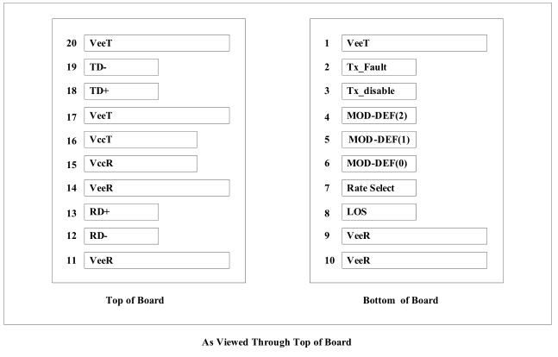

Pin Connections
Pin | Name | Function/Description | Engagement order | Notes
1 | VeeT | Transmitter Ground | 1
2 | TX Fault | Transmitter Fault Indication | 3 | 1
3 | TX Disable | Transmitter Disable-Module disables on high or open | 3 | 2
4 | MOD_DEF2 | Module Definition 2-Two wire serial ID interface | 3 | 3
5 | MOD_DEF1 | Module Definition 1-Two wire serial ID interface | 3 | 3
6 | MOD_DEF0 | Module Definition 0-Two wire serial ID interface | 3 | 3
7 | Rate Select | Not Connected | 3
8 | LOS | Loss of Signal | 3 | 4
9 | VeeR | Receiver Ground | 1
10 | VeeR | Receiver Ground | 1
11 | VeeR | Receiver Ground | 1
12 | RD- | Inverse Received Data out | 3 | 5
13 | RD+ | Received Data out | 3 | 5
14 | VeeR | Receiver Ground | 1
15 | VccR | Receiver Power —— +3.3V±5% | 2 | 6
16 | VccT | Transmitter Power —— +3.3 V±5% | 2 | 6
17 | VeeT | Transmitter Ground | 1
18 | TD+ | Transmitter Data In | 3 | 7
19 | TD- | Inverse Transmitter Data In | 3 | 7
20 | VeeT | Transmitter Ground | 1
Note1. TX Fault is open collector/drain output which should be pulled up externally with a 4.7K – 10KΩresistor on the host
board to supply <VccT+0.3V or VccR+0.3V. When high, this output indicates a laser fault of some kind. Low indicates normal
operation. In the low state, the output will be pulled to <0.8V.
Note2. TX Disable input is used to shut down the laser output per the state table below. It is pulled up within the module with
a 4.7 – 10K resistor.
Low (0 – 0.8V): Transmitter on
Between (0.8V and 2V): Undefined
High (2.0 – VccT): Transmitter Disabled
Open : Transmitter Disabled
Note3. Mod-Def 0, 1, 2. These are the module definition pins. They should be pulled up with a 4.7 - 10K resistor on the host
board to supply less than VccT+0.3V or VccR+0.3V.
Mod-Def 0 is grounded by the module to indicate that the module is present.
Mod-Def 1 is clock line of two wire serial interface for optional serial ID.
Mod-Def 2 is data line of two wire serial interface for optional serial ID.
Note4. LOS (Loss of signal) is an open collector/drain output which should be pulled up externally with a 4.7 – 10K resistor
on the host board to supply <VccT+0.3V or VccR+0.3V. When high, this output indicates the received optical power is below
the worst case receiver sensitivity (as defined by the standard in use). Low indicates normal operation. In the low state, the
output will be pulled to <0.8V.
Note5. RD-/+: These are the differential receiver outputs. They are AC coupled 100Ω differential lines which should be
terminated with 100Ω differential at the user SERDES. The AC coupling is done inside the module and thus not required on
the host board.
Note6. VccR and VccT are the receiver and transmitter power supplies. They are defined as 3.3V±5% at the SFP connector
pin. The in-rush current will typically be no more than 30mA above steady state supply current after 500ns.
Note7. TD-/+: These are the differential transmitter inputs. They are AC coupled differential lines with 100Ω differential
termination inside the module. The AC coupling is done inside the module and is thus not required on host board.

Block Diagram

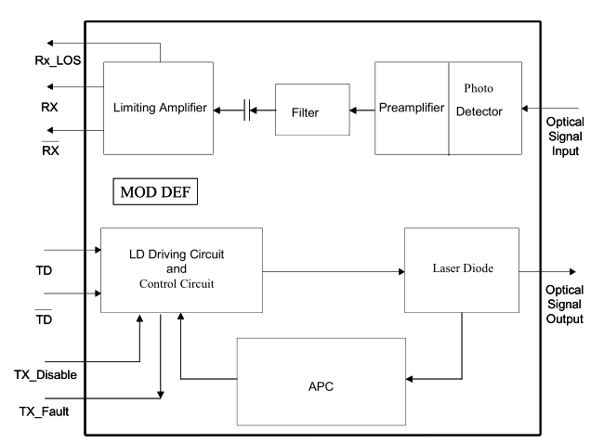
Required Host Board Components
The MSA power supply noise rejection filter is required on the host PCB to meet data sheet performance.The MSA filter incorporates an inductor which should be rated 400mADC and 1Ωserial resistance or better.It should not be replaced with a ferrite. The required filter is illustrated in Figure 3. The MSA also specifiesthat 4.7K to 10KΩ pull-up resistors for TX_FAULT, LOS, and MOD_DEF0,1,2 are required on the hostPCB. Figure is the suggested transceiver/host interface

Typical Application Circuit

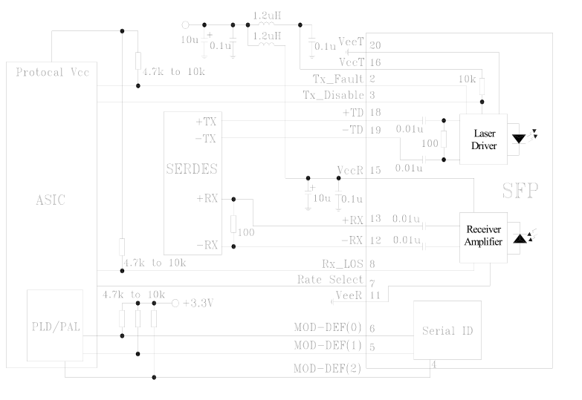

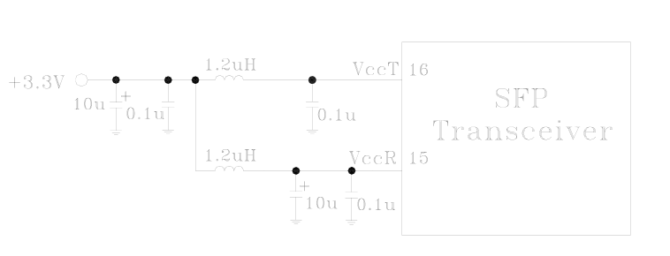

Package Outline

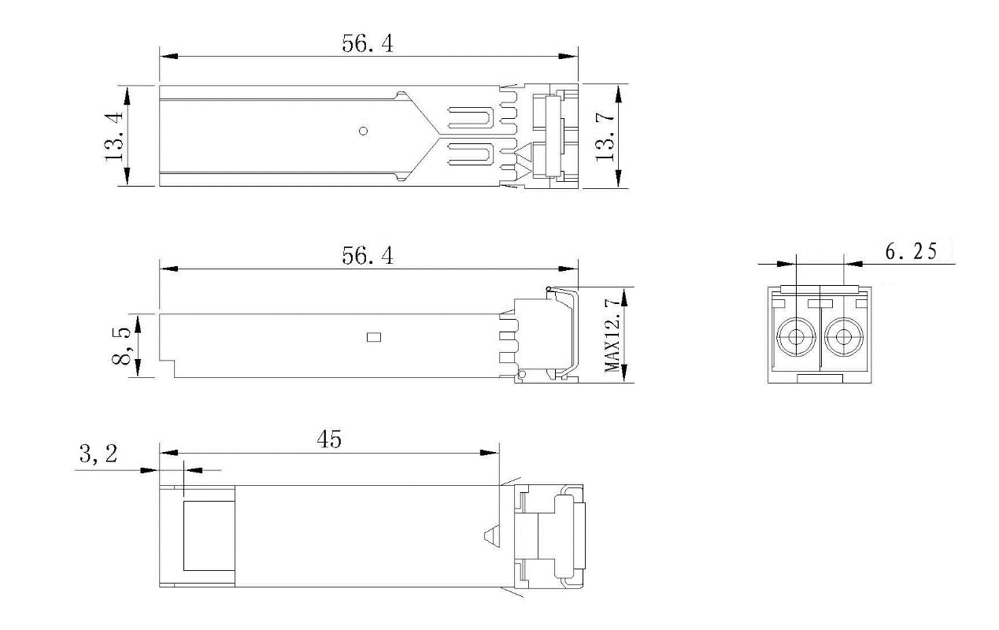
PCB Layout Recommendation
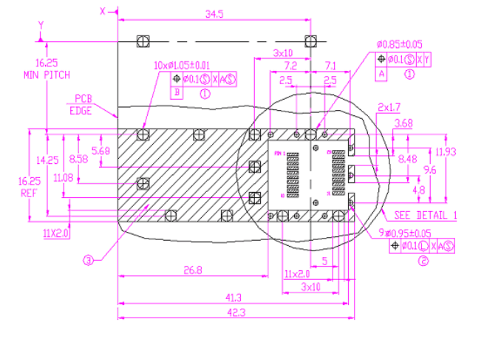
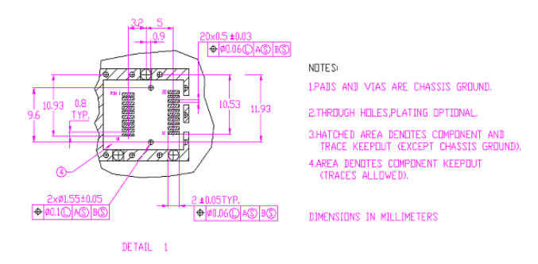

Regulatory Compliance
Feature | Test Method | Performance
Electrostatic Discharge  (ESD) to the ElectricalPins | MIL-STD-883E  Method 3015.7 | Class 1 (>1.5kV) – Human Body Model
Electrostatic Discharge  (ESD) Immunity | IEC61000-4-2 | Class 2(>4.0kV)
Electromagnetic  Interference (EMI) | CISPR22 ITE Class B  FCC Class B  CENELEC EN55022  VCCI Class 1 | Compliant with standard
Immunity | IEC61000-4-3 Class2 | Typically show no measurable effect from a 3V/m field swept from 80 to 1000MHz applied tothe transceiver without a chassis enclosure.
Eye Safety | FDA CDRH 21-CFR 1040 Class 1  NO.:0322110-02
Eye Safety | UL  NO.:E239070

