10Gb/s 40Km SFP+ 1550nm Transceiver

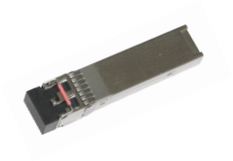

Features
l Operating data 1.25 to
11.3Gbps
l Cooled 1550nm EML laser
l High sensitivity PIN photodiode and TIA
l LC duplex connector
l Hot-pluggable 20 pin connector
l Power consumption <1.5W
l -5℃ to 70℃ case temperature range
l Single +3.3V power supply
l Fully RoHS Compliant
l All metal housing for
superior EMI performance

Applications
l 10GBASE-ER/EW
l 10G Fiber Channel

Standards
l IEEE 802.3
10G BASE-ER/EW
l SFF-8431 & SFF-8432 &SFF-8472

The JH-10G-ER-40 transceivers are designed to transmit and receive serial optical data over 40km single mode optical fiber.
They are compliant with SFF-8431, SFF-8432, 10GFC and 10GBASE-ER/EW. The transmitter converts serial CML electrical data into serial optical data compliant with the IEEE 802.3ae standard. The receiver converts serial optical data into serial CML electrical data. Digital diagnostics functions are available via a 2-wire serial interface, as specified in SFF-8472.

Specifications
(Tc=-5 ℃ to 70 ℃ and Vcc= 3.14 to 3.46V)

Parameter | Symbol | Unit | Min | Typ | Max | Note
Transmitter
Nominal Wavelength | λ | nm | 1530 |  | 1565
Side Mode Suppression Ratio | SMSR | dB | 30
Spectral Width(-20dB) | Δλ | nm |  |  | 0.5
Optical Output Power | Pav | dBm | -4.7 |  | 4
Extinction Ratio | ER | dB | 6
Transmitter and Dispersion Penalty | TDP | dB |  |  | 3 | 1
Average Launch Power of OFF Transmitter | POFF | dBm |  |  | -30
Relative Intensity Noise | RIN | dB/Hz |  |  | -128
Receiver
Center Wavelength | λC | nm | 1260 |  | 1620
Receiver Sensitivity | RSEN | dBm |  |  | -15.8 | 2
Receiver Sensitivity(OMA) | RSEN | dBm |  |  | -14.1 | 2
Overload |  | dBm | -1
Optical Return Loss |  | dB | 27 |  | -
LOS Assert | LOSA | dBm | -30
LOS De-Assert LOS | LOSD | dBm |  |  | -17
LOS Hysteresis |  | dB | 0.5 |  | 6
Note:
1. Dispersion Penalty at BER=1 × 10-12 , 10.3125Gbps, PRBS 231-1, 40km Fiber.
2. Sensitivity for 10.3125G PRBS 231-1 and BER better than or equal to 10E-12 .

© Wuhan Jiuhong Optics Technology Co., Ltd.
Web: www.jh-optics.com
Email: grace@jh-optics.com

Ordering Information

Part No. | Specifications |  |  |  |  |  |  |  |  |  |  |  |  |  | Application
Part No. | Package | Data  rate | Laser | Optical  Power |  | Detector |  | Sensitivity |  | Temp |  | Reach |  | Other
JH-10G-ER-40 | SFP+ | 1.25 to 11.3G | 1550nm EML | -4.7  ~+4dBm |  | PIN |  | < -15.8dBm |  | -5~70℃ |  | 40km |  | DDM | 10GBASE-ER/EW 10G Fiber Channel
Block diagram
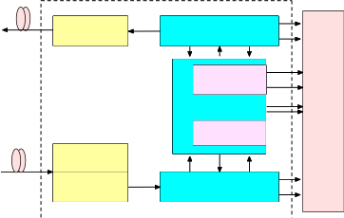
Laser Driver

Controller
MCU
FLASH

Post Amplifier
TOSA

ROSA
TIA
S F P
+ C O N N E C T O R
Figure 1.Transceiver functional diagram

Absolute Maximum Ratings
Parameter |  |  |  |  | Symbol |  |  |  | Unit |  | Min |  |  |  | Max
Storage Temperature Range |  |  |  |  | Ts |  |  |  | oC |  | -40 |  |  |  | 85
Relative Humidity |  |  |  |  | RH |  |  |  | % |  | 0 |  |  |  | 95
Recommended Operating |  |  |  |  | Conditions
Parameter |  |  |  |  | Symbol |  | Unit |  | Min |  |  |  | Typ |  | Max
Operating Case Temperature Range |  |  |  |  | Tc | oC |  |  | -5 |  |  |  |  |  | 70
Power Supply Voltage |  |  |  |  | Vcc V |  |  |  | 3.14 |  | 3.3 |  |  |  | 3.46
Bit Rate |  |  |  |  | BR Gb/s |  |  |  |  |  |  |  |  |  | 11.3
Bit Error Ratio |  |  |  |  | BER |  |  |  |  |  |  |  |  |  |  | 10-12
Max Supported Link Length |  |  |  |  | L Km |  |  |  |  |  |  |  |  |  | 40

Electric Ports Definition

Parameter |  | Symbol | Unit | Min | Typ | Max Note
Supply Voltage |  | VCC | V | 3.14 | 3.3 | 3.46
Power Consumption |  | P | W |  |  | 1.5
Transmitter
Input Differential Impedance |  | RIN | Ω | 80 | 100 | 120
Differential Data Input |  | VIN | mVp-p | 180 |  | 700
Transmit Disable Voltage |  | VDIS | V | 2 |  | VCCHOST
Transmit Enable Voltage |  | VEN | V | VEE |  | VEE+0.8
Transmit Fault Assert Voltage |  | VFA | V | 2 |  | VCCHOST
Transmit Fault De-Assert Voltage |  | VFDA | V | VEE |  | VEE+0.4
Receiver
Differential Data Output |  | VOD | mVp-p | 300 | 850
Output Rise Time |  | tRISE | pS | 28
Output Fall Time |  | tFALL | pS | 28
LOS Fault |  | VLOSFT | V | 2 | VCCHOST
LOS Normal |  | VLOSNR | V | VEE | VEE+0.4
Pin function definitions

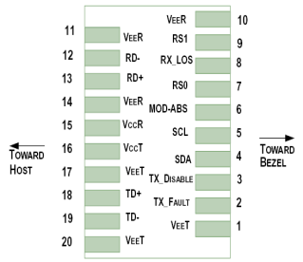
Figure 2.Pin function definitions

Table 1: Transceiver pin descriptions
Pin  Number | Symbol Name Description
1,17,20 VeeT Transmitter Signal Ground |  | These pins should be connected to signal ground on the host board.

2 | TX Fault | Transmitter Fault Out (OC) | Logic “1” Output = Laser Fault (Laser off before t_fault)  Logic “0” Output = Normal Operation  This pin is open collector compatible, and should be pulled  up to Host Vcc with a 10kΩ resistor.
3 | TX  Disable | Transmitter Disable In  (LVTTL) | Logic “1” Input (or no connection) = Laser off Logic “0” Input = Laser on  This pin is internally pulled up to VccT with a 10 kΩ resistor.
4 | SDA | Module Definition Identifiers | Serial ID with SFF 8472 Diagnostics  Module Definition pins should be pulled up to Host Vcc  with 10 kΩ resistors.
5 | SCL | Module Definition Identifiers
6 | MOD-ABS | Module Definition Identifiers
7 | RS0 | Receiver Rate Select (LVTTL) These pins have an internal 30kΩ pull-down to ground. A Transmitter Rate Select signal on either of these pins will not affect module  (LVTTL) performance.
9 | RS1
8 | LOS | Loss of Signal Out (OC) | Sufficient optical signal for potential BER < 1x10- 12 = Logic “0”  Insufficient optical signal for potential BER < 1x10- 12 = Logic “1”  This pin is open collector compatible, and should be pulled up to Host Vcc with a 10kΩ resistor.
10,11,14 | VeeR | Receiver Signal Ground | These pins should be connected to signal ground on the host  board.
12 | RD- | Receiver Negative DATA Out  (CML) | Light on = Logic “0” Output Receiver DATA output is internally AC coupled and series terminated with a 50Ω resistor.
13 | RD+ | Receiver Positive DATA Out  (CML) | Light on = Logic “1” Output Receiver DATA output is  internally AC coupled and series terminated with a 50Ω  resistor.
15 | VccR | Receiver Power Supply | This pin should be connected to a filtered +3.3V power supply on the host board. See Figure 3.Recommended power supply filter
16 | VccT | Transmitter Power Supply | This pin should be connected to a filtered +3.3V power  supply on the host board. See Figure 3.Recommended  power supply filter
18 | TD+ | Transmitter Positive DATA In  (CML) |  | Logic “1” Input = Light on Transmitter DATA inputs are internally AC coupled and terminated with a differential 100Ω resistor.
19 | TD- | Transmitter Negative DATA In  (CML) |  | Logic “0” Input = Light on Transmitter DATA inputs are  internally AC coupled and terminated with a differential  100Ω resistor.

Typical Application Circuit
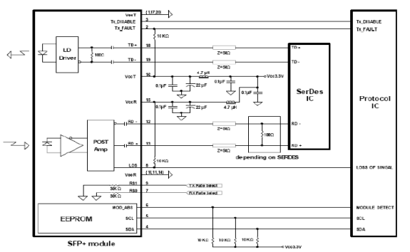

Package Outline

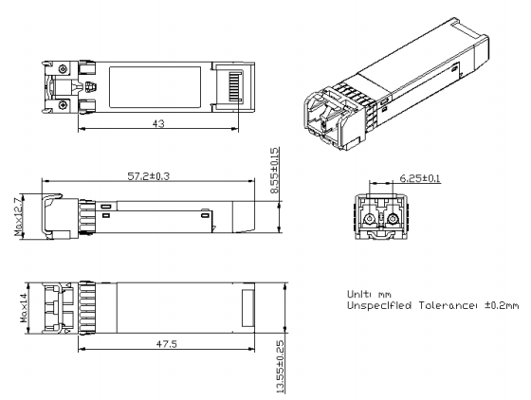

Regulatory Compliance

Feature | Test Method | Performance
Electrostatic Discharge (ESD) to the Electrical Pins | MIL-STD-883C Method 3015.4 | Class1 (>1KV) for high speed I/O pins Class 1 (> 2KV) for all other pins
Electrostatic Discharge (ESD) to the Duplex LC Receptacle | Variation of IEC 61000-4-2 | The SFP+ modules meet ESD  requirements given in EN61000-4-2, criterion B test specification such that units are subjected to 15kV air  discharges during operation and 8kV direct contact discharges to the case.
Electromagnetic Interference (EMI) | CISPR22 ITE Class B  EN55022 Class B | Compliant with standards
EMC |  | FCC Class B/CE Class B
Immunity | IEC61000-4-3 Class 2  EN55024 | Typically show no measurable effect from a 3V/m field swept from 80 to 1000MHz applied to the transceiver without a chassis enclosure.
RoHS Compliance |  | Less than 1000 ppm of cadmium, lead, mercury, hexavalent chromium,  polybrominated biphenyls, and  polybrominated biphenyl ethers.

