10Gb/s 1310nm SFP+ 20km Transceiver
PRODUCT FEATURES
- Up to 11.1Gbps Data Links
- Up to 20km transmission on SMF
- DFB Laser and PIN receiver
- Metal enclosure, for lower EMI
- 2-wire interface with integrated Digital Diagnostic monitoring
- Hot-pluggable SFP+ footprint
- Specifications compliant with SFF 8472
- Compliant with SFP+ MSA with LC connector
- Single 3.3V power supply
- Case operating temperature range:0°C to 70°C
- Power dissipation < 1.5 W
APPLICATIONS
- 10GBASE-LR/LW & 10G Ethernet
STANDARD
- Compliant to SFF-8431
- Compliant to SFF 8472
- RoHS Compliant.

Ⅰ Absolute Maximum Ratings
Parameter | Symbol | Min. | Typ. | Max. | Unit | Note
Storage Temperature | Ts | -40 | - | 85 | ºC
Relative Humidity | RH | 5 | - | 95 | %
Power Supply Voltage | VCC | -0.3 | - | 4 | V
Signal Input Voltage |  | Vcc-0.3 | - | Vcc+0.3 | V
Ⅱ Recommended Operating Conditions
Parameter | Symbol | Min. | Typ. | Max. | Unit | Note
Case Operating Temperature | Tcase | 0 | - | 70 | ºC | Without air flow
Power Supply Voltage | VCC | 3.14 | 3.3 | 3.47 | V
Power Supply Current | ICC | - |  | 450 | mA
Data Rate | BR |  | 10.3125 |  | Gbps
Transmission Distance | TD |  | - | 20 | km
Coupled fiber | Single mode fiber |  |  |  |  | 9/125um SMF
Ⅲ Optical Characteristics
Parameter | Symbol | Min | Typ | Max | Unit | NOTE
Transmitter
Output Opt. Power | POUT | -6 |  | -0.5 | dBm | 1
Optical Wavelength | λ | 1260 | 1310 | 1355 | nm
Spectral Width (-20dB) | σ |  |  | 1 | nm
Optical Extinction Ratio | ER | 3.5 |  |  | dB
Output Eye Mask | Compliant with IEEE 802.3ae
Receiver
Rx Sensitivity | RSENS |  |  | -14.4 | dBm | 2
Input Saturation Power (Overload) | Psat | 0.5 |  |  | dBm
Wavelength Range | λ_{C} | 1270 |  | 1610 | nm
LOS De -Assert | LOSD |  |  | -17 | dBm
LOS Assert | LOSA | -30 |  |  | dBm
LOS Hysteresis |  | 0.5 | 1.0 |  | dB
Notes:
- Class 1 Laser Safety per FDA/CDRH and IEC-825-1 regulations.
- Measured with a PRBS 2³¹-1 test pattern, @10.325Gb/s, BER<10⁻¹² .
  - Electrical Characteristics
Parameter | Symbol | Min | Typ | Max | Unit | NOTE
Supply Voltage | Vcc | 3.14 | 3.3 | 3.46 | V
Supply Current | Icc |  |  | 450 | mA
Transmitter
Input differential impedance | Rin |  | 100 |  | Ω | 1
Single ended data input swing | Vin,pp | 180 |  | 700 | mV
Transmit Disable Voltage | VD | Vcc–1.3 |  | Vcc | V
Transmit Enable Voltage | VEN | Vee |  | Vee+ 0.8 | V | 2
Transmit Disable Assert Time |  |  |  | 10 | us
Receiver
Differential data output swing | Vout,pp | 300 |  | 850 | mV | 3
Data output rise time | tr | 28 |  |  | ps | 4
Data output fall time | tf | 28 |  |  | ps | 4
LOS Fault | VLOS fault | Vcc–1.3 |  | VccHOST | V | 5
LOS Normal | VLOS norm | Vee |  | Vee+0.8 | V | 5
Power Supply Rejection | PSR | 100 |  |  | mVpp | 6
Notes:
- Connected directly to TX data input pins. AC coupled thereafter.
- Or open circuit.
- Into 100 ohms differential termination.
- 20 – 80 %.
- Loss Of Signal is LVTTL. Logic 0 indicates normal operation; logic 1 indicates no signal detected.
- Receiver sensitivity is compliant with power supply sinusoidal modulation of 20 Hz to 1.5 MHz up to specified value applied through the recommended power supply filtering network.

  - Pin Assignment
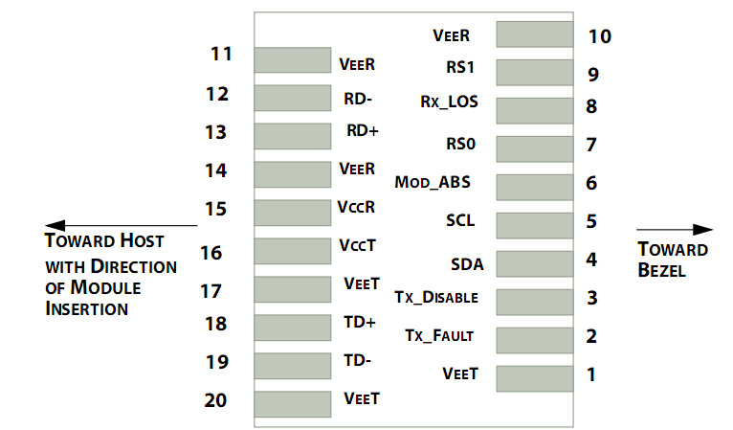
Pin out of Connector Block on Host Board
Pin | Symbol | Name/Description | NOTE
1 | V_{EET} | Transmitter Ground (Common with Receiver Ground) | 1
2 | T_{FAULT} | Transmitter Fault. | 2
3 | T_{DIS} | Transmitter Disable. Laser output disabled on high or open. | 3
4 | SDA | 2-wire Serial Interface Data Line | 4
5 | SCL | 2-wire Serial Interface Clock Line | 4
6 | MOD_ABS | Module Absent. Grounded within the module | 4
7 | RS0 | Rate Select 0 | 5
8 | LOS | Loss of Signal indication. Logic 0 indicates normal operation. | 6
9 | RS1 | No connection required | 1
10 | V_{EER} | Receiver Ground (Common with Transmitter Ground) | 1
11 | V_{EER} | Receiver Ground (Common with Transmitter Ground) | 1
12 | RD- | Receiver Inverted DATA out. AC Coupled
13 | RD+ | Receiver Non-inverted DATA out. AC Coupled
14 | V_{EER} | Receiver Ground (Common with Transmitter Ground) | 1
15 | V_{CCR} | Receiver Power Supply
16 | V_{CCT} | Transmitter Power Supply
17 | V_{EET} | Transmitter Ground (Common with Receiver Ground) | 1
18 | TD+ | Transmitter Non-Inverted DATA in. AC Coupled.
19 | TD- | Transmitter Inverted DATA in. AC Coupled.
20 | V_{EET} | Transmitter Ground (Common with Receiver Ground) | 1
Notes:
- Circuit ground is internally isolated from chassis ground.
- T_{FAULT} is an open collector/drain output, which should be pulled up with a 4.7k – 10k Ohms resistor on the host board if intended for use. Pull up voltage should be between 2.0V to Vcc + 0.3V.A high output indicates a transmitter fault caused by either the TX bias current or the TX output power exceeding the preset alarm threshold. A low output indicates normal operation. In the low state, the output is pulled to <0.8V.
- Laser output disabled on T_{DIS} >2.0V or open, enabled on T_{DIS} <0.8V.
- Should be pulled up with 4.7kΩ- 10kΩ host board to a voltage between 2.0V and 3.6V. MOD_ABS pulls line low to indicate module is plugged in.
- Internally pulled down per SFF-8431 Rev 4.1.
- LOS is open collector output. It should be pulled up with 4.7kΩ – 10kΩ on host board to a voltage between 2.0V and 3.6V. Logic 0 indicates normal operation; logic 1 indicates loss of signal.

  - Digital Diagnostic Functions
JH-10G-LR-20 transceivers support the 2-wire serial communication protocol as defined in the SFP+ MSA.
The standard SFP serial ID provides access to identification information that describes the transceiver’s capabilities, standard interfaces, manufacturer, and other information.

Additionally, SFP+ transceivers provide a unique enhanced digital diagnostic monitoring interface, which allows real-time access to device operating parameters such as transceiver temperature, laser bias current, transmitted optical power, received optical power and transceiver supply voltage. It also defines a sophisticated system of alarm and warning flags, which alerts end-users when particular operating parameters are outside of a factory set normal range.

The SFP MSA defines a 256-byte memory map in EEPROM that is accessible over a 2-wire serial interface at the 8 bit address 1010000X (A0h).The digital diagnostic monitoring interface makes use of the 8 bit address 1010001X (A2h), so the originally defined serial ID memory map remains unchanged.

The operating and diagnostics information is monitored and reported by a Digital Diagnostics Transceiver Controller (DDTC) inside the transceiver, which is accessed through a 2-wire serial interface. When the serial protocol is activated, the serial clock signal (SCL, Mod Def 1) is generated by the host. The positive edge clocks data into the SFP transceiver into those segments of the E2PROM that are not write-protected. The negative edge clocks data from the SFP transceiver. The serial data signal (SDA, Mod Def 2) is bi-directional for serial data transfer. The host uses SDA in conjunction with SCL to mark the start and end of serial protocol activation. The memories are organized as a series of 8-bit data words that can be addressed individually or sequentially.

Transceiver Interface Block Diagram
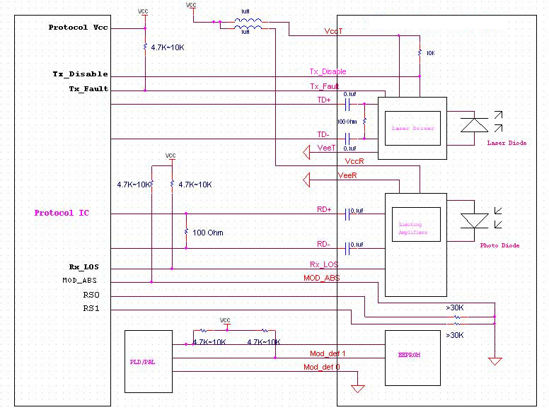

  - Outline Dimensions
Comply to SFF-8432 rev. 5.0, the improved Pluggable form factor specification.
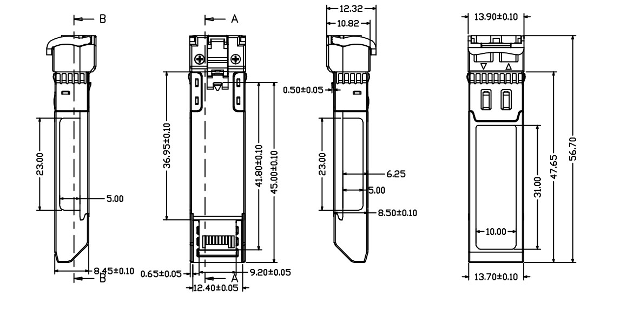
  - Regulatory Compliance
Feature | Reference | Performance
Electrostatic discharge（ESD） | IEC/EN 61000-4-2 | Compatible with standards
Electromagnetic Interference (EMI) | FCC Part 15 Class B EN 55022 Class B (CISPR 22A) | Compatible with standards
Laser Eye Safety | FDA 21CFR 1040.10, 1040.11 IEC/EN 60825-1, 2 | Class 1 laser product
ROHS | 2002/95/EC | Compatible with standards
EMC | EN61000-3 | Compatible with standards
Appendix A. Document Revision
Version No. | Date | Description
1.0 | 2010-09-01 | Preliminary datasheet
2.0 | 2011-09-10 | Update format and company’s logo

