Product Specification
10G SFP+ SR Dual LC Transceivers

PRODUCT FEATURES
- Up to 11.1Gbps Data Links
- 850nm VCSEL transmitter and GaAs PIN PD receiver
- Maximum link length of 300m via OM3 multimode Fiber (MMF)
- Compliant with IEEE 802.3ae 10GBASE-SR/SW
- Hermetic TOs package，high reliability
- Operating temperature range:
Commercial: 0°C to +70°C
Extended: -20°C to +75°C

Application
- Inter Rack Connection
- High-speed Servers
- 10GBASE-SW at 9.953Gbps/10GBASE-SR at 10.3125Gbps
- High-performance Computing Clusters
- SAN, Routers, Hubs, Load Balancer

Ordering information
Part Number | Product Description
JH-10G-SR-C | 10G SFP+ SR Transceivers, C-TEMP
JH-10G-SR-E | 10G SFP+ SR Transceivers, E-TEMP

DESCRIPTION
The JH-10G-SR-X Small Form Factor Pluggable (SFP) transceiver is SFP+ module for duplex optical data communications such as 10GBASE-SR and 10GBASE-SW. It is with the SFP+ 20-pin connector to allow hot plug capability. Digital diagnostic functions are available via an I2C. This module is designed for multi-mode fiber and operates at a nominal wavelength of 850nm.
The transmitter section uses a Vertical Cavity Surface Emitted Laser (VCSEL) and is a Class 1 laser compliant according to International Safety Standard IEC 60825. The receiver section uses an integrated GaAs detector preamplifier (IDP) mounted in an optical header and a limiting post-amplifier IC.
Absolute Maximum Ratings
Parameter | Symbol | Min. | Typ. | Max. | Unit | Note
Storage Temperature | T_{s} | -40 | - | 85 | ºC
Relative Humidity | R_{H} | 5 | - | 95 | %
Power Supply Voltage | V_{CC} | -0.3 | - | 4 | V
Signal Input Voltage | V_{SI} | Vcc-0.3 | - | Vcc+0.3 | V

RECOMMENDED OPERATING CONDITIONS
Parameter | Symbol | Min. | Typ. | Max. | Unit | Note
Case Operating Temperature | Tcase | 0 |  | 70 | ºC | JH-10G-SR-C
Case Operating Temperature | Tcase | -20 |  | 75 | ºC | JH-10G-SR-E
Power Supply Voltage | V_{CC} | 3.14 | 3.3 | 3.47 | V
Power Supply Current | I_{CC} | - |  | 300 | mA
Data Rate | BR |  | 10.3125 |  | Gbps | TX Rate/RX Rate
Transmission Distance | TD |  |  | 300 | m | OM3

TRANSMITTER CHARACTERISTICS
Parameter | Symbol | Min. | Typ. | Max. | Unit | Note
Center wavelength | λ | 840 |  | 860 | nm
RMS spectral width | Pm |  |  | 0.45 | nm
Average optical power | Pavg | -6 |  | +1 | dBm
Average launch power of OFF transmitter | Poff |  |  | -30 | dBm
Extinction ratio | ER | 3 |  |  | dB
Transmitter Dispersion Penalty | TDP |  |  | 3.9 | dB
Output Optical Eye |  | IEEE 802.3-2005 Compliant
Optical return loss tolerance |  |  |  |  | 12 | dB

RECEIVER CHARACTERISTICS
Parameter | Symbol | Min. | Typ. | Max. | Unit | Note
Center wavelength | λ | 840 | 850 | 860 | nm
Damage threshold |  | 3.4 |  |  | dBm
Receive power overload |  | -1 |  |  | dBm | 1
Receiver sensitivity |  |  |  | -12 | dB | 1
LOS Assert | LOS_{A} | -25 |  |  | dBm
LOS De-Assert | LOS_{D} |  |  | -11.5 | dBm
LOS Hysteresis | LOSH | 0.5 |  |  | dB
1. Measured with a 10.3125G, PRBS-31 NRZ, ER>3dB, BER<10-12

PIN ASSIGNMENT

Figure 1. Pin function definitions

PIN DESCRIPTION

Recommended Interface Circuit
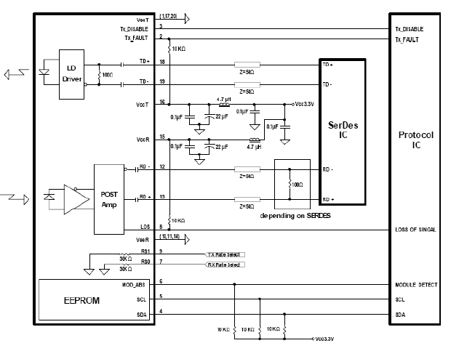
Figure 2. Typical application circuit

Mechanical Dimensions
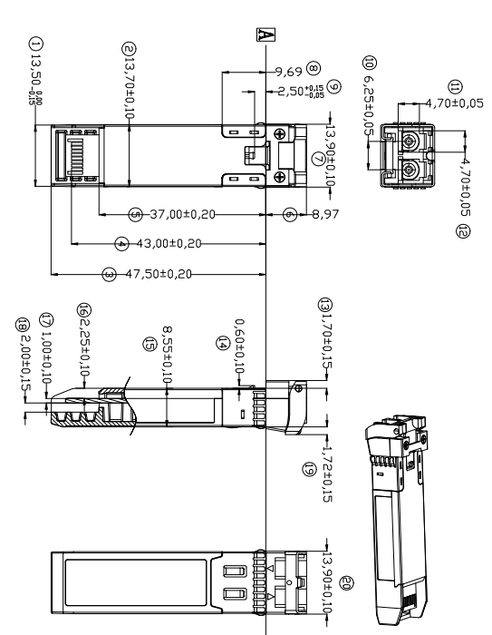
Figure 3. Module Mechanical Dimensions

Digital Diagnostics Functions
As defined by the SFF-8472, Our SFP28 transceivers provide digital diagnostic functions via a 2-wire serial interface, which allows real-time access to the following operating parameters:
- Transceiver temperature
- Laser bias current
- Transmitted optical power
- Received optical power
- Transceiver supply voltage
It also provides a sophisticated system of alarm and warning flags, which may be used to alert end-users when particular operating parameters are outside of a factory-set normal range. The operating and diagnostics information is monitored and reported by a Digital Diagnostics Transceiver Controller (DDTC) inside the transceiver, which is accessed through the 2-wire serial interface. The memories are organized as a series of 8-bit data words that can be addressed individually or sequentially. The 2-wire serial interface provides sequential or random access to the 8 bit parameters, addressed from 0x00h to the maximum address of the memory. For more detailed information, including memory map definitions, please refer the SFF-8472 documentation.

Digital Diagnostic Monitor Accuracy
The following characteristics are defined over recommended operating conditions

Parameter | Accuracy | Unit
Internally measured transceiver temperature | +/-3 | deg.C
Internally measured transceiver supply voltage | +/-3 | %
Measured Tx bias current | +/-10 | %
Measured Tx output power | +/-3 | dB
Measured Rx received average optical power | +/-3 | dB

