1V1F Transmission Module

Overview
The 1V1F transmission module optical transceiver adopts a cost-effective domestic FPGA and utilizes fiber optic transmission technology to achieve long-distance lossless transmission of CVBS video signals and TTL control signals, making the image output smoother. The maximum transmission distance can reach 100 kilometers, suitable for complex electromagnetic environment scenarios such as drone racing, aerial photography, and industrial inspection.
The product is divided into two parts: the transmitter (TX1310nm) and the receiver (RX1550nm), which are used in pairs. The transmitting end is connected to the camera, and the receiving end is connected to the controller. By using fiber optic as a high-speed and low latency data transmission medium, high-definition video signals captured are transmitted back to the control station in real-time. Fiber optic transmission, with its ultra large bandwidth, strong anti-interference ability, and extremely low latency, greatly enhances the stability and application range of data and video signal transmission.

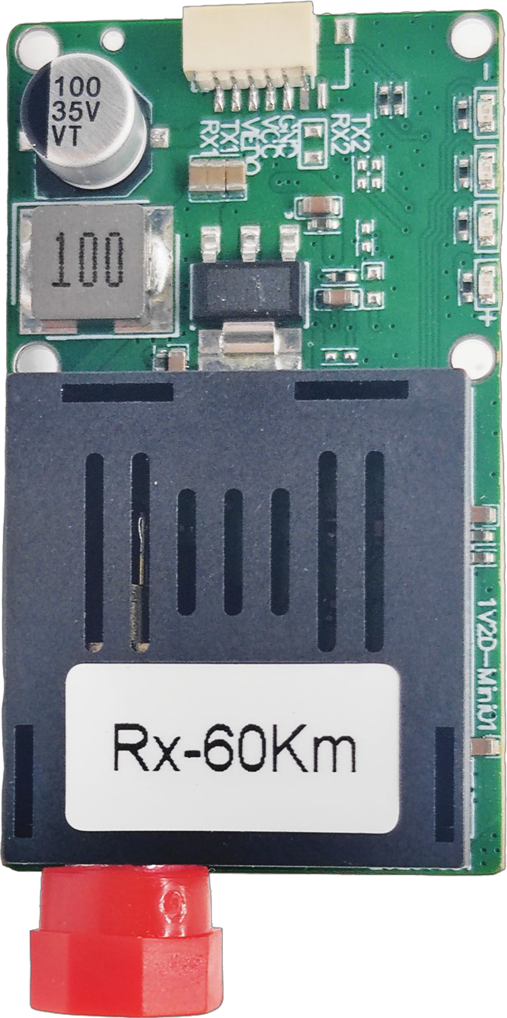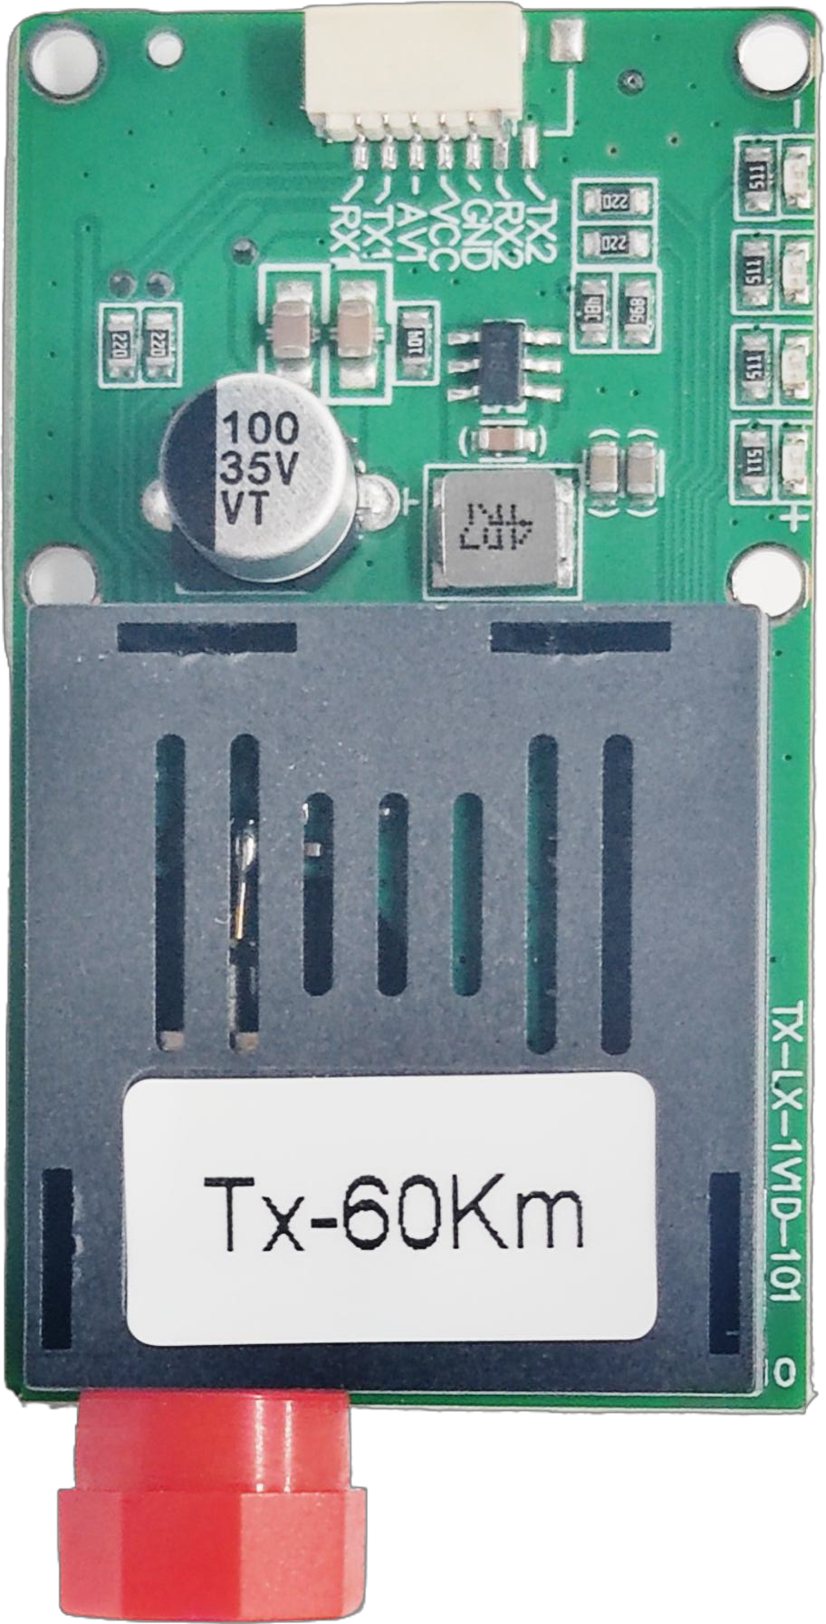

Features

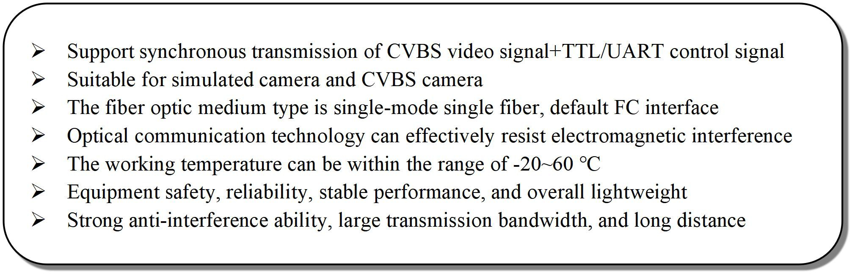

Internet
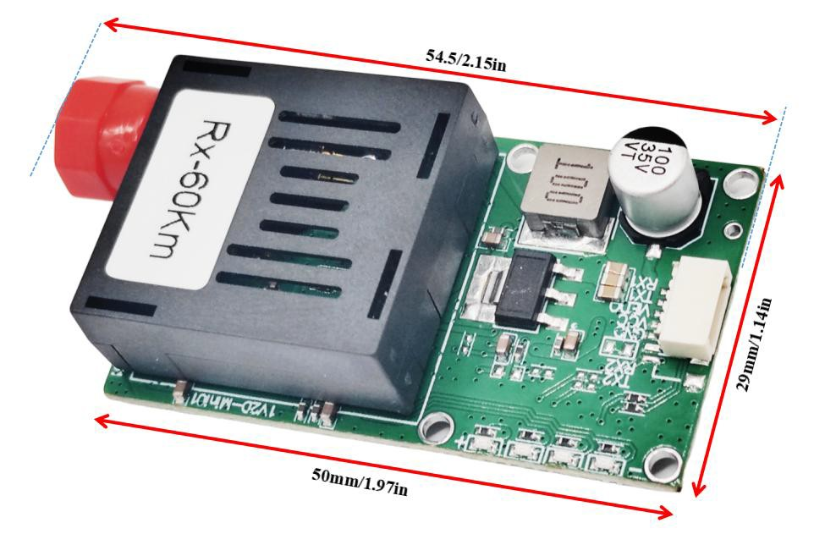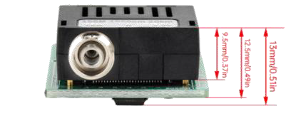
Dimension

Application

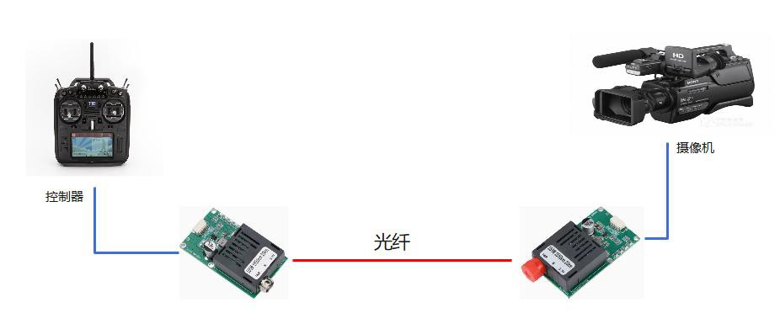
Camera
Controlle
Fiber

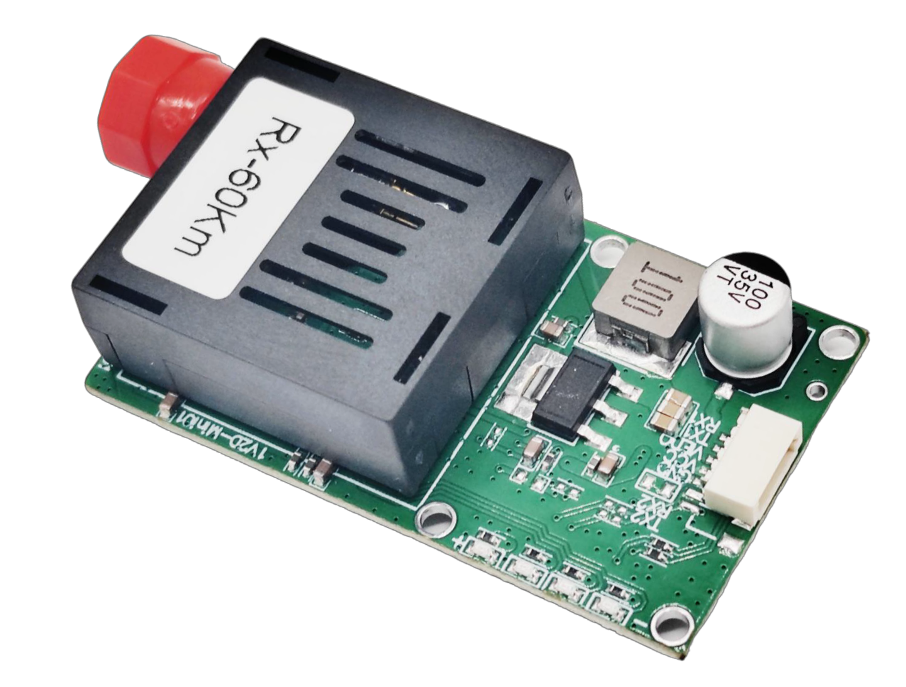
Module parameters

Transmission module transmitter |  |  | 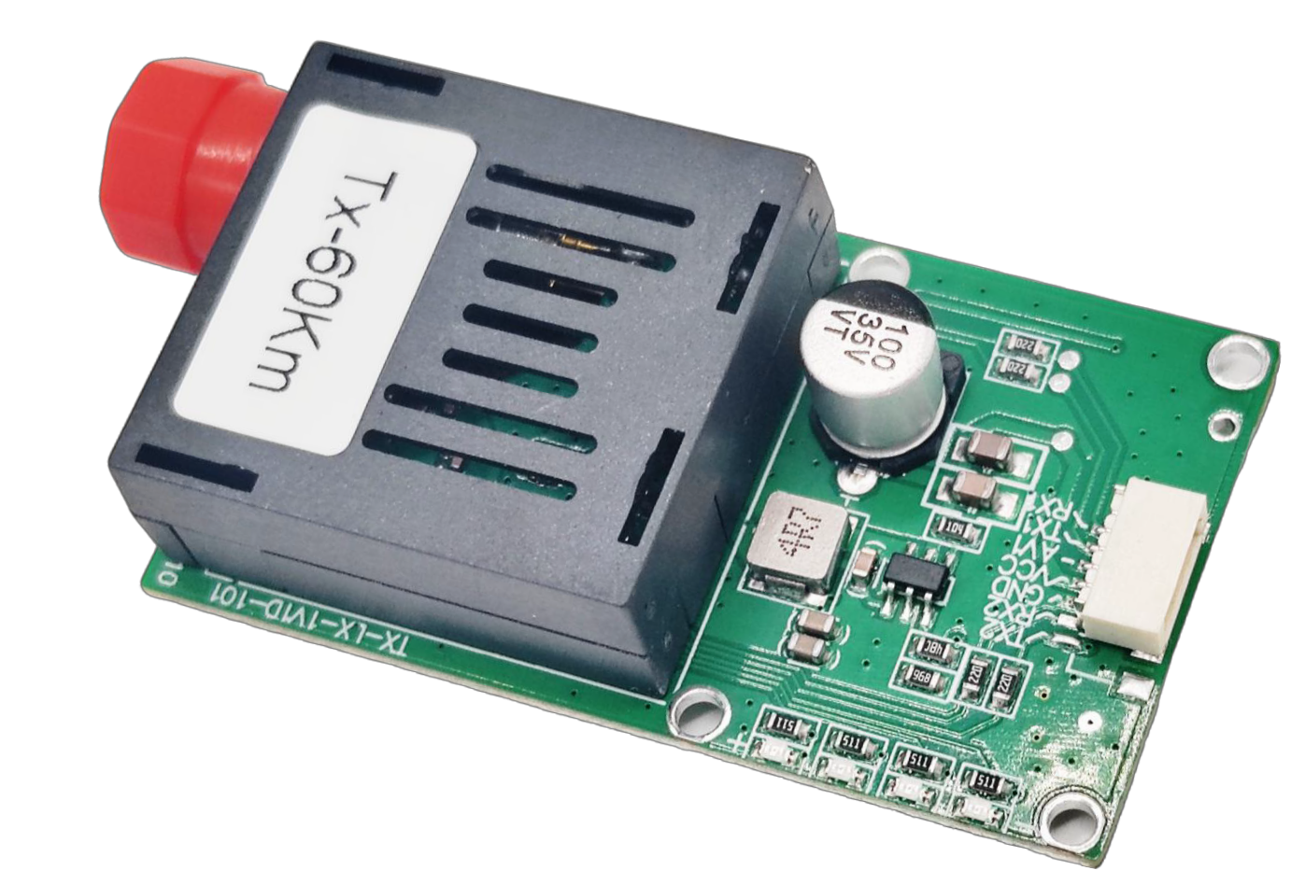
Power supply mode | DC5~16V | Product Specifications | 54.5 * 29 * 13 mm
Operating temperature | -20~60℃ | Storage temperature | -20~70℃
Power dissipation | < 3W | Fiber Optic Interface | FC
Fiber Type | (Single Mode-Single Fiber) | Data Interface | SH1.0* 5PIN
Data Rate | 100Mbps | Video Format | NTSC/PAL
Working wavelength | 1310nm/1550nm | Data Direction | uniderection
Transmission Distance | 0~120km | Data Format | TTL(UART)

Transmission module receiving end

Power supply mode | DC5~16V | Product Specifications | 54.5 * 29 * 13 mm
Operating temperature | -20~60℃ | Storage temperature | -40~80℃
Power dissipation | < 3W | Fiber Optic Interface | FC
Fiber Type | (Single Mode-Single Fiber) | Data Interface | SH1.0* 5PIN
Data Rate | 100Mbps | Video Format | NTSC/PAL
Working wavelength | 1550nm/1310nm | Data Direction | uniderection
Transmission Distance | 0~120km | Data Format | TTL(UART)

（Note: The product is used in pairs and defaults to the FC interface for shipment. When placing an order, please clearly indicate whether you need the sky end or the ground end）

