Product Specification
25G SFP28 AOC Transceivers

PRODUCT FEATURES
- 25Gbps serial optical interface
- 850nm VCSEL transmitter and GaAs PIN PD receiver
- Case operating temperature range: 0°C to 70°C
- Power dissipation < 1.0W per cable end

Application
- Inter Rack Connection
- High-speed Servers
- High-performance Computing Clusters
- SAN, Routers, Hubs, Load Balancer

Ordering information
Part Number | Product Description
JH-25G-SFP28-AOC | 25G SFP28 AOC Transceivers, C-TEMP  XX=01，cable length=1m  XX=03，cable length=3m  XX=05，cable length=5m  XX=0A，cable length=10m  XX=0F，cable length=15m  XX=1E，cable length=30m  XX=32，cable length=50m  XX=64，cable length=100m

DESCRIPTION
The JH-25G-SFP28-AOC Transceiver is intended for short reach service 25.78Gb/s 850nm Multi-mode high-speed communications equipment where low-cost, extraordinary performance and reliability are essential. It consumes low power, operates base on 3.3V DC power supply and is offered in the industrial temperature range. They are compliant with SFP28 MSA, SFF-8431 and SFF-8432.
The low jitter and low bit error rate optical assembly features a VCSEL laser transmitter and PIN/TIA receiver. It utilizes internal clock and data recovery (CDR) units on transmitter and the receiver chains for low jitter compliance. The differential AC coupled Tx and Rx data interfaces are CML compatible. The device is Class I laser safety compliant.

ABSOLUTE MAXIMUM RATINGS
Parameter | Symbol | Conditions | Min. | Max. | Unit
Storage Temperature | T_{Storage} |  | -40 | +85 | °C
Relative Humidity | RH |  | 0 | +85 | %

RECOMMENDED OPERATING CONDITIONS (T=25°C, unless noted)
Parameter | Symbol | Conditions | Min. | Typ. | Max. | Unit
Case Temperature | T_{C} |  | 0 |  | 70 | °C
Power Supply Voltage | V_{CC} |  | 3.15 | 3.3 | 3.45 | V
Data Rate |  |  |  | 25.78125 |  | Gbps
Data Rate Accuracy |  |  | -100 |  | 100 | ppm
Pre-FEC Bit Error Ratio |  |  |  |  | 5e-5
Post-FEC Bit Error Ratio |  |  |  |  | 1e-12

Notes: FEC provided by host system.

ELECTRICAL CHARACTERISTICS (T=25°C, unless noted)
Parameter | Symbol | Conditions | Min. | Typ. | Max. | Unit
Power Consumption |  |  |  |  | 1 | W
Supply Current | Icc |  |  | 180 | 300 | mA

PIN ASSIGNMENT

PIN DESCRIPTION

Recommended Interface Circuit
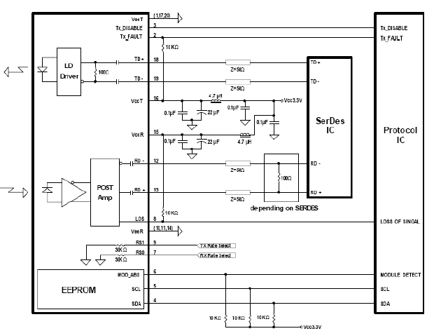
Figure 2. Typical application circuit

Mechanical Dimensions

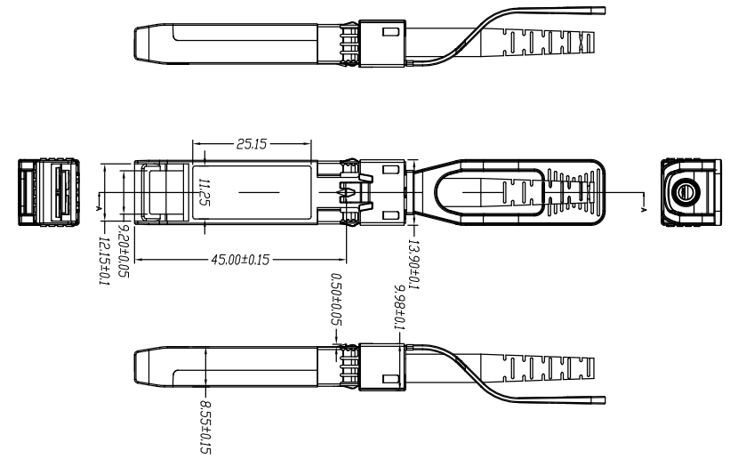

Figure 3. Module Mechanical Dimensions(mm)

Digital Diagnostics Functions
As defined by the SFF-8472, Our SFP28 transceivers provide digital diagnostic functions via a 2-wire serial interface, which allows real-time access to the following operating parameters:
- Transceiver temperature
- Laser bias current
- Transmitted optical power
- Received optical power
- Transceiver supply voltage
It also provides a sophisticated system of alarm and warning flags, which may be used to alert end-users when particular operating parameters are outside of a factory-set normal range. The operating and diagnostics information is monitored and reported by a Digital Diagnostics Transceiver Controller (DDTC) inside the transceiver, which is accessed through the 2-wire serial interface. The memories are organized as a series of 8-bit data words that can be addressed individually or sequentially. The 2-wire serial interface provides sequential or random access to the 8 bit parameters, addressed from 0x00h to the maximum address of the memory. For more detailed information, including memory map definitions, please refer the SFF-8472 documentation.

Digital Diagnostic Monitor Accuracy
The following characteristics are defined over recommended operating conditions

Parameter | Accuracy | Unit
Internally measured transceiver temperature | +/-3 | deg.C
Internally measured transceiver supply voltage | +/-3 | %
Measured Tx bias current | +/-10 | %
Measured Tx output power | +/-3 | dB
Measured Rx received average optical power | +/-3 | dB

Contact:
Wuhan Jiuhong Optics Technology Co., Ltd.
TEL: 86-13476016116
E-mail：grace@jh-optics.com
Web：www.jh-optics.com
Address：
Building 1, 4th Floor, Yunqi Free Trade Innovation Port, Donghu Comprehensive Bonded Zone,Donghu High-tech Zone, Wuhan City

