Product Specification
100Gb/s QSFP28 to 4xSFP28 Active Optical Cable

- Features
- Supports 100G to 25G Ethernet interoperability
- Aggregate 4 discrete SFP28 25G channels into single parallel QSFP28 100G interface
- Maximum link length of 70m links on OM3 multimode fiber or 100m links on OM4 multimode Fiber
- Electrically hot-pluggable
- Electrical interface compliant to QSFP28 connector and SFP28 connectors
- Case operating temperature range: 0°C to 70°C

- Applications
- Network Switch Manufacturers supporting 100/25G
- Server Manufacturers supporting 100/25G
- Data Centers with 25G requirements with Aggregation Architectures

Ordering information
Part Number | Product Description
JH-100G-QSFP28-A4-AOC | 100G QSFP28 to 4xSFP28 Active Optical Cable Transceivers, C-TEMP  XX=01，cable length=1m  XX=03，cable length=3m  XX=05，cable length=5m  XX=0A，cable length=10m  XX=19，cable length=25m  XX=32，cable length=50m  XX=64，cable length=100m

- General Description
This product QSFP28 to 4xSFP28 active optic cables are a high performance, low power consumption, long reach interconnect solution supporting 100G to 25G Ethernet.
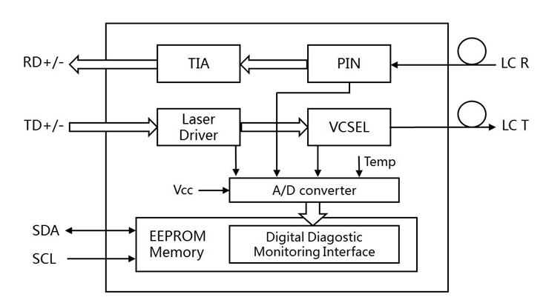
4x25G SFP28

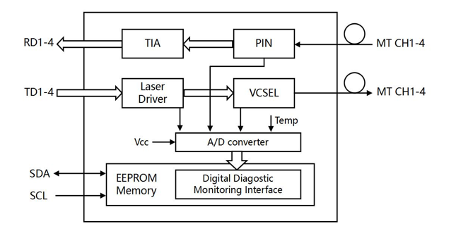
100G QSFP28

- Pin Function Definition

4.1 Pin Definition- SFP28
PIN | Logic | Symbol | Name/Description
1 |  | VeeT | Transmitter Ground
2 | LVTTL-O | TX Fault | Transmitter Fault Indication
3 | LVTTL-I | TX Disable | Transmitter Disable
4 | LVTTL-I/O | SDA | 2-wire Serial Interface Data Line
5 | LVTTL-I | SCL | 2 Wire Serial Interface Clock
6 |  | MOD-ABS | Module Absent, Connected to VeeT or VeeR in the module.
7 | LVTTL-I | RS0 | RX Rate Select, optional
8 | LVTTL-O | LOS | Loss of Signal
9 | LVTTL-I | RS1 | TX Rate Select, optional
10 |  | VeeR | Receiver Ground
11 |  | VeeR | Receiver Ground
12 | CML-O | RD- | Inv. Received Data Out
13 | CML-O | RD+ | Received Data Out
14 |  | VeeR | Receiver Ground
15 |  | VccR | Receiver Power
16 |  | VccT | Transmitter Power
17 |  | VeeT | Transmitter Ground
18 | CML-I | TD+ | Transmit Data In
19 | CML-I | TD- | Inv. Transmit Data In
20 |  | VeeT | Transmitter Ground

4.2 Pin Definition- QSFP28
PIN | Logic | Symbol | Name/Description
1 |  | GND | Ground
2 | CML-I | Tx2n | Transmitter Inverted Data Input
3 | CML-I | Tx2p | Transmitter Non-Inverted Data output
4 |  | GND | Ground
5 | CML-I | Tx4n | Transmitter Inverted Data Input
6 | CML-I | Tx4p | Transmitter Non-Inverted Data output
7 |  | GND | Ground
8 | LVTLL-I | ModSelL | Module Select
9 | LVTLL-I | ResetL | Module Reset
10 |  | VccRx | +3.3V Power Supply Receiver
11 | LVCMOSS-I/O | SCL | 2-Wire Serial Interface Clock
12 | LVCMOSS-I/O | SDA | 2-Wire Serial Interface Data
13 |  | GND | Ground
14 | CML-O | Rx3p | Receiver Non-Inverted Data output
15 | CML-O | Rx3n | Receiver Inverted Data Input
16 |  | GND | Ground
17 | CML-O | Rx1p | Receiver Non-Inverted Data output
18 | CML-O | Rx1n | Receiver Inverted Data Input
19 |  | GND | Ground
20 |  | GND | Ground
21 | CML-O | Rx2n | Receiver Inverted Data Input
22 | CML-O | Rx2p | Receiver Non-Inverted Data output
23 |  | GND | Ground
24 | CML-O | Rx4n | Receiver Inverted Data Input
25 | CML-O | Rx4p | Receiver Non-Inverted Data output
26 |  | GND | Ground
27 | LVTLL-O | ModPrsL | Module Present
28 | LVTLL-O | IntL | Interrupt
29 |  | VccTx | +3.3V Power Supply transmitter
30 |  | Vccl | +3.3V Power Supply
31 | LVTLL-I | LPMode | Low Power Mode
32 |  | GND | Ground
33 | CML-I | Tx3p | Transmitter Non-Inverted Data output
34 | CML-I | Tx3n | Transmitter Inverted Data Input
35 |  | GND | Ground
36 | CML-I | Tx1p | Transmitter Non-Inverted Data output
37 | CML-I | Tx1n | Transmitter Inverted Data Input
38 |  | GND | Ground

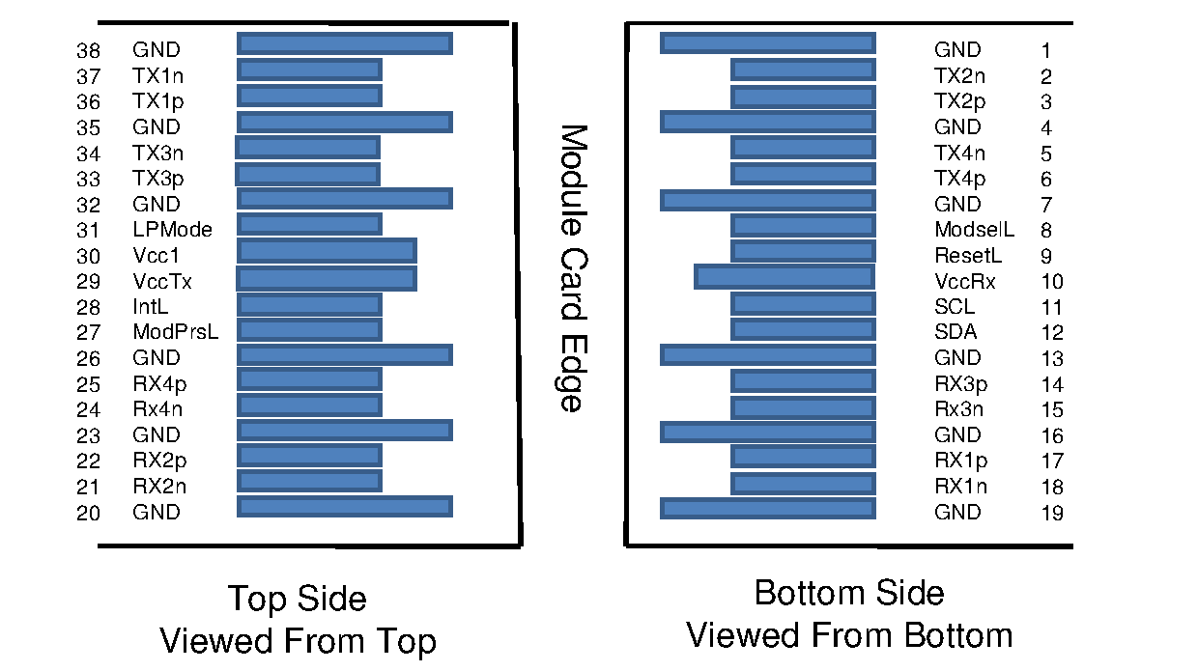

- Recommended Power Supply Filter
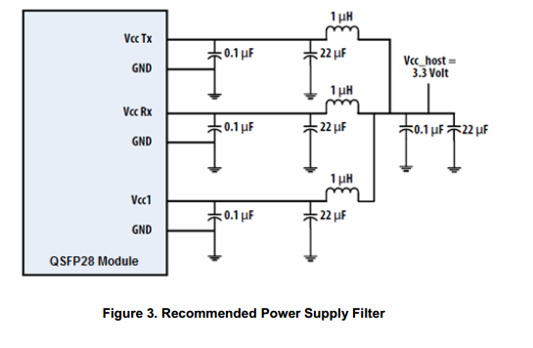
- Performance Specifications
6.1 Absolute Maximum Ratings
It has to be noted that the operation in excess of any individual absolute maximum ratings might cause permanent damage to this module
Parameter | Symbol | Min. | Max. | Unit
Storage Temperature | Tstg | -40 | +85 | °C
Operating relative humidity  (Non- condensing) | RH | 0 | 85 | %
Input Voltage |  | Vcc-0.3 | Vcc+0.3 | V
Supply Voltage | Vcc | -0.3 | 3.6 | dBm

6.2 Recommended Operating Conditions and Power Supply Requirements
Parameter | Symbol | Min. | Type | Max. | Unit | NOTE
Operating Case Temperature | T_{c} | 0 |  | +70 | ℃
Power Supply Voltage | V_{cc} | +3.135 | 3.3 | +3.465 | V
Data Rate | BR |  | 25.78 |  |  | SFP28 Bit Rate
Data Rate | BR |  | 103.12 |  | Gb/s | QSFP28 Bit Rate
Power Consumption Max (per cable) | P |  |  | 1 | W | End-SFP28
Power Consumption Max (per cable) | P |  |  | 2.5 | W | End-QSFP28
Supply Current (per cable) | ICC |  |  | 0.3 | A | End-SFP28
Supply Current (per cable) | ICC |  |  | 0.76 | A | End-QSFP28
Data Rate Accuracy | - | -100 |  | 100 | ppm
Control Input Voltage High | - | - |  | 2 | V
Control Input Voltage Low | - | 0.8 |  | - | V
Link Distance(OM4 MMF) | D | 0 |  | 100 | m

  - Electrical Specification
Parameter | Symbol | Min. | Typ. | Max. | Unit
Differential input impedance | Zin | 90 | 100 | 110 | ohm
Differential Output impedance | Zout | 90 | 100 | 110 | ohm
Differential input voltage amplitude | ΔVin | 300 |  | 1100 | mVp-p
Differential output voltage amplitude | ΔVout | 500 |  | 800 | mVp-p
Pre-FEC Bit Error Ratio | BR |  |  | 5E-5
Post-FEC Bit Error Ratio | BR |  |  | 1E-12
Input Logic Level High | VIH | 2.0 |  | VCC | V
Input Logic Level Low | VIL | 0 |  | 0.8 | V
Output Logic Level High | VOH | VCC-0.5 |  | VCC | V
Output Logic Level Low | VOL | 0 |  | 0.4 | V

- Mechanical Dimensions

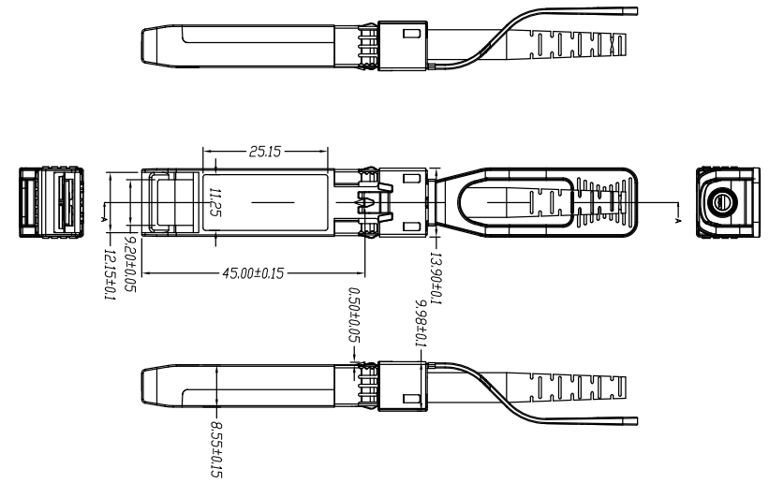
4x25G SFP28

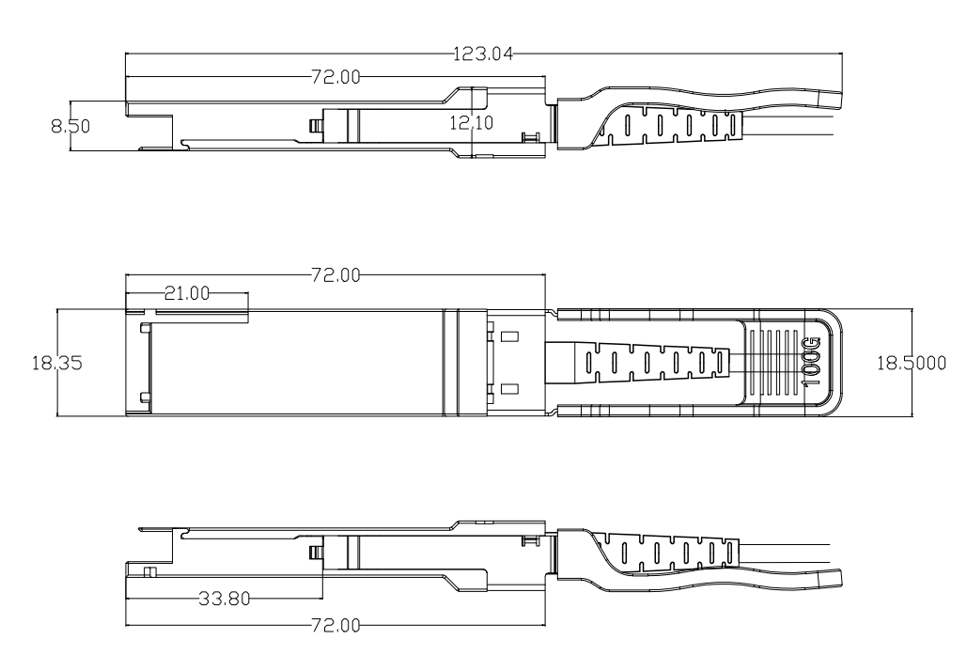
100G QSFP28

(Unit: mm)

- Digital Diagnostic Monitor Accuracy
The following characteristics are defined over recommended operating conditions
Parameter | Accuracy | Unit
Internally measured transceiver temperature | +/-3 | deg.C
Internally measured transceiver supply voltage | +/-3 | %
Measured Tx bias current | +/-10 | %
Measured Tx output power | +/-3 | dB
Measured Rx received average optical power | +/-3 | dB

