Product Specification
200G QSFP56 to 2*100G QSFP56 AOC Transceivers

FEATURES
- Supports IBTA InfiniBand HDR
- 200GbE to 2x100GbE data rate
- 50 Gb/s PAM4 modulation per lane
- SFF-8665 compliant QSFP56 port
- Support SFF-8636 or CMIS 5.0 compliant I2C management
- Single 3.3V power supply
- 4.5W power dissipation each end, with retiming
- Built-in DSP (QSFP56)
- Operating case temp Commercial:

- Hot pluggable
- RoHS compliant

0°C to +70 °C

APPLICATIONS

- 200 Gb/s InfiniBand HDR systems
- 200GBASE-SR4 and 100GBASE-SR2 compliant

Ordering information
Part Number | Product Description
JH-200G-QSFP56-A2-AOC | 200G QSFP56 to 2*100G QSFP56 AOC Transceivers, C-TEMP  xx=01, cable length=1m  xx=03, cable length=3m  xx=05, cable length=5m  xx=0A, cable length=10m  xx=0F, cable length=15m  xx=19, cable length=25m  xx=32, cable length=50m  xx=64, cable length=100m

ABSOLUTE MAXIMUM RATINGS
Parameter | Symbol | Conditions | Min. | Max. | Unit
Storage Temperature | T_{Storage} |  | -40 | +85 | °C
Relative Humidity | RH |  | 0 | +85 | %

RECOMMENDED OPERATING CONDITIONS (T=25°C, unless noted)
Parameter | Symbol | Conditions | Min. | Typ. | Max. | Unit
Case Temperature | T_{C} |  | 0 |  | 70 | °C
Power Supply Voltage | V_{CC} |  | 3.135 | 3.3 | 3.465 | V
Power Consumption |  |  |  |  | 4.5 | W
Signaling Rate each Channel |  |  |  | 26.5625 |  | Gbps
Data Rate Accuracy |  |  | -100 |  | 100 | ppm
Error Bit Rate |  |  |  |  | 2.4E-4

Notes: PRBS31Q@26.5625Gbd PAM4

PIN ASSIGNMENT

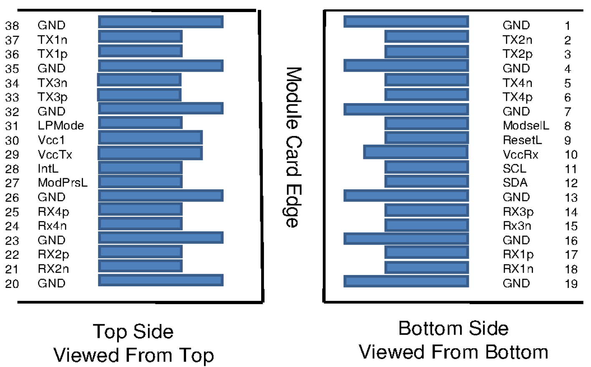

PIN DESCRIPTION - 200G QSFP56 END

PIN | Logic | Symbol | Name/Description | Note
1 |  | GND | Ground
2 | CML-I | Tx2n | Transmitter Inverted Data Input
3 | CML-I | Tx2p | Transmitter Non-Inverted Data output
4 |  | GND | Ground
5 | CML-I | Tx4n | Transmitter Inverted Data Input
6 | CML-I | Tx4p | Transmitter Non-Inverted Data output
7 |  | GND | Ground
8 | LVTTL-I | ModSelL | Module Select
9 | LVTTL-I | ResetL | Module Reset
10 |  | VccRx | ﹢3.3V Power Supply Receiver
11 | LVCMOS-I/O | SCL | 2-Wire Serial Interface Clock
12 | LVCMOS-I/O | SDA | 2-Wire Serial Interface Data
13 |  | GND | Ground
14 | CML-O | Rx3p | Receiver Non-Inverted Data Output
15 | CML-O | Rx3n | Receiver Inverted Data Output
16 |  | GND | Ground
17 | CML-O | Rx1p | Receiver Non-Inverted Data Output
18 | CML-O | Rx1n | Receiver Inverted Data Output
19 |  | GND | Ground
20 |  | GND | Ground
21 | CML-O | Rx2n | Receiver Inverted Data Output
22 | CML-O | Rx2p | Receiver Non-Inverted Data Output
23 |  | GND | Ground
24 | CML-O | Rx4n | Receiver Inverted Data Output
25 | CML-O | Rx4p | Receiver Non-Inverted Data Output
26 |  | GND | Ground
27 | LVTTL-O | ModPrsL | Module Present
28 | LVTTL-O | IntL | Interrupt
29 |  | VccTx | +3.3 V Power Supply transmitter
30 |  | Vcc1 | +3.3 V Power Supply
31 | LVTTL-I | LPMode | Low Power Mode
32 |  | GND | Ground
33 | CML-I | Tx3p | Transmitter Non-Inverted Data Input
34 | CML-I | Tx3n | Transmitter Inverted Data Output
35 |  | GND | Ground
36 | CML-I | Tx1p | Transmitter Non-Inverted Data Input
37 | CML-I | Tx1n | Transmitter Inverted Data Output
38 |  | GND | Ground

PIN DESCRIPTION - 100G QSFP56 END

PIN | Logic | Symbol | Name/Description | Note
1 |  | GND | Ground
2 | CML-I | Tx2n | Transmitter Inverted Data Input
3 | CML-I | Tx2p | Transmitter Non-Inverted Data output
4 |  | GND | Ground
5 | CML-I | Tx4n | NC
6 | CML-I | Tx4p | NC
7 |  | GND | Ground
8 | LVTTL-I | ModSelL | Module Select
9 | LVTTL-I | ResetL | Module Reset
10 |  | VccRx | ﹢3.3V Power Supply Receiver
11 | LVCMOS-I/O | SCL | 2-Wire Serial Interface Clock
12 | LVCMOS-I/O | SDA | 2-Wire Serial Interface Data
13 |  | GND | Ground
14 | CML-O | Rx3p | NC
15 | CML-O | Rx3n | NC
16 |  | GND | Ground
17 | CML-O | Rx1p | Receiver Non-Inverted Data Output
18 | CML-O | Rx1n | Receiver Inverted Data Output
19 |  | GND | Ground
20 |  | GND | Ground
21 | CML-O | Rx2n | Receiver Inverted Data Output
22 | CML-O | Rx2p | Receiver Non-Inverted Data Output
23 |  | GND | Ground
24 | CML-O | Rx4n | NC
25 | CML-O | Rx4p | NC
26 |  | GND | Ground
27 | LVTTL-O | ModPrsL | Module Present
28 | LVTTL-O | IntL | Interrupt
29 |  | VccTx | +3.3 V Power Supply transmitter
30 |  | Vcc1 | +3.3 V Power Supply
31 | LVTTL-I | LPMode | Low Power Mode
32 |  | GND | Ground
33 | CML-I | Tx3p | NC
34 | CML-I | Tx3n | NC
35 |  | GND | Ground
36 | CML-I | Tx1p | Transmitter Non-Inverted Data Input
37 | CML-I | Tx1n | Transmitter Inverted Data Output
38 |  | GND | Ground

Electrical Interface
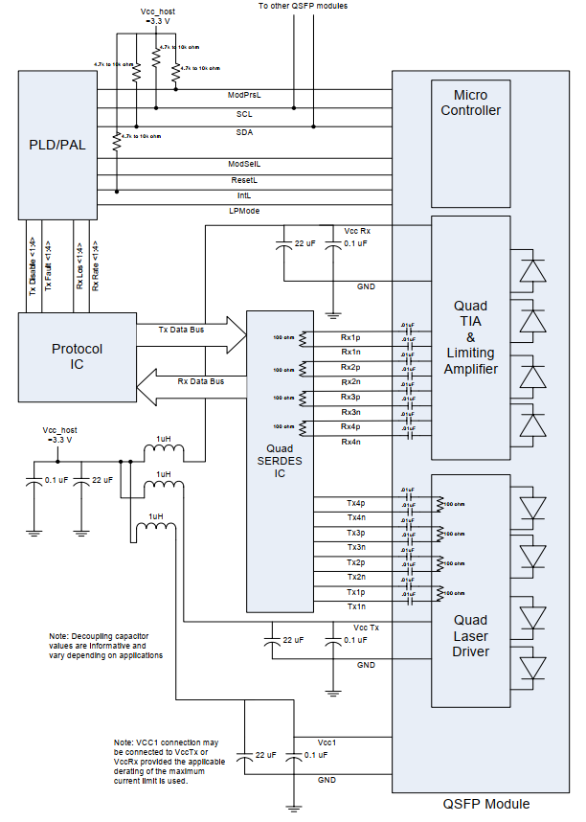

OUTLINE DIMENSIONS

Unit mm
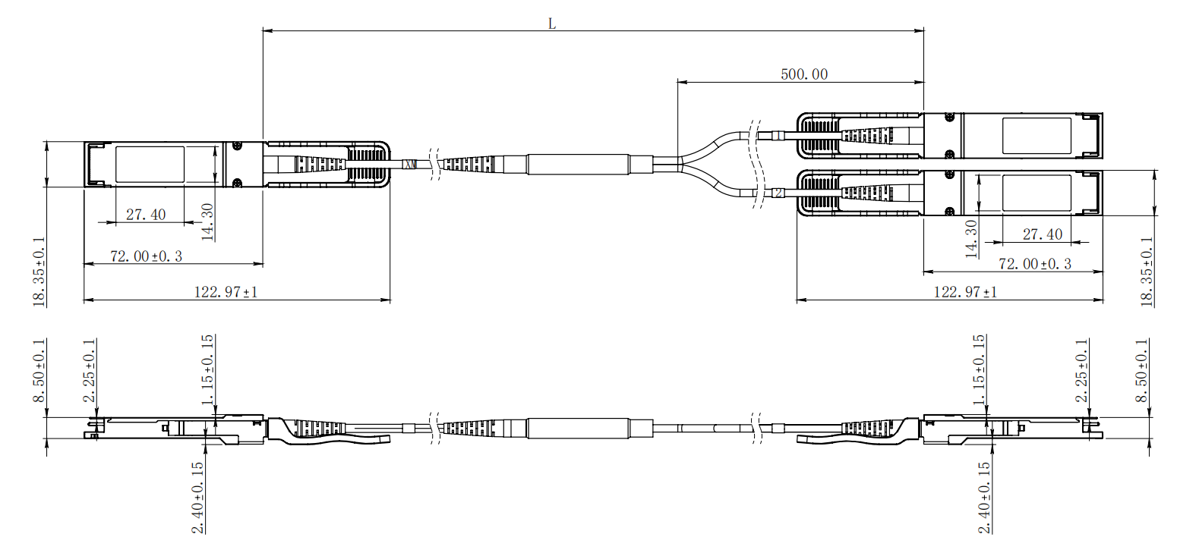

Digital Diagnostic Monitor Accuracy
The following characteristics are defined over recommended operating conditions

Parameter | Accuracy | Unit
Internally measured transceiver temperature | +/-3 | deg.C
Internally measured transceiver supply voltage | +/-3 | %
Measured Tx bias current | +/-10 | %
Measured Tx output power | +/-3 | dB
Measured Rx received average optical power | +/-3 | dB

