400G QSFP-DD to OSFP

Active Optical Cable

Product Features
n QSFP-DD MSA Hardware Specification and OSFP MSA compliant
n CMIS for QSFP-DD side and OSFP side
n Electrical Interface: IEEE 802.3-2022 400GAUI-8 C2M and IEEE 802.3-2022 400GAUI-4 C2M
n Support 425Gb/s aggregate bit rate
n Maximum link length of 70m on OM3 or 100m on OM4
n Transmission operating case temperature 0 to 70℃
n Maximum power consumption of 9W for QSFP-DD terminal and 10W for OSFP terminal
n RoHS compliant
n complies with the common management interface specification (CMIS)

Application
n 400G Ethernet
n Telecom use cases
n Datacenter and Enterprise Networking

Absolute Maximum Ratings

Parameter | Unit | Min. | Typical | Max. | Notes
Storage Temperature | °C | -40 |  | 85
Operating Relative Humidity | % | 0 |  | 85
Power Supply Voltage | V | -0.5 |  | 3.6

Recommended Operating Conditions

Parameter | Unit | Min. | Typical | Max. | Notes
Operating Case Temperature | °C | 0 |  | 70 | 1
Power Supply Working Voltage | V | 3.135 | 3.3 | 3.465
Data Rate, each Lane | GBd |  | 53.125
Data Rate Accuracy |  | 100 |  | 100 | Ppm
Link Distance | D |  |  | 100 | m
Note:
1. The temperature here depends on the module case around max power dissipation.

Electrical Specifications

Parameter | Unit | Min. | Typical | Max. | Note
Input Logic Level High | V | 2.0 |  | Vcc+0.3
Input Logic Level Low | V | -0.3 |  | 0.8
Output Logic Level High | V | Vcc-0.5 |  | Vcc+0.3
Output Logic Level Low | V | 0 |  | 0.4
Transmitter
Signaling rate per lane (range) |  | 26.5625 ± 100 ppm
Differential pk-pk Input Voltage Tolerance | mV | 900
Date Differential Impedance | Ω | 90 | 100 | 110
Receiver
Signaling Rate per lane (range) |  | 26.5625 ± 100 ppm
Differential pk-pk Output Voltage Tolerance | mV |  |  | 900
Date Differential Impedance | Ω | 90 | 100 | 110

PIN Function Definitions of QSFP-DD ends

Pad | Logic | Symbol | Description | Plug Sequence 4 | Notes
1 |  | GND | Ground | 1B | 1
2 | CML-I | Tx2n | Transmitter Inverted Data Input | 3B
3 | CML-I | Tx2p | Transmitter Non-Inverted Data Input | 3B
4 |  | GND | Ground | 1B | 1
5 | CML-I | Tx4n | Transmitter Inverted Data Input | 3B
6 | CML-I | Tx4p | Transmitter Non-Inverted Data Input | 3B
7 |  | GND | Ground | 1B | 1
8 | LVTTL-I | ModSelL | Module Select | 3B
9 | LVTTL-I | ResetL | Module Reset | 3B
10 |  | VccRx | +3.3V Power Supply Receiver | 2B | 2
11 | LVCMOS-I/O | SCL | 2-wire Serial Interface Clock | 3B
12 | LVCMOS-I/O | SDA | 2-wire Serial Interface Data | 3B
13 |  | GND | Ground | 1B | 1
14 | CML-O | Rx3p | Receiver Non-Inverted Data Output | 3B
15 | CML-O | Rx3n | Receiver Inverted Data Output | 3B
16 |  | GND | Ground | 1B | 1
17 | CML-O | Rx1p | Receiver Non-Inverted Data Output | 3B
18 | CML-O | Rx1n | Receiver Inverted Data Output | 3B
19 |  | GND | Ground | 1B | 1
20 |  | GND | Ground | 1B | 1
21 | CML-O | Rx2n | Receiver Inverted Data Output | 3B
22 | CML-O | Rx2p | Receiver Non-Inverted Data Output | 3B
23 |  | GND | Ground | 1B | 1
24 | CML-O | Rx4n | Receiver Inverted Data Output | 3B

25 | CML-O | Rx4p | Receiver Non-Inverted Data Output | 3B
26 |  | GND | Ground | 1B | 1
27 | LVTTL-O | Mod PrsL | Module Present | 3B
28 | LVTTL-O | IntL | Interrupt | 3B
29 |  | VccTx | +3.3V Power Supply Transmitter | 2B | 2
30 |  | Vcc1 | +3.3V Power Supply | 2B | 2
31 | LVTTL-I | InitMode | Initialization Mode; In legacy QSFP  applications, the InitMode pad is called LPMODE | 3B
32 |  | GND | Ground | 1B | 1
33 | CML-I | Tx3p | Transmitter Non-Inverted Data Input | 3B
34 | CML-I | Tx3n | Transmitter Inverted Data Input | 3B
35 |  | GND | Ground | 1B | 1
36 | CML-I | Tx1p | Transmitter Non-Inverted Data Input | 3B
37 | CML-I | Tx1n | Transmitter Inverted Data Input | 3B
38 |  | GND | Ground | 1B | 1
39 |  | GND | Ground | 1A | 1
40 | CML-I | Tx6n | Transmitter Inverted Data Input | 3A
41 | CML-I | Tx6p | Transmitter Non-Inverted Data Input | 3A
42 |  | GND | Ground | 1A | 1
43 | CML-I | Tx8n | Transmitter Inverted Data Input | 3A
44 | CML-I | Tx8p | Transmitter Non-Inverted Data Input | 3A
45 |  | GND | Ground | 1A | 1
46 |  | Reserved | For future use | 3A | 3
47 |  | VS1 | Module Vendor Specific 1 | 3A | 3
48 |  | VccRx1 | 3.3V Power Supply | 2A | 2
49 |  | VS2 | Module Vendor Specific 2 | 3A | 3
50 |  | VS3 | Module Vendor Specific 3 | 3A | 3
51 |  | GND | Ground | 1A | 1
52 | CML-O | Rx7p | Receiver Non-Inverted Data Output | 3A
53 | CML-O | Rx7n | Receiver Inverted Data Output | 3A
54 |  | GND | Ground | 1A | 1
55 | CML-O | Rx5p | Receiver Non-Inverted Data Output | 3A
56 | CML-O | Rx5n | Receiver Inverted Data Output | 3A
57 |  | GND | Ground | 1A | 1
58 |  | GND | Ground | 1A | 1
59 | CML-O | Rx6n | Receiver Inverted Data Output | 3A
60 | CML-O | Rx6p | Receiver Non-Inverted Data Output | 3A
61 |  | GND | Ground | 1A | 1
62 | CML-O | Rx8n | Receiver Inverted Data Output | 3A
63 | CML-O | Rx8p | Receiver Non-Inverted Data Output | 3A
64 |  | GND | Ground | 1A | 1
65 |  | NC | No Connect | 3A | 3

66 |  | Reserved | For future use | 3A | 3
67 |  | VccTx1 | 3.3V Power Supply | 2A | 2
68 |  | Vcc2 | 3.3V Power Supply | 2A | 2
69 |  | Reserved | For future use | 3A | 3
70 |  | GND | Ground | 1A | 1
71 | CML-I | Tx7p | Transmitter Non-Inverted Data Input | 3A
72 | CML-I | Tx7n | Transmitter Inverted Data Input | 3A
73 |  | GND | Ground | 1A | 1
74 | CML-I | Tx5p | Transmitter Non-Inverted Data Input | 3A
75 | CML-I | Tx5n | Transmitter Inverted Data Input | 3A
76 |  | GND | Ground | 1A | 1

Table 1: QSFP-DD Pin Definition
Note:
1. QSFP-DD uses common ground (GND) for all signals and supply (power). All are common within the QSFP-DD module, and all module voltages are referenced to this potential unless otherwise noted. Connect these directly to the host board signal-common ground plane.
2. VccRx, VccRx1, Vcc1, Vcc2, VccTx, and VccTx1 shall be applied concurrently. Requirements defined for the host side of the Host Card Edge Connector are listed in Table 6. VccRx, VccRx1, Vcc1, Vcc2, VccTx, and VccTx1 may be internally connected within the module in any combination. The connector Vcc pins are each rated for a maximum current of 1000 mA.
3. All Vendor-Specific, Reserved, and No Connect pins may be terminated with 50 ohms to ground on the host. Pad 65 (No Connect) shall be left unconnected within the module. Vendor-specific and reserved pads shall have an impedance to GND that is greater than 10 kOhms and less than 100 pF.
4. Plug Sequence specifies the mating sequence of the host connector and module. The sequence is 1A, 2A, 3A, 1B, 2B, 3B. (See Figure 1 for pad locations) Contact sequence A will make, then break contact with
additional QSFP-DD pads. Sequence 1A, 1B will then occur simultaneously, followed by 2A, 2B, followed by 3A, 3B.

PIN Function Definitions of OSFP-DD end

Pin | Symbol | Description | Notes
1 | GND | Ground | 1
2 | TX2p | Transmitter Data Non-Inverted | -
3 | TX2n | Transmitter Data Inverted | -
4 | GND | Ground | 1
5 | TX4p | Transmitter Data Non-Inverted | -
6 | TX4n | Transmitter Data Inverted | -
7 | GND | Ground | 1
8 | Null | NC | -
9 | Null | NC | -
10 | GND | Ground | 1

Pin | Symbol | Description | Notes
11 | Null | NC | -
12 | Null | NC | -
13 | GND | Ground | 1
14 | SCL | 2-wire Serial interface clock | -
15 | VCC | +3.3V Power | -
16 | VCC | +3.3V Power | -
17 | LPWn/PRSn | Low-Power Mode / Module Present | -
18 | GND | Ground | 1
19 | Null | NC | -
20 | Null | NC | -
21 | GND | Ground | 1
22 | Null | NC | -
23 | Null | NC | -
24 | GND | Ground | 1
25 | RX3n | Receiver Data Inverted | -
26 | RX3p | Receiver Data Non-Inverted | -
27 | GND | Ground | 1
28 | RX1n | Receiver Data Inverted | -
29 | RX1p | Receiver Data Non-Inverted | -
30 | GND | Ground | 1
31 | GND | Ground | 1
32 | RX2p | Receiver Data Non-Inverted | -
33 | RX2n | Receiver Data Inverted | -
34 | GND | Ground | 1
35 | RX4p | Receiver Data Non-Inverted | -
36 | RX4n | Receiver Data Inverted | -
37 | GND | Ground | 1
38 | Null | NC | -
39 | Null | NC | -
40 | GND | Ground | 1
41 | Null | NC | -
42 | Null | NC | -
43 | GND | Ground | 1
44 | INT/RSTn | Module Interrupt / Module Reset | -
45 | VCC | +3.3V Power | -

Pin | Symbol | Description | Notes
46 | VCC | +3.3V Power | -
47 | SDA | 2-wire Serial interface data | -
48 | GND | Ground | 1
49 | Null | NC | -
50 | Null | NC | -
51 | GND | Ground | 1
52 | Null | NC | -
53 | Null | NC | -
54 | GND | Ground | 1
55 | TX3n | Transmitter Data Inverted | -
56 | TX3p | Transmitter Data Non-Inverted | -
57 | GND | Ground | 1
58 | TX1n | Transmitter Data Inverted | -
59 | TX1p | Transmitter Data Non-Inverted | -
60 | GND | Ground | 1

Table 2: OSFP Pin Definition
Note:
5. GND is the symbol for signal and supply (power) common for the module. All are common within the module, and all module voltages are referenced to this potential unless otherwise noted. Connect these directly to the host board signal-common ground plane.
6. VccRx, Vcc1, and VccTx shall be applied concurrently and be internally connected within the module in any combination. Vcc contacts in SFF-8662 and SFF-8672 each have a steady state current rating of 1A.
7. Pin31 TxDis (fast mode) is available.
8. Pin 28 RxLOS (fast mode) is available.

Pin Assignment and Description
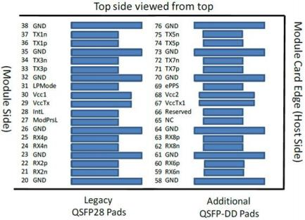
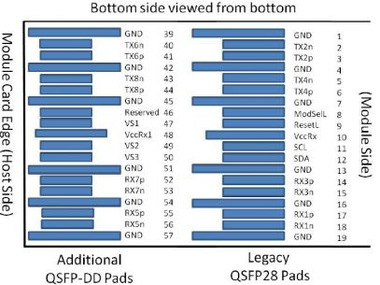

Figure 1: QSFP-DD Module pad layout

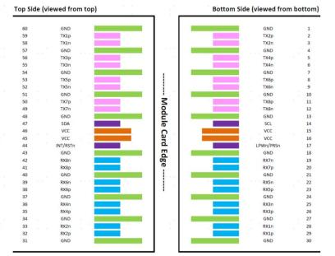

Figure 2: OSFP Module pad layout

Mechanical Specifications
For detailed mechanical information, please refer to the related documents of QSFP-DD MSA and OSFP MSA.
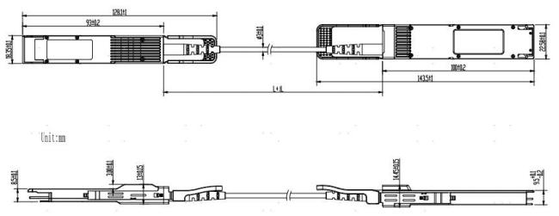

Digital Diagnostic Functions

Parameter | Units | Error | NOTES
Temperature Monitor | °C | ±3 | 1LSB = 1/256°C
Supply Voltage Monitor | V | ±0.1 | 1LSB = 100 uV
Bias Current Monitor | mA | ±10% | 1LSB = 2 uA
TX Power Monitor | dBm | ±3 | 1LSB = 0.1 uW
RX Power Monitor | dBm | ±3 | 1LSB = 0.1 uW

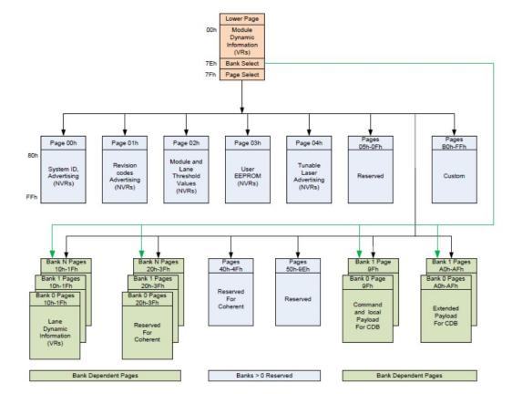

Figure 3. CMIS Bank Page Memory Map

ESD
This transceiver is specified as ESD threshold 1 kV for high-speed data pins and 2 kV for all other electrical input pins, tested per MIL-STD-883, Method 3015.4 / JESD22-A114-A (HBM). However, normal ESD
precautions are still required during the handling of this module. This transceiver is shipped in ESD protective packaging. It should be removed from the packaging and handled only in an ESD-protected environment.

Laser Safety
This is a Class 1 Laser Product according to IEC 60825-1:2007. This product complies with 21 CFR
1040.10 and 1040.11 except for deviations pursuant to Laser Notice No. 50, dated (June 24, 2007).

