Product Specification
400G QSFP-DD to 2x200G AOC Transceivers

FEATURES
- 400Gb/s to 2x200Gb/s data rate
- 50Gb/s PAM4 modulation per-lane
- Single 3.3V power supply
- Max 4.5W power dissipation each QSFP56 end
- Max 8W power dissipation QSFP-DD end
- Build in DSP(QSFP-DD and QSFP56)
- Compliant to CMIS V4.0 QSFP-DD end
- Compliant to CMIS QSFP56 end
- Operating case temp Commercial:
0°C to +70 °C
- Hot pluggable
- RoHS compliant

APPLICATIONS

- 400Gb/s systems
- Other optical links

Ordering information
Part Number | Product Description
JH-400G-QDD-Q56-A2-AOC | 400G QSFP-DD to 2*200G QSFP56 AOC Transceivers, C-TEMP  XX=01，cable length=1m  XX=03，cable length=3m  XX=05，cable length=5m  XX=0A，cable length=10m  XX=0F，cable length=15m  XX=19，cable length=25m  XX=32，cable length=50m  XX=64，cable length=100m

ABSOLUTE MAXIMUM RATINGS
Parameter | Symbol | Conditions | Min. | Max. | Unit
Storage Temperature | T_{Storage} |  | -40 | +85 | °C
Relative Humidity | RH |  | 0 | +85 | %

RECOMMENDED OPERATING CONDITIONS (T=25°C, unless noted)
Parameter | Symbol | Conditions | Min. | Typ. | Max. | Unit
Case Temperature | T_{C} |  | 0 |  | 70 | °C
Power Supply Voltage | V_{CC} |  | 3.135 | 3.3 | 3.465 | V
Power Consumption |  | QSFP56 end |  |  | 4.5 | W
Power Consumption |  | QSFP-DD end |  |  | 8 | W
Signaling Rate each Channel |  |  |  | 26.5625 |  | Gbps
Data Rate Accuracy |  |  | -100 |  | 100 | ppm
Error Bit Rate |  |  |  |  | 2.4E-4

Notes: PRBS31Q@26.5625Gbd PAM4

PIN ASSIGNMENT
PIN DESCRIPTIONS-400G QSFP-DD END
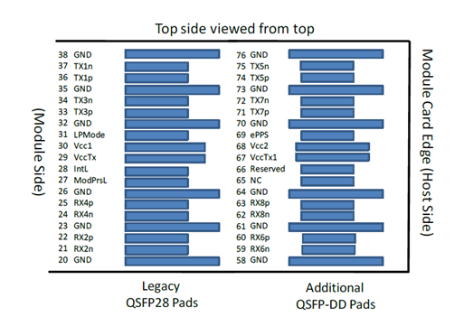
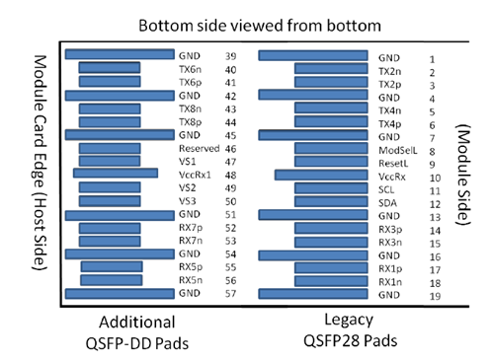
Figure 1 – Pin Definitions 400G QSFP-DD END

PIN DESCRIPTION - 400G QSFP-DD END
Pad | Logic | Symbol | Description | Plug Seq⁴ | Notes
1 |  | GND | Ground | 1B | 1
2 | CML-I | Tx2n | Transmitter Inverted Data Input | 3B
3 | CML-I | Tx2p | Transmitter Non-Inverted Data Input | 3B
4 |  | GND | Ground | 1B | 1
5 | CML-I | Tx4n | Transmitter Inverted Data Input | 3B
6 | CML-I | Tx4p | Transmitter Non-Inverted Data Input | 3B
7 |  | GND | Ground | 1B | 1
8 | LVTTL-I | ModSelL | Module Select. | 3B
9 | LVTTL-I | ResetL | Module Reset. | 3B
10 |  | VccRx | +3.3V Power Supply Receiver | 2B | 2
11 | LVCMOS-I/O | SCL | 2-wire serial interface clock | 3B
12 | LVCMOS-I/O | SDA | 2-wire serial interface data | 3B
13 |  | GND | Ground | 1B | 1
14 | CML-O | Rx3p | Receiver Non-Inverted Data Output | 3B
15 | CML-O | Rx3n | Receiver Inverted Data Output | 3B
16 |  | GND | Ground | 1B | 1
17 | CML-O | Rx1p | Receiver Non-Inverted Data Output | 3B
18 | CML-O | Rx1n | Receiver Inverted Data Output | 3B
19 |  | GND | Ground | 1B | 1
20 |  | GND | Ground | 1B | 1
21 | CML-O | Rx2n | Receiver Inverted Data Output | 3B
22 | CML-O | Rx2p | Receiver Non-Inverted Data Output | 3B
23 |  | GND | Ground | 1B | 1
24 | CML-O | Rx4n | Receiver Inverted Data Output | 3B
25 | CML-O | Rx4p | Receiver Non-Inverted Data Output | 3B
26 |  | GND | Ground | 1B | 1
27 | LVTTL-O | ModPrsL | Module Present. | 3B
28 | LVTTL-O | IntL | Interrupt. | 3B
29 |  | VccTx | +3.3V Power supply transmitter | 2B | 2
30 |  | Vcc1 | +3.3V Power supply | 2B | 2
31 | LVTTL-I | LPMode | Low Power Mode | 3B
32 |  | GND | Ground | 1B | 1
33 | CML-I | Tx3p | Transmitter Non-Inverted Data Input | 3B
34 | CML-I | Tx3n | Transmitter Inverted Data Input | 3B
35 |  | GND | Ground | 1B | 1
36 | CML-I | Tx1p | Transmitter Non-Inverted Data Input | 3B
37 | CML-I | Tx1n | Transmitter Inverted Data Input | 3B
38 |  | GND | Ground | 1B | 1
39 |  | GND | Ground | 1A | 1
40 | CML-I | Tx6n | Transmitter Inverted Data Input | 3A
41 | CML-I | Tx6p | Transmitter Non-Inverted Data Input | 3A
42 |  | GND | Ground | 1A | 1
43 | CML-I | Tx8n | Transmitter Inverted Data Input | 3A
44 | CML-I | Tx8p | Transmitter Non-Inverted Data Input | 3A
45 |  | GND | Ground | 1A | 1
46 |  | Reserved | For future use | 3A | 3
47 |  | VS1 | Module Vendor Specific 1 | 3A | 3
48 |  | VccRx1 | 3.3V Power Supply | 2A | 2
49 |  | VS2 | Module Vendor Specific 2 | 3A
50 |  | VS3 | Module Vendor Specific 3 | 3A
51 |  | GND | Ground | 1A | 1
52 | CML-O | Rx7p | Receiver Non-Inverted Data Output | 3A
53 | CML-O | Rx7n | Receiver Inverted Data Output | 3A
54 |  | GND | Ground | 1A | 1
55 | CML-O | Rx5p | Receiver Non-Inverted Data Output | 3A
56 | CML-O | Rx5n | Receiver Inverted Data Output | 3A
57 |  | GND | Ground | 1A | 1
58 |  | GND | Ground | 1A | 1
59 | CML-O | Rx6n | Receiver Inverted Data Output | 3A
60 | CML-O | Rx6p | Receiver Non-Inverted Data Output | 3A
61 |  | GND | Ground | 1A | 1
62 | CML-O | Rx8n | Receiver Inverted Data Output | 3A
63 | CML-O | Rx8p | Receiver Non-Inverted Data Output | 3A
64 |  | GND | Ground | 1A | 1
65 |  | NC | No Connect | 3A | 3
66 |  | Reserved | For future use | 3A | 3
67 |  | VccTx1 | 3.3V Power Supply | 2A | 2
68 |  | Vcc2 | 3.3V Power Supply | 2A | 2
69 | LVTTL-I | ePPS | Precision Time Protocol (PTP) reference clock input | 3A | 3
70 |  | GND | Ground | 1A | 1
71 | CML-I | Tx7p | Transmitter Non-Inverted Data Input | 3A
72 | CML-I | Tx7n | Transmitter Inverted Data Input | 3A
73 |  | GND | Ground | 1A | 1
74 | CML-I | Tx5p | Transmitter Non-Inverted Data Input | 3A
75 | CML-I | Tx5n | Transmitter Inverted Data Input | 3A
76 |  | GND | Ground | 1A | 1

Notes:
[1] QSFP-DD uses common ground (GND) for all signals and supply (power). All are common within the QSFP-DD module and all module voltages are referenced to this potential unless otherwise noted. Connect these directly to the host board signal-common ground plane.
[2] VccRx, VccRx1, Vcc1, Vcc2, VccTx and VccTx1 shall be applied concurrently. Requirements defined for the host side of the Host Card Edge Connector are listed in Table 7. VccRx, VccRx1, Vcc1, Vcc2, VccTx and VccTx1 may be internally connected within the module in any combination. The connector Vcc pins are each rated for a maximum current of 1000 mA.
[3] All Vendor Specific, Reserved, No Connect and ePPS (if not used) pins may be terminated with 50 Ohms to ground on the host. Pad 65 (No Connect) shall be left unconnected within the module. Vendor specific and Reserved pads shall have an impedance to GND that is greater than 10 kOhms and less than 100 pF.
[4] Plug Sequence specifies the mating sequence of the host connector and module. The sequence is 1A, 2A, 3A, 1B, 2B, 3B (see Figure 2 for pad locations). Contact sequence A will make, then break contact with additional QSFP-DD pads. Sequence 1A,1B will then occur simultaneously, followed by 2A,2B, followed by 3A, 3B.

PIN DESCRIPTIONS-200G QSFP56 END

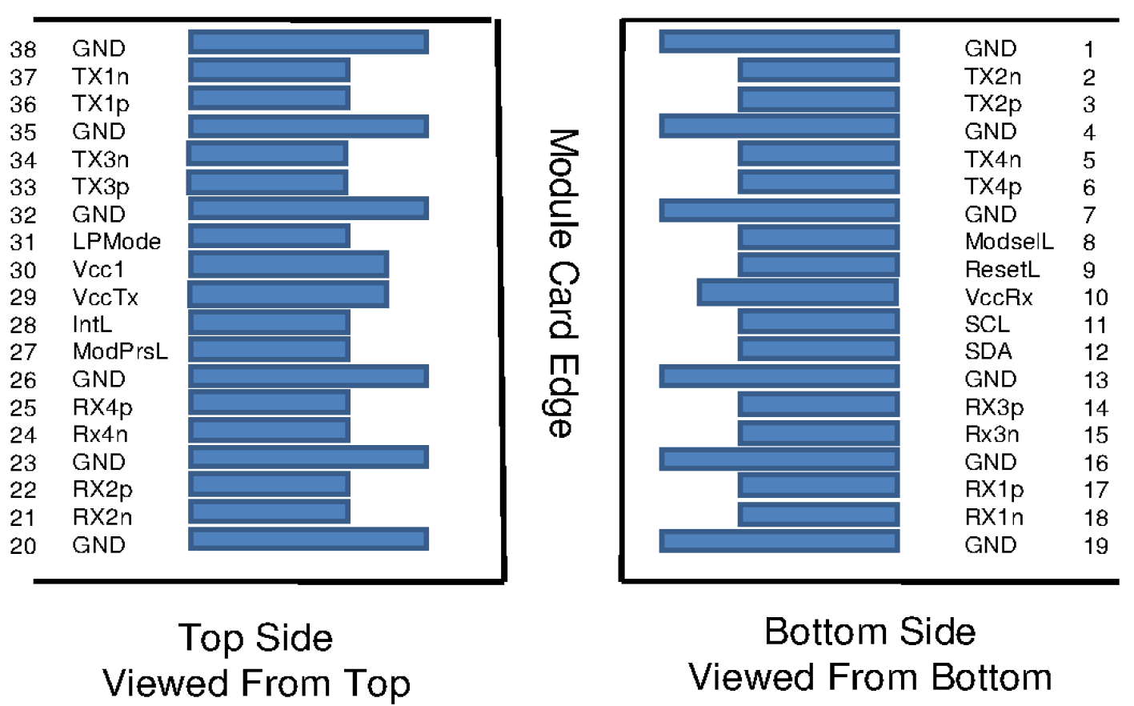
Figure 2 – Pin Definitions 200G QSFP56 END

PIN DESCRIPTION - 200G QSFP56 END

PIN | Logic | Symbol | Name/Description | Note
1 |  | GND | Ground
2 | CML-I | Tx2n | Transmitter Inverted Data Input
3 | CML-I | Tx2p | Transmitter Non-Inverted Data output
4 |  | GND | Ground
5 | CML-I | Tx4n | Transmitter Inverted Data Input
6 | CML-I | Tx4p | Transmitter Non-Inverted Data output
7 |  | GND | Ground
8 | LVTTL-I | ModSelL | Module Select
9 | LVTTL-I | ResetL | Module Reset
10 |  | VccRx | ﹢3.3V Power Supply Receiver
11 | LVCMOS-I/O | SCL | 2-Wire Serial Interface Clock
12 | LVCMOS-I/O | SDA | 2-Wire Serial Interface Data
13 |  | GND | Ground
14 | CML-O | Rx3p | Receiver Non-Inverted Data Output
15 | CML-O | Rx3n | Receiver Inverted Data Output
16 |  | GND | Ground
17 | CML-O | Rx1p | Receiver Non-Inverted Data Output
18 | CML-O | Rx1n | Receiver Inverted Data Output
19 |  | GND | Ground
20 |  | GND | Ground
21 | CML-O | Rx2n | Receiver Inverted Data Output
22 | CML-O | Rx2p | Receiver Non-Inverted Data Output
23 |  | GND | Ground
24 | CML-O | Rx4n | Receiver Inverted Data Output
25 | CML-O | Rx4p | Receiver Non-Inverted Data Output
26 |  | GND | Ground
27 | LVTTL-O | ModPrsL | Module Present
28 | LVTTL-O | IntL | Interrupt
29 |  | VccTx | +3.3 V Power Supply transmitter
30 |  | Vcc1 | +3.3 V Power Supply
31 | LVTTL-I | LPMode | Low Power Mode
32 |  | GND | Ground
33 | CML-I | Tx3p | Transmitter Non-Inverted Data Input
34 | CML-I | Tx3n | Transmitter Inverted Data Output
35 |  | GND | Ground
36 | CML-I | Tx1p | Transmitter Non-Inverted Data Input
37 | CML-I | Tx1n | Transmitter Inverted Data Output
38 |  | GND | Ground

OUTLINE DIMENSIONS

Unit mm

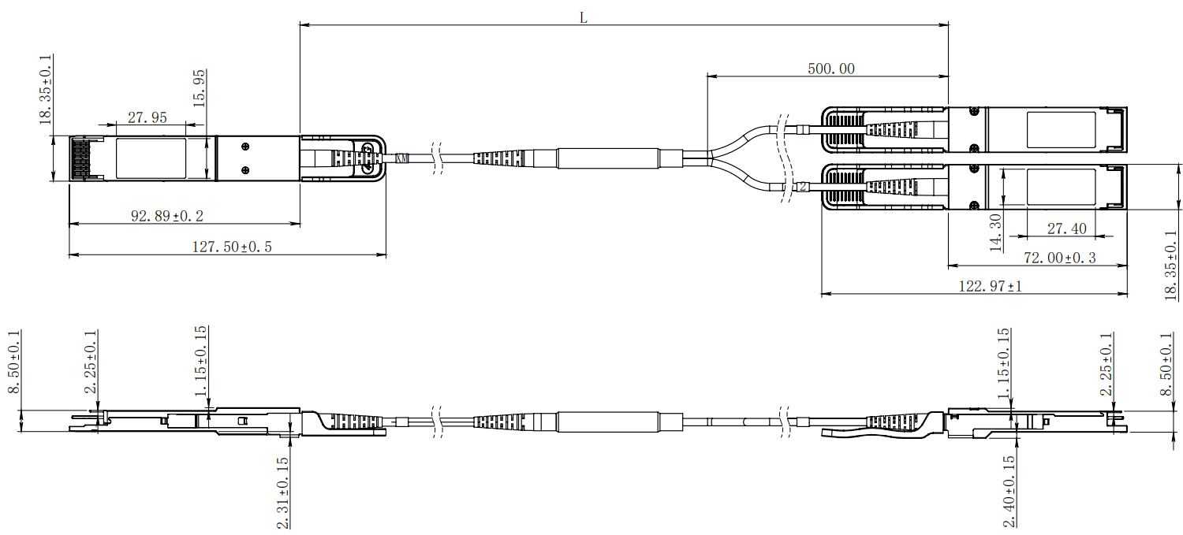
Digital Diagnostic Monitor Accuracy
The following characteristics are defined over recommended operating conditions

Parameter | Accuracy | Unit
Internally measured transceiver temperature | +/-3 | deg.C
Internally measured transceiver supply voltage | +/-3 | %
Measured Tx bias current | +/-10 | %
Measured Tx output power | +/-3 | dB
Measured Rx received average optical power | +/-3 | dB

