Product Specification
400G QSFP-DD AOC Transceivers

DESCRIPTION

JH-400G-QSFP-DD-A1-AOC is 400Gb/s QSFP-DD active optical cable (AOC).It is compliant with the QSFP-DD MSA Rev5.0 and IEEE 802.3bs, IEEE802.3cm, and Common Management Interface Specification Rev4.0. The 400G AOC is an assembly of eight full-duplex lanes, where each lane is capable of transmitting data at rates up to 53.125Gb/s PAM-4 signal mode.

FEATURES
- Data rate up to 425Gb/s (8x PAM4 53Gb/s)
- 850nm VCSEL laser and PIN receiver
- High speed I/O electrical interface (400GAUI-8)
- I2C interface with integrated Digital Diagnostic Monitoring (DDM)
- Single +3.3V power supply
- Power consumption less than 10W per end
- Low latency time with CDR solution
- Operating case temperature:0~+70°C
- Compliant to RoHS-10

APPLICATION
- 400GBASE-SR8

Ordering information
Part Number | Product Description
JH-400G-QSFP-DD-A1-AOC | 400G QSFP-DD SR8 AOC Transceivers,CDR type, C-TEMP  xx=01~99,cable length=1m~99m

ABSOLUTE MAXIMUM RATINGS (TC=25°C, UNLESS OTHERWISE NOTED)
Stresses in excess of the absolute maximum ratings can cause permanent damage to the device. These are absolute stress ratings only. Functional operation of the device is not implied at these or any other conditions in excess of those given in the operational sections of the data sheet. Exposure to absolute maximum ratings will cause permanent damage and/or adversely affect device reliability.
Parameter | Symbol | Min | Typical | Max | Unit | Notes
Storage Temperature | TS | -40 | - | +85 | ºC
Maximum Supply Voltage | Vcc | -0.5 | - | 4.0 | V
Operating Relative Humidity | RH | 15 | - | +85 | %

RECOMMENDED OPERATING CONDITIONS
Parameter | Symbol | Min | Typical | Max | Unit | Notes
Operating Case temperature | Tc | 0 | - | +70 | ºC
Supply Voltage | Vcc | 3.13 | 3.3 | 3.47 | V
Power Supply Current | Icc | - | - | 3 | A
Power Consumption (per end) |  | - | - | 10 | W
Data Rate (per lane) |  | - | 53.125 | - | Gb/s
PIN DESCRIPTIONS
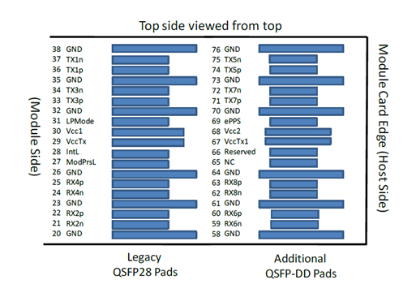
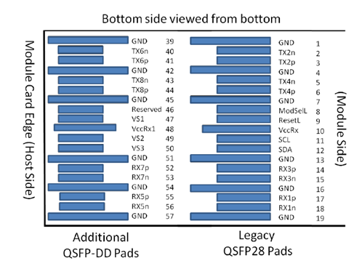
Figure 1 – Pin Definitions
Pad | Logic | Symbol | Description | Plug Seq⁴ | Notes
1 |  | GND | Ground | 1B | 1
2 | CML-I | Tx2n | Transmitter Inverted Data Input | 3B
3 | CML-I | Tx2p | Transmitter Non-Inverted Data Input | 3B
4 |  | GND | Ground | 1B | 1
5 | CML-I | Tx4n | Transmitter Inverted Data Input | 3B
6 | CML-I | Tx4p | Transmitter Non-Inverted Data Input | 3B
7 |  | GND | Ground | 1B | 1
8 | LVTTL-I | ModSelL | Module Select. | 3B
9 | LVTTL-I | ResetL | Module Reset. | 3B
10 |  | VccRx | +3.3V Power Supply Receiver | 2B | 2
11 | LVCMOS-I/O | SCL | 2-wire serial interface clock | 3B
12 | LVCMOS-I/O | SDA | 2-wire serial interface data | 3B
13 |  | GND | Ground | 1B | 1
14 | CML-O | Rx3p | Receiver Non-Inverted Data Output | 3B
15 | CML-O | Rx3n | Receiver Inverted Data Output | 3B
16 |  | GND | Ground | 1B | 1
17 | CML-O | Rx1p | Receiver Non-Inverted Data Output | 3B
18 | CML-O | Rx1n | Receiver Inverted Data Output | 3B
19 |  | GND | Ground | 1B | 1
20 |  | GND | Ground | 1B | 1
21 | CML-O | Rx2n | Receiver Inverted Data Output | 3B
22 | CML-O | Rx2p | Receiver Non-Inverted Data Output | 3B
23 |  | GND | Ground | 1B | 1
24 | CML-O | Rx4n | Receiver Inverted Data Output | 3B
25 | CML-O | Rx4p | Receiver Non-Inverted Data Output | 3B
26 |  | GND | Ground | 1B | 1
27 | LVTTL-O | ModPrsL | Module Present. | 3B
28 | LVTTL-O | IntL | Interrupt. | 3B
29 |  | VccTx | +3.3V Power supply transmitter | 2B | 2
30 |  | Vcc1 | +3.3V Power supply | 2B | 2
31 | LVTTL-I | LPMode | Low Power Mode | 3B
32 |  | GND | Ground | 1B | 1
33 | CML-I | Tx3p | Transmitter Non-Inverted Data Input | 3B
34 | CML-I | Tx3n | Transmitter Inverted Data Input | 3B
35 |  | GND | Ground | 1B | 1
36 | CML-I | Tx1p | Transmitter Non-Inverted Data Input | 3B
37 | CML-I | Tx1n | Transmitter Inverted Data Input | 3B
38 |  | GND | Ground | 1B | 1
39 |  | GND | Ground | 1A | 1
40 | CML-I | Tx6n | Transmitter Inverted Data Input | 3A
41 | CML-I | Tx6p | Transmitter Non-Inverted Data Input | 3A
42 |  | GND | Ground | 1A | 1
43 | CML-I | Tx8n | Transmitter Inverted Data Input | 3A
44 | CML-I | Tx8p | Transmitter Non-Inverted Data Input | 3A
45 |  | GND | Ground | 1A | 1
46 |  | Reserved | For future use | 3A | 3
47 |  | VS1 | Module Vendor Specific 1 | 3A | 3
48 |  | VccRx1 | 3.3V Power Supply | 2A | 2
49 |  | VS2 | Module Vendor Specific 2 | 3A
50 |  | VS3 | Module Vendor Specific 3 | 3A
51 |  | GND | Ground | 1A | 1
52 | CML-O | Rx7p | Receiver Non-Inverted Data Output | 3A
53 | CML-O | Rx7n | Receiver Inverted Data Output | 3A
54 |  | GND | Ground | 1A | 1
55 | CML-O | Rx5p | Receiver Non-Inverted Data Output | 3A
56 | CML-O | Rx5n | Receiver Inverted Data Output | 3A
57 |  | GND | Ground | 1A | 1
58 |  | GND | Ground | 1A | 1
59 | CML-O | Rx6n | Receiver Inverted Data Output | 3A
60 | CML-O | Rx6p | Receiver Non-Inverted Data Output | 3A
61 |  | GND | Ground | 1A | 1
62 | CML-O | Rx8n | Receiver Inverted Data Output | 3A
63 | CML-O | Rx8p | Receiver Non-Inverted Data Output | 3A
64 |  | GND | Ground | 1A | 1
65 |  | NC | No Connect | 3A | 3
66 |  | Reserved | For future use | 3A | 3
67 |  | VccTx1 | 3.3V Power Supply | 2A | 2
68 |  | Vcc2 | 3.3V Power Supply | 2A | 2
69 | LVTTL-I | ePPS | Precision Time Protocol (PTP) reference clock input | 3A | 3
70 |  | GND | Ground | 1A | 1
71 | CML-I | Tx7p | Transmitter Non-Inverted Data Input | 3A
72 | CML-I | Tx7n | Transmitter Inverted Data Input | 3A
73 |  | GND | Ground | 1A | 1
74 | CML-I | Tx5p | Transmitter Non-Inverted Data Input | 3A
75 | CML-I | Tx5n | Transmitter Inverted Data Input | 3A
76 |  | GND | Ground | 1A | 1

Notes:
[1] QSFP-DD uses common ground (GND) for all signals and supply (power). All are common within the QSFP-DD module and all module voltages are referenced to this potential unless otherwise noted. Connect these directly to the host board signal-common ground plane.
[2] VccRx, VccRx1, Vcc1, Vcc2, VccTx and VccTx1 shall be applied concurrently. Requirements defined for the host side of the Host Card Edge Connector are listed in Table 7. VccRx, VccRx1, Vcc1, Vcc2, VccTx and VccTx1 may be internally connected within the module in any combination. The connector Vcc pins are each rated for a maximum current of 1000 mA.
[3] All Vendor Specific, Reserved, No Connect and ePPS (if not used) pins may be terminated with 50 Ohms to ground on the host. Pad 65 (No Connect) shall be left unconnected within the module. Vendor specific and Reserved pads shall have an impedance to GND that is greater than 10 kOhms and less than 100 pF.
[4] Plug Sequence specifies the mating sequence of the host connector and module. The sequence is 1A, 2A, 3A, 1B, 2B, 3B (see Figure 2 for pad locations). Contact sequence A will make, then break contact with additional QSFP-DD pads. Sequence 1A,1B will then occur simultaneously, followed by 2A,2B, followed by 3A, 3B.
DATA RATE SPECIFICATION
Parameter | Symbol | Min | Typical | Max | Units | Notes
Bit Rate (per lane) | BR |  | 53.125 |  | Gb/s
Electrical Bit Error Rate (per lane) | BER |  |  | 2.4E-4 |  | Notes
Notes: PRBS31Q@26.5625GBd. Pre-FEC

LOW SPEED CONTROL AND SENSE SIGNALS
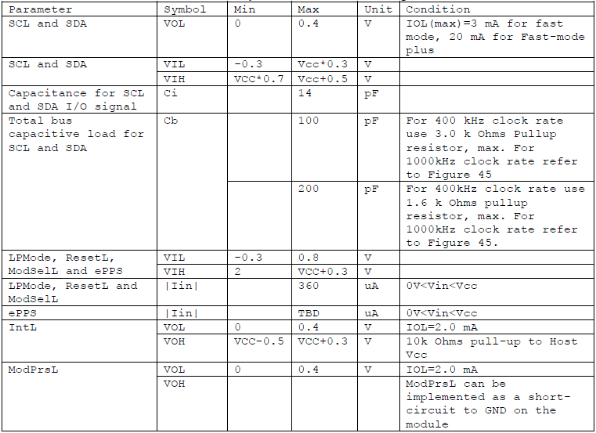

Memory Map
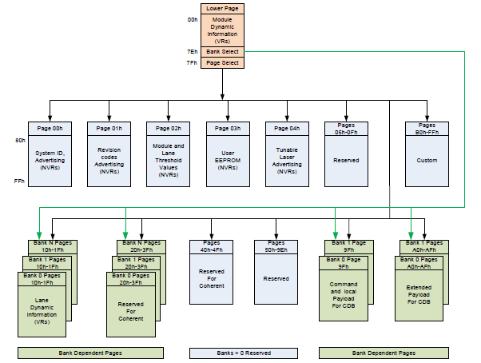
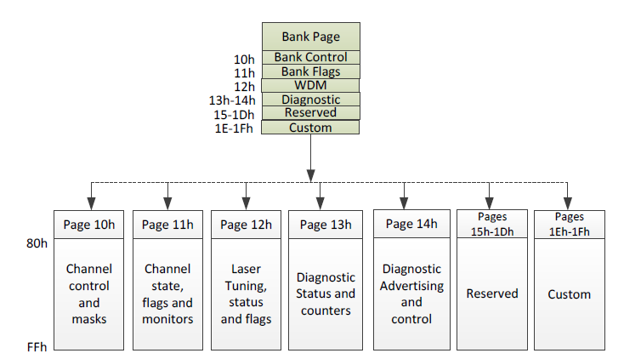
Figure 2 – QSFP-DD Memory Map

DIGITAL DIAGNOSTIC SPECIFICATIONS
Parameter | Symbol | Min | Max | Units | Notes
Transceiver case temperature accuracy | DMI_TEMP | -5 | +5 | ℃ | Over operating temp
Supply voltage monitor accuracy | DMI _VCC | -3% | +3% | V | Full operating range
Channel Bias current monitor accuracy | DMI_IBIAS | -10% | +10% | mA | Per channel
Channel RX power monitor absolute error | DMI_RX | -3 | 3 | dB | Per channel
Channel TX power monitor absolute error | DMI_TX | -3 | 3 | dB | Per channel
DDM TX Power | DDM_TX_  Power | -6.2 |  | dBm | Per channel
DDM RX Power | DDM_RX_  Power | -6.2 |  | dBm | Per channel
OUTLINE DIAGRAM
Unit: mm

