800G OSFP to 2x400Gb/s OSFP Active Copper Cable (ACC) Splitter Cable

PRODUCT FEATURES
- Hot Pluggable OSFP form factor with finned top heat sink design
- Maximum Aggregate Data Rate: 800Gb/s (8 x 100G/Per Lane)
- Based on 8-channels of 100G-PAM4 modulation
- Built-in EQ Linear Driver chip
- 5 meter length max
- OSFP switch end 1.5 Watts; Single port OSFP ends 0.6 Watts
- SFF-8665 compliant
- CMIS compliant I2C management interface
- Commercial case temperature range of 0°C to 70°C
- DAC Firmware supports both InfiniBand and Ethernet

PRODUCT APPLICATIONS
- Infiniband 2x400Gb/s Quantum-2
- InfiniBand Spectrum-4 Ethernet switch-to-switch and switch-to-DGX-H100
- Data storage and communication industry
- Switch / router / HBA
- Enterprise network
- Data Center Network

PRODUCT P/N
PN | Data Rate | Temp | Length (meter) | Remark
JH-800G-OSFP-A2-AOC | 800Gbps | 0-70℃ | 3~5

Description
JH-800G-OSFP-A2-AOC is an 800G OSFP (Octal Small Formfactor Pluggable) to 2x400Gb/s Splitter OSFP Active Copper Cable (ACC). It’s with an equalizer integrated circuit to extend the length while maintaining very low-latency and very low-power. The DAC supports both InfiniBand and Ethernet and is automatically enabled depending on the protocol of the switch attached to.

JH-800G-OSFP-A2-AOC cable assemblies is compliant with the OSFP-MSA and IEEE 802.3ck, it’s a high performance & cost effective I/O solutions for LAN, HPC and SAN. The high speed cable assemblies meet and exceed 800Gigabit Ethernet, InfiniBand EDR /HDR and temperature requirements for performance and reliability.

Absolute Maximum Ratings
Parameter | Symbol | Min | Max | Unit
Storage Temperature | T_{s} | -20 | 85 | ºC
Case Operating Temperature | T_{c} | 0 | 70 | ºC
Humidity (non-condensing) | Rh | 5 | 95 | %

Recommended Operating Conditions
Parameter | Symbol | Min | Typical | Max | Unit
Operating Case Temperature | T_{c} | 0 |  | 70 | ºC
Baud Rate per Lane (PAM4) | fd |  | 53.125 |  | GBaud/s
Humidity | Rh | 5 |  | 85 | %

Electrical Specifications

Parameter | Min | Typ | Max | Units | Note
Characteristic impedance | 90 | 100 | 110 | Ω
Time propagation delay | -- | -- | 4.5 | ns/m | Informative Reference

SI Requirements
Test Items | Specification | Notes
SDD21&SDD12 | (Please reference only, when the length is more than 1.5m)  ≤19.75 dB Min. @26.56 GHz;  ≥ 11.0 dB max. @26.56GHz; | From 0.01 GHz to  26.56GHz
ERL | Minimum cable assembly ERL(*) : ≥ 8.25dB | /
SCD12-SDD12 SCD21-SDD21 | ≥ 10 0.05GHz≤f<12.89GHz  ≥ 14-0.3108f 12.89GHz≤f≤40GHz | ( up to 40GHz)

Electrical Pinout
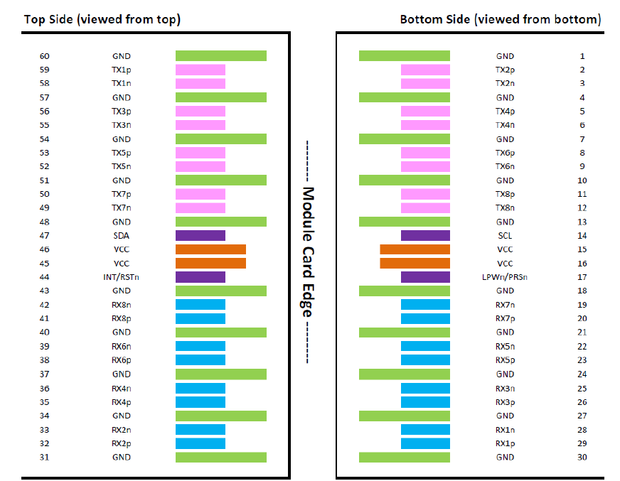

Electrical pin list and description
Pin | Symbol | Description | Pin | Symbol | Description
1 | GND | Ground | 31 | GND | Ground
2 | Tx2p | Transmitter Non-Inverted Data Input | 32 | Rx2p | Receiver Non-Inverted Data Output
3 | Tx2n | Transmitter Inverted Data Input | 33 | Rx2n | Receiver Inverted  Data Output
4 | GND | Ground | 34 | GND | Grounds
5 | Tx4p | Transmitter Non-Inverted Data Input | 35 | Rx4p | Receiver Non-Inverted Data Output
6 | Tx4n | Transmitter Inverted Data Input | 36 | Rx4n | Receiver Inverted Data Output
7 | GND | Ground | 37 | GND | Ground
8 | Tx6p | Transmitter Non-Inverted Data Input | 38 | Rx6p | Receiver Non-Inverted Data Output
9 | Tx6n | Transmitter Inverted Data Input | 39 | Rx6n | Receiver Inverted Data Output
10 | GND | Ground | 40 | GND | Ground
11 | Tx8p | Transmitter Non-Inverted Data Input | 41 | Rx8p | Receiver Non-Inverted Data Output
12 | Tx8n | Transmitter Inverted Data Input | 42 | Rx8n | Receiver Inverted Data Output
13 | GND | Ground | 43 | GND | Ground
14 | SCL | 2-wire serial interface clock | 44 | INT / RSTn | Module Interrupt / Module Reset
15 | VCC | +3.3V Power | 45 | VCC | +3.3V Power
16 | VCC | +3.3V Power | 46 | VCC | +3.3V Power
17 | LPWn / PRSn | Low-Power Mode / Module Present | 47 | SDA | 2-wire Serial interface data
18 | GND | Ground | 48 | GND | Ground
19 | Rx7n | Receiver Inverted Data Output | 49 | Tx7n | Transmitter Inverted Data Input
20 | Rx7p | Receiver Non-Inverted Data Output | 50 | Tx7p | Transmitter Non-Inverted Data Input
21 | GND | Ground | 51 | GND | Ground
22 | Rx5n | Receiver Inverted Data Output | 52 | Tx5n | Transmitter Inverted Data Input
23 | Rx5p | Receiver Non-Inverted Data Output | 53 | Tx5p | Transmitter Non-Inverted Data Input
24 | GND | Ground | 54 | GND | Ground
25 | Rx3n | Receiver Inverted Data Output | 55 | Tx3n | Transmitter Inverted Data Input
26 | Rx3p | Receiver Non-Inverted Data Output | 56 | Tx3p | Transmitter Non-Inverted Data Input
27 | GND | Ground | 57 | GND | Ground
28 | Rx1n | Receiver Inverted Data Output | 58 | Tx1n | Transmitter Inverted Data Input
29 | Rx1p | Receiver Non-Inverted Data Output | 59 | Tx1p | Transmitter Non-Inverted Data Input
30 | GND | Ground | 60 | GND | Ground

Mechanical Dimensions （mm）
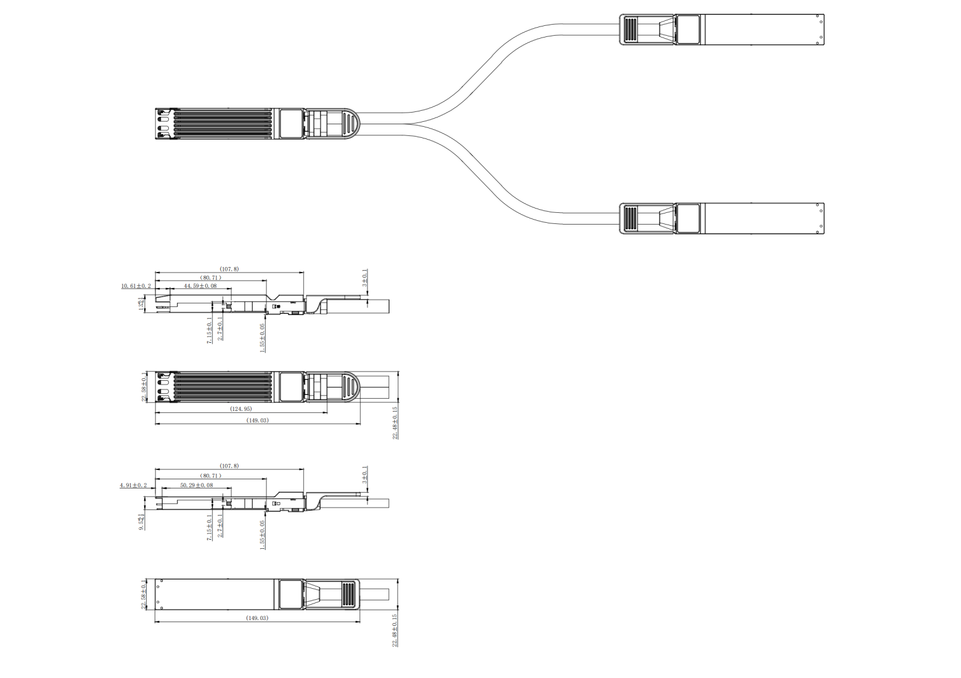

Length (m) | Cable AWG
0.5 | 30
1 | 30
1.5 | 28
2 | 28
2.5 | 28
3 | 28
4 | 26
5 | 26

Regulatory Compliance
Feature | Test Method | Performance
Electrostatic Discharge (ESD) to the Electrical Pins | MIL-STD-883C Method 3015.7 | Class 1(>2000 Volts)
Electromagnetic Interference( EMI) | FCC Class B | Compliant with Standards
Electromagnetic Interference( EMI) | CENELEC EN5 5 0 2 2 Class B | Compliant with Standards
Electromagnetic Interference( EMI) | CISPR2 2 ITE Class B | Compliant with Standards
RF Immunity( RFI) | IEC61000-4-3 | Typically Show no Measurable Effect from a 10V/m Field Swept from 80 to 1000MHz
RoHS Compliance | RoHS Directive 2011/65/EU andit's AmendmentDirectives(EU)2015/863 | RoHS (EU) 2015/863  compliant

Contact:
Wuhan Jiuhong Optics Technology Co., Ltd.
TEL: 86-13476016116
E-mail：grace@jh-optics.com
Web：www.jh-optics.com
Address：
Building 1, 4th Floor, Yunqi Free Trade Innovation Port, Donghu Comprehensive Bonded Zone,Donghu High-tech Zone, Wuhan City

