10G SFP+ Direct Attach Cable
General Description
SFP+ Direct Attach Cables are compliant with the SFF-8431, SFF-8432 and SFF-8472 specifications. Various choices of wire gauge are available from 30 to 24 AWG with various choices of cable length (up to 7m).

PRODUCT FEATURES
- Compliant with SFF-8431, 8432 and 8472.
- Up to 10.3125Gbps data rate per channel
- Up to 7m transmission
- Operating temperature:0℃ to +70℃
- Single 3.3V power supply
- RoHS compliant

BENEFITS
- Cost-effective copper solution
- Lowest total system power solution
- Lowest total system EMI solution
- Optimized design for Signal Integrity

PRODUCT APPLICATIONS
- Ethernet for 2x40/100GBASE-SR4
- HPC Interconnects
- Proprietary Interconnections

GENERAL PRODUCT CHARACTERISTICS
Number of Lanes | Tx & Rx
Channel Data Rate | 10.3125 Gbps
Operating Temperature | 0 to + 70°C
Storage Temperature | -40 to + 85°C
Supply Voltage | 3.3 V nominal
Electrical Interface | 20 pins edge connector
Management Interface | Serial, I2C

HIGH SPEED CHARACTERISTICS
Parameter | Symbol | Min | Typ | Max | Units | Notes
Differential Impedance | Zd | 90 | 100 | 110 | Ω
Differential Input Return Loss | SDDXX | <-12+2* SQRT (f) with f in GHz |  |  | dB | 0.01~4.1GHz
Differential Input Return Loss | SDDXX | <-6.3+13*  Log10/(f/5.5) with f in GHz |  |  | dB | 4.1~11.1GHz
Common Mode Output Return Loss | SCCXX | < -7+1.6*f with f in GHz |  |  | dB | 0.01~2.5GHz
Common Mode Output Return Loss | SCCXX |  |  | -3 | dB | 2.5~11.1GHz
Difference Waveform Distortion Penalty | dWDPc |  |  | 6.75 | dB
VMA Loss | L |  |  | 4.4 | dB
VMA Loss to Crosstalk Ratio | VCR | 32.5 |  |  | dB

MECHANICAL SPECIFICATIONS
The connector is compatible with the SFF-8432 specification.

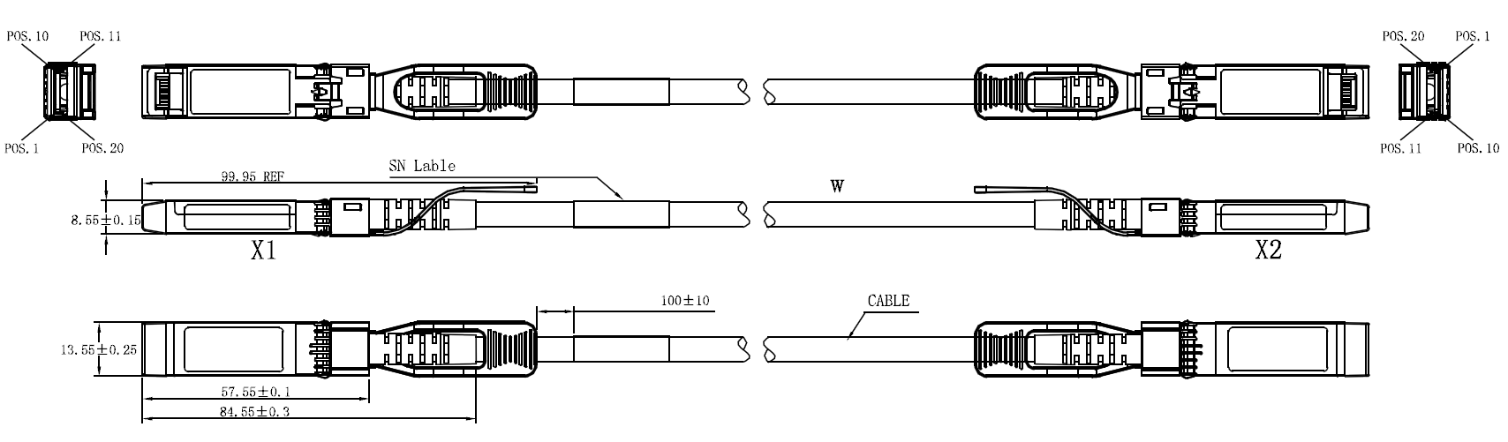

Length (m) | Cable AWG
1 | 30
3 | 30
5 | 24
7 | 24

Pin Function Definition
Pin | Logic | Symbol | Description
1 |  | VeeT | Module Transmitter Ground
2 | LVTTL-O | Tx_Fault | Module Transmitter Fault
3 | LVTTL-I | Tx_Disable | Transmitter disable; Turns off transmitter laser output
4 | LVTTL-I/O | SDA | 2-wire Serial Interface Data Line (Same as MOD-DEF2 in INF-8074i)
5 | LVTTL-I/O | SCL | 2-wire Serial Interface Clock (Same as MOD-DEF1 in INF-8074i)
6 |  | Mod_ABS | Module Absent, connected to VeeT or VeeR in the module
7 | LVTTL-I | RS0 | Rate Select 0, optionally controls SFP+ module receiver
8 | LVTTL-O | Rx_LOS | Receiver Loss of Signal Indication (In FC designated as Rx_LOS and in Ethernet designated as Signal Detect)
9 | LVTTL-I | RS1 | Rate Select 1, optionally controls SFP+ module transmitter
10 |  | VeeR | Module Receiver Ground
11 |  | VeeR | Module Receiver Ground
12 | CML-O | RD- | Receiver Inverted Data Output
13 | CML-O | RD+ | Receiver Non-Inverted Data Output
14 |  | VeeR | Module Receiver Ground
15 |  | VccR | Module Receiver 3.3 V Supply
16 |  | VccT | Module Transmitter 3.3 V Supply
17 |  | VeeT | Module Transmitter Ground
18 | CML-I | TD+ | Transmitter Non-Inverted Data Input
19 | CML-I | TD- | Transmitter Inverted Data Input
20 |  | VeeT | Module Transmitter Ground

Regulatory Compliance

Feature | Test Method | Performance
Electrostatic Discharge (ESD) to the Electrical Pins | MIL-STD-883C Method 3015.7 | Class 1(>2000 Volts)
Electromagnetic Interference(EMI) | FCC Class B | Compliant with Standards
Electromagnetic Interference(EMI) | CENELEC EN55022 Class B | Compliant with Standards
Electromagnetic Interference(EMI) | CISPR22 ITE Class B | Compliant with Standards
RF Immunity(RFI) | IEC61000-4-3 | Typically Show no Measurable Effect from a 10V/m Field Swept from 80 to 1000MHz
RoHS Compliance | RoHS Directive 2011/65/EU and it's Amendment Directives 6/6 | RoHS 6/6 compliant

Contact:
Wuhan Jiuhong Optics Technology Co., Ltd.
TEL: 86-13476016116
E-mail：grace@jh-optics.com
Web：www.jh-optics.com
Address：
Building 1, 4th Floor, Yunqi Free Trade Innovation Port, Donghu Comprehensive Bonded Zone,
Donghu High-tech Zone, Wuhan City

