40Gbps QSFP+ To 4x 10G SFP+
Passive High Speed Cable Specification

Signature | (Drafted By) | （Approved by ） | （ Customer Approved by ）
Signature | DANIEL | GRACE
Signature | 2025-07-21 | 2025-07-21

Description：
QSFP + to 4SFP + Passive Direct Copper is a cost-effective, high-speed interconnect solution that allows cables to connect QSFP + and SFP + switches and network devices without the need to upgrade an entire data center or storage array. Enables Customers to Interconnect Between 40G and 10G Devices (NIC / HBA / CNA, Switch Devices, and Servers).

- Features：
• Protocol agnostic support of 40GbE, QDR InfiniBand, SAS & Fibre Channel
• 10Gbps transfer rate per SFP+ channel (40 Gb/s aggregate)
• Compliant with SFF-8436 / SFF-8431
• Compliant with IEEE 802.3ba/ Infiniband QDR specifications
• Enhanced EMI/EMC performance
• Supports serial ID functionality thru EEPROM
• Passive cable assembly supports distances up to 7meters
• 30AWG to 24AWG cable sizes available
• RoHS compliant
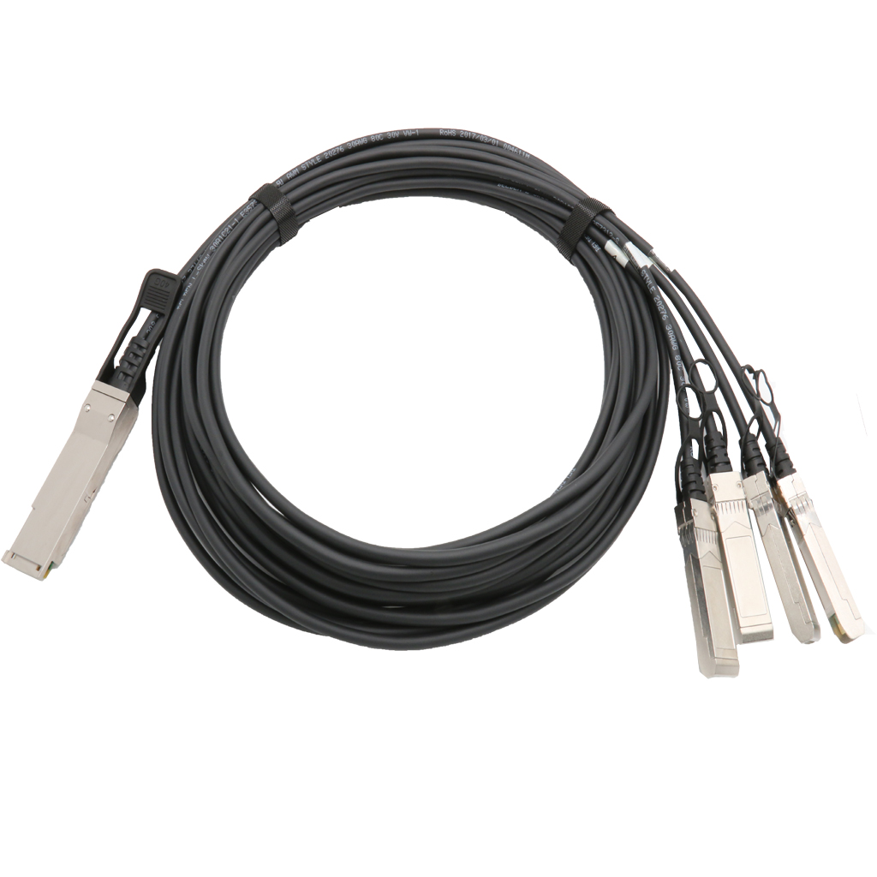

Applications :

• Switches / Routers / HBAs/SAN,NIC cards
• Server & Storage Devices
• Data Center Networking
• Fiber Channel
• InfiniBand QDR/DDR
• 10Gbs/40Gbs Ethernet

Outline drawing :

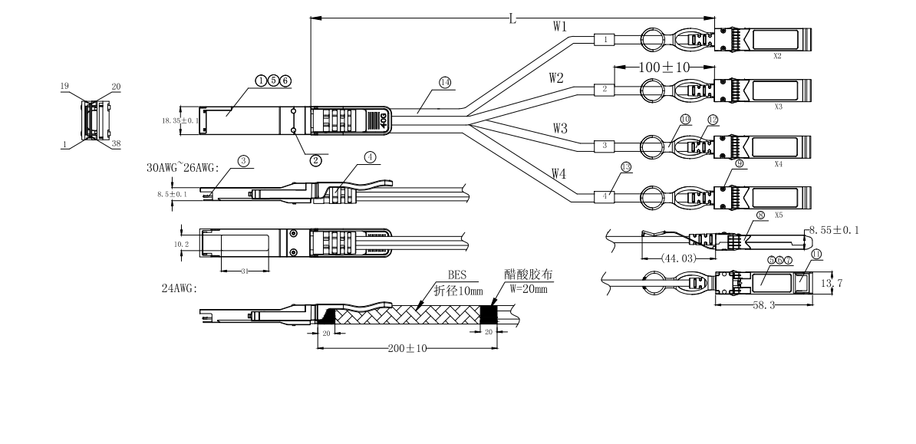
- Wiring Diagram：
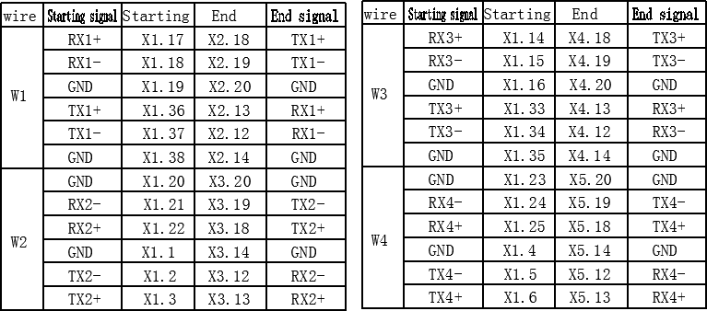

- Electrical Performance：
  - （Signal Integrity）

（ITEM） |  | （REQUIREMENT） |  |  |  |  | （TEST CONDITION）
（Differe ntial Impedan ce） | Cable  Impedance | 105+5/-5Ω |  |  |  |  | Rise time of 35ps (20 % - 80 %).
（Differe ntial Impedan ce） | Paddle Card  Impedance | 100±10Ω |  |  |  |  | Rise time of 35ps (20 % - 80 %).
（Differe ntial Impedan ce） | Cable Termination  Impedance | 100±15Ω |  |  |  |  | Rise time of 35ps (20 % - 80 %).
[Differential (Input/Output)Return loss SDD11/SDD22] |  | Return loss(f)≥ 10 0.01≤f﹤4.1  6.3-13log₁₀(f/ 5.5) 4.1≤f≤11.1  Where  f is the frequency in GHz Return loss(f) is the return loss at frequency f |  |  |  |  | 0.01GHz≤f≤11.1GH  z  SFF-8431 Rev.4.1
[Differential Insertion Loss (S_{DD21} Max.)] |  | (Differential InsertionLoss Max. For TPa to TPb  Excluding Test fixture ) |  |  |  |  | 10MHz≤f ≤5GHz
 |  | F  AWG | 0.6GHz | 1.25GHz | 2.5GHz | 5.0GHz | 10MHz≤f ≤5GHz
 |  | 30AWG(1m)Max. | 2dB | 3dB | 4.5dB | 7.5dB | 10MHz≤f ≤5GHz
 |  | 30 AWG(2m)Max. | 4dB | 5dB | 7dB | 10dB | 10MHz≤f ≤5GHz
 |  | 28AWG（3m)Max. | 4dB | 5.5dB | 7.5 dB | 12dB | 10MHz≤f ≤5GHz
 |  | 26AWG(5m)Max. | 5.5dB | 7dB | 10dB | 16.0dB | 10MHz≤f ≤5GHz
 |  | 24AWG(7m&10m  )Max. | 6.5dB | 10dB | 14dB | 21dB | 10MHz≤f ≤5GHz
[MDNEXT(multiple disturber  near-end crosstalk)] |  | ≥26dB |  |  |  |  | 10MHz≤f ≤5GHz
[Insertion Loss  Deviation] |  | -0.7-0.2*10⁻³f ≤ ILD ≤ 0.7+0.2*10⁻³f  (f is the frequency in MHz), |  |  |  |  | 10MHz≤f ≤5GHz

  - （Other Electrical Performance）

（ITEM） | （REQUIREMENT） | （TEST CONDITON）
[Low Level Contact Resistance] | 70milliohms Max. From initial. | EIA-364-23:Apply a maximum voltage of 20mV  And a current of 100 mA.
Insulation Resistance | 10Mohm(Min.) | EIA364-21:AC 300V 1minute
[Dielectric Withstanding Voltage] | DC 500V 1 minute disruptive discharge. | EIA-364-20:Apply a voltage of 500 VDC for 1minute between adjacent terminals  And between adjacent terminals and  ground.

（Environment Performance）

（ITEM） | （REQUIREMENT） | （TEST CONDITON）
[Operating Temp.  Range] | -20°C to +75°C | Cable operating temperature range.
[Storage Temp.  Range  (in packed condition)] | -25°C to +65°C | Cable storage temperature range in packed condition.
[Thermal Cycling  Non-Powered] | No evidence of physical damage | EIA-364-32D, Method A, -25 to 90C, 100  cycles, 15 min. dwells
[Salt Spraying] | 48 hours salt spraying after shell  corrosive area less than 5％. | EIA-364-26
Mixed Flowing Gas | Pass electrical tests per 3.1 after  stressing. (For connector only) | EIA-364-35 Class II,14 days.
Temp. Life | No evidence of physical damage | EIA-364-17C w/ RH, Damp heat 90℃ at  85% RH for 500 hours then return to ambient
Cable Cold Bend | 4H,No evidence of physical damage | Condition: -20℃±2℃, mandrel diameter is 6 times the cable diameter.

- Mechanical and Physical Characteristics

（ITEM） | （REQUIREMENT） | （TEST CONDITON）
Vibration | Pass electrical tests per 3.1 after stressing. | Clamp & vibrate per EIA-364-28E,  TC-VII, test condition letter – D, 15 minutes in X, Y & Z axis.
Cable Flex | No evidence of physical damage | Flex cable 180° for 20 cycles (±90° from nominal position) at 12 cycles per minute with a 1.0kg load applied to the cable jacket. Flex in the boot area 90º in each  direction from vertical. Per EIA-364-41C
Cable Plug Retention in Cage | 90N Min.  No evidence of physical damage | Force to be applied axially with no damage to cage. Per SFF 8661 Rev 2.1  Pull on cable jacket approximately 1 ft behind cable plug. No functional damage to cable plug below 90N.  Per SFF-8432 Rev 5.0
Cable Retention in Plug | 90N Min.  No evidence of physical damage | Cable plug is fixtured with the bulk cable hanging vertically. A 90N axial load is applied (gradually) to the cable jacket and  held for 1 minute. Per EIA-364-38B
Mechanical Shock | Pass electrical tests  Per 3.1 after stressing. | Clamp and shock per EIA-364-27B, TC-G,3  times in 6 directions, 100g, 6ms.
Cable Plug Insertion | 40N Max.(QSFP+)  18N Max.(SFP+) | Per SFF8432 Rev 5.0.
Cable plug Extraction | 30N Max. (QSFP28)  12.5N Max. (SFP28) | Measure without the aid of any cage kick-out springs. Place axial load on  de-latch to de-latch plug. Per SFF-8432  Rev 5.0.
Durability | 50 cycles,No evidence of physical damage | EIA-364-09, perform plug &unplug cycles:Plug and receptacle mate rate: 250times/hour. 50times for QSFP28/SFP28  module (CONNECTOR TO PCB)

Contact:
Wuhan Jiuhong Optics Technology Co., Ltd.
TEL: 86-13476016116
E-mail：grace@jh-optics.com
Web：www.jh-optics.com
Address：
Building 1, 4th Floor, Yunqi Free Trade Innovation Port, Donghu Comprehensive Bonded Zone,Donghu High-tech Zone, Wuhan City

