100G QSFP28 to 2*50G QSFP28 Direct Attach Cable

Features and Benefits

- QSFP28 conforms to the Small Form Factor SFF8665
- 4-Channel Full-Duplex Passive Copper Cable Transceiver
- Support data rates : 25.78Gb/s (per channel)
- Maximum aggregate data rate: 100Gb/s (4 x 25.78Gb/s)
- Meets or exceeds strict 100-Gigabit Ethernet (100GBASE-CR4) standards
- Complies with latest QSFP28 MSA (Multi-Source Agreement) SFF-8665 architecture
- Complies with IEEE 802.3bj and RoHS
- Compatible with all QSFP ports
- Pull-to-release slide latch design

Product Applications
- Switches,servers and routers
- Data Center networks
- Storage area networks
- High performance computing
- Telecommunication and wireless infrastructure
- 100G Ethernet(IEEE 802.3bj)
- InfiniBand EDR

General Description

The 100G QSFP28 cable assemblies are high performance, cost effective I/O solutions for LAN, HPC and SAN. The high speed cable assemblies meet and exceed 100 Gigabit Ethernet, InfiniBand EDR and temperature requirements for performance and reliability. The cables are compliant with SFF-8436 specifications and provide connectivity between devices using QSFP ports.

Recommended Operating Conditions
Parameter | Symbol | Min | Typical | Max | Unit
Storage Ambient Temperature |  | -40 |  | +85 | °C
Operating Case Temperature | Tc | 0 |  | +70 | °C
Power Supply Voltage | V_{CC3} | 3.14 | 3.3 | 3.47 | V
Data Rate Per Lane |  | 1 |  | 25.78 | Gb/s

Performance Information

Parameter | Symbol | Min | Typical | Max | Unit | Note
Differential Impedance | TDR | 90 | 100 | 110 | Ώ
Insertion loss | SDD21 | -22.48 |  |  | B  d | At 12.89GHz
Differential Return Loss | SDD11  SDD22 |  |  | See 1 | B  d | At 0 05 to 4 1 GHz
Differential Return Loss | SDD11  SDD22 |  |  | See 2 | B  d | At 4 1 to 19 GHz
Common-mode to  common-mode output return  loss | SCC11  SCC22 |  |  | -2 | d  B | At 0.2 to 19 GHz
Differential to common-mode return loss | SCD11  SCD22 |  |  | See 3 | d  B | At 0.01 to 12.89 GHz
Differential to common-mode return loss | SCD11  SCD22 |  |  | See 4 |  | At 12.89 to 19 GHz
Differential to common Mode Conversion Loss | SCD21-IL |  |  | - 10 | d  B | At 0 01 to 12 89 GHz
Differential to common Mode Conversion Loss | SCD21-IL |  |  | See 5 |  | At 12.89 to 15.7 GHz
Differential to common Mode Conversion Loss | SCD21-IL |  |  | -6.3 |  | At 15.7 to 19 GHz
Notes:
1. Reflection Coefficient given by equation SDD11(dB) < - 16.5 + 2 × SQRT(f ), with f in GHz
2. Reflection Coefficient given by equation SDD11(dB) < - 10.66 + 14 × log10(f/5.5), with f in GHz
3. Reflection Coefficient given by equation SCD11(dB) < -22 + (20/25.78)*f, with f in GHz
4. Reflection Coefficient given by equation SCD11(dB) < - 15 + (6/25.78)*f, with f in GHz
5. Reflection Coefficient given by equation SCD21(dB) < -27 + (29/22)*f, with f in GHz

Pin Descriptions
QSFP28 Pin Function Definition
Pin | Logic | Symbol | Name/Description | Notes
1 |  | GND | Ground | 1
2 | CML-I | Tx2n | Transmitter Inverted Data Input
3 | CML-I | Tx2p | Transmitter Non-Inverted Data Input
4 |  | GND | Ground | 1
5 | CML-I | Tx4n | Transmitter Inverted Data Input
6 | CML-I | Tx4p | Transmitter Non-Inverted Data Input
7 |  | GND | Ground | 1
8 | LVTTL-I | ModSelL | Module Select
9 | LVTTL-I | ResetL | Module Reset
10 |  | Vcc Rx | +3.3V Power Supply Receiver | 2
11 | LVCMOSI/O | SCL | 2-wire serial interface clock
12 | LVCMOSI/O | SDA | 2-wire serial interface data
13 |  | GND | Ground | 1
14 | CML-O | Rx3p | Receiver Non-Inverted Data Output
15 | CML-O | Rx3n | Receiver Inverted Data Output
16 |  | GND | Ground | 1
17 | CML-O | Rx1p | Receiver Non-Inverted Data Output
18 | CML-O | Rx1n | Receiver Inverted Data Output
19 |  | GND | Ground | 1
20 |  | GND | Ground | 1
21 | CML-O | Rx2n | Receiver Inverted Data Output
22 | CML-O | Rx2p | Receiver Non-Inverted Data Output
23 |  | GND | Ground | 1
24 | CML-O | Rx4n | Receiver Inverted Data Output
25 | CML-O | Rx4p | Receiver Non-Inverted Data Output
26 |  | GND | Ground | 1
27 | LVTTL-O | ModPrsL | Module Present
28 | LVTTL-O | IntL | Interrupt
29 |  | Vcc Tx | +3.3V Power supply transmitter | 2
30 |  | Vcc1 | +3.3V Power supply | 2
31 | LVTTL-I | LPMode | Low Power Mode
32 |  | GND | Ground | 1
33 | CML-I | Tx3p | Transmitter Non-Inverted Data Input
34 | CML-I | Tx3n | Transmitter Inverted Data Input
35 |  | GND | Ground | 1
36 | CML-I | Tx1p | Transmitter Non-Inverted Data Input
37 | CML-I | Tx1n | Transmitter Inverted Data Input
38 |  | GND | Ground | 1

Note:

- GND is the symbol for signal and supply (power) common for the QSFP+ module. All are common within the QSFP+ module and all module voltages are referenced to this potential unless otherwise noted. Connect these directly to the host board signal-common ground plane.
- Vcc Rx, Vcc1 and Vcc Tx are the receiver and transmitter power supplies and shall be applied concurrently. Requirements defined for the host side of the Host Edge Card Connector are listed in Table 6. Recommended host board power supply filtering is shown in Figure 4. Vcc Rx Vcc1 and Vcc Tx may be internally connected within the QSFP+ Module module in any combination. The connector pins are each
rated for a maximum current of 500 mA.

Wire Diagram
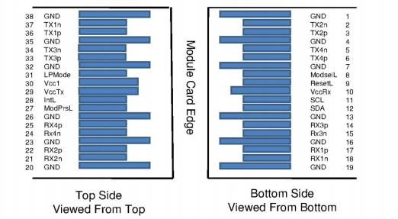
Mechanical Specifications
The connector is compatible with the SFF-8436 specification.

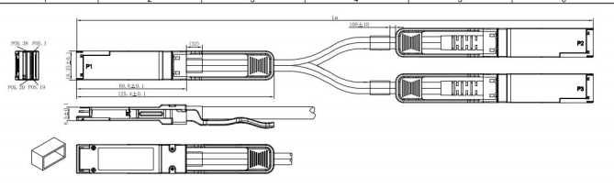

Length (m) | CableAWG
1 | 30
2 | 30
3 | 30
4 | 26
5 | 26

RegulatoryCompliance

Feature | Test Method | Performance
Electrostatic Discharge  (ESD) to the Electrical Pins | MIL-STD-883C Method 3015.7 | Class 1(>2000 Volts)
Electromagnetic  Interference(EMI) | FCC Class B | Compliant with  Standards
Electromagnetic  Interference(EMI) | CENELEC EN55022 Class B | Compliant with  Standards
Electromagnetic  Interference(EMI) | CISPR22 ITE Class B | Compliant with  Standards
RF Immunity(RFI) | IEC61000-4-3 | Typically Show no Measurable Effect from a 10V/m Field Swept from 80 to 1000MHz
RoHS Compliance | RoHS Directive 2011/65/EU and it's Amendment Directives (EU) 2015/863 | RoHS (EU) 2015/863 compliant
REACH Compliance | REACH Regulation (EC) No  1907/2006 | REACH (EC) No 1907/2006 compliant

Contact:
Wuhan Jiuhong Optics Technology Co., Ltd.
TEL: 86-13476016116
E-mail：grace@jh-optics.com
Web：www.jh-optics.com
Address：
Building 1, 4th Floor, Yunqi Free Trade Innovation Port, Donghu Comprehensive Bonded Zone,Donghu High-tech Zone, Wuhan City

