100Gbps QSFP28 Passive High Speed Cable Specification

- Description：
The 100G QSFP28 Direct Connect Cable (DAC) is a 4-channel parallel passive copper product for storage, data centers and high-performance computing connections. Each channel is capable of transmitting data at 25 Gbps, enabling a 100 Gbps total data rate of 5 meters.

- Features：
• Enhanced EMI / EMC performance
• 25Gbps data transfer rate per channel, up to 100Gbps
• Compliant with the IEEE 802.3bj standard and Infiniband EDR specifications
• Meets QSFP + MSA and SFF-8661 / SFF-8665 standards
• Support serial ID function through EEPROM
• 30AWG to 26AWG cable available
• RoHS and halogen-free options

- Applications :
• Switch / router / HBA / SAN, NIC card
• 40G \ 100G Ethernet
• Storage, switch, data center, network center
• Infiniband, QDR / EDR

- Outline drawing :
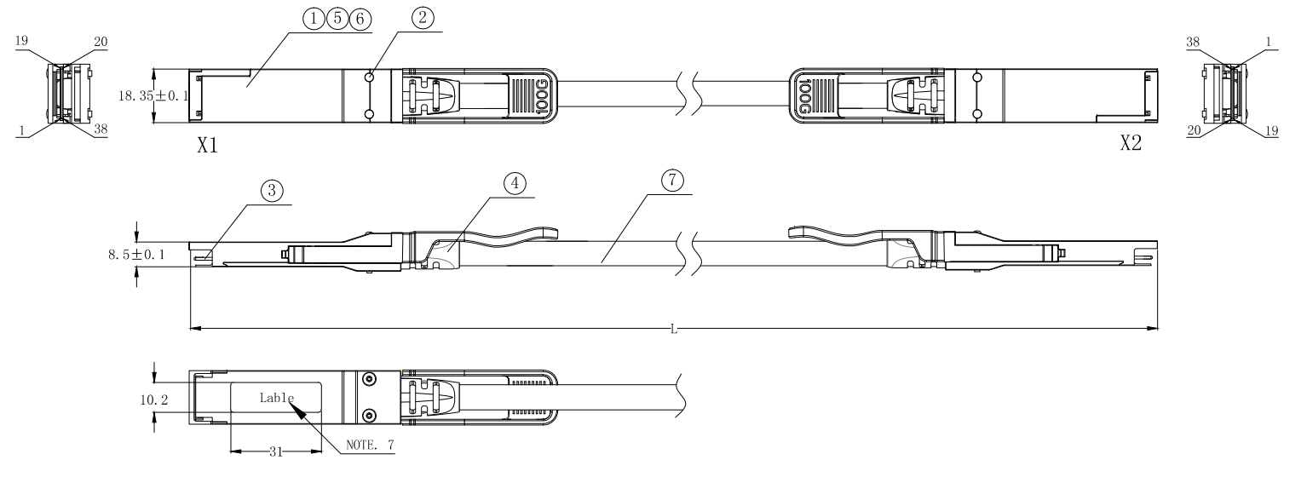
- Wiring Diagram：
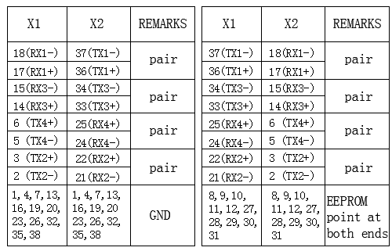

- Electrical Performance：
  - Signal Integrity

（ITEM） |  | （REQUIREMENT） |  |  |  |  |  |  | （TEST CONDITION）
（Differential Impedance） | Cable Impedance | 105+5/-10Ω |  |  |  |  |  |  | Rise time of 25ps  (20 % - 80 %).
（Differential Impedance） | Paddle Card Impedance | 100±10Ω |  |  |  |  |  |  | Rise time of 25ps  (20 % - 80 %).
（Differential Impedance） | Cable Termination Impedance | 100±15Ω |  |  |  |  |  |  | Rise time of 25ps  (20 % - 80 %).
[Differential (Input/Output)Return loss S_{DD11}/S_{DD22]} |  | 16.5-2√f 0.05≤f﹤4.1  10.66-14log₁₀(f/ 5.5) 4.1≤f≤19  Return_loss(f)≥  Where  f is the frequency in GHz  Return loss(f) is the return loss at frequency f |  |  |  |  |  |  | 10MHz≤f ≤19GHz
[Differential to common-mode (Input/Output)Return loss S_{CD11}/S_{CD22]} |  | 22-(20/25.78)f 0.01≤f﹤12.89  15-(6/25.78)f 12.89≤f≤19  Return_loss(f)≥  Where  f is the frequency in GHz  Return_loss(f) is the Differential to common-mode return loss at frequency f |  |  |  |  |  |  | 10MHz≤f ≤19GHz
[Common-mode to Common-mode  (Input/Output)Return loss S_{CC11}/S_{CC22]} |  | Return_loss(f)≥2dB 0.2≤f≤19  Where  f is the frequency in GHz  Return_loss(f) is the common-mode to common-mode return loss at frequency f |  |  |  |  |  |  | 10MHz≤f ≤19GHz
[Differential Insertion Loss (S_{DD21} Max.)] |  | (Differential InsertionLoss Max. For TPa to TPb Excluding Test fixture ) |  |  |  |  |  |  | 10MHz≤f ≤19GHz
 |  | F AWG | 1.25GHz | 2.5GHz | 5.0GHz | 7.0GHz | 10Ghz | 12.89Ghz | 10MHz≤f ≤19GHz
 |  | 30(1m)Max. | 4.5dB | 5.4dB | 6.3dB | 7.5dB | 8.5dB | 10.5dB | 10MHz≤f ≤19GHz
 |  | 30/28(3m)Max. | 7.5dB | 9.5dB | 12.2dB | 14.8dB | 18.0dB | 21.5dB | 10MHz≤f ≤19GHz
 |  | 26(3m)Max. | 5.7dB | 7.2dB | 9.9 dB | 11.9dB | 14.1dB | 16.5dB | 10MHz≤f ≤19GHz
 |  | 26/25(5m)Max. | 7.8dB | 10.0dB | 13.5dB | 16.0dB | 19.0dB | 22.0dB | 10MHz≤f ≤19GHz
[Insertion Loss Deviation] |  | -0.176*f - 0.7 ≤ ILD ≤ 0.176* f + 0.7 |  |  |  |  |  |  | 50MHz≤f ≤19GHz
Differential to common-mode Conversion Loss-Differential Insertion Loss(S_{CD21}-S_{DD21}) |  | 10 0.01≤f﹤12.89  27-(29/22)f 12.89≤f﹤15.7  6.3 15.7≤f≤19  Conversion _loss(f) – IL(f)≥  Where  f is the frequency in GHz  Conversion_loss(f ) is the cable assembly differential to common-mode conversion loss  IL(f) is the cable assembly insertion loss |  |  |  |  |  |  | 10MHz≤f ≤19GHz
[MDNEXT(multiple disturber  near-end crosstalk)] |  | ≥35dB @12.89GHz |  |  |  |  |  |  | 10MHz≤f ≤19GHz
[Intra Skew] |  | 15ps/m, |  |  |  |  |  |  | 10MHz≤f ≤19GHz

6.2 Other Electrical Performance
（ITEM） | （REQUIREMENT） | （TEST CONDITON）
[Low Level Contact Resistance] | 70milliohms Max. From initial. | EIA-364-23:Apply a maximum voltage of 20mV  And a current of 100 mA.
Insulation Resistance | 10Mohm(Min.) | EIA364-21:AC 300V 1minute
[Dielectric Withstanding Voltage] | NO disruptive discharge. | EIA-364-20:Apply a voltage of 300 VDC for 1minute between adjacent terminals  And between adjacent terminals and ground.

- Environment Performance
（ITEM） | （REQUIREMENT） | （TEST CONDITON）
[Operating Temp. Range] | -20°C to +75°C | Cable operating temperature range.
[Storage Temp. Range  (in packed condition)] | -40°C to +80°C | Cable storage temperature range  in packed condition.
[Thermal Cycling Non-Powered] | No evidence of physical damage | EIA-364-32D, Method A, -25 to 90C, 100 cycles, 15 min. dwells
[Salt Spraying] | 48 hours salt spraying after shell  corrosive area less than 5％. | EIA-364-26
Mixed Flowing Gas | Pass electrical tests per 3.1 after  stressing. (For connector only) | EIA-364-35 Class II,14 days.
Temp. Life | No evidence of physical damage | EIA-364-17C w/ RH, Damp heat 90℃ at 85% RH for 500 hours then return to ambient
Cable Cold Bend | 4H,No evidence of physical damage | Condition: -20℃±2℃, mandrel diameter is 6 times the cable diameter.

- Mechanical and Physical Characteristics
（ITEM） | （REQUIREMENT） | （TEST CONDITON）
Vibration | Pass electrical tests  per 3.1 after stressing. | Clamp & vibrate per EIA-364-28E,  TC-VII, test condition letter – D, 15 minutes in X, Y & Z axis.
Twist | No evidence of physical damage | Twist cable 180° (±90° from nominal position) for 100 cycles at 30 cycles per minute with a 0.5kg load applied to the cable jacket.  Clamp position: 300mm
Cable Flex | No evidence of physical damage | Flex cable 180° for 20 cycles (±90° from nominal position) at 12 cycles per minute with a 1.0kg load applied to the cable jacket. Flex in the boot area 90º in each direction from vertical. Per EIA-364-41C
Cable Plug Retention in Cage | 90N Min.  No evidence of physical damage | Force to be applied axially with no damage to cage. Per SFF 8661 Rev 2.1  Pull on cable jacket approximately 1 ft behind cable plug. No functional damage to cable plug below 90N.  Per SFF-8432 Rev 5.0
Cable Retention in Plug | 90N Min.  No evidence of physical damage | Cable plug is fixtured with the bulk cable hanging vertically. A 90N axial load is applied (gradually) to the cable jacket and held for 1 minute. Per EIA-364-38B
Mechanical Shock | Pass electrical tests  Per 3.1 after stressing. | Clamp and shock per EIA-364-27B, TC-G,3 times in 6 directions, 100g, 6ms.
Cable Plug Insertion | 40N Max.(QSFP28) | Per SFF8661 Rev 2.1
Cable plug Extraction | 30N Max. (QSFP28) | Place axial load on de-latch to de-latch plug.Per SFF8661 Rev 2.1
Durability | 50 cycles,No evidence of physical damage | EIA-364-09, perform plug &unplug cycles:Plug and receptacle mate rate: 250times/hour. 50times for QSFP28/SFP28 module (CONNECTOR TO PCB)

