200G QSFP-DD-2X100G QSFP28 Direct Attach Cable

Features and Benefits

-  Compatible with IEEE 802.3bj and IEEE 802.3cd
- Supports aggregate data rates of 200Gbps
-  Optimized construction to minimize insertion loss and cross talk
-  Pull-to-release slide latch design
-  28AWG through 30AWG cable
-  Straight and break out assembly configurations available
- Customized cable braid termination limits EMI radiation
- Customizable EEPROM mapping for cable signature
- RoHS Compliance

Product Applications

  - Switches, servers and routers
  - Data Center networks
  - Storage area networks
  - High performance computing
  - Telecommunication and wireless infrastructure
  - Medical diagnostics and networking
  - Test and measurement equipment

Industry Standards

  - 200G Ethernet(IEEE 802.3cd)
  - InfiniBand EDR

General Description

QSFP-DD_2XQSFP28 passive copper cable assembly feature eight differential copper pairs, providing four data transmission channels at speeds up to 28Gbps per channel and meets 200G Ethernet and InfiniBand Enhanced Data Rate(EDR) requirements. Available in a broad rang of wire gages-from 28AWG through 30AWG-this 200G copper cable assembly features low insertion loss and low cross talk.

High Speed Characteristics
Parameter | Symbol | Min | Typical | Max | Unit | Note
Differential Impedance | TDR | 90 | 100 | 110 | Ώ
Insertion loss | SDD21 | -22.48 |  |  | dB | At 12.89 GHz
Differential Return Loss | SDD11  SDD22 |  |  | See 1 | dB | At 0.05 to 4.1 GHz
Differential Return Loss | SDD11  SDD22 |  |  | See 2 | dB | At 4.1 to 19 GHz
Common-mode to common-mode output return loss | SCC11  SCC22 |  |  | -2 | dB | At 0.2 to 19 GHz
Differential to common-mode  return loss | SCD11  SCD22 |  |  | See 3 | dB | At 0.01 to 12.89 GHz
Differential to common-mode  return loss | SCD11  SCD22 |  |  | See 4 | dB | At 12.89 to 19 GHz
Differential to common Mode  Conversion Loss | SCD21-IL |  |  | -10 | dB | At 0.01 to 12.89 GHz
Differential to common Mode  Conversion Loss | SCD21-IL |  |  | See 5 | dB | At 12.89 to 15.7 GHz
Differential to common Mode  Conversion Loss | SCD21-IL |  |  | -6.3 | dB | At 15.7 to 19 GHz
Notes:
- Reflection Coefficient given by equation SDD11(dB) < -16.5 + 2 × SQRT(f ), with f in GHz
- Reflection Coefficient given by equation SDD11(dB) < -10.66 + 14 × log10(f/5.5), with f in GHz
- Reflection Coefficient given by equation SCD11(dB) < -22 + (20/25.78)*f, with f in GHz
- Reflection Coefficient given by equation SCD11(dB) < -15 + (6/25.78)*f, with f in GHz
- Reflection Coefficient given by equation SCD21(dB) < -27 + (29/22)*f, with f in GHz

Pin Descriptions
QSFP-DD Pin Function Definition

Pin | Logic | Symbol | Description
1 |  | GND | Ground
2 | CML-I | Tx2n | Transmitter Inverted Data Input
3 | CML-I | Tx2p | Transmitter Non-Inverted Data Input
4 |  | GND | Ground
5 | CML-I | Tx4n | Transmitter Inverted Data Input
6 | CML-I | Tx4p | Transmitter Non-Inverted Data Input
7 |  | GND | Ground
8 | LVTTL-I | ModSelL | Module Select
9 | LVTTL-I | ResetL | Module Reset
10 |  | Vcc Rx | +3.3V Power Supply Receiver
11 | LVCMOS- | SCL | 2-wire serial interface clock
11 | I/O | SCL | 2-wire serial interface clock
12 | LVCMOS- | SDA | 2-wire serial interface data
12 | I/O | SDA | 2-wire serial interface data
13 |  | GND | Ground
14 | CML-O | Rx3p | Receiver Non-Inverted Data Output
15 | CML-O | Rx3n | Receiver Inverted Data Output
16 |  | GND | Ground
17 | CML-O | Rx1p | Receiver Non-Inverted Data Output
18 | CML-O | Rx1n | Receiver Inverted Data Output
19 |  | GND | Ground
20 |  | GND | Ground
21 | CML-O | Rx2n | Receiver Inverted Data Output
22 | CML-O | Rx2p | Receiver Non-Inverted Data Output
23 |  | GND | Ground
24 | CML-O | Rx4n | Receiver Inverted Data Output
25 | CML-O | Rx4p | Receiver Non-Inverted Data Output
26 |  | GND | Ground
27 | LVTTL-O | ModPrsL | Module Present
28 | LVTTL-O | IntL | Interrupt
29 |  | Vcc Tx | +3.3V Power supply transmitter
30 |  | Vcc1 | +3.3V Power supply
31 | LVTTL-I | LPMode | Low Power Mode
32 |  | GND | Ground
33 | CML-I | Tx3p | Transmitter Non-Inverted Data Input
34 | CML-I | Tx3n | Transmitter Inverted Data Input
35 |  | GND | Ground
36 | CML-I | Tx1p | Transmitter Non-Inverted Data Input
37 | CML-I | Tx1n | Transmitter Inverted Data Input
38 |  | GND | Ground
39 |  | GND | Ground
40 | CML-I | Tx6n | Transmitter Inverted Data Input
41 | CML-I | Tx6p | Transmitter Non-Inverted Data Input
42 |  | GND | Ground
43 | CML-I | Tx8n | Transmitter Inverted Data Input
44 | CML-I | Tx8p | Transmitter Non-Inverted Data Input
45 |  | GND | Ground
46 |  | Reserved
47 |  | VS1
48 |  | VccRx1 | +3.3V Power supply
49 |  | VS2
50 |  | VS3
51 |  | GND | Ground
52 | CML-O | Rx7p | Receiver Non-Inverted Data Output
53 | CML-O | Rx7n | Receiver Inverted Data Output
54 |  | GND | Ground
55 | CML-O | Rx5p | Receiver Non-Inverted Data Output
56 | CML-O | Rx5n | Receiver Inverted Data Output
57 |  | GND | Ground
58 |  | GND | Ground
59 | CML-O | Rx6n | Receiver Inverted Data Output
60 | CML-O | Rx6p | Receiver Non-Inverted Data Output
61 |  | GND | Ground
62 | CML-O | Rx8n | Receiver Inverted Data Output
63 | CML-O | Rx8p | Receiver Non-Inverted Data Output
64 |  | GND | Ground
65 |  | NC
66 |  | Reserved
67 |  | VccTx1 | +3.3V Power supply
68 |  | VCC2 | +3.3V Power supply
69 |  | Reserved
70 |  | GND | Ground
71 | CML-I | Tx7p | Transmitter Non-Inverted Data Input
72 | CML-I | Tx7n | Transmitter Inverted Data Input
73 |  | GND | Ground
74 | CML-I | Tx5p | Transmitter Non-Inverted Data Input
75 | CML-I | Tx5n | Transmitter Inverted Data Input
76 |  | GND | Ground
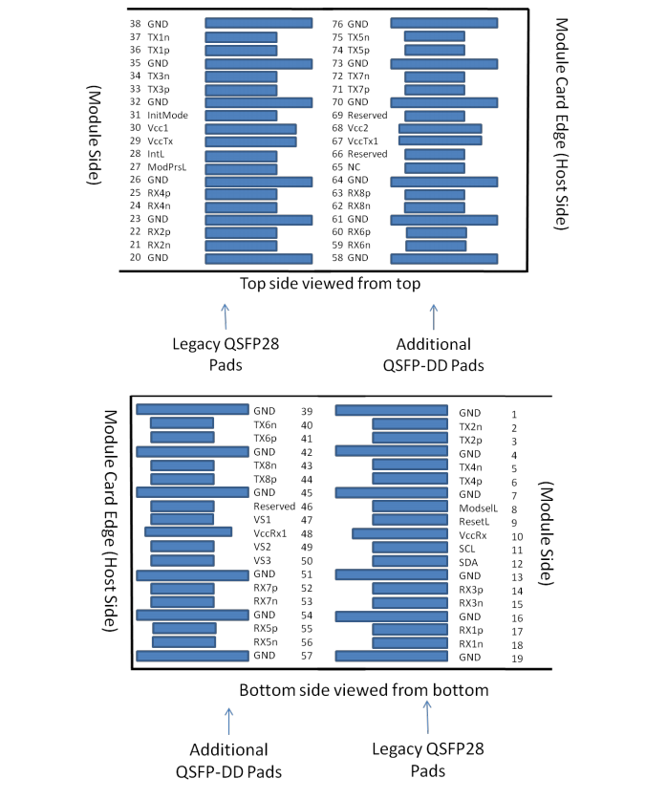

QSFP28 Pin Function Definition
Pin | Logic | Symbol | Description
1 |  | GND | Ground
2 | CML-I | Tx2n | Transmitter Inverted Data Input
3 | CML-I | Tx2p | Transmitter Non-Inverted Data Input
4 |  | GND | Ground
5 | CML-I | Tx4n | Transmitter Inverted Data Input
6 | CML-I | Tx4p | Transmitter Non-Inverted Data Input
7 |  | GND | Ground
8 | LVTTL-I | ModSelL | Module Select
9 | LVTTL-I | ResetL | Module Reset
10 |  | Vcc Rx | +3.3V Power Supply Receiver
11 | LVCMOS- | SCL | 2-wire serial interface clock
11 | I/O | SCL | 2-wire serial interface clock
12 | LVCMOS- | SDA | 2-wire serial interface data
12 | I/O | SDA | 2-wire serial interface data
13 |  | GND | Ground
14 | CML-O | Rx3p | Receiver Non-Inverted Data Output
15 | CML-O | Rx3n | Receiver Inverted Data Output
16 |  | GND | Ground
17 | CML-O | Rx1p | Receiver Non-Inverted Data Output
18 | CML-O | Rx1n | Receiver Inverted Data Output
19 |  | GND | Ground
20 |  | GND | Ground
21 | CML-O | Rx2n | Receiver Inverted Data Output
22 | CML-O | Rx2p | Receiver Non-Inverted Data Output
23 |  | GND | Ground
24 | CML-O | Rx4n | Receiver Inverted Data Output
25 | CML-O | Rx4p | Receiver Non-Inverted Data Output
26 |  | GND | Ground
27 | LVTTL-O | ModPrsL | Module Present
28 | LVTTL-O | IntL | Interrupt
29 |  | Vcc Tx | +3.3V Power supply transmitter
30 |  | Vcc1 | +3.3V Power supply
31 | LVTTL-I | LPMode | Low Power Mode
32 |  | GND | Ground
33 | CML-I | Tx3p | Transmitter Non-Inverted Data Input
34 | CML-I | Tx3n | Transmitter Inverted Data Input
35 |  | GND | Ground
36 | CML-I | Tx1p | Transmitter Non-Inverted Data Input
37 | CML-I | Tx1n | Transmitter Inverted Data Input
38 |  | GND | Ground
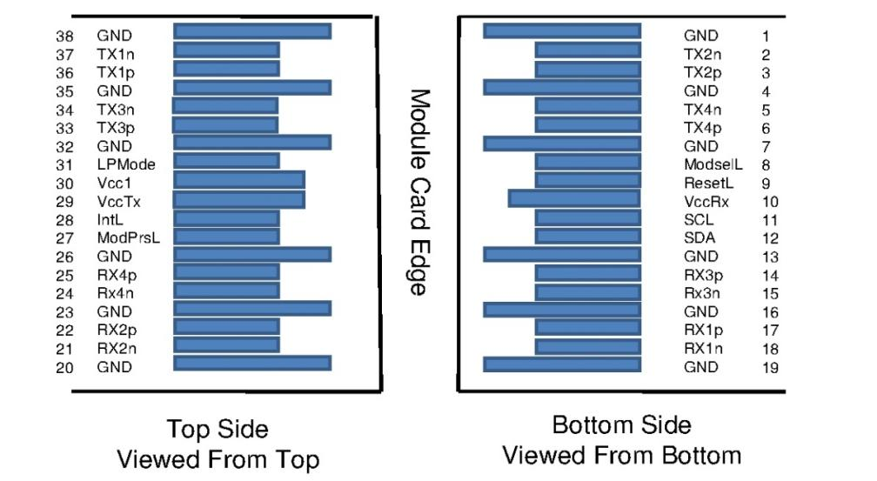

Mechanical Specifications
The connector is compatible with the QSFP-DD and SFF-8661 specification.

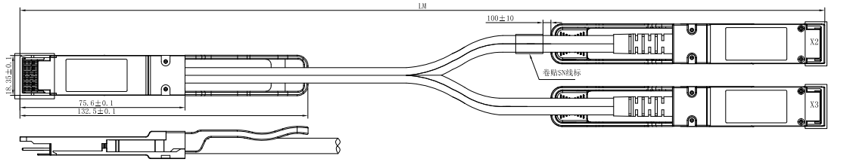

Length (m) | Wire Gauge
0.5~3 | 30AWG
3~4 | 28AWG

Regulatory Compliance

Feature | Test Method | Performance
Electrostatic Discharge (ESD) to the Electrical Pins | MIL-STD-883C Method 3015.7 | Class 1(>2000 Volts)
Electromagnetic Interference(EMI) | FCC Class B | Compliant with Standards
Electromagnetic Interference(EMI) | CENELEC EN55022 Class B | Compliant with Standards
Electromagnetic Interference(EMI) | CISPR22 ITE Class B | Compliant with Standards
RF Immunity(RFI) | IEC61000-4-3 | Typically Show no Measurable Effect from a 10V/m Field Swept from 80 to 1000MHz
RoHS Compliance | RoHS Directive 2011/65/EU and it's Amendment Directives （EU） 2015/863 | RoHS （EU）2015/863 compliant
REACH Compliance | REACH Regulation (EC) No 1907/2006 | REACH (EC) No 1907/2006 compliant

Contact:
Wuhan Jiuhong Optics Technology Co., Ltd.
TEL: 86-13476016116
E-mail：grace@jh-optics.com
Web：www.jh-optics.com
Address：
Building 1, 4th Floor, Yunqi Free Trade Innovation Port, Donghu Comprehensive Bonded Zone,Donghu High-tech Zone, Wuhan City

