400GbE to 4x100GbE (QSFP56-DD to 4xQSFP56)
Direct Attach Cable

Features
- Compatible with IEEE 802.3bj and IEEE 802.3cd
- Hot-pluggable QSFP56-DD and QSFP56 form factor
- Support 4x 100Gb/s PAM4 modulation, aggregate data rates of 400Gbps
- Commercial case temperature range of 0°C to 70°C
- 28 AWG ~30 AWG support up to 3m length
- I2C management interface
- RoHS compliant
Applications
- Data storage and communication industry
- Switches / Routers / HBA / Servers
- Enterprise network
- Storage Area Networks(SAN)
- Data Center Network
Standards compliance
- 400G Ethernet(IEEE 802.3cd)
- QSFP-DD MSA
- InfiniBand EDR

Description
Cable assembly is used in 4 X 100 Gigabit Ethernet links over copper cable, which provides connectivity between system units with a 400GbE connector on one side and four separate 100GbE connectors on the other four sides. The cable connects data signals from each of the 16 pairs on the single QSFP56-DD end to the dual pairs of each of the QSFP56 multiport ends.

Cable assemblies is compliant with the QSFP-DD-MSA and IEEE802.3cd,it’s high performance, cost effective I/O solutions for LAN , HPC and SAN . The high speed cable assemblies meet and exceed 400Gigabit Ethernet, InfiniBand EDR /HDR and temperature requirements for performance and reliability.

Absolute Maximum Ratings

Parameter | Symbol | Min | Max | Unit
Storage Temperature | Ts | -20 | 85 | C  º
Case Operating Temperature | Tc | 0 | 70 | C  º
Humidity (non-condensing) | Rh | 5 | 95 | %

Recommended Operating Conditions

Parameter | Symbol | Min | Typical | Max | Unit
Operating Case Temperature | Tc | 0 |  | 70 | C  º
Baud Rate per Lane (PAM4) | fd |  | 26.5625 |  | GBaud /s
Humidity | Rh | 5 |  | 85 | %

High Speed Characteristics
Parameter | Symbol | Min | Typical | Max | Unit | Note
Differential Impedance | TDR | 90 | 100 | 110 | Ώ
Insertion loss | SDD21 | -17.16 |  |  | dB | At 13.28 GHz
Differential Return Loss | SDD11  SDD22 |  |  | See 1 | dB | At 0.05 to 4.1 GHz
Differential Return Loss | SDD11  SDD22 |  |  | See 2 | dB | At 4.1 to 19 GHz
Common-mode to common-mode output return loss | SCC11  SCC22 |  |  | -2 | dB | At 0.2 to 19 GHz
Differential to common-mode  return loss | SCD11  SCD22 |  |  | See 3 | dB | At 0.01 to 12.89 GHz
Differential to common-mode  return loss | SCD11  SCD22 |  |  | See 4 | dB | At 12.89 to 19 GHz
Differential to common Mode  Conversion Loss | SCD21-IL |  |  | -10 | dB | At 0.01 to 12.89 GHz
Differential to common Mode  Conversion Loss | SCD21-IL |  |  | See 5 | dB | At 12.89 to 15.7 GHz
Differential to common Mode  Conversion Loss | SCD21-IL |  |  | -6.3 | dB | At 15.7 to 19 GHz
Notes:
- Reflection Coefficient given by equation SDD11(dB) < -16.5 + 2 × SQRT(f ), with f in GHz
- Reflection Coefficient given by equation SDD11(dB) < -10.66 + 14 × log10(f/5.5), with f in GHz
- Reflection Coefficient given by equation SCD11(dB) < -22 + (20/25.78)*f, with f in GHz
- Reflection Coefficient given by equation SCD11(dB) < -15 + (6/25.78)*f, with f in GHz
- Reflection Coefficient given by equation SCD21(dB) < -27 + (29/22)*f, with f in GHz

Pin Descriptions
QSFP-DD Pin Function Definition
Pin | Logic | Symbol | Description
1 |  | GND | Ground
2 | CML-I | Tx2n | Transmitter Inverted Data Input
3 | CML-I | Tx2p | Transmitter Non-Inverted Data Input
4 |  | GND | Ground
5 | CML-I | Tx4n | Transmitter Inverted Data Input
6 | CML-I | Tx4p | Transmitter Non-Inverted Data Input
7 |  | GND | Ground
8 | LVTTL-I | ModSelL | Module Select
9 | LVTTL-I | ResetL | Module Reset
10 |  | Vcc Rx | +3.3V Power Supply Receiver
11 | LVCMOS- I/O | SCL | 2-wire serial interface clock
12 | LVCMOS- I/O | SDA | 2-wire serial interface data
13 |  | GND | Ground
14 | CML-O | Rx3p | Receiver Non-Inverted Data Output
15 | CML-O | Rx3n | Receiver Inverted Data Output
16 |  | GND | Ground
17 | CML-O | Rx1p | Receiver Non-Inverted Data Output
18 | CML-O | Rx1n | Receiver Inverted Data Output
19 |  | GND | Ground
20 |  | GND | Ground
21 | CML-O | Rx2n | Receiver Inverted Data Output
22 | CML-O | Rx2p | Receiver Non-Inverted Data Output
23 |  | GND | Ground
24 | CML-O | Rx4n | Receiver Inverted Data Output
25 | CML-O | Rx4p | Receiver Non-Inverted Data Output
26 |  | GND | Ground
27 | LVTTL-O | ModPrsL | Module Present
28 | LVTTL-O | IntL | Interrupt
29 |  | Vcc Tx | +3.3V Power supply transmitter
30 |  | Vcc1 | +3.3V Power supply
31 | LVTTL-I | LPMode | Low Power Mode
32 |  | GND | Ground
33 | CML-I | Tx3p | Transmitter Non-Inverted Data Input
34 | CML-I | Tx3n | Transmitter Inverted Data Input
35 |  | GND | Ground
36 | CML-I | Tx1p | Transmitter Non-Inverted Data Input
37 | CML-I | Tx1n | Transmitter Inverted Data Input
38 |  | GND | Ground
39 |  | GND | Ground
40 | CML-I | Tx6n | Transmitter Inverted Data Input
41 | CML-I | Tx6p | Transmitter Non-Inverted Data Input
42 |  | GND | Ground
43 | CML-I | Tx8n | Transmitter Inverted Data Input
44 | CML-I | Tx8p | Transmitter Non-Inverted Data Input
45 |  | GND | Ground
46 |  | Reserved
47 |  | VS1
48 |  | VccRx1 | +3.3V Power supply
49 |  | VS2
50 |  | VS3
51 |  | GND | Ground
52 | CML-O | Rx7p | Receiver Non-Inverted Data Output
53 | CML-O | Rx7n | Receiver Inverted Data Output
54 |  | GND | Ground
55 | CML-O | Rx5p | Receiver Non-Inverted Data Output
56 | CML-O | Rx5n | Receiver Inverted Data Output
57 |  | GND | Ground
58 |  | GND | Ground
59 | CML-O | Rx6n | Receiver Inverted Data Output
60 | CML-O | Rx6p | Receiver Non-Inverted Data Output
61 |  | GND | Ground
62 | CML-O | Rx8n | Receiver Inverted Data Output
63 | CML-O | Rx8p | Receiver Non-Inverted Data Output
64 |  | GND | Ground
65 |  | NC
66 |  | Reserved
67 |  | VccTx1 | +3.3V Power supply
68 |  | VCC2 | +3.3V Power supply
69 |  | Reserved
70 |  | GND | Ground
71 | CML-I | Tx7p | Transmitter Non-Inverted Data Input
72 | CML-I | Tx7n | Transmitter Inverted Data Input
73 |  | GND | Ground
74 | CML-I | Tx5p | Transmitter Non-Inverted Data Input
75 | CML-I | Tx5n | Transmitter Inverted Data Input
76 |  | GND | Ground

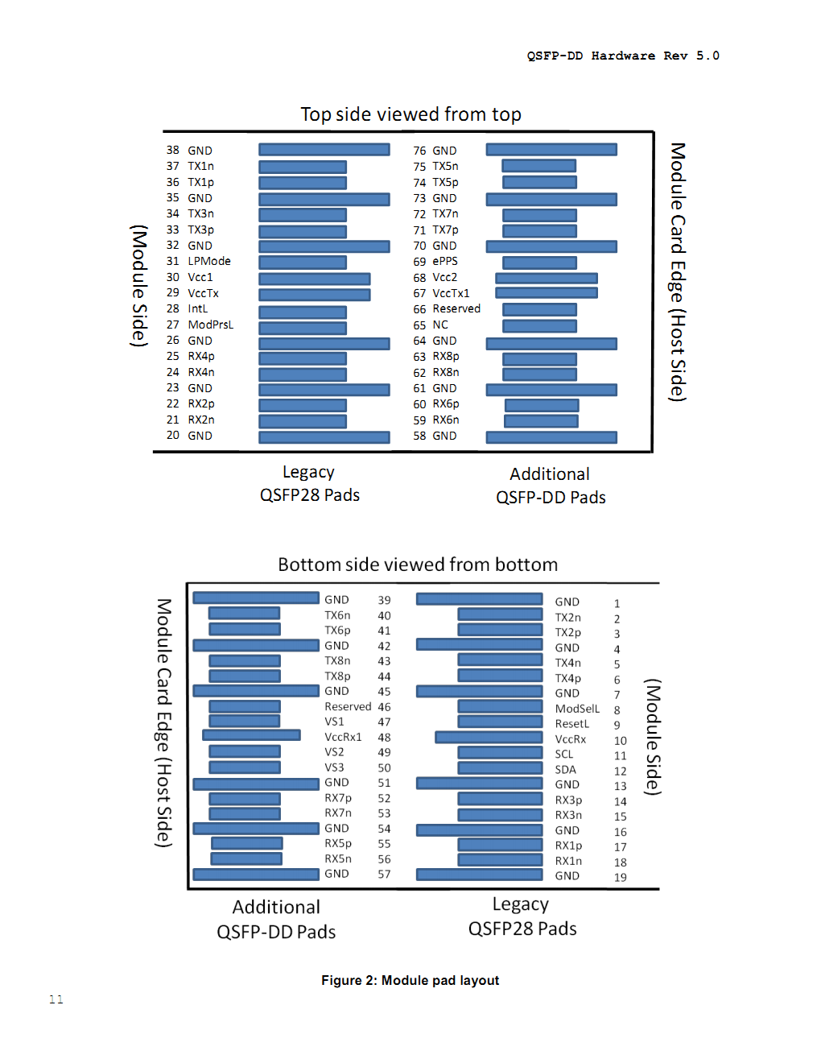
QSFP56 Pin Function Definition
Pin | Logic | Symbol | Description
1 |  | GND | Ground
2 | CML-I | Tx2n | Transmitter Inverted Data Input
3 | CML-I | Tx2p | Transmitter Non-Inverted Data Input
4 |  | GND | Ground
5 | CML-I | Tx4n | Transmitter Inverted Data Input
6 | CML-I | Tx4p | Transmitter Non-Inverted Data Input
7 |  | GND | Ground
8 | LVTTL-I | ModSelL | Module Select
9 | LVTTL-I | ResetL | Module Reset
10 |  | Vcc Rx | +3.3V Power Supply Receiver
11 | LVCMOS- I/O | SCL | 2-wire serial interface clock
12 | LVCMOS- I/O | SDA | 2-wire serial interface data
13 |  | GND | Ground
14 | CML-O | Rx3p | Receiver Non-Inverted Data Output
15 | CML-O | Rx3n | Receiver Inverted Data Output
16 |  | GND | Ground
17 | CML-O | Rx1p | Receiver Non-Inverted Data Output
18 | CML-O | Rx1n | Receiver Inverted Data Output
19 |  | GND | Ground
20 |  | GND | Ground
21 | CML-O | Rx2n | Receiver Inverted Data Output
22 | CML-O | Rx2p | Receiver Non-Inverted Data Output
23 |  | GND | Ground
24 | CML-O | Rx4n | Receiver Inverted Data Output
25 | CML-O | Rx4p | Receiver Non-Inverted Data Output
26 |  | GND | Ground
27 | LVTTL-O | ModPrsL | Module Present
28 | LVTTL-O | IntL | Interrupt
29 |  | Vcc Tx | +3.3V Power supply transmitter
30 |  | Vcc1 | +3.3V Power supply
31 | LVTTL-I | LPMode | Low Power Mode
32 |  | GND | Ground
33 | CML-I | Tx3p | Transmitter Non-Inverted Data Input
34 | CML-I | Tx3n | Transmitter Inverted Data Input
35 |  | GND | Ground
36 | CML-I | Tx1p | Transmitter Non-Inverted Data Input
37 | CML-I | Tx1n | Transmitter Inverted Data Input
38 |  | GND | Ground

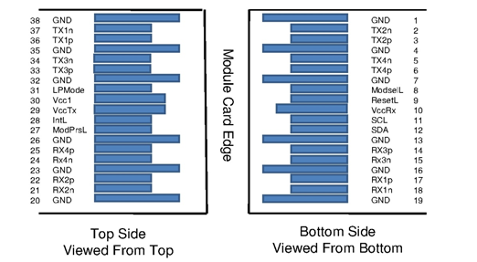

Mechanical Specifications
The connector is compatible with the QSFP-DD and SFF-8436 specification.

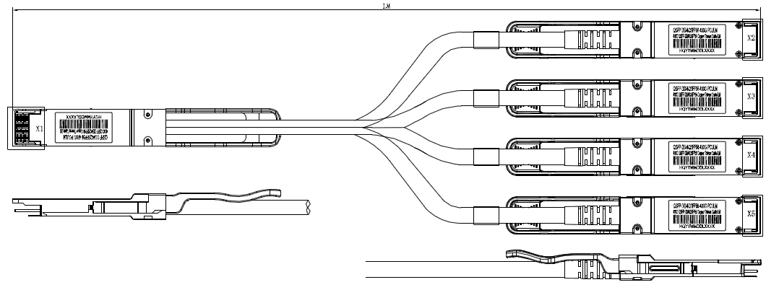

Length (m) | Cable AWG
0~1.5 | 30
2~2.5 | 28

Regulatory Compliance

Feature | Test Method | Performance
Electrostatic Discharge (ESD) to the Electrical Pins | MIL-STD-883C Method 3015.7 | Class 1(>2000 Volts)
Electromagnetic Interference(EMI) | FCC Class B | Compliant with Standards
Electromagnetic Interference(EMI) | CENELEC EN55022 Class B | Compliant with Standards
Electromagnetic Interference(EMI) | CISPR22 ITE Class B | Compliant with Standards
RF Immunity(RFI) | IEC61000-4-3 | Typically Show no Measurable Effect from a 10V/m Field Swept from 80 to 1000MHz
RoHS Compliance | RoHS Directive 2011/65/EU and it's Amendment Directives （EU） 2015/863 | RoHS （EU）2015/863 compliant
REACH Compliance | REACH Regulation (EC) No 1907/2006 | REACH (EC) No 1907/2006 compliant

Contact:
Wuhan Jiuhong Optics Technology Co., Ltd.
TEL: 86-13476016116
E-mail：grace@jh-optics.com
Web：www.jh-optics.com
Address：
Building 1, 4th Floor, Yunqi Free Trade Innovation Port, Donghu Comprehensive Bonded Zone,Donghu High-tech Zone, Wuhan City

