400G QSFP-DD Direct Attach Cable - PAM4 Datasheet

General Description
QSFP-DD passive copper cable assembly feature eight differential copper pairs,providing four data transmission channels at speeds up to 56Gbps(PAM4) per channel,and meets 400G Ethernet and InfiniBand Enhanced Data Rate(EDR) requirements.Available in a broad rang of wire gages-from 28AWG through 30AWG-this 400G copper cable assembly features low insertion loss and low cross talk.
QSFP-DD uses PAM4 signals for transmission, which doubles the rate. However, there are more stringent requirements for cable insertion loss. For detailed requirements, please see High Speed Characteristics.

Features and Benefits
l Compatible with IEEE 802.3bj and IEEE 802.3cd
l Supports aggregate data rates of 400Gbps(PAM4)
l Optimized construction to minimize insertion loss and cross talk
l Pull-to-release slide latch design
l 28AWG through 30AWG cable
l Straight and break out assembly configurations available
l Customized cable braid termination limits EMI radiation
l Customizable EEPROM mapping for cable signature
l RoHS omplia

Product Applications
l Switches,servers and routers
l Data Center networks
l Storage area networks
l High performance computing
l Telecommunication and wireless infrastructure
l Medical diagnostics and networking
l Test and measurement equipment

Industry Standards
l 400G Ethernet(IEEE 802.3cd)
l InfiniBand EDR

High Speed Characteristics

Parameter | Symbol | Min | Typical | Max | Unit | Note
Differential Impedance | TDR | 90 | 100 | 110 | Ώ
Insertion loss | SDD21 | -16.06 |  |  | dB | At 13.28 GHz
Differential Return Loss | SDD11  SDD22 |  |  | See 1 | dB | At 0.05 to 4.1 GHz
Differential Return Loss | SDD11  SDD22 |  |  | See 2 | dB | At 4.1 to 19 GHz
Common-mode to common-mode output return loss | SCC11  SCC22 |  |  | -2 | dB | At 0.2 to 19 GHz
Differential to common-mode  return loss | SCD11  SCD22 |  |  | See 3 | dB | At 0.01 to 12.89 GHz
Differential to common-mode  return loss | SCD11  SCD22 |  |  | See 4 | dB | At 12.89 to 19 GHz
Differential to common Mode Conversion Loss | SCD21-IL |  |  | -10 | dB | At 0.01 to 12.89 GHz
Differential to common Mode Conversion Loss | SCD21-IL |  |  | See 5 | dB | At 12.89 to 15.7 GHz
Differential to common Mode Conversion Loss | SCD21-IL |  |  | -6.3 | dB | At 15.7 to 19 GHz
Notes:
1. Reflection Coefficient given by equation SDD11(dB) < -16.5 + 2 × SQRT(f ), with f in GHz
2. Reflection Coefficient given by equation SDD11(dB) < -10.66 + 14 × log10(f/5.5), with f in GHz
3. Reflection Coefficient given by equation SCD11(dB) < -22 + (20/25.78)*f, with f in GHz
4. Reflection Coefficient given by equation SCD11(dB) < -15 + (6/25.78)*f, with f in GHz
5. Reflection Coefficient given by equation SCD21(dB) < -27 + (29/22)*f, with f in GHz

Pin Descriptions
QSFP-DD Pin Function Definition

Pin | Logic | Symbol | Description
1 |  | GND | Ground
2 | CML-I | Tx2n | Transmitter Inverted Data Input
3 | CML-I | Tx2p | Transmitter Non-Inverted Data Input
4 |  | GND | Ground
5 | CML-I | Tx4n | Transmitter Inverted Data Input
6 | CML-I | Tx4p | Transmitter Non-Inverted Data Input
7 |  | GND | Ground
8 | LVTTL-I | ModSelL | Module Select
9 | LVTTL-I | ResetL | Module Reset
10 |  | Vcc Rx | +3.3V Power Supply Receiver
11 | LVCMOS- | SCL | 2-wire serial interface clock
11 | I/O | SCL | 2-wire serial interface clock

12 | LVCMOS- | SDA | 2-wire serial interface data
12 | I/O | SDA | 2-wire serial interface data
13 |  | GND | Ground
14 | CML-O | Rx3p | Receiver Non-Inverted Data Output
15 | CML-O | Rx3n | Receiver Inverted Data Output
16 |  | GND | Ground
17 | CML-O | Rx1p | Receiver Non-Inverted Data Output
18 | CML-O | Rx1n | Receiver Inverted Data Output
19 |  | GND | Ground
20 |  | GND | Ground
21 | CML-O | Rx2n | Receiver Inverted Data Output
22 | CML-O | Rx2p | Receiver Non-Inverted Data Output
23 |  | GND | Ground
24 | CML-O | Rx4n | Receiver Inverted Data Output
25 | CML-O | Rx4p | Receiver Non-Inverted Data Output
26 |  | GND | Ground
27 | LVTTL-O | Mod PrsL | Module Present
28 | LVTTL-O | IntL | Interrupt
29 |  | Vcc Tx | +3.3V Power supply transmitter
30 |  | Vcc1 | +3.3V Power supply
31 | LVTTL-I | LPMode | Low Power Mode
32 |  | GND | Ground
33 | CML-I | Tx3p | Transmitter Non-Inverted Data Input
34 | CML-I | Tx3n | Transmitter Inverted Data Input
35 |  | GND | Ground
36 | CML-I | Tx1p | Transmitter Non-Inverted Data Input
37 | CML-I | Tx1n | Transmitter Inverted Data Input
38 |  | GND | Ground
39 |  | GND | Ground
40 | CML-I | Tx6n | Transmitter Inverted Data Input
41 | CML-I | Tx6p | Transmitter Non-Inverted Data Input
42 |  | GND | Ground
43 | CML-I | Tx8n | Transmitter Inverted Data Input
44 | CML-I | Tx8p | Transmitter Non-Inverted Data Input
45 |  | GND | Ground
46 |  | Reserved
47 |  | VS1
48 |  | VccRx1 | +3.3V Power supply
49 |  | VS2
50 |  | VS3
51 |  | GND | Ground
52 | CML-O | Rx7p | Receiver Non-Inverted Data Output
53 | CML-O | Rx7n | Receiver Inverted Data Output
54 |  | GND | Ground
55 | CML-O | Rx5p | Receiver Non-Inverted Data Output
56 | CML-O | Rx5n | Receiver Inverted Data Output
57 |  | GND | Ground
58 |  | GND | Ground
59 | CML-O | Rx6n | Receiver Inverted Data Output
60 | CML-O | Rx6p | Receiver Non-Inverted Data Output
61 |  | GND | Ground

62 | CML-O | Rx8n | Receiver Inverted Data Output
63 | CML-O | Rx8p | Receiver Non-Inverted Data Output
64 |  | GND | Ground
65 |  | NC
66 |  | Reserved
67 |  | VccTx1 | +3.3V Power supply
68 |  | VCC2 | +3.3V Power supply
69 |  | Reserved
70 |  | GND | Ground
71 | CML-I | Tx7p | Transmitter Non-Inverted Data Input
72 | CML-I | Tx7n | Transmitter Inverted Data Input
73 |  | GND | Ground
74 | CML-I | Tx5p | Transmitter Non-Inverted Data Input
75 | CML-I | Tx5n | Transmitter Inverted Data Input
76 |  | GND | Ground
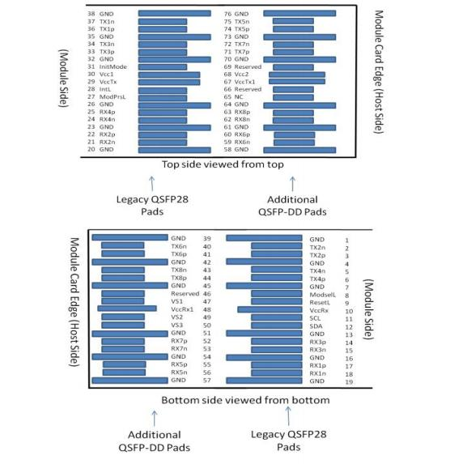

Mechanical Specifications
The connector is compatible with the QSFP-DD specification.
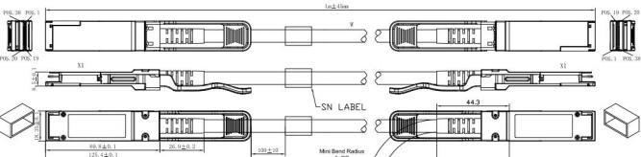

Length (m) | Cable AWG
1 | 30
2 | 28
3 | 28

Regulatory Compliance

Feature | Test Method | Performance
Electrostatic Discharge  (ESD) to the Electrical Pins | MIL-STD-883C Method 3015.7 | Class 1(>2000 Volts)
Electromagnetic Interference(EMI) | FCC Class B | Compliant with Standards
Electromagnetic Interference(EMI) | CENELEC EN55022 Class B | Compliant with Standards
Electromagnetic Interference(EMI) | CISPR22 ITE Class B | Compliant with Standards
RF Immunity(RFI) | IEC61000-4-3 | Typically Show no  Measurable Effect from a  10V/m Field Swept from 80 to 1000MHz
RoHS Compliance | RoHS Directive 2011/65/EU and it's Amendment Directives （EU）  2015/863 | RoHS （EU）2015/863 compliant
REACH Compliance | REACH Regulation (EC) No 1907/2006 | REACH (EC) No 1907/2006 compliant

Contact Information:

Wuhan Jiuhong Optics Technology Co., Ltd.
TEL: 86-13476016116
E-mail：grace@jh-optics.com
Web：www.jh-optics.com
Address：
Building 1, 4th Floor, Yunqi Free Trade Innovation Port, Donghu Comprehensive Bonded Zone,Donghu High-tech Zone, Wuhan City

