400G OSFP Direct Attach Cable (DAC) Passive

Product Specification

Features

- Compliant to IEEE802.3ck&802.3cd
- Data rates : 112-PAM4（400G CR4） or 56G-PAM4(400G CR8）
- Maximum aggregate data rate: 400Gb/s (8 x 50Gb/s or 4X100Gb/s)
- I/O Connector designed for high speed differential signal applications
- Compliant with OSFP Octal Small Form Factor Pluggable- OSFP MSA
- Low Power Consumption < 0.5W
- Wire AWG : 30 / 28 / 26
- Length = 1- 3 meters
- EEPROM signature can be customized
- RoHS compliant

Applications

- Storage, Switch, & RAID Systems
- High-Performance Computing (HPC)
- Network Interface Cards (NIC's)
- Infniband NDR&HDR data rate
- Telecommunication equipment
- Data center and enterprise storage systems

Part Number Ordering Information

Part No. | Bit Rate (Gbps) | Distance | AWG | Temp^{note1}
JH-400G-OSFP-D1-DAC | 400Gbps | 1m | 30，28，26AWG | 0℃~+70℃
Note: 1 Case Temperature

General Specifications

Parameter | Value
Type | Passive / Copper
End | End A =OSFP 8X (OSFP MSA)
End | End B =OSFP 8X (OSFP MSA)
Bend Radius | 5X OD (Compliant to SFF 8417)
Differential signal rate | Tx and Rx each 56G-PAM4 X8 pair
Impedance | 100 Ohms differential, AC-coupled I/O
Voltage | 30 Volts AC (RMS)/DC Max.
Current | 0.5 Amps Max
Temperature | Operating: 0°C to 70°C
Temperature | Storage:-20°C to +80°C
Durability | Contact Pad Plating:0.76μm Au  Module Cycles -50 cycles  Connector/Cage:Cycles:100 cycles

Performance Test

Electrical Connector Performance Test

Test | Test Procedure | Condition | Requirement
EIA-364-23  Low Level Contact Resistance | Apply a maximum voltage of 20 mV and a current of 100mA | Mated | <10 mΩ, △ max from initial
EIA-364-09  Durability (precondition) | Perform plug & unplug cycles: 50 times |  | No evidence of physical damage
EIA-364-17  Temperature Life | method A, Test Condition 3 a105°±2°C :( 120 hours) | Mate | Conditioning Exposure
Reseating | Manually unplug & plug the connector, 3 cycles |  | No evidence of physical damage
EIA 364-32;  Thermal Shock | Method A, test condition I Cycle connectors 10 times between 15°±3°C at 80% RH and 85°±3°C at  50% RH.  Ramp should be a minimum of 2°C per minute and dwell times should insure that the contacts reach the extreme  temperature for a minimum of 5 minutes | Mated | None
EIA-364-31  Cyclic Temperature & Humidity | Cycle connector between 25°±3°C at 80% RH and 65°±3°C at 50% RH  24 cycles.  Ramp times should be 0.5 hour and dwell should be 1.0 hour | Mated | None
EIA-364-28 Mechanical Vibration | Test Condition VII Test Condition letter D 15 minutes in each of 3 mutually perpendicular directions.  Both mating halves rigidly fixed to not contribute to relative motion of  one contact against another. | Mated | Discontinuity  <1μsec No evidence of physical damage
EIA-364-27 Mechanical Shock | Test Condition letter A  3 shocks in each axis(18)  Both mating halves rigidly fixed to not contribute to relative motion of one contact against another. | Mated | Discontinuity  <1μsec No evidence of  physical damage
EIA-364-65  Mixed Flowing Gas  (Mated) | Class IIA :14 days | See Note | None
Thermal Disturbance | Cycle connectors 10 times between  15°±3°C at 80% RH and 85°±3°C at  50% RH.  Ramp should be a minimum of 2°C per minute and dwell times should insure that the contacts reach the temperature extremes for a minimum  of 5 minutes | Mated | None
EIA-364-20  Dielectric Withstanding voltage | Apply a voltage of 500 VDC for 1 minute between adjacent terminals and between adjacent terminals and  ground | Mated | No disruptive discharge No leakage  current in excess  of 5mA
Note:
- For PL1, expose ¹/₂ of the specimens unmated for 224 hours of the test duration. Mate the specimen to the same one used during preconditioning temperature life. Expose for the duration of the test (112 hours).
- For PL2, expose¹/₂of the specimens unmated for 5 days, mate & un-mate all Specimens 1 time, measure LLCR on all specimens. Expose same¹/₂of specimens unmated for 5 days, mate & un-mate all specimens 1 time, measure LLCR on all Specimens. Expose all specimens mated for 5 days, mate & un-mate all specimens 1 time, measure LLCR on all specimens. Expose all specimens mated for 5 days, mate & un-mate all specimens 1 time.
Characterize porosity & plating thickness before test sequence.

General requirements
Test | Parameter | Requirement
Connection testing (Capacitance measurement) | CTXy-RXy (300µs @ 3V) | 100nF ± 10%
Short circuit testing | RXXy-XXy (500µs @ 25V DC) | ≥ 1MΩ

Mechanical Test 1

Test | Test Procedure | Condition | Requirement
Temperature Rise  (via current cycling) | Measure the temperature rise at the rated current after 96 hours.  (45 minutes ON and 15 minutes OFF).  Fixture as required. | Mated | Temperature Rise:  +30°C maximum
Module Mate Forces (Module only) | Mate connector at a rate of 12.7 mm per minute | Mated | 40N MAX  Mating force
Module  Un-mate Forces  (Module only) | Un-Mate connector at a rate of 12.7  mm per minute | Un-Mated | 30N MAX  Unmating force
Module Retention | Apply force of 125N to the cable module Axial Load with latch enabled | Mated | 125N MIN  No damage
Cage Retention (Latch Strength) | Measure force necessary to remove OSFP Module from cage assembly with latch enabled | Mated | 125N MIN  No damage
Cage Press-fit Insertion Force | Axial load on top of Cage |  | 550N  MAXIMUN  Insertion force
Cage Press-fit  Retention Force | Axial load on all exposed Press-fit tails simultaneously |  | 114N  MINIMUM  Retention force
Cable Latitudinal Force | Apply force of 75N to the cable module parallel to the test board and perpendicular to the cage in either  direction for 10 minutes | Mated | No discontinuities of 1μsec or longer  duration
Cable Longitudinal Force | Apply force of 75N to the cable module perpendicular to the test board and downward for 10 minutes | Mated | No discontinuities of 1μsec or longer  duration

Mechanical Test 2

Test | Test Procedure | Condition | Requirement
Differential Impedance | EIA-364-108  Rise time of 70 ps (20 % - 80 %) | Mated | 100Ω+/-10Ω
Cable Minimum bend Radius | EIA-364-41  1Cycle in each of 4 Perpendicular directions |  | No physical damage
Wire Flex | EIA-368-41E  Flex cable 180° for 15 cycles 2.5 inch. from back of shell to top of  roller | Mated | Discontinuity  <1μsec No physical  damage
Cable Strain Relief | 25 mm/min ,90N min. | Mated | No physical damage
Solderability | Per SMES-152 | Mated | Solder coverage  95% minimum
SMT Process compatibility |  | - | Dimensional: Conformance to sales Drawing Requirements Visual:  No Damage

Signal Integrity Requirements Test (Connector ONLY)

Test | Test Procedure | Requirement
Differential Impedance (Connector Area) | EIA 364-108  Rise time: 25ps (20-80%) Includes Host Board  Interface, Connector and Edge Card  Interface | For Reference Only  90-110 Ohms (Distribution)
Near End Isolation | EIA 364-90  60 MHz to 16 GHz | -40 dB Min. at 6GHz  -30 dB Min. at 6~16GHz (Frequencies up to 16 GHz)
Differential Insertion Loss | EIA 364-101  50 MHz to 16 GHz | -1.0 dB Max. at 6GHz  -2.5 dB Max. at 6~8GHz  -6 dB Max. at 8~16GHz (Frequencies up to 16 GHz)
Differential Return Loss | EIA 364-108  10 MHz to 16 GHz | -12 dB Min. at 4GHz  -5 dB Min. at 4~16GHz (Frequencies up to 16 GHz)

Signal Integrity Requirements (Connector& Cable systems)

Test | Condition | Requirement
Return Loss (SDD22) | Measured from 10 MHz <f < 19 GHz | Following SPEC  Equation
Insertion Loss  (SDD21) | Measured from 10 MHz <f < 19 GHz | Max: 17.16 dB  @13.28GHz
Differential to common-mode  return loss (SCD22) | Measured from 10 MHz <f < 19 GHz | Following SPEC Equation
Differential to common-mode conversion loss  (SCD21) | Measured from 10 MHz <f < 19 GHz | Following SPEC Equation
Common-mode to common-mode  return loss (SCC22) | Measured from 10 MHz <f < 19 GHz | Following SPEC Equation
SCD21-SDDD21 | Measured from 10 MHz <f < 19 GHz | Following SPEC  Equation
Channel  Operating Margin | COM = THRU+4NEXT+3FEXT | Min: 3 dB

Temperature - (Connector only )

Parameter | Value
Average Ramp Rate | 3°C/sec Max
Preheat Temperature | 150°C Min to 200°C Max
Preheat Time | 60 to 180 sec
Ramp to Peak | 3°C/sec Max
Time over Liquid as(217℃) | 60 to 150 sec
Peak Temperature | 250+0/-5°C
Time within 5℃ of Peak | 20 to 40 sec
Ramp-Cool Down | 6°C/sec Max
Time 25℃ to Peak | 7min Max

Pin Descriptions

Pin # | Symbol | Description | Logic | Direction | Plug Sequence
1 | GND |  | Ground |  | 1
2 | TX2p | Transmitter Data Non-Inverted | CML-I | Input from Host | 3
3 | TX2n | Transmitter Data Inverted | CML-I | Input from Host | 3
4 | GND |  | Ground |  | 1
5 | TX4p | Transmitter Data Non-Inverted | CML-I | Input from Host | 3
6 | TX4n | Transmitter Data Inverted | CML-I | Input from Host | 3
7 | GND |  | Ground |  | 1
8 | TX6p | Transmitter Data Non-Inverted | CML-I | Input from Host | 3
9 | TX6n | Transmitter Data Inverted | CML-I | Input from Host | 3
10 | GND |  | Ground |  | 1
11 | TX8p | Transmitter Data Non-Inverted | CML-I | Input from Host | 3
12 | TX8n | Transmitter Data Inverted | CML-I | Input from Host | 3
13 | GND |  | Ground |  | 1
14 | SCL | 2-wire Serial interface clock | LVCMOS-I/O | Bi-directional | 3
15 | VCC | +3.3V Power |  | Power from Host | 2
16 | VCC | +3.3V Power |  | Power from Host | 2
17 | LPWn/PRSn | Low-Power Mode / Module Present | Multi-Level | Bi-directional | 3
18 | GND |  | Ground |  | 1
19 | RX7n | Receiver Data Inverted | CML-O | Output to Host | 3
20 | RX7p | Receiver Data Non-Inverted | CML-O | Output to Host | 3
21 | GND |  | Ground |  | 1
22 | RX5n | Receiver Data Inverted | CML-O | Output to Host | 3
23 | RX5p | Receiver Data Non-Inverted | CML-O | Output to Host | 3
24 | GND |  | Ground |  | 1
25 | RX3n | Receiver Data Inverted | CML-O | Output to Host | 3
26 | RX3p | Receiver Data Non-Inverted | CML-O | Output to Host | 3
27 | GND |  | Ground |  | 1
28 | RX1n | Receiver Data Inverted | CML-O | Output to Host | 3
29 | RX1p | Receiver Data Non-Inverted | CML-O | Output to Host | 3
30 | GND |  | Ground |  | 1
31 | GND |  | Ground |  | 1
32 | RX2p | Receiver Data Non-Inverted | CML-O | Output to Host | 3
33 | RX2n | Receiver Data Inverted | CML-O | Output to Host | 3
34 | GND |  | Ground |  | 1
35 | RX4p | Receiver Data Non-Inverted | CML-O | Output to Host | 3
36 | RX4n | Receiver Data Inverted | CML-O | Output to Host | 3
37 | GND |  | Ground |  | 1
38 | RX6p | Receiver Data Non-Inverted | CML-O | Output to Host | 3

Pin # | Symbol | Description | Logic | Direction | Plug  Sequence
39 | RX6n | Receiver Data Inverted | CML-O | Output to Host | 3
40 | GND |  | Ground |  | 1
41 | RX8p | Receiver Data Non-Inverted | CML-O | Output to Host | 3
42 | RX8n | Receiver Data Inverted | CML-O | Output to Host | 3
43 | GND |  | Ground |  | 1
44 | INT/RSTn | Module Interrupt / Module Reset | Multi-Level | Bi-directional | 3
45 | VCC | +3.3V Power |  | Power from Host | 2
46 | VCC | +3.3V Power |  | Power from Host | 2
47 | SDA | 2-wire Serial interface data | LVCMOS-I/O | Bi-directional | 3
48 | GND |  | Ground |  | 1
49 | TX7n | Transmitter Data Inverted | CML-I | Input from Host | 3
50 | TX7p | Transmitter Data Non-Inverted | CML-I | Input from Host | 3
51 | GND |  | Ground |  | 1
52 | TX5n | Transmitter Data Inverted | CML-I | Input from Host | 3
53 | TX5p | Transmitter Data Non-Inverted | CML-I | Input from Host | 3
54 | GND |  | Ground |  | 1
55 | TX3n | Transmitter Data Inverted | CML-I | Input from Host | 3
56 | TX3p | Transmitter Data Non-Inverted | CML-I | Input from Host | 3
57 | GND |  | Ground |  | 1
58 | TX1n | Transmitter Data Inverted | CML-I | Input from Host | 3
59 | TX1p | Transmitter Data Non-Inverted | CML-I | Input from Host | 3
60 | GND |  | Ground |  | 1

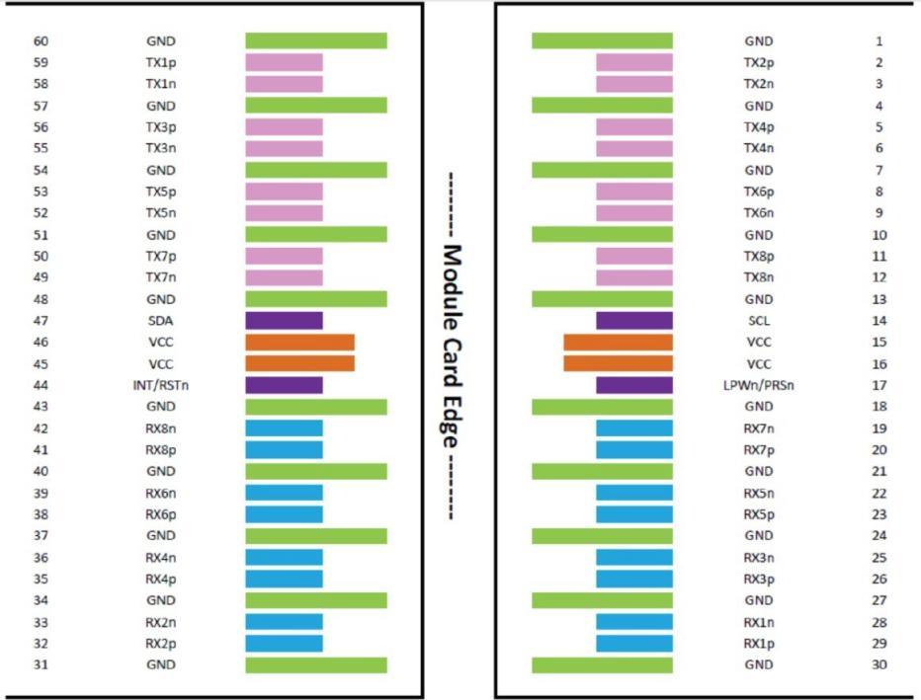
Electrical Pin-out Assignment

Contact:

Wuhan Jiuhong Optics Technology Co., Ltd.
TEL: 86-13476016116
E-mail：grace@jh-optics.com
Web：www.jh-optics.com
Address：
Building 1, 4th Floor, Yunqi Free Trade Innovation Port, Donghu Comprehensive Bonded Zone,Donghu High-tech Zone, Wuhan City

