10GBASE-T Copper SFP+ Transceiver
SFP+-10G-T-RM-Y

Rate Matching mode
1. PRODUCT FEATURES
- Support 10Gbase-T / 5Gbase-T / 2.5Gbase-T / 1000base-T on line port
- Support 10Gbase-R on the host port
- Hot-pluggable SFP footprint
- Compact RJ-45 connector assembly
- RoHS compliant and lead-free
- Single +3.3V power supply
- 10 Gigabit Ethernet over Cat 6a cable
- Ambient Operating temperature:0°C to +70°C
2. PRODUCT DESCRIPTION
SFP+-10G-T-RM Copper Small Form Pluggable (SFP) transceivers are based on the SFP Multi Source Agreement (MSA) . They are compatible with the 10Gbase-T / 5Gbase-T / 2.5Gbase-T / 1000base-T standards as specified in IEEE Std 802.3 . SFP+-10GBASE-T uses the SFP's RX_LOS (must be pulled up on the host) pin for link indication. If you pull up or open the SFP's TX_DISABLE pin, the PHY IC is reset.
3. Cable Length
Line Port | Cable | Reach | Host Port
10Gbase-T | Cat 6a F/FTP | 80m | 10GBase-R
5Gbase-T | CAT5E | 100m | 10GBase-R
2.5Gbase-T | CAT5E | 100m | 10GBase-R
1000base-T | CAT5E | 100m | 10GBase-R
100BASE-Tx | CAT5E | 100m | 10GBase-R

4. SFP to Host Connector Pin Out
Pin | Symbol | Name/Description | Ref.
1 | VEET | Transmitter Ground (Common with Receiver Ground)
2 | TFAULT | Transmitter Fault. Not supported.
3 | TDIS | Transmitter Disable. Laser output is disabled on high or open. | 1
4 | MOD_DEF(2) | Module Definition 2. Data line for Serial ID. | 2
5 | MOD_DEF(1) | Module Definition 1. Clock line for Serial ID. | 2
6 | MOD_DEF(0) | Module Definition 0. Grounded within the module. | 2
7 | RS0 | No connection required
8 | LOS | High indicates no link. Low indicates linked.
9 | RS1 | No connection required
10 | VEER | Receiver Ground (Common with Transmitter Ground)
11 | VEER | Receiver Ground (Common with Transmitter Ground)
12 | RD- | Receiver Inverted DATA out. AC Coupled
13 | RD+ | Receiver Non-inverted DATA out. AC Coupled
14 | VEER | Receiver Ground (Common with Transmitter Ground)
15 | VCCR | Receiver Power Supply
16 | VCCT | Transmitter Power Supply
17 | VEET | Transmitter Ground (Common with Receiver Ground)
18 | TD+ | Transmitter Non-Inverted DATA in. AC Coupled.
19 | TD- | Transmitter Inverted DATA in. AC Coupled.
20 | VEET | Transmitter Ground (Common with Receiver Ground)
Notes:
1. PHY disabled on TDIS > 2.0V or open, enabled on TDIS < 0.8V
2. Should be pulled up with 4.7 k–10 k Ohms on the host board to a voltage between 2.0 V and 3.6 V. MOD_DEF(0) pulls the line low to indicate the module is plugged in.
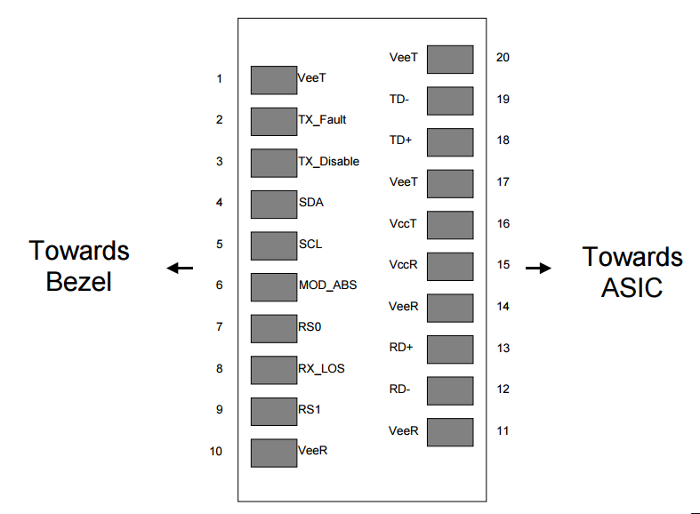
Figure 1. Diagram of host board connector block pin numbers and names
5. +3.3V Volt Electrical Power Interface
The SFP+-10G-T has an input voltage range of 3.3 V +/- 5%. The 4V maximum voltage is not allowed for continuous operation.
+3.3 Volt Electrical Power Interface
Parameter | Symbol | Min | Typ | Max | unit | Notes/Conditions
Supply Current | Is |  | 570 | 600 | mA | 10G speed 80m transmission
Input Voltage | Vcc | 3.13 | 3.3 | 3.47 | V | Referenced to GND
Maximum Voltage | Vmax |  |  | 4 | V
6. Low-Speed Signals
MOD_DEF(1) (SCL) and MOD_DEF(2) (SDA) are open-drain CMOS signals (see section VII, "Serial Communication Protocol"). Both MOD_DEF(1) and MOD_DEF(2) must be pulled up to host_Vcc

Low-Speed Signals, Electronic Characteristics
Parameter | Symbol | Min | Max | unit | Notes/Conditions
SFP Output LOW | VOL | 0 | 0.5 | V | 4.7k to 10k pull-up to host_Vcc,  measured at the host side of the connector
SFP Output HIGH | VOH | host_Vcc -0.5 | host_Vcc + 0.3 | V | 4.7k to 10k pull-up to host_Vcc,  measured at the host side of the connector
SFP Input LOW | VIL | 0 | 0.8 | V | 4.7k to 10k pull-up to Vcc,  measured at the SFP side of the connector
SFP Input HIGH | VIH | 2 | Vcc + 0.3 | V | 4.7k to 10k pull-up to Vcc,  measured at the SFP side of the connector
7. High-Speed Electrical Interface
All high-speed signals are AC-coupled internally.
High-Speed Electrical Interface, Transmission Line-SFP
Parameter | Symbol | Min | Typ | Max | unit | Notes/Conditions
Line Frequency | fL |  | 125 |  | MHz | 5-level encoding, per  IEEE 802.3
Tx Output Impedance | Zout, TX |  | 100 |  | Ohm | Differential, for all  frequencies between  1MHz and 125 MHz
Rx Input Impedance | Zin, RX |  | 100 |  | Ohm | Differential, for all  frequencies between  1MHz and 125 MHz

High-Speed Electrical Interface, Host-SFP
Parameter | Symbol | Min | Typ | Max | unit | Notes/Conditions
Single-ended data input  swing | Vinsing | 250 |  | 1200 | mV | Single-ended
Single-ended data output  swing | Voutsing | 350 |  | 800 | mV | Single ended
Rise/Fall Time | Tr, Tf |  | 175 |  | psec | 20%-80%
Tx Input Impedance | Zin |  | 50 |  | Ohm | Single ended
Rx Output Impedance | Zout |  | 50 |  | Ohm | Single ended
8. General Specifications
General
Parameter | Symbol | Min | Typ | Max | unit | Notes/Conditions
Data Rate | BR | 1 |  | 10 | Gb/sec | IEEE 802.3 compatible.  See Notes 1,2 below
Notes:
- Clock tolerance is +/- 50 ppm
Addr | Field Size  (Bytes) | Name of Field | HEX | Description
0 | 1 | Identifier | 03 | SFP
1 | 1 | Ext. Identifier | 04 | MOD4
2 | 1 | Connector | 07 | LC
3-10 | 8 | Transceiver | 10 00 00 00 40 40 0C 00 | Transmitter Code
11 | 1 | Encoding | 06 | 64B66B
12 | 1 | BR, nominal | 67 | 10300 Mbps
13 | 1 | Reserved | 00
14 | 1 | Length (9 um)-km | 00
15 | 1 | Length (9 μm) | 00
16 | 1 | Length (50 μm) | 08 | 80
17 | 1 | Length (62.5 μm) | 03 | 30
18 | 1 | Length (copper) | 00
19 | 1 | Reserved | 1E | 30
20-35 | 16 | Vendor name | 57 49 4E 54 4F 50 20 20  20 20 20 20 20 20 20 20 | JH
36 | 1 | Reserved | 00
37-39 | 3 | Vendor OUI | 00 00 00
40-55 | 16 | Vendor PN | xx xx xx xx xx xx xx xx  xx xx xx xx xx xx xx xx | ASC II
56-59 | 4 | Vendor Rev | 31 2E 30 20 | V1.0
60-61 | 2 | Wavelength | 03 52 | 850nm
62 | 1 | Reserved | 00
63 | 1 | CC BASE | XX | Check sum of bytes 0~62
64-65 | 2 | Options | 00 1A | LOS, TX_DISABLE, TX_FAULT
66 | 1 | BR, max | 00
67 | 1 | BR, min | 00
68-83 | 16 | Vendor SN | 00 00 00 00 00 00 00 00  00 00 00 00 00 00 00 00 | Unspecified
84-91 | 8 | Vendor date code | XX XX XX 20 | Year, Month, Day
92-94 | 3 | Reserved | XX XX XX
95 | 1 | CC_EXT | XX | Check sum of bytes 64~94
96-255 | 160 | Vendor-specific
9. EEPROM INFORMATION (A0)

10. Environmental Specifications
Automatic crossover detection is enabled. An external crossover cable is not required
Environmental
Specifications
Parameter | Symbol | Min | Typ | Max | unit | Notes/Conditions
Operating Temperature | Top | 0 |  | 70 | °C | Case temperature
Storage temperature | Tsto | -40 |  | 85 | °C | Ambient temperature
11. Serial Communication Protocol
Serial Bus Timing, Requirements
Parameter | Symbol | Min | Typ | Max | unit | Notes/Conditions
I 2C Clock Rate |  | 0 |  | 200,000 | Hz
All JH SFPs support the 2-wire serial communication protocol outlined in the SFP MSA. These SFPs use an MCU and can be accessed with an address of A0h.
12. Recommended Application Circuit
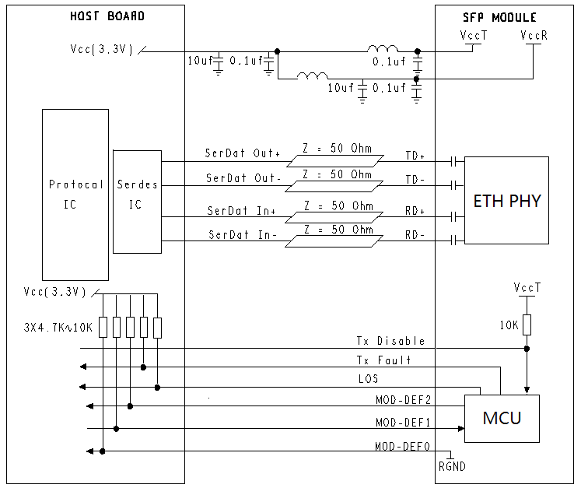

13. Outline Dimensions (mm)
