800G QSFP-DD800 DR8 V1.1

The 800G QSFP-DD800 DR8 Transceiver is
designed to transmit and receive serial optical data links up to 106.25Gps data rate (per channel) by PAM4 modulation format over single-mode fiber. It is a small-form-factor hot pluggable transceiver
module integrated with high performance EML
laser. It is compliant with 800G Ethernet specs and QSFP-DD MSA.

Features Applications

l Up to 106.25Gb ps data rate per channel by PAM4 modulation
l 8 duplex channels transmitters and receivers
l 8 × 100G PAM4 EML lasers
l Single MPO-16 connector receptacle optical interface compliant
l Single +3.3V power supply
l DDM function implemented
l Hot-pluggable QSFP-DD800 form factor
l Maximum link length of 500m on SMF fiber
l Power consumption: <14W
l International class 1 laser safety certified
l Operating temperature range: 0℃ ~ +70℃

l Compliant with RoHS6.0

l 800GBASE-DR8 Ethernet
l Switch & Router Connections
l Data Centers
l Other 800G Interconnect Requirements

Standards
l IEEE Std 802.3cu™-2021
l IEEE Std 802.3ck™-2022
l IEEE Std 802.3df ™-2024
l QSFP-DD MSA 6.3
l CMIS Rev 5.1 or later version

1

Document History

VER.&STATUS | DATE | DESCRIPTION OF CHANGE | Modifier
1.0 | 2023-04-06 | Initial Release | YJQ
1.1 | 2024-07-01 | Optical parameters refer to IEEE Std 802.3df™-2024 | WAQ

Specifications
(Tested under recommended operating conditions, unless otherwise noted)

Parameter | Min | Typ | Max | Unit | Notes
Transmit characteristics
Signaling rate | 53.125  -50ppm | 53.125 | 53.125  +50ppm | GBd
Modulation format | PAM4
Wavelength | 1304.5 |  | 1317.5 | nm
Side-mode suppression ratio(SMSR) | 30 |  |  | dB
Average launch power, each lane | -2.9 |  | 4 | dBm | a,b
Outer Optical Modulation Amplitude (OMAouter), each lane  for TDECQ < 1.4 dB | -0.8 |  | 4.2 | dBm | c
for 1.4 dB < TDECQ < 3.4 dB | –2.2  +TDECQ |  | 4.2 | dBm | c
Transmitter and dispersion eye closure for PAM4(TDECQ) |  |  | 3.4 | dB
Transmitter eye closure for PAM4 (TECQ) |  |  | 3.4 | dB
| TDECQ – TECQ | |  |  | 2.5 | dB
Transmitter overshoot and undershoot |  |  | 22 | %
Transmitter power excursion |  |  | 5 | dBm
Extinction ratio | 3.5 |  |  | dB
Transmitter transition time |  |  | 17 | ps
Average launch power of OFF transmitter |  |  | -15 | dBm
RIN21.4OMA |  |  | -136 | dB/H  z
Optical return loss tolerance |  |  | 21.4 | dB
Transmitter reflectance |  |  | -26 | dB | d
Receive characteristics
Signaling rate | 53.125  -50ppm | 53.125 | 53.125  +50ppm | GBd
Modulation format | PAM4
Wavelength | 1304.5 |  | 1317.5 | nm
Damage threshold | 5 |  |  | dBm | e
Average receive power | -5.9 |  | 4 | dBm | f
Receive power (OMAouter) |  |  | 4.2 | dBm
Receiver reflectance |  |  | -26 | dB

Receiver sensitivity (OMAouter) for TECQ < 1.4 dB |  |  | -3.9 | dBm
for 1.4 dB ≤ TECQ ≤ 3.4 dB |  |  | TECQ-5.3 | dBm
Stressed receiver sensitivity (OMAouter) |  |  | -1.9 | dBm | g
Conditions of stressed receiver sensitivity test: |  |  |  |  | h
Stressed eye closure for PAM4 (SECQ), lane under test | 3.4 |  |  | dB
OMAouter of each aggressor lane | 4.2 |  |  | dBm
Note a. Average launch power, each lane (min) is not the principal indicator of signal strength. A transmitter with launch power below this value cannot be compliant; however, a value above this does not ensure compliance.
Note b. Average launch power of –2.9 dBm corresponds to an OMA of –0.8 dBm with an extinction ratio of approximately 10 dB or an OMA of –0.1 dBm with an extinction ratio of approximately 16 dB.
Note c. For 400GBASE-DR4, the requirement on the OMAouter (min) applies even in the cases where TDECQ < 1.4 dB.
Note d. Transmitter reflectance is defined looking into the transmitter.
Note e. The receiver shall be able to tolerate, without damage, continuous exposure to an optical input signal having this average power level. The receiver does not have to operate correctly at this input power.
Note f. Average receive power, each lane (min) is not the principal indicator of signal strength. A received power below this value cannot be compliant; however, a value above this does not ensure compliance.
Note g. Measured with conformance test signal at TP3 (see IEEE Std 802.3df ™-2024 124.8.10) for the BER specified in IEEE Std 802.3df ™-2024 124.1.1.
Note h. These test conditions are for measuring stressed receiver sensitivity. They are not characteristics of

the receiver.

Ordering Information

Part No. | Specifications |  |  |  |  |  |  |  |  | Application
Part No. | Package | Data  rate | Laser | Optical  Power | Detector | Sensitivity | Temp | Reach | Others | Application
JH-800G-QDD-DR8 | QSFP-DD  800 | 850G | EML | -2.9~4dBm | PD | < -3.9dBm  @2E-4 | 0~70 oC | 500m | RoHS | Ethernet

Absolute Maximum Ratings

Parameter | Symbol | Unit | Min | Max
Storage Temperature | Ts | oC | -40 | +85
Relative Humidity | RH | % | 5 | 85
Power Supply Voltage | Vcc | V | -0.3 | +3.6

Recommended Operating Conditions

Parameter | Symbol | Unit | Min | Typ | Max
Operating Case Temperature | Tc | oC | 0 |  | 70
Power Supply Voltage | Vcc | V | 3.135 | 3.3 | 3.465
Power Consumption | Pc | W |  |  | 14

Optical Interface
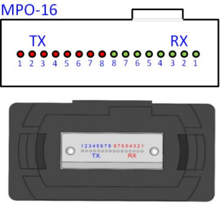
Figure 1 Optical Lane Sequence
Note: Optical interface is 8° APC MPO-16. Lane sequence is shown in Figure 1.

Principle diagram

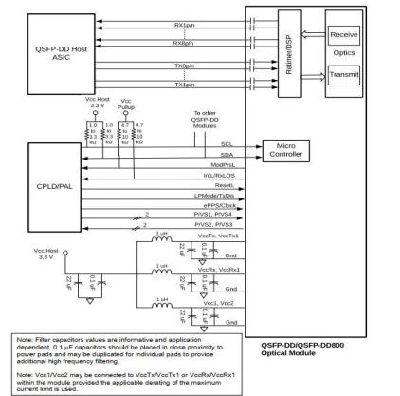
Figure 2 Module Principle Diagram

Electric Ports Definition

Parameter | Min | Typ | Max | Unit | Notes
Supply voltage | 3.135 |  | 3.465 | V
Signaling rate, each lane | 53.125  -100ppm | 53.125 | 53.125  +100ppm | GBd
Module input characteristics
Differential peak-to-peak input voltage tolerance | 750 |  |  | mV | TP1a
Peak-to-peak AC common-mode voltage tolerance  Low-frequency, VCMLF | 32 |  |  | mV | TP1a
Full-band, VCMFB | 80 |  |  | mV | TP1a
Differential-mode to common-mode return loss, RLcd | See IEEE Std 802.3ck™-2022  Equation(120G-2) |  |  | dB | TP1

Parameter | Min | Typ | Max | Unit | Notes
Effective return loss, ERL | 8.5 |  |  | dB | TP1
Differential termination mismatch |  |  | 10 | % | TP1
Module stressed input tolerance | See IEEE Std 802.3ck™-2022 120G.3.4.3 |  |  |  | TP1a
Single-ended voltage tolerance | -0.4 |  | 3.3 | V | TP1a
DC common-mode voltage tolerance | -0.35 |  | 2.85 | V | TP1
Module output characteristics
Peak-to-peak AC common-mode voltage Low-frequency, VCMLF |  |  | 32 | mV | TP4
Full-band, VCMFB |  |  | 80 | mV | TP4
Differential peak-to-peak output voltage Short mode |  |  | 600 | mV | TP4
Long mode |  |  | 845 | mV | TP4
Eye height | 15 |  |  | mV | TP4
Vertical eye closure, VEC |  |  | 12 | dB | TP4
Common-mode to differential-mode return loss, RLdc | See IEEE Std 802.3ck™-2022  Equation(120G-1) |  |  | dB | TP4
Effective return loss, ERL | 8.5 |  |  | dB | TP4
Differential termination mismatch |  |  | 10 | % | TP4
Transition time | 8.5 |  |  | ps | TP4
DC common-mode voltage tolerance | -0.35 |  | 2.85 | V | TP4
IIC communication
IIC Clock frequency | 100 |  | 1000 | kHz
Clock stretching |  |  | 500 | μs
Data In Hold Time | 0 |  |  | μs
Data In Setup Time | 0.1 |  |  | μs

Pin Description
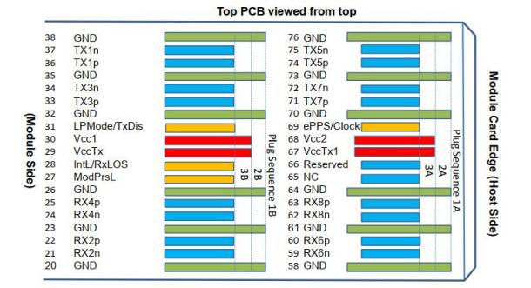
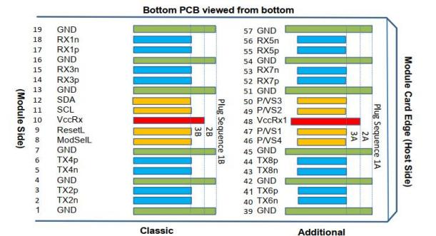
Figure 3 Module pad assignment and layout

Pad | Logic | Symbol | Description | Notes
1 |  | GND | Ground | 1
2 | CML-I | Tx2n | Transmitter Inverted Data Input
3 | CML-I | Tx2p | Transmitter Non-Inverted Data Intput
4 |  | GND | Ground | 1
5 | CML-I | Tx4n | Transmitter Inverted Data Input
6 | CML-I | Tx4p | Transmitter Non-Inverted Data Input
7 |  | GND | Ground | 1
8 | LVTTL-I | ModSelL | Module Select
9 | LVTTL-I | ResetL | Module Reset
10 |  | VccRx | +3.3V Power Supply Receiver | 2
11 | LVCOMS-I/O | SCL | TWI serial interface clock
12 | LVCOMS-I/O | SDA | TWI serial interface data
13 |  | GND | Ground | 1
14 | CML-O | Rx3p | Receiver Non-Inverted Data Output
15 | CML-O | Rx3n | Receiver Inverted Data Output
16 |  | GND | Ground | 1
17 | CML-O | Rx1p | Receiver Non-Inverted Data Output
18 | CML-O | Rx1n | Receiver Inverted Data Output
19 |  | GND | Ground | 1
20 |  | GND | Ground | 1
21 | CML-O | Rx2n | Receiver Inverted Data Output
22 | CML-O | Rx2p | Receiver Non-Inverted Data Output
23 |  | GND | Ground | 1
24 | CML-O | Rx4n | Receiver Inverted Data Output
25 | CML-O | Rx4p | Receiver Non-Inverted Data Output
26 |  | GND | Ground | 1
27 | LVTTL-O | Mod PrsL | Module Present
28 | LVTTL-O | IntL/RxLOS | Interrupt/optional RxLOS
29 |  | VccTx | +3.3V Power supply transmitter | 2
30 |  | Vcc1 | +3.3V Power supply | 2
31 | LVTTL-I | LPMode/TxDis | Low Power mode/optional TX Disable

Pad | Logic | Symbol | Description | Notes
32 |  | GND | Ground | 1
33 | CML-I | Tx3p | Transmitter Non-Inverted Data Input
34 | CML-I | Tx3n | Transmitter Inverted Data Input
35 |  | GND | Ground | 1
36 | CML-I | Tx1p | Transmitter Non-Inverted Data Input
37 | CML-I | Tx1n | Transmitter Inverted Data Input
38 |  | GND | Ground | 1
39 |  | GND | Ground | 1
40 | CML-I | Tx6n | Transmitter Inverted Data Input
41 | CML-I | Tx6p | Transmitter Non-Inverted Data Input
42 |  | GND | Ground | 1
43 | CML-I | Tx8n | Transmitter Inverted Data Input
44 | CML-I | Tx8p | Transmitter Non-Inverted Data Input
45 |  | GND | Ground | 1
46 | LVCMOS/CML-I | P/VS4 | Programmable/Module Vendor Specific 4 | 5
47 | LVCMOS/CML-I | P/VS1 | Programmable/Module Vendor Specific 1 | 5
48 |  | VccRx1 | +3.3V Power Supply | 2
49 | LVCMOS/CML-O | P/VS2 | Programmable/Module Vendor Specific 2 | 5
50 | LVCMOS/CML-O | P/VS3 | Programmable/Module Vendor Specific 3 | 5
51 |  | GND | Ground | 1
52 | CML-O | Rx7p | Receiver Non-Inverted Data Output
53 | CML-O | Rx7n | Receiver Inverted Data Output
54 |  | GND | Ground | 1
55 | CML-O | Rx5p | Receiver Non-Inverted Data Output
56 | CML-O | Rx5n | Receiver Inverted Data Output
57 |  | GND | Ground | 1
58 |  | GND | Ground | 1
59 | CML-O | Rx6n | Receiver Inverted Data Output
60 | CML-O | Rx6p | Receiver Non-Inverted Data Output
61 |  | GND | Ground | 1
62 | CML-O | Rx8n | Receiver Inverted Data Output

Pad | Logic | Symbol | Description | Notes
63 | CML-O | Rx8p | Receiver Non-Inverted Data Output
64 |  | GND | Ground | 1
65 |  | NC | Not Connect | 3
66 |  | Reserved | For future use | 3
67 |  | VccTx1 | +3.3 V Power Supply | 2
68 |  | Vcc2 | +3.3 V Power Supply | 2
69 | LVCMOS-I | ePPS/Clock | 1PPS PTP clock or reference clock input | 6
70 |  | GND | Ground | 1
71 | CML-I | Tx7p | Transmitter Non-Inverted Data Input
72 | CML-I | Tx7n | Transmitter Inverted Data Input
73 |  | GND | Ground | 1
74 | CML-I | Tx5p | Transmitter Non-Inverted Data Input
75 | CML-I | Tx5n | Transmitter Inverted Data Input
76 |  | GND | Ground | 1
Note 1: QSFP-DD uses common ground (GND) for all signals and supply (power). All are common within the QSFP-DD module and all module voltages are referenced to this potential unless otherwise noted. Connect these directly to the host board signal-common ground plane. Each connector Gnd contact is rated for a steady state current of 500mA.
Note 2: VccRx, VccRx1, Vcc1, Vcc2, VccTx and VccTx1 shall be applied concurrently. Supply requirements defined for the host side of the Host Card Edge Connector are listed in QSFP-DD MSA Specification Table 13. For power classes 4 and above the module differential loading of input voltage pads must not result in exceeding contact current limits. Each connector Vcc contact is rated for a steady state current of 1500mA.
Note 3: Reserved pad recommended to be terminated with 10kΩ to ground on the host. Pad 65 (No Connect) Shall be left unconnected within the module, optionally pad 65 may get terminated with 10kΩ to ground on the host.
Note 4: Plug Sequence specifies the mating sequence of the host connector and module. The sequence is 1A, 2A, 3A, 1B, 2B, 3B. (see Figure 3 for pad locations) Contact sequence A will make, then break contact with additional QSFP-DD pads. Sequence 1A and 1B will then occur simultaneously, followed by 2A and 2B, followed by 3A and 3B.
Note 5: Full definitions of the P/VSx signals currently under development. For module designs using
programmable/vendor specific inputs P/VS1 and P/VS4 signals it is recommended each to be terminated in the module with 10kΩ . For host designs using programmable/vendor specific outputs P/VS2 and P/VS3 signals it is recommended each to be terminated on the host with 10kΩ .
Note 6: For host not implementing ePPS/Clock, it is not necessary to parallel terminate the ePPS/Clock signal to ground on the host. ePPS/Clock already has parallel termination in the module see QSFP-DD MSA Specification clause 4.2.6.

Module Memory Map

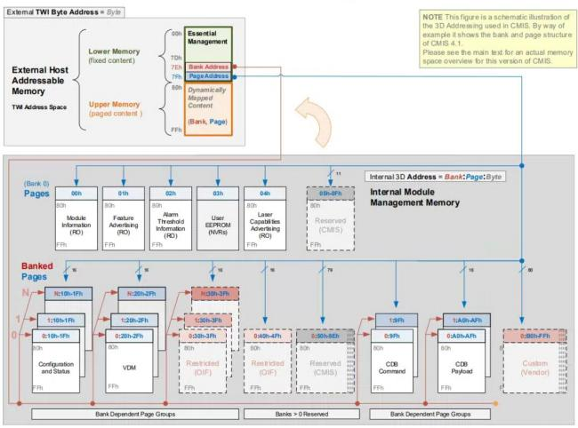
Figure 4 Digital Diagnostic Memory Map

Host Board Power Supply Filtering
Any voltage drop across a filter network on the host is counted against the host DC set point accuracy
specification. System designers should choose components with appropriate DCR and ESR, to minimize the voltage drop and the amount of noise coupled to the module. Hosts supporting higher power classes modules may require additional design considerations, in order to minimize the voltage drop and the amount of noise coupled to the module.
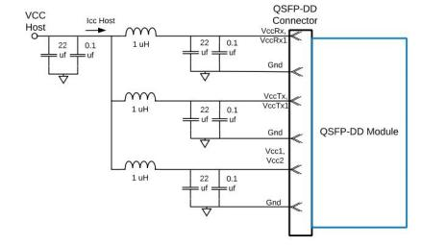
Figure 5 Reference Power Supply Filter for Module Testing

Package Outline
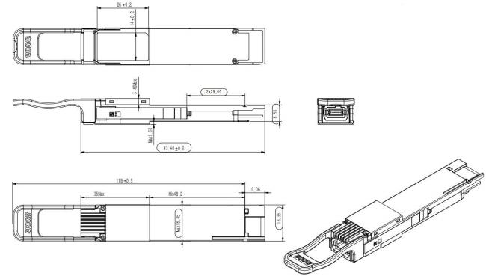
Figure 6 Package Outline

