
800G OSFP 2DR4

Features
● Hot-pluggable 800G OSFP 2DR4 form factor
● Compliant with OSFP MSA and CMIS Rev 5.2
● Built-in DDMI function
● Silicon photonics MZM solution
● 8x53.125GBd PAM4 electrical and optical interface
● Maximum link length of 500m G.652 SMF fiber with KP4-FEC
● Single 3.3V power supply
● Operating case temperature 0°C to +70 °C
● Power dissipation < 15W
● Dual MPO-12 APC receptacles
● Compliant with RoHS 2.0

Applications
● Data center and cloud networks
● 800G Ethernet and InfiniBand NDR
● Support applications: 1x800G,2x400G,4x200G, 8x100G

Order Information

Table 1-Order Information
Part No. | Bit Rate (Gbps) | Wavelength  (nm) | Distancenote1 | Fiber Type | DDMI |  | Connector | Tempnote2
JH-800G-OSFP-2DR4 | 850.0 | 1310 | 500m | SMF |  | YES | Dual MPO-12  APC | 0~70℃
Note:

1. 500m G.652 SMF fiber with KP4-FEC

2. Case Temperature

Absolute Maximum Ratings

Table2- Absolute Maximum Ratings

Parameter | Symbol | Min. | Typical |  | Max. | Unit | Notes
Supply Voltage | Vcc | -0.3 | - |  | 3.6 | V
Storage Temperature | Ts | -40 | - |  | +85 | °C
Operating Humidity | RH | 5 | - |  | +85 | % | 1
Control Input Voltage | VI | -0.3 | - |  | VCC+0.3 | V
RX damage threshold, each Lane | - | 5 |  | - | - | dBm
Note:1 No condensation

1 / 7

800G OSFP 2DR4

Recommended Operating Conditions

Table 3- Recommended operating Conditions
Parameter | Symbol | Min. | Typical | Max. | Unit | Notes
Operating Case Temperature | TC | 0 | - | 70 | °C
Power Supply Voltage | Vcc | 3.135 | 3.3 | 3.465 | V
Power Dissipation | Pdiss | - | - | 15 | W
Supply Current | Icc | - | - | 4.79 | A
Pre-FEC Bit Error Ratio | - | - | - | 2.4x10-4 | -
Post-FEC Bit Error Ratio | - | - | - | 1x10-12 | - | 1
Link Distance (G.652 SMF) | - | 2 | - | 500 | m | 2
Note:

1. FEC provided by host system

2. FEC required on host system to support maximum distance

Electrical Characteristics

Table 4- Electrical Characteristics

Parameter | Symbol | Unit | Min | Typ | Max | Notes
Transmitter
Signaling Rate,each Lane | - | Gbaud | 53.125±100 ppm
Modulation Format | - | - | PAM4
Differential Input Voltage Amplitude | Vin,ppd | mV | 400 | - | 900
Differential Termination Mismatch | - | % | - | - | 10
DC Common-mode Voltage Tolerance | - | mV | 350 | - | 2850
Receiver
Signaling Rate,each Lane | - | Gbaud | 53.125±100 ppm
Modulation Format | - | - | PAM4
Differential Output Voltage (Long mode) | Vout,ppd | mV | - | - | 845
Differential Output Voltage (Short mode) | Vout,ppd | mV | - | - | 600
Eye Height | - | mV | 15 | - | -
Vertical Eye Closure | VEC | mV | - | - | 12
Differential Termination Mismatch | - | % | - | - | 10
DC Common-mode Voltage Tolerance | - | mV | -350 | - | 2850

Table 5-Optical Characteristics
Parameter | Symbol | Unit | Min | Typ | Max | Not es
Transmitter
Signaling Rate,each Lane | - | Gbaud | 53.125±100 ppm

800G OSFP 2DR4

Modulation Format | - | - | PAM4
Center Wavelength | λc | nm | 1304.5 | 1310 |  | 1317.5
Side-mode Suppression Ratio | SMSR | dB | 30 | - |  | -
Average Launch Power, each Lane | TxAOP | dBm | -2.9 | - |  | 4 | 1
Outer Optical Modulation Amplitude, (OMAouter), each Lane | OMA | dBm | -0.8 | - |  | 4.2
Transmitter and Dispersion Eye Closure for  PAM4, each Lane | TDECQ | dB | - | - |  | 3.4
Extinction Ratio, each lane | ER | dB | 3.5 | 4 |  | -
Average Launch Power of OFF Transmitter,  each lane | TOFF | dBm | - | - |  | -15
RIN21.4OMA | RIN | dB/Hz | - | - |  | -136
Optical Return Loss Tolerance | ORL | dB | - | - |  | 21.4
Transmitter reflectance | - | dB | - | - |  | -26 | 2
Receiver
Signaling Rate,each Lane | - | Gbaud | 53.125±100 ppm
Modulation format | - | - | PAM4
Receive Wavelength Range | λc | nm | 1304.5 |  | 1310 | 1317.5
Average Receive Power, each lane | RxAOP | dBm | -5.9 |  | - | 4
Receive Power (OMAouter), each Lane | RxOMA | dBm | - |  | - | 4.2
Receiver Reflectance | - | dB | - |  | - | -26
LOS Assert | LOSassert | dBm | -18 |  | - | -11
LOS De-assert | LOSde-assert | dBm | -17 |  | - | -10
LOS Hysteresis | LOSHys | dB | 0.5 |  | - | -

Note:
1. Average launch power, each lane (min) is informative and not the principal indicator of signal strength. A transmitter with launch power below this value cannot be compliant; however, a value above this does not ensure compliance.
2. Transmitter reflectance is defined looking into the transmitter.

Digital Diagnostic Specifications

Table 6-Digital Diagnostic Characteristics
Parameter | Symbol | Unit | Min | Max | Notes
Temperature monitor absolute error | DMI_Temp | degC | -3 | 3 | Over operating temperature range
Supply voltage monitor absolute error | DMI_VCC | V | -0.1 | 0.1 | Over full operating range
Channel RX power monitor absolute error | DMI_RX_Ch | dB | -3 | 3
Channel Bias current monitor | DMI_Ibias_Ch | mA | -10% | 10%
Channel TX power monitor absolute error | DMI_TX_Ch | dB | -3 | 3

800G OSFP 2DR4

Recommended Interface
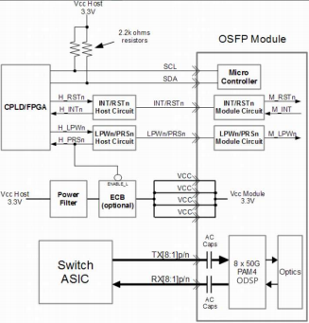

Figure 1 Recommended Interface Circuit

Pin arrangement
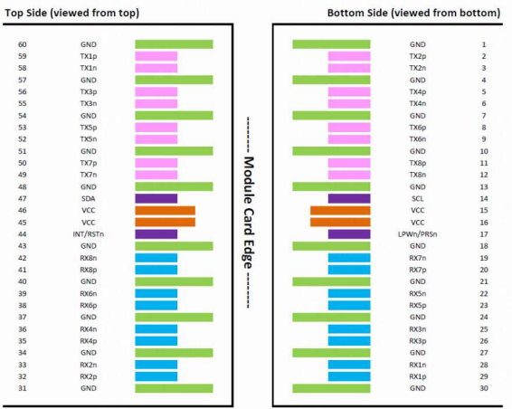

Figure 2 Pin View

800G OSFP 2DR4

Table 7-Pin Function Definitions
Pin# | Symbol | Description | Logic | Direction | Plug  Sequnce
1 | GND |  | Ground |  | 1
2 | TX2p | Transmitter Data Non-Inverted | CML-I | Input from Host | 3
3 | TX2n | Transmitter Data Inverted | CML-I | Input from Host | 3
4 | GND |  | Ground |  | 1
5 | TX4p | Transmitter Data Non-Inverted | CML-I | Input from Host | 3
6 | TX4n | Transmitter Data Inverted | CML-I | Input from Host | 3
7 | GND |  | Ground |  | 1
8 | TX6p | Transmitter Data Non-Inverted | CML-I | Input from Host | 3
9 | TX6n | Transmitter Data Inverted | CML-I | Input from Host | 3
10 | GND |  | Ground |  | 1
11 | TX8p | Transmitter Data Non-Inverted | CML-I | Input from Host | 3
12 | TX8n | Transmitter Data Inverted | CML-I | Input from Host | 3
13 | GND |  | Ground |  | 1
14 | SCL | 2-wire Serial interface clock | LVCMOS-I/O | Bi-directional | 3
15 | VCC | +3.3V Power |  | Power from Host | 2
16 | VCC | +3.3V Power |  | Power from Host | 2
17 | LPWn/PRSn | Low-Power Mode / Module  Present | Multi-Level | Bi-directional | 3
18 | GND |  | Ground |  | 1
19 | RX7n | Receiver Data Inverted | CML-O | Output to Host | 3
20 | RX7p | Receiver Data Non-Inverted | CML-O | Output to Host | 3
21 | GND |  | Ground |  | 1
22 | RX5n | Receiver Data Inverted | CML-O | Output to Host | 3
23 | RX5p | Receiver Data Non-Inverted | CML-O | Output to Host | 3
24 | GND |  | Ground |  | 1
25 | RX3n | Receiver Data Inverted | CML-O | Output to Host | 3
26 | RX3p | Receiver Data Non-Inverted | CML-O | Output to Host | 3
27 | GND |  | Ground |  | 1
28 | RX1n | Receiver Data Inverted | CML-O | Output to Host | 3
29 | RX1p | Receiver Data Non-Inverted | CML-O | Output to Host | 3
30 | GND |  | Ground |  | 1
31 | GND |  | Ground |  | 1
32 | RX2p | Receiver Data Inverted | CML-O | Output to Host | 3
33 | RX2n | Receiver Data Non-Inverted | CML-O | Output to Host | 3
34 | GND |  | Ground |  | 1
35 | RX4p | Receiver Data Inverted | CML-O | Output to Host | 3
36 | RX4n | Receiver Data Non-Inverted | CML-O | Output to Host | 3
37 | GND |  | Ground |  | 1
38 | RX6p | Receiver Data Inverted | CML-O | Output to Host | 3
39 | RX6n | Receiver Data Non-Inverted | CML-O | Output to Host | 3
40 | GND |  | Ground |  | 1
41 | RX8p | Receiver Data Inverted | CML-O | Output to Host | 3
42 | RX8n | Receiver Data Non-Inverted | CML-O | Output to Host | 3
43 | GND |  | Ground |  | 1
44 | INT/RSTn | Module Interrupt / Module Reset | Multi-Level | Bi-directional | 3
45 | VCC | +3.3V Power |  | Power from Host | 2
46 | VCC | +3.3V Power |  | Power from Host | 2
47 | SDA | 2-wire Serial interface data | LVCMOS-I/O | Bi-directional | 3
48 | GND |  | Ground |  | 1
49 | TX7n | Transmitter Data Non-Inverted | CML-I | Input from Host | 3
50 | TX7p | Transmitter Data Inverted | CML-I | Input from Host | 3
51 | GND |  | Ground |  | 1
52 | TX5n | Transmitter Data Non-Inverted | CML-I | Input from Host | 3
53 | TX5p | Transmitter Data Inverted | CML-I | Input from Host | 3
54 | GND |  | Ground |  | 1
55 | TX3n | Transmitter Data Non-Inverted | CML-I | Input from Host | 3
56 | TX3p | Transmitter Data Inverted | CML-I | Input from Host | 3
57 | GND |  | Ground |  | 1
58 | TX1n | Transmitter Data Non-Inverted | CML-I | Input from Host | 3
59 | TX1p | Transmitter Data Inverted | CML-I | Input from Host | 3
60 | GND |  | Ground |  | 1

800G OSFP 2DR4

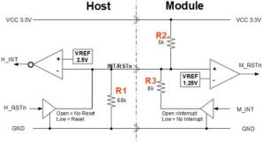

Figure 3, INT/RS Tn circuit
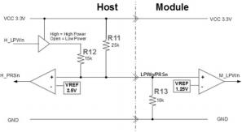

Figure 4 LPWn/PRSn circuit

Memory Map
Compatible with CMIS rev 5.2.

Optical interface arrangement
The optical port is dual MPO-12 APC connector, with fiber lane assignments as shown in Figure 5
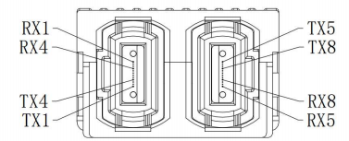

Figure 5 Optical interface arrangement.

Mechanical
800G 2DR4 OSFP transceivers are compatible with OSFP Module Specification Rev5.0 for pluggable form factor module.

Unit mm

800G OSFP 2DR4

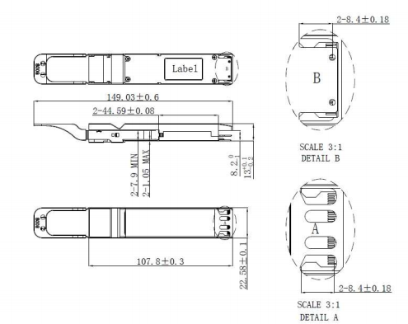

Figure 6 Mechanical Diagram

Warnings
Handling Precautions: This device is susceptible to damage as a result of electrostatic discharge (ESD).
A static free environment is highly recommended. Follow guidelines according to proper ESD procedures.
Laser Safety: Radiation emitted by laser devices can be dangerous to human eyes. Avoid eye exposure to direct or indirect radiation.
Contact:
Wuhan Jiuhong Optics Technology Co., Ltd.
TEL: 86-13476016116
E-mail：grace@jh-optics.com
Web：www.jh-optics.com
Address：
Building 1, 4th Floor, Yunqi Free Trade Innovation Port, Donghu Comprehensive Bonded Zone,Donghu High-tech Zone, Wuhan City

