JH-400G-QDD-ER8

400Gb/s QSFP-DD ER8 1310nm SMF 40km Optical Transceiver

PRODUCT FEATURES

- QSFP-DD MSA compliant
- Compliant to IEEE 802.3bs 400GBASE-ER8
- Digital diagnostic monitoring support
- Hot pluggable 76 pin electrical interface
- 8 LAN-WDM lanes MUX/DEMUX design
- 53.125Gbit/s PAM4 Channel Electrical Serial Interface (400GAUI-8)
- Maximum power consumption 15.4W
- LC duplex connector
- Supports 425Gb/s bit rate
- Up to 40km transmission on single mode fiber
- Operating case temperature: 0℃ to 70℃
- Single 3.3V power supply
- RoHS 2.0 compliant

APPLICATIONS

- 400GBASE-ER8 Ethernet
- Telecom networking
- Data Center Interconnect

DESCRIPTIONS
This module are designed for 40km optical communication applications, and it is compliant to IEEE 802.3bs for 400GE Ethernet. This module contains 8-lane optical transmitter, 8-lane optical receiver and module management block including 2 wire serial interface. The optical signals are multiplexed to a single- mode fiber through an industry standard LC connector.
Module Block Diagram
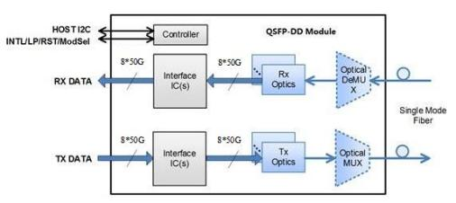

Ordering Information
Part No. | Data Rate(optical) | Laser | Fiber Type | Distance | Optical Interface | Temp | DDMI
JH-400G-QDD-ER8 | 400Gb/s | EML | SMF | 40km | LC | 0~+70°C | Y

Absolute Maximum Ratings
It has to be noted that the operation in excess of any individual absolute maximum ratings might cause permanent damage to this module.
Parameter | Symbol | Min | Typ | Max | Units | Notes
Maximum Supply Voltage | Vcc | -0.5 | 3.3 | 3.6 | V
Storage Temperature | Ts | -40 |  | 85 | ℃
Relative Humidity | RH | 10 |  | 85 | % | 1
Damage Threshold, each lane | THd | -3.4 |  |  | dBm

Notes ：Non-condensing

Recommended Operating Conditions
Electrical and optical characteristics below are defined under this operating environment, unless otherwise spec- ified.
Parameter | Symbol | Min | Typ | Max | Units
Supply Voltage | Vcc | 3.135 | 3.3 | 3.465 | V
Case Temperature | Top | 0 |  | 70 | ℃
Link Distance with G.652 |  |  |  | 40 | km

Electrical Characteristics
The following electrical characteristics are defined over the Recommended Operating Environment unless otherwise specified.
Parameter | Symbol | Min | Typical | Max | Units | Notes
Power Consumption |  |  |  | 15.4 | W
Supply Current | Icc |  |  | 4.444 | A | Steady state
Transmitter (each Lane)
Signaling Rate, each lane |  |  | 26.5625 |  | GBd | PAM4
Differential Voltage pk-pk | Vin, pp |  |  | 880 | mV
Common Mode Voltage | Vcm | -0.3 |  | 2.8 | V
Common Mode Noise | RMS |  |  | 17.5 | mV
Differential Termination Re- sistance Mismatch |  |  |  | 10 | %
Transition time | Trise/Tfall | 12 |  |  | ps | 20%~80%
Eye Width at 10-6 probability | EW6 | 0.2 |  |  | UI
Eye Height at at 10-6 proba- bility | EH6 | 32 |  |  | mV
Eye Linearity |  | 0.85
Receiver (each Lane)
Signaling Rate, each lane |  |  | 26.5625 |  | GBd | PAM4
Differential Voltage pk-pk | Vout, pp |  |  | 900 | mV
Transition time | Trise/Tfall | 9.5 |  |  | ps | 20%~80%
Near-end eye width at 10-6probability | EW6 | 0.265 |  |  | UI
Near-end eye height at 10-6probability | EH6 | 70 |  |  | mV
Far-end eye width at 10-6probability | EW6 | 0.2 |  |  | UI
Far-end eye height at 10-6probability | EH6 | 30 |  |  | mV
Near-end Eye Linearity |  | 0.85
Notes:
1.400GAUI-8 Electrical Characteristics refers to CEI-56G-VSR-PAM4 of OIF-CEI-04.0

Optical and Characteristics
400GBASE-ER8 Operation（EOL, TOP = 0 to +70℃, VCC = 3.135 to 3.465 Volts）
Parameter | Min | Typical | Max | Units | Notes
Transmitter
Signaling Speed per Lane | 26.5625 ± 100 ppm |  |  | GBd
Transmit wavelengths | 1272.55 | 1273.54 | 1274.54 | nm
Transmit wavelengths | 1276.89 | 1277.89 | 1278.89 | nm
Transmit wavelengths | 1281.25 | 1282.26 | 1283.27 | nm
Transmit wavelengths | 1285.65 | 1286.66 | 1287.68 | nm
Transmit wavelengths | 1294.53 | 1295.56 | 1296.59 | nm
Transmit wavelengths | 1299.02 | 1300.05 | 1301.09 | nm
Transmit wavelengths | 1303.54 | 1304.58 | 1305.63 | nm
Transmit wavelengths | 1308.09 | 1309.14 | 1310.19 | nm
Total Average Launch Power |  |  | 14.6 | dBm
Average launch power, each lane | -0.6 |  | 5.6 | dBm
Optical Modulation Amplitude (OMA), each lane | 2.4 |  | 6.4 | dBm
Extinction Ratio (ER) | 6 |  |  | dB
Side-Mode Suppression Ratio (SMSR) | 30 |  |  | dB
Transmitter and Dispersion Eye Closure for PAM4 (TDECQ), each lane |  |  | 3.4 | dB
Average launch power of OFF transmitter, each lane (max) |  |  | -30 | dBm
RIN15OMA |  |  | -132 | dB/Hz
Optical return loss tolerance |  |  | 15 | dB
Transmitter reflectance |  |  | -26 | dB
Receiver
Signaling Speed per Lane | 26.5625 ± 100 ppm |  |  | GBd
Transmit wavelengths | 1272.55 | 1273.54 | 1274.54 | nm
Transmit wavelengths | 1276.89 | 1277.89 | 1278.89 | nm
Transmit wavelengths | 1281.25 | 1282.26 | 1283.27 | nm
Transmit wavelengths | 1285.65 | 1286.66 | 1287.68 | nm
Transmit wavelengths | 1294.53 | 1295.56 | 1296.59 | nm
Transmit wavelengths | 1299.02 | 1300.05 | 1301.09 | nm
Transmit wavelengths | 1303.54 | 1304.58 | 1305.63 | nm
 | 1308.09 | 1309.14 | 1310.19 | nm
Average receiver power, each lane | -18.6 |  | -4.4 | dBm
Receiver power, each lane (OMA) |  |  | -3.6 | dBm
Difference in receive power between any two lanes(OMA) |  |  | 5.8 | dB
Receiver sensitivity (OMA), each lane |  |  | RS | dBm | 1
LOS Assert | -30 |  |  | dBm
LOS Deassert |  |  | -20.6 | dBm
LOS Hysteresis | 0.5 |  |  | dB
Receiver reflectance |  |  | -26 | dB

Notes:RS=max(-16.1, SECQ-17.5) (dBm). For the requirement of receiver sensitivity, the value of BER is 2e-4 before FEC.

Digital Diagnostics
Optical Transceiver support the I2C-based Diagnostic Monitoring Interface (DMI) defined in document QSFP-DD Common Management Interface
Specification Rev 4.0. The host can access real-time performance of transmitter and receiver optical power, temperature, supply voltage and bias current.

Performance Item | Related Bytes | Monitor Error | Notes
Module temperature | 14 to 15 at Page low | +/-3°C | 1 ，2
Module voltage | 16 to 17 at Page low | < 5% | 2
LD Bias current | 170 to 185 at Page 11h | < 10% | 2
Transmitter optical power | 154 to 169 at Page 11h | < 3dB | 2
Receiver optical power | 186 to 201 at Page 11h | < 3dB | 2

Notes:
- Actual temperature test point is fixed on module case around Laser Array.
- Full operating temperature range

Pin Diagram

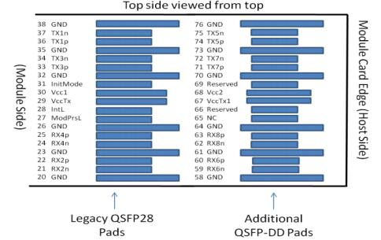

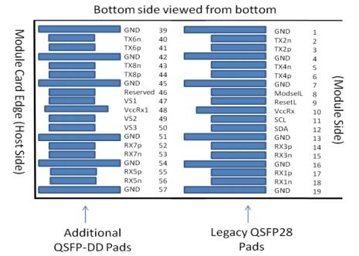

Pin Definitions
PIN | Symbol | Name/Description | Notes
1 | GND | Ground | 1
2 | Tx2n | Transmitter Inverted Data Input
3 | Tx2p | Transmitter Non-Inverted Data Input
4 | GND | Ground | 1
5 | Tx4n | Transmitter Inverted Data Input
6 | Tx4p | Transmitter Non-Inverted Data Input
7 | GND | Ground | 1
8 | ModSelL | Module Select
9 | ResetL | Module Reset
10 | VccRx | +3.3V Power Supply Receiver | 2
11 | SCL | 2-wire serial interface clock
12 | SDA | 2-wire serial interface data
13 | GND | Ground | 1
14 | Rx3p | Receiver Non-Inverted Data Output
15 | Rx3n | Receiver Inverted Data Output
16 | GND | Ground | 1
17 | Rx1p | Receiver Non-Inverted Data Output
18 | Rx1n | Receiver Inverted Data Output
19 | GND | Ground | 1
20 | GND | Ground | 1
21 | Rx2n | Receiver Inverted Data Output
22 | Rx2p | Receiver Non-Inverted Data Output
23 | GND | Ground | 1
24 | Rx4n | Receiver Inverted Data Output
25 | Rx4p | Receiver Non-Inverted Data Output
26 | GND | Ground | 1
27 | ModPrsL | Module Present
28 | IntL | Interrupt
29 | VccTx | +3.3V Power supply transmitter | 2
30 | Vcc1 | +3.3V Power supply | 2
31 | LPMode | Low Power mode
32 | GND | Ground | 1
33 | Tx3p | Transmitter Non-Inverted Data Input
34 | Tx3n | Transmitter Inverted Data Input
35 | GND | Ground | 1
36 | Tx1p | Transmitter Non-Inverted Data Input
37 | Tx1n | Transmitter Inverted Data Input
38 | GND | Ground | 1
39 | GND | Ground | 1
40 | Tx6n | Transmitter Inverted Data Input
41 | Tx6p | Transmitter Non-Inverted Data Input
42 | GND | Ground | 1
43 | Tx8n | Transmitter Inverted Data Input
44 | Tx8p | Transmitter Non-Inverted Data Input
45 | GND | Ground | 1
46 | Reserved | For future use | 3
47 | VS1 | Module Vendor Specific 1 | 3
48 | VccRx1 | 3.3V Power Supply | 2
49 | VS2 | Module Vendor Specific 2 | 3
50 | VS3 | Module Vendor Specific 3 | 3
51 | GND | Ground | 1
52 | Rx7p | Receiver Non-Inverted Data Output
53 | Rx7n | Receiver Inverted Data Output
54 | GND | Ground | 1
55 | Rx5p | Receiver Non-Inverted Data Output
56 | Rx5n | Receiver Inverted Data Output
57 | GND | Ground | 1
58 | GND | Ground | 1
59 | Rx6n | Receiver Inverted Data Output
60 | Rx6p | Receiver Non-Inverted Data Output
61 | GND | Ground | 1
62 | Rx8n | Receiver Inverted Data Output
63 | Rx8p | Receiver Non-Inverted Data Output
64 | GND | Ground | 1
65 | NC | No Connect | 3
66 | Reserved | For future use | 3
67 | VccTx1 | 3.3V Power Supply | 2
68 | Vcc2 | 3.3V Power Supply | 2
69 | ePPS | Precision Time Protocol (PTP) reference clock input. It is not used. | 3
70 | GND | Ground | 1
71 | Tx7p | Transmitter Non-Inverted Data Input
72 | Tx7n | Transmitter Inverted Data Input
73 | GND | Ground | 1
74 | Tx5p | Transmitter Non-Inverted Data Input
75 | Tx5n | Transmitter Inverted Data Input
76 | GND | Ground | 1
Notes:
1.QSFP-DD uses common ground (GND) for all signals and supply (power). All are comon within the QSFP-DD module and all module voltages are referenced to this po-te-nial unless otherwise noted. Connect these directly to the host board signal-common ground plane.
2.VccRx, VccRx1, Vcc1, Vcc2, VccTx and VccTx1 shall be applied concurrently.Requirements defined for the host side of the Host Card Edge Connector. VccRx, VccRx1, Vcc1, Vcc2, VccTx and VccTx1 may be internally connected within the module in any combination. The connector Vcc pins are each rated for a maximum current of 1000 mA.
3.All Vendor Specific, Reserved and No Connect pins may be terminated with 50ohms to ground on the host. Pad 65 (No Connect) shall be left unconnected within the module. Vendor specific and Reserved pads shall have an impedance to GND that is greater than 10K ohms and less than 100pF.

Recommended Interface Circuit
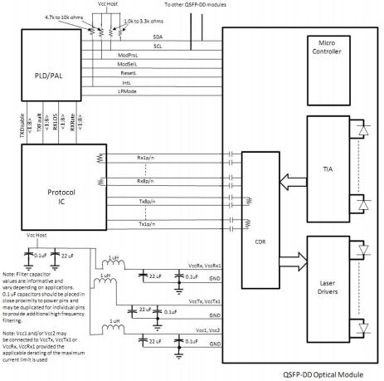

Mechanical Diagram
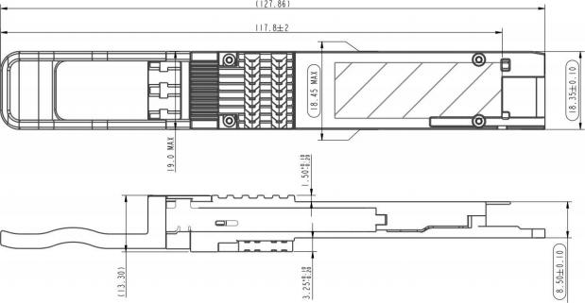

Contact:
Wuhan Jiuhong Optics Technology Co., Ltd.
TEL: 86-13476016116
E-mail：grace@jh-optics.com
Web：www.jh-optics.com
Address：
Building 1, 4th Floor, Yunqi Free Trade Innovation Port, Donghu Comprehensive Bonded Zone,Donghu High-tech Zone, Wuhan City

