JH-400G-QDD-LR4

400G QSFP-DD LR4 Optical Transceiver

Product Features

➢ Compliant with QSFP-DD MSA

➢ Compliant with 100G Lambda MSA 400G-LR4 Specification compliant

➢ Compliant with CMIS5.0

➢ Compliant with IEEE Std 802.3bs

➢ 8x53. 125Gb/s electrical interface (400GAUI-8)

➢ Cooled EML laser with CWDM wavelength

➢ Up to 10km transmission on single mode fiber (SMF) with FEC

➢ Single +3.3V power supply

➢ Case temperature range: 0 ~ +70℃

➢ Maximum power consumption 12W

➢ Duplex LC connector

➢ RoHS complaint

Applications
400G
BASE-LR4 Ethernet
Data Center Interconnect •Enterprise Networking

Description

This product is a 400Gb/s QSFP-DD optical module designed for 10km optical communication applications. The module converts 8 channels of 50Gb/s (PAM4) electrical input data to 4 channels of CWDM optical signals and multiplexes them into a single channel for 400Gb/s optical transmission.

On the receiver side, the module optically de-multiplexes a 400Gb/s optical input into 4 channels of CWDM optical signals and converts them to 8 channels of 50Gb/s (PAM4) electrical output data.

The central wavelengths ofthe 4 CWDM channels are 1271, 1291, 1311 and 1331 nm as members of the CWDM wavelength grid defined in ITU-T G.694.2.

Host FEC is required to support up to 10km fiber transmission.

Module Block Diagram

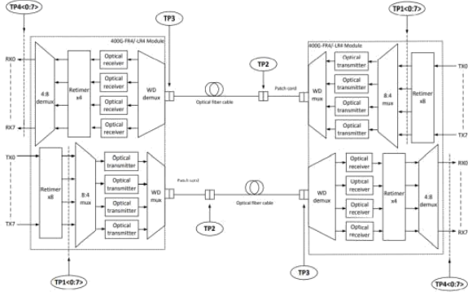
Ordering Information

Part Number | Description
JH-400G-QDD-LR4 | 400G QSFP-DD LR4 Optical Transceiver

Absolute Maximum Ratings

Parameter | Symbol | Min | Max | Unit
Storage Temperature Range | TSTG | -40 | +85 | ⁰C
Supply Voltage | VCC | 0 | 4 | V
Relative Humidity | RH | 10% to 90%  non-condensing

Operating Conditions
Max

Parameter | Symbol | Min |  | Unit
Case Temperature- Operating | TCASE | 0 | 70 | ⁰C
Supply Voltage | Vcc | 3.14 | 3.46 | V
Power Consumption | PDISS |  | 12 | W
Pre-FEC Bit Error Ratio |  |  | 2.4x10-4
Link Distance | 2 |  | 10, | KM
Electrical Characteristics

Parameter | Min | Typical | Max | Unit | Notes
Receiver electrical output characteristics at TP4
Signaling rate per lane |  | 26.5625 |  | GBd
AC common-mode output voltage(RMS) |  | - | 17.5 | mV
Differential peak-to-peak output voltage |  |  | 900 | mV
Near-end ESMW (Eye symmetry mask width) |  | 0.265 |  | UI
Near-end Eye height, differential | 70 |  |  | mV
Near-end vertical eye closure |  |  | 7.5 | dB
Far-end ESMW (Eye symmetry mask width) |  | 0.20 |  | UI
Far-end Eye height, differential | 30 |  |  | mV
Far-end vertical eye closure |  |  | 7.5 | dB
Far-end pre-cursor ISI ratio | -4.5 |  | 2.5 | %
Common mode to differential conversion return loss | 802.3 Equation(83E-3) |  |  | dB
Differential output return loss | 802.3 Equation(83E-2) |  |  | dB
Differential termination mismatch |  |  | 10 | %

Transition time (min, 20% to 80%) |  |  | 9.5 |  |  |  | ps
DC common mode voltage |  | -350 |  |  | 2850 |  | mV
Transmitter electrical input characteristics at TP1
Signaling rate, per lane |  |  | 26.5625 |  |  |  | GBd
Differential peak-to-peak input voltage tolerance |  | 900 |  |  |  |  | mV
Differential input return loss |  | 802.3 Equation(83E-5)
Differential to common mode input return loss |  | 802.3 Equation(83E-6) |  |  |  |  | mV
AC common-mode output voltage(RMS) |  |  |  |  | 17.5 |  | mV
Single-ended voltage tolerance range |  | -0.4 |  |  | 3.3 |  | V
Module stressed input |  | 802.3 120E.3.4.1 |  |  |  |  | UI
Differential termination mismatch |  |  |  |  | 10 |  | %
DC common mode voltage | -350 |  |  |  |  | mV
Optical Characteristics

Transmitter Parameter | Lane | Min | Typical | Max | Units
Lane Wavelength Range | Lane 0  Lane 1  Lane 2  Lane 3 | 1264.5  1284.5  1304.5  1324.5 | 1271  1291  1311  1331 | 1277.5  1297.5  1317.5  1337.5 | nm  nm  nm  nm
Signal rate per lane |  |  | 53.125 |  | GBd
Average launch Power per lane |  | -2.7 |  | 5.1 | dBm
Total Average launch power |  |  |  | 11.1 | dBm
Outer Optical Modulation Amplitude (OMAouter), each lane for TDECQ<1 .4 dB  for 1.4dB<=TDECQ<=3 .9dB |  | 0.3  -1. 1+TDECQ |  | 4.4 | dBm
Difference in launch power between any two lanes (OMAouter) |  |  |  | 4 | dB
Average Launch Power per Lane @ TX Off State |  |  |  | -16 | dBm
Transmitter Eye Closure for PAM4(TECQ),each Lane |  |  |  | 3.9 | dB
Transmitter and dispersion Eye Closure for PAM4(TDECQ), each Lane |  |  |  | 3.9 | dB
|TDECQ - TECQ| |  |  |  | 2.5 | dB
Extinction Ratio |  | 3.5 |  |  | dB
Relative Intensity Noise (OMA) |  |  |  | -136 | dB/H

 |  |  |  |  | z
Side-Mode Suppression Ration (SMSR) |  | 30 |  |  | dB
Optical Return Loss Tolerance |  |  |  | 15.6 | dB
Transmitter Reflectance |  |  |  | -26 | dB
Transmitter over/under-shoot |  |  |  | 25 | %
Transmitter peak-to-peak power |  |  |  | 5.2 | dBm
Transmitter transition time |  |  |  | 17 | ps

Receiver Optical Specifications
Min Typica
l

Receiver Parameter | Lane |  |  | Max | Units
Lane Wavelength Range | Lane 0  Lane 1  Lane 2  Lane 3 | 1264.5  1284.5  1304.5  1324.5 | 1271  1291  1311  1331 | 1277.5  1297.5  1317.5  1337.5 | nm  nm  nm  nm
Signal rate per lane |  |  | 53.125 |  | GBd
Damage Threshold |  | 6.1 |  |  | dBm
Average Receive Power, each lane |  | -9 |  | 5.1 | dBm
Receiver Power, each lane (OMA) |  |  |  | 4.4 | dBm
Receiver Reflectance |  |  |  | -26 | dB
Difference in receive Power between any Two Lanes(OMAouter) |  |  |  | 4.3 | dBm
Receiver Sensitivity each lane  (OMAouter) for TECQ<1 .4dB  for 1.4dB<=TECQ<=3 .9dB |  |  |  | -6.8  -  8.2+TECQ | dBm
Stressed Receiver Sensitivity (OMAouter), each |  |  |  | -4.3 | dBm
Stressed Conditions for Stress Receiver Sensitivity
Stressed Eye Closure for PAM4 (SECQ),Lane under Test |  |  | 3.9 |  | dB
OMAouter of each Aggressor Lane |  |  | -0.4 |  | dBm

Receiver Output Power Thresholds for Loss of Signal(LOS)

Parameter | Min | Typical Max |  | Unit
RX_LOS_Assert Min/Max | -20.0 |  |  | dBm

RX_LOS_De-Assert Min/Max |  |  | -12.2 | dBm
RX_LOS_Hysteresis | 0.5 |  |  | dB

Digital Diagnostic Functions

Parameters | Unit | Specification
Temperature Monitor absolute error | 。C | ±3
Supply Voltage Monitor absolute error | % | ±5
I_bias Monitor absolute error | % | ±10
Received Power (Rx) Monitor absolute error | dB | ±3.0
Transmit Power (Tx) Monitor absolute error | dB | ±3.0

Pin Definition

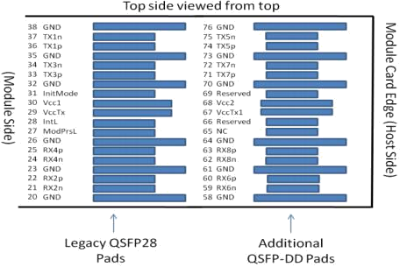

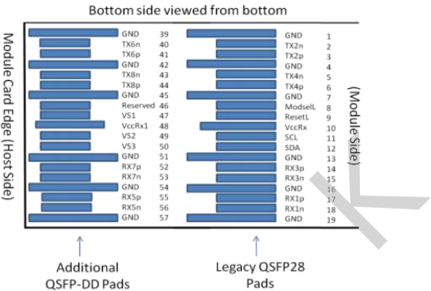

PIN Description

Pin No. | Symbol | Description | Note
1 | GND | Ground | 1
2 | Tx2n | Transmitter Inverted Data Input
3 | Tx2p | Transmitter Non-Inverted Data output
4 | GND | Ground | 1
5 | Tx4n | Transmitter Inverted Data Input
6 | Tx4p | Transmitter Non-Inverted Data output
7 | GND | Ground | 1
8 | ModSelL | Module Select
9 | ResetL | Module Reset
10 | VccRx | 3.3V Power Supply Receiver | 2
11 | SCL | 2-Wire serial Interface Clock
12 | SDA | 2-Wire serial Interface Data
13 | GND | Ground | 1
14 | Rx3p | Receiver Non-Inverted Data Output
15 | Rx3n | Receiver Inverted Data Output
16 | GND | Ground | 1
17 | Rx1p | Receiver Non-Inverted Data Output
18 | Rx1n | Receiver Inverted Data Output

19 | GND | Ground | 1
20 | GND | Ground | 1
21 | Rx2n | Receiver Inverted Data Output
22 | Rx2p | Receiver Non-Inverted Data Output
23 | GND | Ground | 1
24 | Rx4n | Receiver Inverted Data Output
25 | Rx4p | Receiver Non-Inverted Data Output
26 | GND | Ground | 1
27 | ModPrsL | Module Present
28 | IntL | Interrupt
29 | VccTx | 3.3V power supply transmitter | 2
30 | Vcc1 | 3.3V power supply | 2
31 | Init Mode | Initialization mode
32 | GND | Ground | 1
33 | Tx3p | Transmitter Non-Inverted Data Input
34 | Tx3n | Transmitter Inverted Data Output
35 | GND | Ground | 1
36 | Tx1p | Transmitter Non-Inverted Data Input
37 | Tx1n | Transmitter Inverted Data Output
38 | GND | Ground | 1
39 | GND | Ground | 1
40 | Tx6n | Transmitter Inverted Data Input
41 | Tx6p | Transmitter Non-Inverted Data output
42 | GND | Ground | 1
43 | Tx8n | Transmitter Inverted Data Input
44 | Tx8p | Transmitter Non-Inverted Data output
45 | GND | Ground | 1
46 | Reserved | For Future Use | 3
47 | VS1 | Module Vendor Specific 1 | 3
48 | VccRx1 | 3.3V Power Supply | 2
49 | VS2 | Module Vendor Specific 2 | 3
50 | VS3 | Module Vendor Specific 3 | 3
51 | GND | Ground | 1
52 | Rx7p | Receiver Non-Inverted Data Output

53 | Rx7n | Receiver Inverted Data Output
54 | GND | Ground | 1
55 | Rx5p | Receiver Non-Inverted Data Output
56 | Rx5n | Receiver Inverted Data Output
57 | GND | Ground | 1
58 | GND | Ground | 1
59 | Rx6n | Receiver Inverted Data Output
60 | Rx6p | Receiver Non-Inverted Data Output
61 | GND | Ground | 1
62 | Rx8n | Receiver Inverted Data Output
63 | Rx8p | Receiver Non-Inverted Data Output
64 | GND | Ground | 1
65 | NC | No Connect | 3
66 | Reserved | For Future Use | 3
67 | VccTx1 | 3.3Vpower supply | 2
68 | Vcc2 | 3.3Vpower supply | 2
69 | Reserved | For Future Use | 3
70 | GND | Ground | 1
71 | Tx7p | Transmitter Non-Inverted Data Input
72 | Tx7n | Transmitter Inverted Data Output
73 | GND | Ground | 1
74 | Tx5p | Transmitter Non-Inverted Data Input
75 | Tx5n | Transmitter Inverted Data Output
76 | GND | Ground | 1
Note：
1．QSFP-DD uses common ground (GND)for all signals and supply (power). All are common within the
QSFP-DD module and all module voltages are referenced to this potential unless otherwise noted. Connect these directly to the host board signal-common ground plane.
2．VccRx, VccRx1, Vcc1, Vcc2, VccTx and VccTx1 shall be applied concurrently. Requirements defined for
the host side of the Host Card Edge Connector are listed in Table 8. VccRx, VccRx1, Vcc1, Vcc2, VccTx and VccTx1 may be internally connected within the module in any combination. For power classes 4 and above the module differential loading of input voltage pins must not result in exceeding pin current limits. The connector Vcc pins are each rated for a maximum current of 1000 mA.
3． All Vendor Specific, Reserved, No Connect and ePPS (if not used) pins may be terminated with 50 to
ground on the host. Pad 65 (No Connect) shall be left unconnected within the module. Vendor specific and Reserved pads shall have an impedance to GND that is greater than 10 k and less than 100 pF.

Recommended application circuit

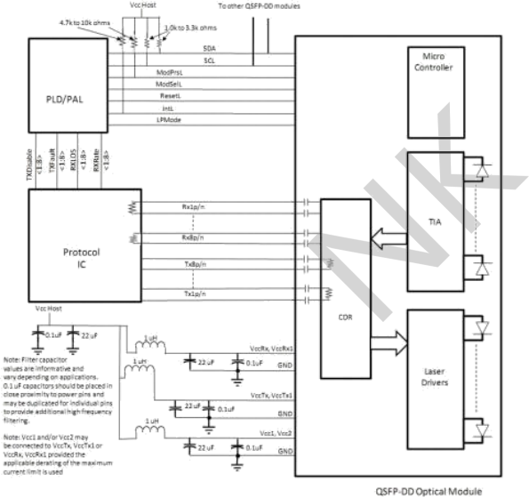

Mechanical Dimensions

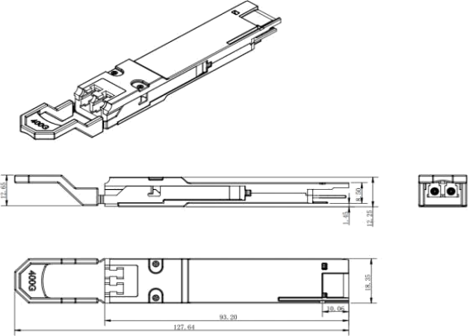

Contact:
Wuhan Jiuhong Optics Technology Co., Ltd.
TEL: 86-13476016116
E-mail：grace@jh-optics.com
Web：www.jh-optics.com
Address：
Building 1, 4th Floor, Yunqi Free Trade Innovation Port, Donghu Comprehensive Bonded Zone,Donghu High-tech Zone, Wuhan City

