Product Specification
QSFP-DD 400G-DR4 500m transceivers

Description

The Transceiver is a high-performance, cost-effective module for optical data communication applications supporting 400G Ethernet. The Transceiver is designed to operate in switch and router applications supporting QSFP-DD MSA / 400G DR4 compliant traffic for up to 500m links.

The Transceiver can convert 8-channel 53.125Gb/s electrical data to 4-channel 106.25Gb/s optical signals. Similarly, it optically converts 4-channel 106.25Gb/s optical signals to 8-channel electrical data output on the receiver side. It has been designed to withstand the maximum range of external operating conditions including temperature, humidity and EMI. The module offers very high functionality and feature integration, accessible via a two-wire serial interface.

Features
- QSFP-DD MSA compliant
- 8x53.125Gb/s PAM4 electrical interface (400GAUI-8)
- Maximum power consumption 8W
- MPO-12 APC connector
- Up to 500m transmission on single mode fiber
- Operating case temperature: 0℃~70℃
- Single 3.3V power supply
- RoHS-6 compliant

Applications
- 400G Ethernet
- Data Center Applications

Compliance
- QSFP-DD MSA Rev5.1
- IEEE 802.3bs
- CMIS Rev4.0
- RoHS compliance
- GR-468-CORE

Absolute Maximum Ratings

Table1-Absolute Maximum Ratings
Parameter | Symbol | Min | Typical | Max | Unit | Notes
Storage Temperature | TSTG | -40 |  | 85 | ºC
Operating Relative Humidity | RH | 5 |  | 85 | % | Note1
Supply Voltage | VCC | -0.5 | 3.3 | 3.6 | V
Damage Threshold, each lane |  | 5 |  |  | dBm
Note:
[1] Non-condensing.

Recommended Operating Conditions

Table2-Recommended Operating Conditions
Parameter | Symbol | Min | Typical | Max | Unit | Notes
Case temperature | Tcase | 0 |  | 70 | ℃
Supply Voltage | VCC | 3.135 | 3.3 | 3.465 | V
Supply Current | ICC |  |  | 2552 | mA
Module Power Dissipation | P |  |  | 8 | W

Optical，Electrical Characteristic

Tested under recommended operating conditions, unless otherwise noted
Table3-Transmitter Operating Characteristic-Optical，Electrical
Parameter | Symbol | Min | Typical | Max | Units | Notes
Optical Data Rate, each Lane |  | 53.125±100ppm |  |  | GBd
Modulation Format |  | PAM4
Line wavelengths | λ | 1304.5 | 1311 | 1317.5 | nm
Average Launch Power, each lane | P_{AVG} | -2.9 |  | 4 | dBm
Optical Modulation Amplitude (OMA), each lane | OMA | -0.8 |  | 4.2 | dBm
Extinction Ratio | ER | 3.5 |  |  | dB
Side-Mode Suppression Ratio | SMSR | 30 |  |  | dB
Launch power in OMA minus TDECQ, each lane |  | -2.2 |  |  | dBm
Transmitter and Dispersion Eye Closure for PAM4, each Lane | TDECQ |  |  | 3.4 | dB
Optical Return Loss Tolerance |  |  |  | 21.4 | dB
Transmitter Reflectance |  |  |  | -26 | dB
Average Launch Power of OFF Transmitter, each Lane |  |  |  | -15 | dBm
Electrical Data Rate, each lane |  | 26.5625±100ppm |  |  | GBd
Differential pk-pk input Voltage tolerance | Vpp |  | 900 |  | mV | Note1
DC Common Mode Voltage | Vcm | -350 |  | 2850 | mV | Note2
Differential Termination Resistance Mismatch |  | -10 |  | 10 | %
Differential Input Return Loss |  | IEEE 802.3-2018 Equation (83E-5) |  |  | dB
Differential to Common Mode Input Return Loss |  | IEEE 802.3-2018 Equation (83E-6) |  |  | dB
Module Stressed Input Test |  | IEEE 802.3bs 120E.3.4.1 |  |  |  | Note3
Notes:
[1] With the exception to IEEE 802.3bs 120E.3.1.2 that the pattern is PRBS31Q or scrambled idle.
[2] DC common mode voltage generated by the host. Specification includes effects of ground offset voltage.
[3] BER specified in IEEE 802.3bs 120E.1.1.

Table4-Receiver Operating Characteristic-Optical，Electrical
Parameter | Symbol | Min | Typical | Max | Units | Notes
Optical Data Rate, each Lane |  | 53.125±100ppm |  |  | GBd
Modulation Format |  | PAM4
Optical Input Power | PIN |  |  | 5 | dBm
Line wavelengths | λ | 1304.5 | 1311 | 1317.5 | nm
Average receiver power, each lane |  | -5.9 |  | 4 | dBm
Receiver power, each lane (OMA) |  |  |  | 4.2 | dBm
Receiver Sensitivity (OMAouter) , each lane |  |  |  | -4.4 | dBm
Stressed receiver sensitivity (OMAouter), each laned (max) |  |  |  | -1.9 | dBm
Receiver reflectance |  |  |  | -26 | dB
Losa |  | -15 |  |  | dBm
Losd |  |  |  | -8.4 | dBm
Losh |  | 0.5 |  |  | dB
Electrical Data Rate, each lane |  | 26.5625±100ppm |  |  | GBd
Differential Termination Resistance Mismatch |  | -10 |  | 10 | %
Differential output Voltage pk-pk | Vpp |  |  | 900 | mV
DC Common Mode Voltage | Vcm | -350 |  | 2850 | mV | Note 1
Differential output return loss |  | IEEE 802.3-2018 Equation (83E-2) |  |  | dB
Common to differential mode conversion return loss |  | IEEE 802.3-2018 Equation (83E-3) |  |  | dB
Note:
[1] DC common mode voltage generated by the host. Specification includes effects of ground offset voltage.

Digital Diagnostic Functions and Control and Status I/O Timing Characteristics

Table5- Digital Diagnostic Functions
Parameter | Symbol | Min | Typical | Max | Units | Notes
Temperature monitor absolute error | DMI_Temp | -3 |  | 3 | ℃ | Note1
Supply voltage monitor absolute error | DMI_Vcc | -3% |  | 3% | V | Note2
Bias current monitor absolute error | DMI_Ibias | -10% |  | 10% | mA
Laser power monitor absolute error | DMI_Tx | -3 |  | 3 | dB
RX power monitor absolute error | DMI_Rx | -3 |  | 3 | dB
Notes:
[1] Temperature here is depending on module case around Max power dissipation. Temperature monitor is done over operating temperature.
[2] Supply voltage monitor is done over operating voltage.

Table6- Control and Status I/O Timing Characteristics
Parameter | Symbol | Min | Typical | Max | Units | Notes
MgmtInitDuration | Max MgmtInit  Duration |  |  | 2000 | ms | Note1
ResetL Assert Time | t_reset_init | 10 |  |  | µs | Note2
IntL Assert Time | ton_IntL |  |  | 200 | ms | Note3
IntL Deassert Time | toff_IntL |  |  | 500 | µs | Note4
Rx LOS Assert Time | ton_los |  |  | 100 | ms | Note5
Tx Fault Assert Time | ton_Txfault |  |  | 200 | ms | Note6
Flag Assert Time | ton_flag |  |  | 200 | ms | Note7
Mask Assert Time | ton_mask |  |  | 100 | ms | Note8
Mask Deassert Time | toff_mask |  |  | 100 | ms | Note9
Notes:
[1] Time from power on, hot plug or rising edge of reset until completion of the MgmtInit State.
[2] Minimum pulse time on the ResetL signal to initiate a module reset.
[3] Time from occurrence of condition triggering IntL until Vout:IntL=Vol.
[4] Time from clear on read operation of associated flag until Vout:IntL=Voh.This includes deassert times for Rx LOS, Tx Fault and other flag bits.
[5] Time from Rx LOS state to Rx LOS bit set (value = 1b) and IntL asserted.
[6] Time from Tx Fault state to Tx Fault bit set (value=1b) and IntL asserted.
[7] Time from occurrence of condition triggering flag to associated flag bit set (value=1b) and IntL asserted.
[8] Time from mask bit set (value=1b) until associated IntL assertion is inhibited.
[9] Time from mask bit cleared (value=0b) until associated IntL operation resumes.

Table7- Surge Current Requirements
Parameter | Symbol | Min | Typical | Max | Units | Notes
Power supply voltages VccTx, VccTx1, VccRx, VccRx1, Vcc1 & Vcc2 including ripple, droop and noise below 100kHz |  | 3.135 | 3.3 | 3.465 | V | Note1
Module RMS noise output 10 Hz - 10 MHz |  |  |  | 30 | mV
Module power supply noise tolerance 10 Hz  - 10 MHz (peak-to-peak) | PSNRmod |  |  | 66 | mV
Module inrush - instantaneous peak duration | T_ip |  |  | 50 | µs | Note2
Module inrush - initialization time | T_init |  |  | 500 | ms | Note2
High Power Mode Power Class 4 module
Power Consumption | P_4 |  |  | 8 | W | Note3
Instantaneous peak current | Icc_ip_4 | - | - | 3200 | mA
Sustained peak current | Icc_sp_4 | - | - | 2640 | mA
Steady state current | Icc_4 |  |  | 2551 | mA | Note4
Notes:
[1] Measured at VccTx, VccTx1, VccRx, VccRx1, Vcc1 and Vcc2.
[2] T_ip and T_init are test conditions for measuring inrush current and not characteristics of the module.
[3] User must read management register for maximum power consumption.
[4] The module must stay within its declared power class.
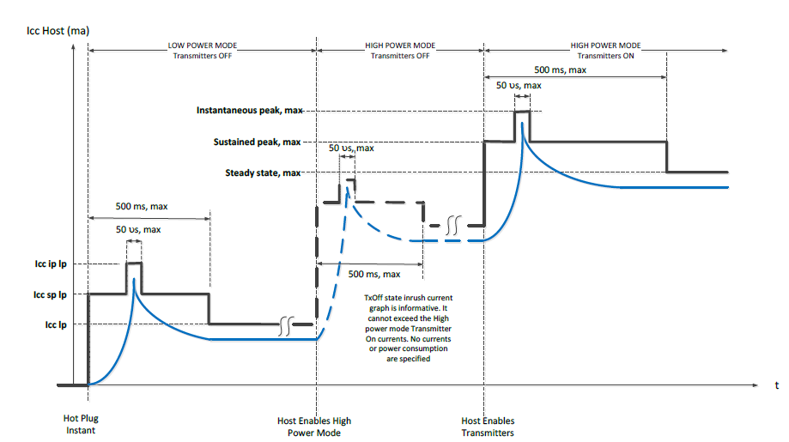
Figure1
Pin-out Definitions

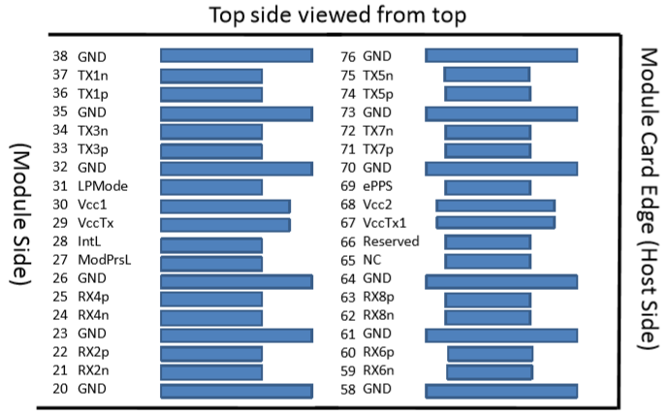
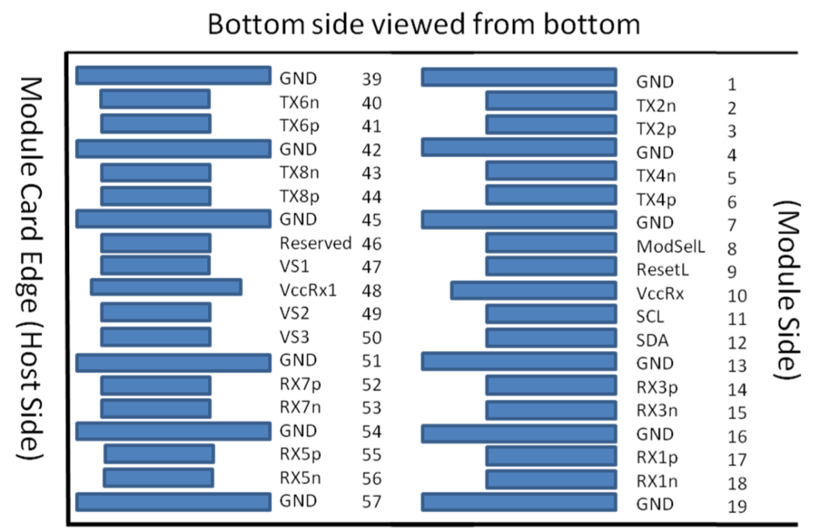

Figure2

Table8-Pin Function Definitions
Pin | Logic | Symbol | Description | Plug Sequence | Notes
1 |  | GND | Ground | 1B | Note1
2 | CML-I | Tx2n | Transmitter Inverted Data Input | 3B
3 | CML-I | Tx2p | Transmitter Non-Inverted Data Input | 3B
4 |  | GND | Ground | 1B | Note1
5 | CML-I | Tx4n | Transmitter Inverted Data Input | 3B
6 | CML-I | Tx4p | Transmitter Non-Inverted Data Input | 3B
7 |  | GND | Ground | 1B | Note1
8 | LVTTL-I | ModSelL | Module Select | 3B
9 | LVTTL-I | ResetL | Module Reset | 3B
10 |  | Vcc Rx | +3.3V Power Supply Receiver | 2B | Note2
11 | LVCMOS-I/O | SCL | 2-wire serial interface clock | 3B
12 | LVCMOS-I/O | SDA | 2-wire serial interface data | 3B
13 |  | GND | Ground | 1B | Note1
14 | CML-O | Rx3p | Receiver Non-Inverted Data Output | 3B
15 | CML-O | Rx3n | Receiver Inverted Data Output | 3B
16 |  | GND | Ground | 1B | Note1
17 | CML-O | Rx1p | Receiver Non-Inverted Data Output | 3B
18 | CML-O | Rx1n | Receiver Inverted Data Output | 3B
19 |  | GND | Ground | 1B | Note1
20 |  | GND | Ground | 1B | Note1
21 | CML-O | Rx2n | Receiver Inverted Data Output | 3B
22 | CML-O | Rx2p | Receiver Non-Inverted Data Output | 3B
23 |  | GND | Ground | 1B | Note1
24 | CML-O | Rx4n | Receiver Non-Inverted Data Output | 3B
25 | CML-O | Rx4p | Receiver Inverted Data Output | 3B
26 |  | GND | Ground | 1B | Note1
27 | LVTTL-I | ModPrsL | Module Present | 3B
28 | LVTTL-I | IntL | Interrupt | 3B
29 |  | VccTx | +3.3V Power supply transmitter | 2B | Note2
30 |  | Vcc1 | +3.3V Power supply | 2B | Note2
31 | LVTTL-I | LPMode | Low Power Mode | 3B
32 |  | GND | Ground | 1B | Note1
33 | CML-I | Tx3p | Transmitter Non-Inverted Data Input | 3B
34 | CML-I | Tx3n | Transmitter Inverted Data Input | 3B
35 |  | GND | Ground | 1B | Note1
36 | CML-I | Tx1p | Transmitter Non-Inverted Data Input | 3B
37 | CML-I | Tx1n | Transmitter Inverted Data Input | 3B
38 |  | GND | Ground | 1B | Note1
39 |  | GND | Ground | 1A | Note1
40 | CML-I | Tx6n | Transmitter Inverted Data Input | 3A
41 | CML-I | Tx6p | Transmitter Non-Inverted Data Input | 3A
42 |  | GND | Ground | 1A | Note1
43 | CML-I | Tx8n | Transmitter Inverted Data Input | 3A
44 | CML-I | Tx8p | Transmitter Non-Inverted Data Input | 3A
45 |  | GND | Ground | 1A | Note1
46 |  | Reserved | For future use | 3A | Note3
47 |  | VS1 | Module Vendor Specific 1 | 3A | Note3
48 |  | VccRx1 | +3.3V Power supply | 2A | Note2
49 |  | VS2 | Module Vendor Specific 2 | 3A | Note3
50 |  | VS3 | Module Vendor Specific 3 | 3A | Note3
51 |  | GND | Ground | 1A | Note1
52 | CML-O | Rx7p | Receiver Non-Inverted Data Output | 3A
53 | CML-O | Rx7n | Receiver Inverted Data Output | 3A
54 |  | GND | Ground | 1A | Note1
55 | CML-O | Rx5p | Receiver Non-Inverted Data Output | 3A
56 | CML-O | Rx5n | Receiver Inverted Data Output | 3A
57 |  | GND | Ground | 1A | Note1
58 |  | GND | Ground | 1A | Note1
59 | CML-O | Rx6n | Receiver Non-Inverted Data Output | 3A
60 | CML-O | Rx6p | Receiver Inverted Data Output | 3A
61 |  | GND | Ground | 1A | Note1
62 | CML-O | Rx8n | Receiver Non-Inverted Data Output | 3A
63 | CML-O | Rx8p | Receiver Inverted Data Output | 3A
64 |  | GND | Ground | 1A | Note1
65 |  | NC | No Connect | 3A | Note3
66 |  | Reserved | For Future Use | 3A | Note3
67 |  | VccTx1 | +3.3V Power supply | 2A | Note2
68 |  | Vcc2 | +3.3V Power supply | 2A | Note2
69 | LVTTL-I | ePPS | Precision Time Protocol (PTP) reference clock input | 3A | Note3
70 |  | GND | Ground | 1A | Note1
71 | CML-I | Tx7p | Transmitter Non-Inverted Data Input | 3A
72 | CML-I | Tx7n | Transmitter Inverted Data Input | 3A
73 |  | GND | Ground | 1A | Note1
74 | CML-I | Tx5p | Transmitter Non-Inverted Data Input | 3A
75 | CML-I | Tx5n | Transmitter Inverted Data Input | 3A
76 |  | GND | Ground | 1A | Note1
Notes:
[1] QSFP-DD uses common ground (GND) for all signals and supply (power). All are common within the QSFP-DD module and all module voltages are referenced to this potential unless otherwise noted. Connect these directly to the host board signal-common ground plane.
[2] VccRx, VccRx1, Vcc1, Vcc2, VccTx and VccTx1 shall be applied concurrently. Requirements defined for the host side of the Host Card Edge Connector are listed in Table 6 from QSFP-DD MSA. VccRx, VccRx1, Vcc1, Vcc2, VccTx and VccTx1 may be internally connected within the module in any combination. The connector Vcc pins are each rated for a maximum current of 1000 mA.
[3] All Vendor Specific, Reserved and No Connect and ePPS(if not used) pins may be terminated with 50 ohms to ground on the host. Pad 65 (No Connect) shall be left unconnected within the module. Vendor specific and Reserved pads shall have an impedance to GND that is greater than 10 kOhms and less than 100 pF.
[4] Plug Sequence specifies the mating sequence of the host connector and module. The sequence is 1A,2A,3A,1B,2B,3B. (see Figure 2 for pad locations) Contact sequence A will make, then break contact with additional QSFP-DD pads. Sequence 1A,1B will then occur simultaneously, followed by 2A,2B, followed by 3A,3B.

Block Diagram of Transceiver

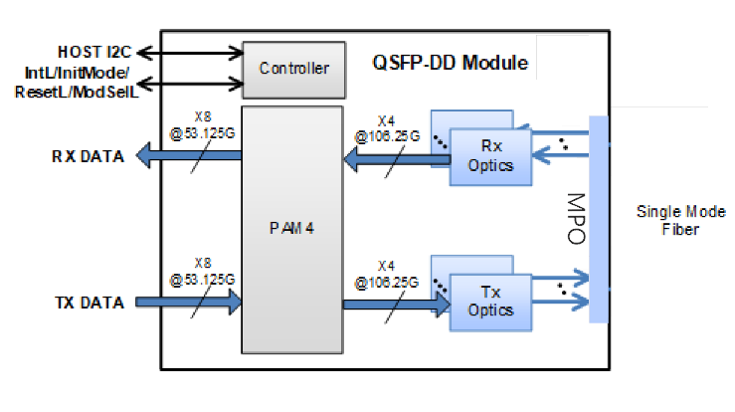

Figure3

<Transmitter Section>: The MQD-35F2C converts 8-channel 53.125Gb/s electrical data to 4-channel 1310nm 106.25Gb/s optical signals for 425Gb/s optical transmission.

<Receiver Section>: Similarly, it optically converts 4-channel 1310nm 106.25Gb/s optical signals to 8-channel electrical data output on the receiver side.

Recommended Interface Circuit

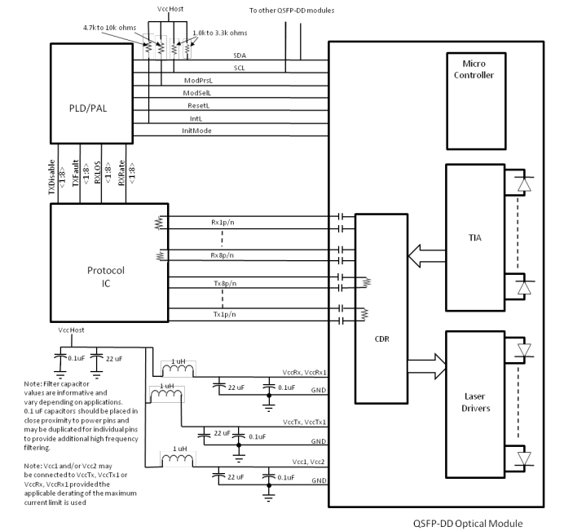
Figure4

Dimensions

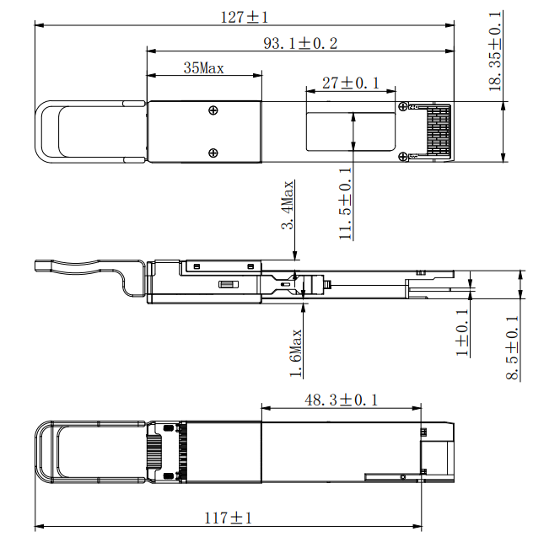
Figure5

Notes:
[1] Flatness: 0.05mm for the heat dissipation area and 0.075mm for the rest.
[2] Roughness: 0.8μm for the heat dissipation area and 1.6μm for the rest.

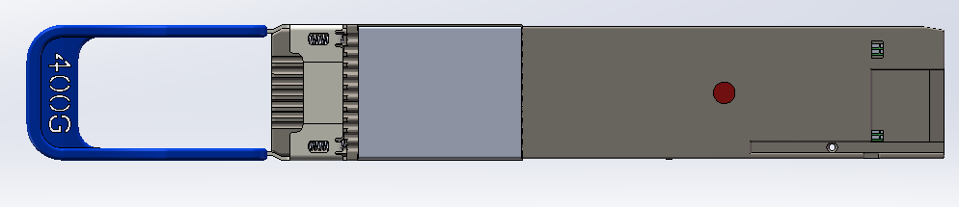
Figure6 Temperature measuring piont

