400G QSFP-DD SR8 Optical Transceiver

Features

● 8 independent parallel optical channels
● Each channel data rate up to 26.56GBaud with CDR
● Hot Pluggable
● Up to 100m link on OM4 Multi-mode
● 850nm VCSEL/PD Array Technology
● CML Compatible electrical I/O
● QSFP-DD MSA Compliance
● Optical connectivity via industry standard
MPO/ MTP terminated fiber ribbon
● MPO-16 APC Optical Receptacle Type
● CMIS 4.0 Compliance

● Monitors for VCSEL bias, transmitted, received power , module
● temperature, and module supply
● Case Operating Temperature: Commercial: 0 to 70ºC
● RoHS II Compliance

Applications

● High performance computing interconnect
● Data center

Description

JH-400G-QDD-SR8 is a QSFP-DD Optical transceiver for 8 x 26.56GBaud optical links. It is compliant with the QSFP-DD MSA specifications. It operates at 26.56GBaud up to 100m over OM4 Multi-mode fiber.

400G QSFP-DD SR8 Optical Transceiver

Absolute Maximum Ratings

Parameter | Symbol | Min | Max | Units | Notes
Storage Ambient Temperature | Tstg | -40 | +85 | ºC | Exceeding the Absolute Maximum  Ratings may cause irreversible damage to the device. The device is not intended to be operated under the condition of sim- ultaneous Absolute Maximum Ratings, a  condition which may cause irreversible damage to the device. RH is Non-  condensing condition.
Relative Humidity - Storage | RHS | 0 | 95 | %
Relative Humidity - Operating | RHO | 0 | 85 | %
Module Supply Voltage | VCC | -0.5 | 3.6 | V

Recommended Operating Conditions

Parameter | Symbol | Min | Typ | Max | Units | Notes
Case Operating Tempera- ture | Tcase | 0 | +25 | +70 | ºC | Temperature Range = C
Module Supply Voltage | VCC | 3.14 | 3.3 | 3.46 | V
Power Consumption | P | - | - | 10 | W
Signaling Speed Per Channel | S | - | 26.56 | - | GB

Transmitter Electrical Interfaces

Parameter | Symbol | Min | Typ | Max | Units | Notes
Tx_Data Differential Input Voltage | VIN | - | - | 900 | mV
Tx_Data Differential Input Impedance | ZIN | - | 100 | - | Q

Receiver Electrical Interfaces

Parameter | Symbol | Min | Typ | Max | Units | Notes
Rx_Data Differential Output Voltage | VOUT | - | - | 900 | mV
Rx_Data Differential Output Impedance | ZOUT | - | 100 | - | Q

400G QSFP-DD SR8 Optical Transceiver

Transmitter Optical Characteristics

Parameter | Symbol |  |  |  | Units | Notes
Parameter | Symbol | Min | Typ | Max | Units | Notes
Signaling rate, each lane | SR | - | 26.56 | - | GBd
Signaling Speed Accuracy | SSA | -100 |  | 100 | ppm
Modulation format |  | PAM4
Average Launch Power ,each lane | POUT | -6.5 | - | 4 | dBm | Average Optical Out- put
Outer Optical Modulation Amplitude each lane | OMAouter | -4.5 | - | 3 | dBm
Optical Output with Tx OFF | POFF | - | - | -30 | dBm
Extinction ratio | ER | 3 |  |  | dB
Center Wavelength | λ | 840 | 850 | 868 | nm
RMS Spectral Width | Δλ | - | - | 0.6 | nm
Transmitter and dispersion eye closure (TDECQ) each lane | TDECQ | - | - | 4.5 | dB
Launch power in OMAouter minus TDECQ, each lane (min) |  | -5.9 | - | - | dB
TDECQ – 10log10(Ceq), each lane (max) |  | - | - | 4.5 | dB
RIN12 OMA | RIN12  OMA | - | - | -128 | dB/Hz
Optical return loss tolerance (Max) | ORLT |  |  | 12 | dB

400G QSFP-DD SR8 Optical Transceiver
Receiver Optical Characteristics
Parameter | Symbol |  |  |  | Units | Notes
Parameter | Symbol | Min | Typ | Max | Units | Notes
Signaling rate, each lane | SR | - | 26.56 | - | GBd
Signaling Speed Accuracy |  | -100 |  | 100 | ppm
Modulation format |  | PAM4
Average power at receive input, each lane | PIN | -8.4 | - | 4 | dBm | Note1
Receive power (OMAouter), each lane (max) |  | - | - | 3 | dBm
Receiver sensitivity (OMAouter) each lane | Sen | - | - | max(– 6.6,  SECQ – 8) | dBm | Note2
Center Wavelength | λ | 840 | 850 | 868 | nm
Rx_LOS of Signal - Assert | PA | -24.6 | - | - | dBm
Rx_LOS of Signal - Deassert | PD | - | - | -7 | dBm
Rx_LOS of Signal - Hysteresis | PHy | 0.5 | - | - | dB
Note 1: Average received power where the BER = 2.4E-4 measured with a PRBS 31Q test pattern@26.56GBaud Note 2: Sensitivity where the BER = 2.4E-4 measured with a PRBS 31Q test pattern@26.56GBaud

400G QSFP-DD SR8 Optical Transceiver
Block Diagram
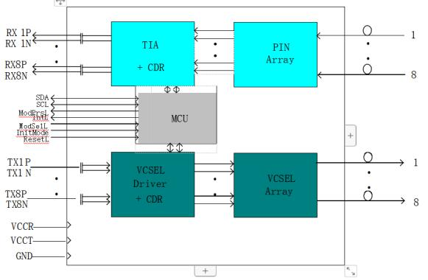
Pin Assignment
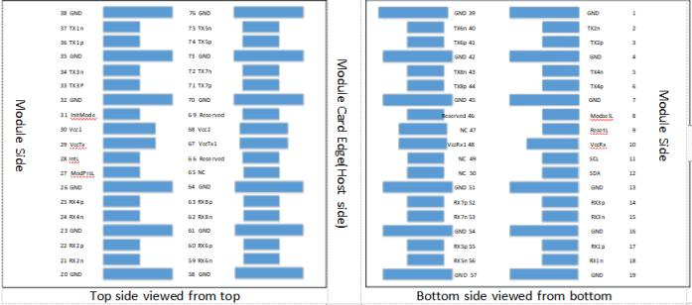

400G QSFP-DD SR8 Optical Transceiver
Pin Description
Pin | Symbol | Description | Notes
1 | GND | Ground
2 | Tx2n | Transmitter Inverted Data Input
3 | Tx2p | Transmitter Non Inverted Data Input
4 | GND | Ground
5 | Tx4n | Transmitter Inverted Data Input
6 | Tx4p | Transmitter Non Inverted Data Input
7 | GND | Ground
8 | ModselL | Module Select
9 | ResetL | Module Reset
10 | VCC Rx | Receiver +3.3V DC Power Supply
11 | SCL | I2C Serial Clock
12 | SDA | I2C Serial Data
13 | GND | Ground
14 | Rx3p | Receiver Non Inverted Differential Output
15 | Rx3n | Receiver Inverted Differential Output
16 | GND | Ground
17 | Rx1p | Receiver Non Inverted Differential Output
18 | Rx1n | Receiver Inverted Differential Output
19 | GND | Ground
20 | GND | Ground
21 | Rx2n | Receiver Inverted Differential Output
22 | Rx2p | Receiver Non Inverted Differential Output
23 | GND | Ground
24 | Rx4n | Receiver Inverted Differential Output
25 | Rx4p | Receiver Non Inverted Differential Output
26 | GND | Ground
27 | ModPrsL | Module Present
28 | IntL | Interrupt
29 | VCC Tx | Transmitter +3.3V DC Power Supply
30 | VCC 1 | +3.3V DC Power Supply
31 | Init Mode | Initialization Mode

400G QSFP-DD SR8 Optical Transceiver

32 | GND | Ground
33 | Tx3p | Transmitter Non Inverted Data Input
34 | Tx3n | Transmitter Inverted Data Input
35 | GND | Ground
36 | Tx1p | Transmitter Non Inverted Data Input
37 | Tx1n | Transmitter Inverted Data Input
38 | GND | Ground
39 | GND | Ground
40 | Tx6n | Transmitter Inverted Data Input
41 | Tx6p | Transmitter Non Inverted Data Input
42 | GND | Ground
43 | Tx8n | Transmitter Inverted Data Input
44 | Tx8p | Transmitter Non Inverted Data Input
45 | GND | Ground
46 | Reserved | No connect
47 | NC | No connect
48 | VCC Rx1 | +3.3V DC Power Supply
49 | NC | No connect
50 | NC | No connect
51 | GND | Ground
52 | Rx7p | Receiver Non Inverted Differential Output
53 | Rx7n | Receiver Inverted Differential Output
54 | GND | Ground
55 | Rx5p | Receiver Non Inverted Differential Output
56 | Rx5n | Receiver Inverted Differential Output
57 | GND | Ground
58 | GND | Ground
59 | Rx6n | Receiver Inverted Differential Output
60 | Rx6p | Receiver Non Inverted Differential Output
61 | GND | Ground

400G QSFP-DD SR8 Optical Transceiver

62 | Rx8n | Receiver Inverted Differential Output
63 | Rx8p | Receiver Non Inverted Differential Output
64 | GND | Ground
65 | NC | No Connect
66 | Reserved | No Connect
67 | VCCTx1 | +3.3V DC Power Supply
68 | VCC2 | +3.3V DC Power Supply
69 | Reserved | No Connect
70 | GND | Ground
71 | Tx7p | Transmitter Non Inverted Data Input
72 | Tx7n | Transmitter Inverted Data Input
73 | GND | Ground
74 | Tx5p | Transmitter Non Inverted Data Input
75 | Tx5n | Transmitter Inverted Data Input
76 | GND | Ground

400G QSFP-DD SR8 Optical Transceiver

Electrical Interface
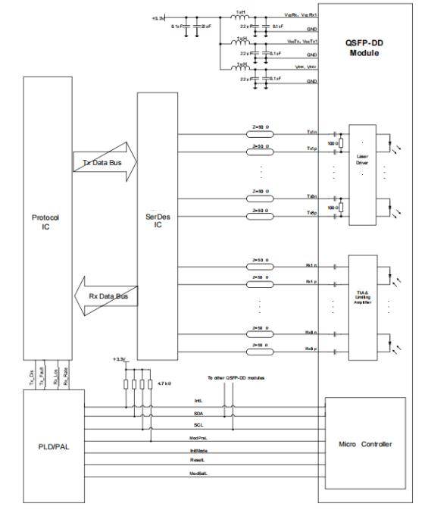

400G QSFP-DD SR8 Optical Transceiver

Mechanical Dimensions
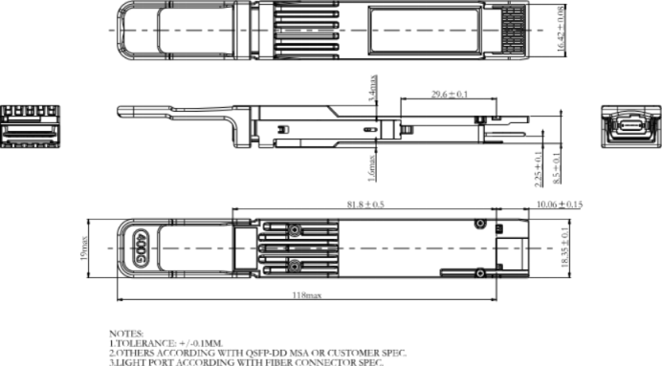

Optical Lane Assignment
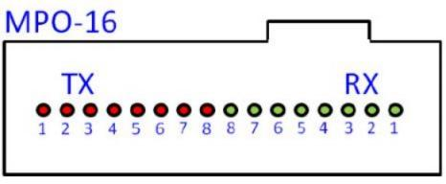
Connector type: MPO-16

400G QSFP-DD SR8 Optical Transceiver

Warnings

Handling Precautions:
This device is susceptible to damage as a result of electrostatic discharge (ESD). A static free environment is highly recommended. Follow guidelines according to proper ESD procedures.
Laser Safety:
Radiation emitted by laser devices can be dangerous to human eyes. Avoid eye exposure to direct or indirect radia- tion.
Notice:
The information provided on this page contains the product target specifications which are subject to change with- out notice.
Check with your Sales Office for product updates, changes in specifications, sample availability and production release dates.
EYE SAFETY
Complies with 21 CFR 1040.10 and 1040.11 except for conformance with IEC 60825-1 Ed.3., as described in La- ser Notice No. 56, dated May 8, 2019.
Complies with IEC/EN 60825-1 and IEC/EN 60825-2. Class 1 laser safety compliant.
INVISIBLE LASER RADIATION.
CAUTION:
Use of controls or adjustments or performance of procedures other than those specified herein may result in haz- ardous radiation exposure.

Contact:
Wuhan Jiuhong Optics Technology Co., Ltd.
TEL: 86-13476016116
E-mail：grace@jh-optics.com
Web：www.jh-optics.com
Address：
Building 1, 4th Floor, Yunqi Free Trade Innovation Port, Donghu Comprehensive Bonded Zone,Donghu High-tech Zone, Wuhan City

