Product Specification
400GBASE SR4 QSFP-DD 100m Transceiver

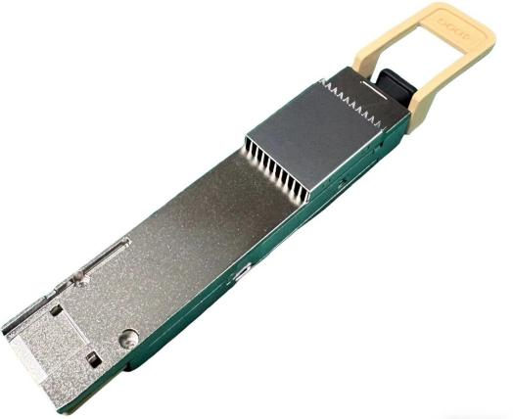
Features
- Hot-pluggable QSFP-DD form factor
- Maximum link length of 100m on OM4 fiber with FEC
● +3.3V single power supply
- Power dissipation < 8W
- Operating case temp Commercial: 0°C to +70 °C
- Single MPO-12 APC connector
- RoHS compliant
- Compliant with IEEE 802.3bs standard: 400GAUI-8 electrical interface

Applications
- 400GBASE-SR4 Ethernet
- Data Center
- Application case 1, 400G SR4, 1 of 400G per port point to point connections
- Application case 2, 2x200G SR2, 2 of 200G per channel breakout connections
- Application case 3, 4x100G SR, 4 of 100G per channel breakout connections

Order Information

Table 1-Order Information
Part No. | Bit Rate (Gbps) | Laser (nm) | Distance note1 | Fiber Type | DDMI | Connector | Temp note2
JH-400G-QDD-SR4 | 425.0 | 850 | 60m@OM3  100m@OM4 | MMF | YES | MPO 1x12 APC | 0℃~+70℃
Note:
- 400 Gigabit Ethernet links over multimode fiber up to 60m on OM3 MMF or 100m on OM4 MMF.
- Case Temperature

Absolute Maximum Ratings

Table2- Absolute Maximum Ratings
Parameter | Symbol | Min. | Typical | Max. | Unit | Notes
Supply Voltage | Vcc3 | -0.5 | - | +3.6 | V
Storage Temperature | Ts | -40 | - | +85 | °C
Operating Humidity | RH | 0 | - | +85 | % | 1
Control Input Voltage | VI | -0.3 | - | VCC+0.5 | V | 1
Note:1 No condensation

Recommended Operating Conditions

Table 3- Recommended operating Conditions
Parameter | Symbol | Min. | Typical | Max. | Unit | Notes
Operating Case Temperature | TC | 0 | - | +70 | °C
Power Supply Voltage | Vcc | 3.135 | 3.3 | 3.465 | V
Power Dissipation | Pd | - | - | 8 | W
Supply Current | Icc | - | - | 2550 | mA
Pre-FEC Bit Error Ratio | - | - | - | 2.4x10⁻⁴ | -
Post-FEC Bit Error Ratio | - | - | - | 1x10⁻¹² | - | 1
Link Distance (OM4) | - | 2 | - | 100 | m | 2
Link Distance (OM3) | - | 2 | - | 60 | m | 2
Note:
- FEC provided by host system
- FEC required on host system to support maximum distance

Electrical Characteristics

Table 4- Electrical Characteristics

Parameter | Symbol | Unit | Min | Typ | Max | Notes
Transmitter
Differential pk-pk input Voltage tolerance | - | mV | 900 | - | -
Differential termination mismatch | - | % | - | - | 10
Single-ended voltage tolerance range | - | V | -0.4 | - | 3.3
DC common mode Voltage | - | mV | -350 | - | 2850
Receiver
AC common-mode output Voltage (RMS) | - | mV | - | - | 17.5
Differential output Voltage | - | mV | - | - | 900
Near-end Eye height, differential | - | mV | 70 | - | -
Far-end Eye height, differential | - | mV | 30 | - | -
Far end pre-cursor ISI ratio | - | % | -4.5 | - | 2.5
Differential Termination Mismatch | - | % | - | - | 10
Transition Time (min, 20% to 80%) | - | ps | 9.5 | - | -
DC common mode Voltage | - | mV | -350 | - | 2850

Table 5-Optical Characteristics
Parameter | Symbol | Unit | Min | Typ | Max | Notes
Transmitter
Signaling Rate per Lane | SR | Gbd | 53.125 ± 100 ppm
Modulation format | - | - | PAM4
Center wavelength | CW | nm | 842 | - | 948
RMS Spectral Width | SW | dBm | - | - | 0.65 | 1

Average Launch Power per Lane | AOP | dBm | -4.6 | - | 4.0
Outer Optical Modulation Amplitude (OMAouter), each lane (min)  For max(TECQ,TDECQ)≤1.8dB  For 1.8<max(TECQ,TDECQ)≤4.4dB | TxOMA | dBm | -2.6  -4.4+max( TECQ,TDE CQ) | - | 3.5
Transmitter and Dispersion Eye Closure for PAM4  (TDECQ), each lane | TDECQ | dB | - | - | 4.4
Overshoot/undershoot | - | % | - | - | 29
Transimitter power excursion,each lane | - | dBm | - | - | 2.3
Transition Time | Tt | ps | - | - | 17
Average Launch Power of OFF Transmitter,  each lane | TOFF | dBm | - | - | -30
Extinction Ratio, each lane | ER | dB | 2.5 | - | -
Encircled flux | - | dBm | ≥86% at 19μm  ≤30% at 4.5μm |  |  | 2
Receiver
Signaling Rate per Lane | SR | Gbd | 53.125 ± 100 ppm
Modulation format | - | - | PAM4
Wavelength | W | nm | 842 | - | 948
Damage Threshold, average optical power,  each lane | DT | dBm | 5 | - | - | 3
Average Receive Power, each lane | RXPx | dBm | -6.3 | - | 4 | 4
Receive Power (OMA) per Lane | RxOMA | dBm | - | - | 3.5
Receiver sensitivity (OMA outer) (max) for TECQ≤1.8dB  for 1.8＜TECQ≤4.4dB | Rx Sen | dBm | - | - | -4.4  -6.2+TE  CQ | 5
LOS Assert | LOSA | dBm | -15 | - | -
LOS De-assert | LOSD | dBm | - | - | -9.2
LOS Hysteresis | LOSH | dB | 0.5 | - | -
OMA outer of each aggressor lane | - | dBm | - | 3.5 | -

Note:
- RMS spectral width is the standard deviation of the spectrum
- Receiver sensitivity (OMAouter) is informative and is defined for a transmitter with a value of TECQ up to
4.4 dB

Recommended Interface
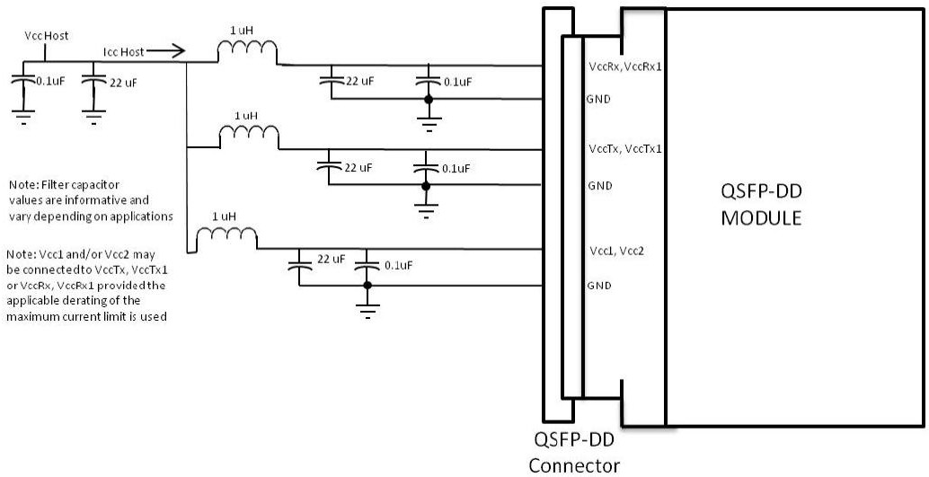
Figure 1, Recommended Interface Circuit

Pin arrangement
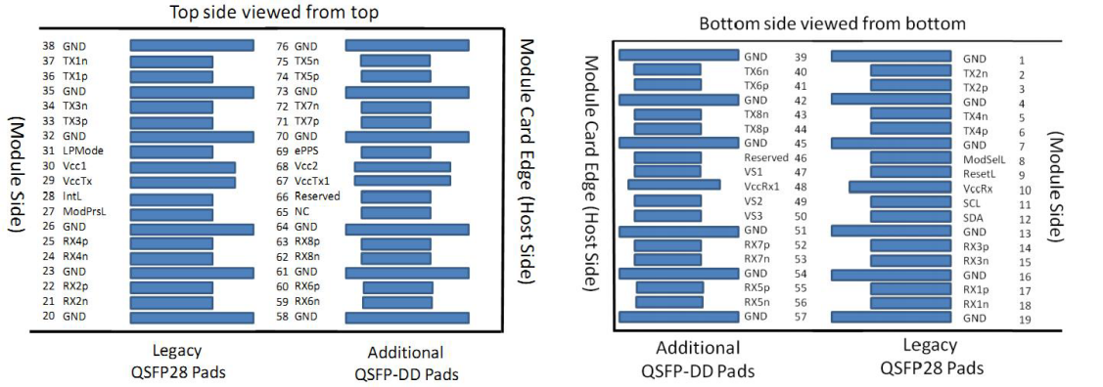

Table 7-Pin Function Definitions
Figure 2, Pin View

Pin # | Logic | Symbol | Definition | Pin # | Logic | Symbol | Definition
1 |  | GND | Ground | 39 |  | GND | Ground
2 | CML-I | Tx2n | Transmitter Inverted Data Input | 40 | CML-I | Tx6n | Transmitter Inverted Data Input
3 | CML-I | Tx2p | Transmitter Non-inverted Data Input | 41 | CML-I | Tx6p | Transmitter Non-inverted Data Input
4 |  | GND | Ground | 42 |  | GND | Ground
5 | CML-I | Tx4n | Transmitter Inverted Data Input | 43 | CML-I | Tx8n | Transmitter Inverted Data Input
6 | CML-I | Tx4p | Transmitter Non-inverted Data Input | 44 | CML-I | Tx8p | Transmitter Non-inverted Data Input
7 |  | GND | Ground | 45 |  | GND | Ground
8 | LVTTL-I | ModSelL | Module Select | 46 |  | Reserved
9 | LVTTL-I | ResetL | Module Reset | 47 |  | VS1 | Module Vendor Specific 1
10 |  | VccRx | +3.3V Power Supply Receiver | 48 |  | VccRx1 | 3.3V Power Supply
11 | LVCMOS-I/O | SCL | 2-wire serial interface clock | 49 |  | VS2 | Module Vendor Specific 2
12 | LVCMOS-I/O | SDA | 2-wire serial interface data | 50 |  | VS3 | Module Vendor Specific 3
13 |  | GND | Ground | 51 |  | GND | Ground
14 | CML-O | Rx3p | Receiver Non-inverted Data Output | 52 | CML-O | Rx7p | Receiver Non-inverted Data Output
15 | CML-O | Rx3n | Receiver Inverted Data Output | 53 | CML-O | Rx7n | Receiver Inverted Data Output
16 |  | GND | Ground | 54 |  | GND | Ground
17 | CML-O | Rx1p | Receiver Non-inverted Data Output | 55 | CML-O | Rx5p | Receiver Non-inverted Data Output
18 | CML-O | Rx1n | Receiver Inverted Data Output | 56 | CML-O | Rx5n | Receiver Inverted Data Output
19 |  | GND | Ground | 57 |  | GND | Ground

20 |  | GND | Ground | 58 |  | GND | Ground
21 | CML-O | Rx2n | Receiver Inverted Data Output | 59 | CML-O | Rx6n | Receiver Inverted Data Output
22 | CML-O | Rx2p | Receiver Non-inverted Data Output | 60 | CML-O | Rx6p | Receiver Non-inverted Data Output
23 |  | GND | Ground | 61 |  | GND | Ground
24 | CML-O | Rx4n | Receiver Inverted Data Output | 62 | CML-O | Rx8n | Receiver Inverted Data Output
25 | CML-O | Rx4p | Receiver Non-inverted Data Output | 63 | CML-O | Rx8p | Receiver Non-inverted Data Output
26 |  | GND | Ground | 64 |  | GND | Ground
27 | LVTTL-O | ModPrsL | Module Present | 65 |  | NC | Not connected
28 | LVTTL-O | IntL | Interrupt | 66 |  | Reserved
29 |  | VccTx | +3.3V Power Supply Transmitter | 67 |  | VccTx1 | 3.3V Power Supply
30 |  | Vcc1 | +3.3V Power Supply | 68 |  | Vcc2 | 3.3V Power Supply
31 | LVTTL-I | InitMode | Initialization mode | 69 |  | Reserved
32 |  | GND | Ground | 70 |  | GND | Ground
33 | CML-I | Tx3p | Transmitter Non-inverted Data Input | 71 | CML-I | Tx7p | Transmitter Non-inverted Data Input
34 | CML-I | Tx3n | Transmitter Inverted Data Input | 72 | CML-I | Tx7n | Transmitter Inverted Data Input
35 |  | GND | Ground | 73 |  | GND | Ground
36 | CML-I | Tx1p | Transmitter Non-inverted Data Input | 74 | CML-I | Tx5p | Transmitter Non-inverted Data Input
37 | CML-I | Tx1n | Transmitter Inverted Data Input | 75 | CML-I | Tx5n | Transmitter Inverted Data Input
38 |  | GND | Ground | 76 |  | GND | Ground

Memory Map
Compatible with CMIS rev 5.2.

Optical interface arrangement
The optical port is a male MPO connector receptacle, with fiber lane assignments as shown in Figure 3
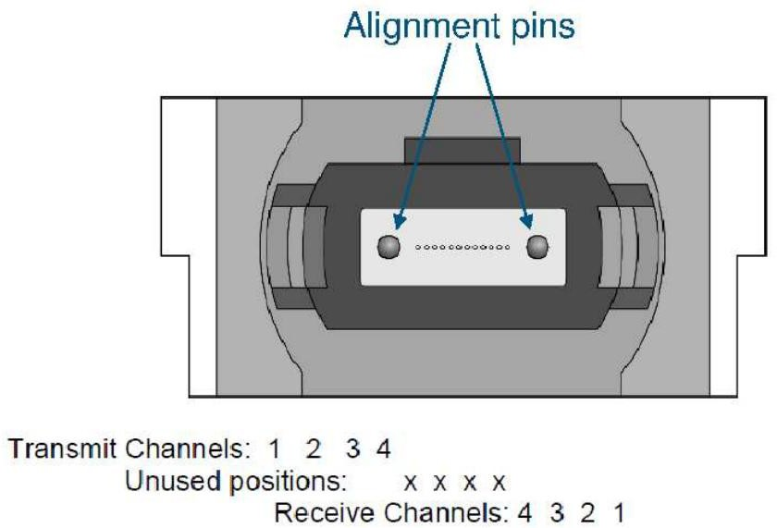

Mechanical
Figure 3, Optical interface arrangement.

400G SR4 QSFP-DD transceivers are compatible with the QSFP-DD Type 2 Specification for pluggable form factor modules.

Unit mm

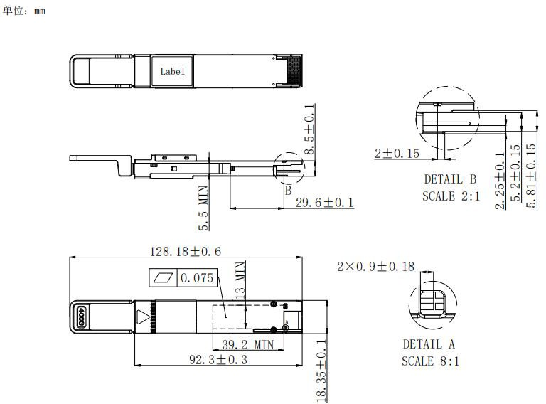

Warnings
Figure 4, Mechanical Diagram

Handling Precautions: This device is susceptible to damage as a result of electrostatic discharge (ESD).
A static free environment is highly recommended. Follow guidelines according to proper ESD procedures.
Laser Safety: Radiation emitted by laser devices can be dangerous to human eyes. Avoid eye exposure to direct or indirect radiation.

