
400G DR4 OSFP

Features
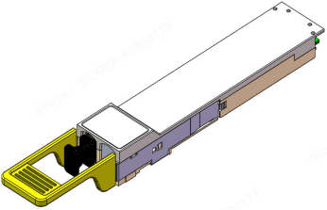
l OSFP Hot-pluggable form factor
l Maximum link length of 500m on SMF with FEC
l Single 3.3V power supply
l Power dissipation 8W
l Support DDMI
l Operating case temp: 0°C to +70 °C
l Single APC MPO-12 connector
l Compliant with CMIS 5.2
l Anti-sulphuration Compliant
l RoHS 6 Compliant

Applications
l 400GBASE-DR4
l 200GBASE-DR2
l 100GBASE-DR1

Order Information
Table 1-Order Information
Part No. | Bit Rate (Gbps) | Laser (nm) | Distance note1 | Fiber Type | DDMI | Connector | Tempnote2
JH-400G-OSFP-DR4 | 425 | 1311 | 500m | SMF | YES | APC MPO12 | 0℃~+70℃
Note:
1. SMF with FEC.
2. Case Temperature.

Absolute Maximum Ratings
Table2- Absolute Maximum Ratings
Parameter | Symbol | Min. | Typ. | Max. | Unit | Notes
Supply Voltage | VCC | -0.5 | - | +3.6 | V
Storage Temperature | Ts | -40 | - | +85 | °C
Operating Case Temperature | TC | -5 | - | +75 | °C
Operating Humidity | RH | 5 | - | 85 | % | 1
Control Input Voltage | Vcontrol | -0.3 | - | VCC+0.3 | V | 1
Optical Receiver Damage Threshold,  each lane | Rdamage | 5 |  |  | dBm
Note:1 No condensation.

Recommended Operating Conditions
Table 3- Recommended operating Conditions
Parameter | Symbol | Min. | Typ. | Max. | Unit | Notes
Operating Case Temperature | TC | 0 | - | +70 | °C
Power Supply Voltage | Vcc | 3.135 | 3.3 | 3.465 | V
Power Dissipation | Pd | - | - | 8 | W
Operating Humidity | RH | 5 | - | 85 | % | 1
Note:1 No condensation.

Electrical Characteristics
Table 4- Electrical Characteristics
Parameter | Symbol | Min. | Typ. | Max. | Unit | Notes
Host to Module Side
Data Rate, each lane | DR | 53.125 |  |  | GBd
Data Rate Variation | - | -100 | - | +100 | ppm
Modulation Format | - | PAM4 |  |  | -
Differential Input Peak-peak Voltage  Tolerance | Vin-diff | 750 | - | - | mVpp
Differential Input Termination  Mismatch | - | - | - | 10 | %
Single-ended Voltage Tolerance | - | -0.4 | - | 3.3 | V
DC Common-mode Voltage Tolerance | - | -0.35 | - | 2.85 | V
Module to Host Side
Data Rate, each lane | DR | 53.125 |  |  | GBd
Data Rate Variation | - | -100 | - | +100 | ppm
Modulation Format | - | PAM4 |  |  | -
Differential Output Peak-to-peak  Voltage (Short mode) | Vout-diff,short | - | - | 600 | mVpp
Differential Output Peak-to-peak  Voltage (Long mode) | Vout-diff,Long | - | - | 845 | mVpp
Transition Time (20% to 80%) | Tr/tf | 8.5 | - | - | ps
Eye Height | EH | - | - | 15 | mV
Vertical Eye Closure | VEC | - | - | 12 | dB
Differential Output Termination  Mismatch | - | - | - | 10 | %
DC Common-mode Voltage Tolerance | - | -0.35 | - | 2.85 | V

Optical Characteristics
Table 5-Optical Characteristics

Parameter | Symbol | Min. | Typ. | Max. | Unit | Notes
Optical Transmitter

Data Rate, each lane | DR | 53.125±100 ppm |  |  | GBd
Data Rate Variation | - | -100 | - | +100 | ppm
Modulation Format | - | PAM4 |  |  | -
Center Wavelength Lane0 | L0 | 1304.5 | 1311 | 1317.5 | nm
Center Wavelength Lane1 | L1 | 1304.5 | 1311 | 1317.5 | nm
Center Wavelength Lane2 | L2 | 1304.5 | 1311 | 1317.5 | nm
Center Wavelength Lane3 | L3 | 1304.5 | 1311 | 1317.5 | nm
Single-mode Suppression Ration , each  lane | SMSR | 30 |  |  | dB
Average Launch Power, each lane | PTxAOP | -2.9 | - | 4 | dBm | 1
Outer Optical Modulation Amplitude,  each lane | TxOMA | -0.8 | - | 4.2 | dBm | 2
Extinction Ration, each lane | ER | 3.5 | 4.5 | - | dB
Launch Power in OMA minus TDECQ,  each lane | - | -2.2 | - | - | dBm
Transmitter and Dispersion Eye Closure  for PAM4, each lane | TDECQ | - | - | 3.4 | dB
RIN OMA | RIN | - | - | -136 | dB/ Hz
Optical Return Loss Tolerance | ORL | - | - | 21.4 | dB
Transmitter Reflectance | - | - | - | -26 | dB
Average Launch Power of OFF Transmitter, each lane | - | - | - | -15 | dBm
Optical Receiver
Data Rate, each lane | DR | 53.125±100 ppm |  |  | GBd
Data Rate Variation | - | -100 | - | +100 | ppm
Modulation Format | - | PAM4 |  |  | -
Receiver Wavelength Range Lane0 | L0 | 1304.5 | 1311 | 1317.5 | nm
Receiver Wavelength Range Lane1 | L1 | 1304.5 | 1311 | 1317.5 | nm
Receiver Wavelength Range Lane2 | L2 | 1304.5 | 1311 | 1317.5 | nm
Receiver Wavelength Range Lane3 | L3 | 1304.5 | 1311 | 1317.5 | nm
Average Receiver Power, each lane | PRxAOP | -5.9 | - | 4 | dBm
Receive Power(OMAouter), each lane | RxOMA | - | - | 4.2 | dBm
Receiver Reflectance | - | - | - | -26 | dB
Receiver Sensitivity(OMAouter), each  lane | OMASen | - | - | -4.5 | dBm | 3
Stressed Receiver  Sensitivity(OMAouter), each lane | - | - | - | -1.9 | dBm
Stressed Eye Closure fo  PAM4(SECQ),lane under test | - | - | - | 3.4 | dB
OMAouter of each Aggressor Lane | - | - | - | 4.2 | dBm
Los Assert | LOSAssert | -14 | - | -11.5 | dBm

Los De-assert | LOSDe-assert | -11 | - | -8 | dBm
LOS Hysteresis | LOSHys | 0.5 | - | 4 | dB
Note:
1. Minimum value is informative only and not the principal indicator of signal strength.
2. Transmitter reflectance is defined looking into the transmitter.
3. @BER 1E-6.
Recommended Interface
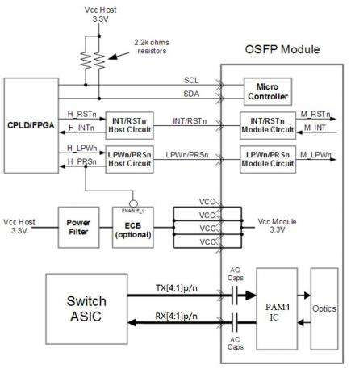
Figure 1 Recommended Interface Circuit

Pin Arrangement
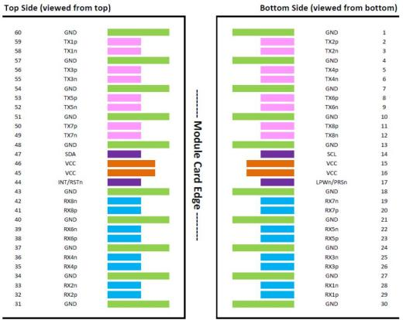
Figure 2 Pin Arrangement

Table 6-Pin Function Definitions
Pin | Symbol | Name/Description | Notes
1 | GND | Ground | 1
2 | TX2p | Transmitter Data Non-Inverted
3 | TX2n | Transmitter Data Inverted
4 | GND | Ground | 1
5 | TX4p | Transmitter Data Non-Inverted
6 | TX4n | Transmitter Data Inverted
7 | GND | Ground | 1
8 | NC | NC,unsued | 2
9 | NC | NC,unsued | 2
10 | GND | Ground | 1
11 | NC | NC,unsued | 2
12 | NC | NC,unsued | 2
13 | GND | Ground | 1
14 | SCL | 2-wire Serial interface clock | 3
15 | VCC | +3 .3V Power
16 | VCC | +3 .3V Power
17 | LPWn/PRSn | Low-Power Mode/Module Present | 4

18 | GND | Ground | 1
19 | NC | NC,unsued | 2
20 | NC | NC,unsued | 2
21 | GND | Ground | 1
22 | NC | NC,unsued | 2
23 | NC | NC,unsued | 2
24 | GND | Ground | 1
25 | RX3n | Receiver Data Inverted
26 | RX3p | Receiver Data Non-Inverted
27 | GND | Ground | 1
28 | RX1n | Receiver Data Inverted
29 | RX1p | Receiver Data Non-Inverted
30 | GND | Ground | 1
31 | GND | Ground | 1
32 | RX2p | Receiver Data Non-Inverted
33 | RX2n | Receiver Data Inverted
34 | GND | Ground | 1
35 | RX4p | Receiver Data Non-Inverted
36 | RX4n | Receiver Data Inverted
37 | GND | Ground | 1
38 | NC | NC,unsued | 2
39 | NC | NC,unsued | 2
40 | GND | Ground | 1
41 | NC | NC,unsued | 2
42 | NC | NC,unsued | 2
43 | GND | Ground | 1
44 | INT/ RSTn | Module Interrupt / Module Reset | 5
45 | VCC | +3 .3V Power
46 | VCC | +3 .3V Power
47 | SDA | 2-wire Serial interface data | 3
48 | GND | Ground | 1
49 | NC | NC,unsued | 2
50 | NC | NC,unsued | 2
51 | GND | Ground | 1
52 | NC | NC,unsued | 2
53 | NC | NC,unsued | 2
54 | GND | Ground | 1
55 | TX3n | Transmitter Data Inverted
56 | TX3p | Transmitter Data Non-Inverted
57 | GND | Ground | 1
58 | TX1n | Transmitter Data Inverted

59 | TX1p | Transmitter Data Non-Inverted
60 | GND | Ground | 1
Note 1. Circuit ground is internally isolated from chassis ground. Note 2. 400G DR4 unused PINs, NC.
Note 3. Open-Drain with pull up resistor on Host.
Note 4. See pin description for required circuit as shown in Figure 3.
Note 5. See pin description for required circuit as shown in Figure 4.

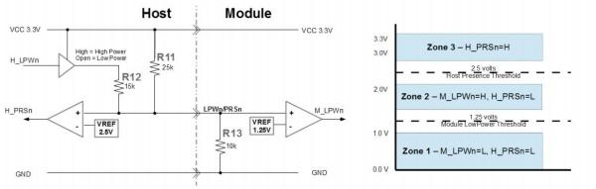
Figure 3 LPWn/PRSn circuit and voltage zones
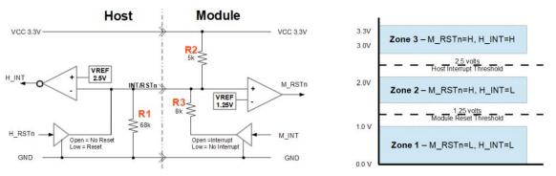
Figure 4 INT/RSTn circuit and voltage zones

Memory Map
Compatible with CMIS rev 5.2.

400G DR4 OSFP

Optical Interface Arrangement
The optical port is a male MPO connector receptacle, with fiber lane assignments as shown in Figure 5.
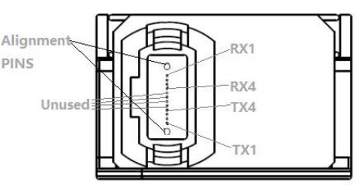
Figure 5 Optical interface arrangement
Mechanical
400G OSFP DR4 transceivers are compatible with OSFP module specification. (Unit: mm)

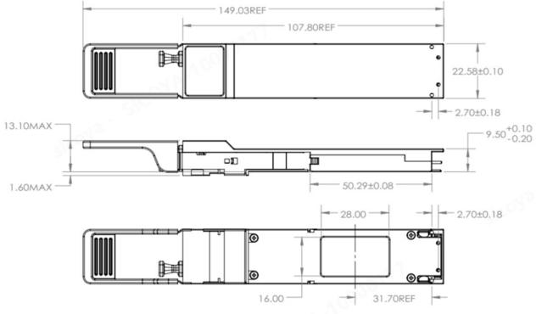

Figure 6 Mechanical Diagram

Warnings
Handling Precautions: This device is susceptible to damage as a result of electrostatic discharge (ESD).
A static free environment is highly recommended. Follow guidelines according to proper ESD procedures.
Laser Safety: Radiation emitted by laser devices can be dangerous to human eyes. Avoid eye exposure to direct or indirect radiation.
Contact:
Wuhan Jiuhong Optics Technology Co., Ltd.
TEL: 86-13476016116
E-mail：grace@jh-optics.com
Web：www.jh-optics.com
Address：
Building 1, 4th Floor, Yunqi Free Trade Innovation Port, Donghu Comprehensive Bonded Zone,Donghu High-tech Zone, Wuhan City

