Product Specification
200G QSFP56 2km FR4 Transceivers
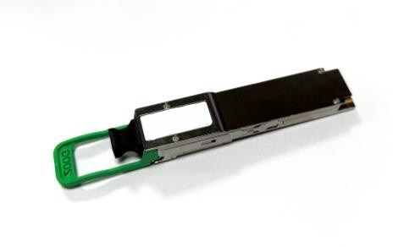

Features
- Up to 2km transmission on single mode fiber with FEC
- 4x53.125G PAM4 electrical interface (200GAUI-4)

- Supports 212.5Gb/s aggregate bit rate

- Maximum power consumption 6.5W

- 4 CWDM lanes MUX/DEMUX design

- Non-hermetic package design

- Operating case temperature: 0℃~70℃

- Single +3.3V power supply

- I2C digital management interface

- LC duplex connector

Applications
- Data Center Interconnect

Compliance
- IEEE 802.3-2018

- QSFP-DD-Hardware MSA

- SFF-8661

- SFF-8679

- CMIS Rev4.0

- RoHS compliance

- GR-468-CORE

Description

The JH-200G-QSFP56-FR4 transceiver is a high performance, cost effective module for optical data communication applications supporting 200G. And its transmission distance up to 2km on SM fiber. The transceiver consists of two sections. The transmitter section incorporates a quad channel EA-DFB Laser and a DSP. The receiver section consists of a quad channel PIN photodiode, a quad channel trans-impedance preamplifier (TIA) and a DSP shared with the transmitter.

The JH-200G-QSFP56-FR4 can convert 4-channel 53.125Gb/s electrical data to 4-channel optical signals, and multiplex them into a single channel for 212.5Gb/s optical transmission. Similarly, they optically de-multiplexes a 212.5Gb/s input into 4-channel signals, and convert them to 4-channel output electrical data on the receiver side. It has been designed to meet the harshest external operating conditions including temperature, humidity and EMI. The module offers very high functionality and feature integration, accessible via a two-wire serial interface.

Absolute Maximum Ratings

Table1-Absolute Maximum Ratings
Parameter | Symbol | Min | Typical | Max | Unit | Notes
Storage Temperature | TSTG | -40 |  | 85 | ºC
Operating Relative Humidity | RH | 5 |  | 85 | % | Note1
Supply Voltage | VCC | -0.3 | 3.3 | 3.6 | V
Note:
[1] Non-condensing.

Recommended Operating Conditions

Table2-Recommended Operating Conditions
Parameter | Symbol | Min | Typical | Max | Unit | Notes
Case temperature | Tcase | 0 |  | 70 | ℃
Supply Voltage | VCC | 3.135 | 3.3 | 3.465 | V
Supply Current | ICC |  |  | 2.073 | A
Module Power Dissipation | P |  |  | 6.5 | W
Link Distance with G.652 | L |  |  | 2 | km

Optical，Electrical Characteristic

JH-200G-QSFP56-FR4

Tested under recommended operating conditions, unless otherwise noted Table3-Transmitter Operating Characteristic-Optical，Electrical
Parameter | Symbol | Min | Typical | Max | Units | Notes
Optical Data Rate, each Lane |  | 26.5625±100ppm |  |  | GBd
Modulation Format |  | PAM4 |  |  | -
Line wavelengths | λ1 | 1264.5 | 1271 | 1277.5 | nm
Line wavelengths | λ2 | 1284.5 | 1291 | 1297.5 | nm
Line wavelengths | λ3 | 1304.5 | 1311 | 1317.5 | nm
Line wavelengths | λ4 | 1324.5 | 1331 | 1337.5 | nm
Average Launch Power, each lane | PAVG | -4.2 |  | 4.7 | dBm
Total Average launch power | PTOTAL |  |  | 10.7 | dBm
Optical Modulation Amplitude  (OMA), each lane | OMA | -1.2 |  | 4.5 | dBm
Difference in launch Power between any Two  Lanes(OMAouter) |  |  |  | 4 | dB

Average Launch Power of OFF  Transmitter, each Lane |  |  |  | -30 | dBm
Extinction Ratio | ER | 3.5 |  |  | dB
Side-Mode Suppression Ratio | SMSR | 30 |  |  | dB
Launch power in OMA minus TDECQ, each lane ER≥4.5dB  ER＜4.5dB |  | -2.6  -2.5 |  |  | dBm
Transmitter and Dispersion Eye  Closure for PAM4, each Lane | TDECQ |  |  | 3.3 | dB
Optical Return Loss Tolerance |  |  |  | 16.5 | dB
Transmitter Reflectance |  |  |  | -26 | dB
Relative intensity Noise(OMA) |  |  |  | -132 | dB/Hz
Electrical Data Rate, each lane |  | 26.5625±100ppm |  |  | GBd
Differential pk-pk input Voltage  tolerance | Vpp | 900 |  |  | mV | Note1
DC Common Mode Voltage | Vcm | -350 |  | 2850 | mV | Note2
Differential Termination  Resistance Mismatch |  | -10 |  | 10 | %
Module Stressed Input Test |  | IEEE 802.3bs 120E.3.4.1 |  |  |  | Note3
Notes:
- With the exception to IEEE 802.3bs 120E.3.1.2 that the pattern is PRBS31Q or scrambled idle.
- DC common mode voltage generated by the host. Specification includes effects of ground offset voltage.
- BER specified in IEEE 802.3bs 120E.1.1.

Table4-Receiver Operating Characteristic-Optical，Electrical
Parameter | Symbol | Min | Typical | Max | Units | Notes
Optical Data Rate, each Lane |  | 53.125±100ppm |  |  | GBd
Modulation Format |  | PAM4
Damage Threshold, each lane |  | 5.7 |  |  | dBm
Line wavelengths | λ1 | 1264.5 | 1271 | 1277.5 | nm
Line wavelengths | λ2 | 1284.5 | 1291 | 1297.5 | nm
Line wavelengths | λ3 | 1304.5 | 1311 | 1317.5 | nm
Line wavelengths | λ4 | 1324.5 | 1331 | 1337.5 | nm
Average receiver power, each  lane |  | -8.2 |  | 4.7 | dBm

Receiver power, each lane  (OMA) |  |  |  | 4.5 |  | dBm
Difference in receive Power between any Two  Lanes(OMAouter) |  |  |  | 4.1 |  | dBm
Receiver Sensitivity  (OMAouter) , each lane |  |  |  | -6 |  | dBm
Stressed receiver sensitivity  (OMAouter), each laned (max) |  |  |  | -3.6 |  | dBm
Receiver reflectance |  |  |  | -26 |  | dB
Electrical Data Rate, each lane |  | 26.5625±100ppm |  |  |  | GBd
Differential Termination  Resistance Mismatch |  | -10 |  | 10 |  | %
Differential output Voltage  pk-pk | Vpp |  |  | 900 |  | mV
DC Common Mode Voltage | Vcm | -350 |  | 2850 |  | mV
Near-end Eye Width at 10E-6  probability | EW6 | 0.265 |  |  |  | UI
Near-end Eye Height at 10E-6  probability | EH6 | 70 |  |  |  | mV
Far-end Eye Width at 10E-6  probability | EW6 | 0.2 |  |  |  | UI
Far-end Eye Height at 10E-6  probability | EH6 | 30 |  |  |  | mV
Transition time | Trise/Tfall | 9.5 |  |  |  | ps | Note1
Note:
[1] 20%~80%.

Digital Diagnostic Functions and Control and Status I/O Timing Characteristics

Table5- Digital Diagnostic Functions
Parameter | Symbol | Min | Typical | Max | Units | Notes
Temperature monitor absolute error | DMI_Temp | -3 |  | 3 | ℃ | Note1
Supply voltage monitor absolute error | DMI_Vcc | -3% |  | 3% | V | Note2
Bias current monitor absolute error | DMI_Ibias | -10% |  | 10% | mA
Laser power monitor absolute error | DMI_Tx | -3 |  | 3 | dB
RX power monitor absolute error | DMI_Rx | -3 |  | 3 | dB
Notes:
- Temperature here is depending on module case around max power dissipation. Temperature monitor is done over operating temperature.
- Supply voltage monitor is done over operating voltage.

Table6- Control and Status I/O Timing Characteristics
Parameter | Symbol | Min | Typical | Max | Units | Notes
MgmtInitDuration | Max MgmtInit  Duration |  |  | 2000 | ms | Note1
ResetL Assert Time | t_reset_init | 10 |  |  | µs | Note2
IntL Assert Time | ton_IntL |  |  | 200 | ms | Note3
IntL Deassert Time | toff_IntL |  |  | 500 | µs | Note4
Rx LOS Assert Time | ton_los |  |  | 100 | ms | Note5
Tx Fault Assert Time | ton_Txfault |  |  | 200 | ms | Note6
Flag Assert Time | ton_flag |  |  | 200 | ms | Note7
Mask Assert Time | ton_mask |  |  | 100 | ms | Note8
Mask Deassert Time | toff_mask |  |  | 100 | ms | Note9
Notes:
- Time from power on, hot plug or rising edge of reset until completion of the MgmtInit State.
- Minimum pulse time on the ResetL signal to initiate a module reset.
- Time from occurrence of condition triggering IntL until Vout:IntL=Vol.
- Time from clear on read operation of associated flag until Vout:IntL=Voh.This includes deassert times for Rx LOS, Tx Fault and other flag bits.
- Time from Rx LOS state to Rx LOS bit set (value = 1b) and IntL asserted.
- Time from Tx Fault state to Tx Fault bit set (value=1b) and IntL asserted.
- Time from occurrence of condition triggering flag to associated flag bit set (value=1b) and IntL asserted.
- Time from mask bit set (value=1b) until associated IntL assertion is inhibited.
- Time from mask bit cleared (value=0b) until associated IntL operation resumes.

Table7- Surge Current Requirements
Parameter | Symbol | Min | Typical | Max | Units | Notes
Power supply voltages VccTx, Vcc1 & VccRx  including ripple, droop and noise below 100kHz |  | 3.135 | 3.3 | 3.465 | V | Note1
Module RMS noise output 10 Hz - 10 MHz |  |  |  | 30 | mV
Module power supply noise tolerance 10 Hz  - 10 MHz (peak-to-peak) | PSNRmod |  |  | 66 | mV
Module inrush - instantaneous peak duration | T_ip |  |  | 50 | µs | Note2
Module inrush - initialization time | T_init |  |  | 500 | ms | Note2
High Power Mode Power Class 3 module
Power Consumption | P_3 |  |  | 7 | W | Note3
Instantaneous peak current | Icc_ip_3 | - | - | 2800 | mA
Sustained peak current | Icc_sp_3 | - | - | 2310 | mA
Steady state current | Icc_3 |  |  | 2232.8 | mA | Note4
Notes:
- Measured at VccTx, Vcc1, VccRx.
- T_ip and T_init are test conditions for measuring inrush current and not characteristics of the module.

- User must read management register for maximum power consumption.
- The module must stay within its declared power class.

Pin-out Definitions

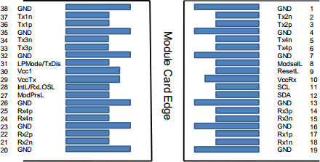

Figure1

Table8-Pin Function Definitions
Pin | Name | Description | Notes
1 | GND | Ground | Note1
2 | Tx2n | Transmitter Inverted Data Input
3 | Tx2p | Transmitter Non-Inverted Data Input
4 | GND | Ground | Note1
5 | Tx4n | Transmitter Inverted Data Input
6 | Tx4p | Transmitter Non-Inverted Data Input
7 | GND | Ground
8 | ModSelL | Module Select
9 | ResetL | Module Reset
10 | Vcc Rx | +3.3V Power Supply Receiver | Note2
11 | SCL | 2-wire serial interface clock
12 | SDA | 2-wire serial interface data
13 | GND | Ground
14 | Rx3p | Receiver Non-Inverted Data Output
15 | Rx3n | Receiver Inverted Data Output
16 | GND | Ground | Note1
17 | Rx1p | Receiver Non-Inverted Data Output
18 | Rx1n | Receiver Inverted Data Output | Note1
19 | GND | Ground | Note1
20 | GND | Ground
21 | Rx2n | Receiver Inverted Data Output
22 | Rx2p | Receiver Non-Inverted Data Output

23 | GND | Ground
24 | Rx4n | Receiver Inverted Data Output
25 | Rx4p | Receiver Non-Inverted Data Output
26 | GND | Ground | Note1
27 | ModPrsL | Module Present
28 | IntL/RxLOSL | Interrupt. Optionally configurable as RxLOSL via the  management interface (SFF-8636).
29 | VccTx | +3.3V Power supply transmitter | Note2
30 | Vcc1 | +3.3V Power supply | Note2
31 | LPMode/TxDis | Low Power Mode. Optionally configurable as TxDis via the  management interface (SFF-8636).
32 | GND | Ground | Note1
33 | Tx3p | Transmitter Non-Inverted Data Input
34 | Tx3n | Transmitter Inverted Data Input
35 | GND | Ground | Note1
36 | Tx1p | Transmitter Non-Inverted Data Input
37 | Tx1n | Transmitter Inverted Data Input
38 | GND | Ground | Note1
Notes：
- GND is the symbol for signal and supply (power) common for the module. All are common within the module and all module voltages are referenced to this potential unless otherwise noted. Connect these directly to the host board signal-common ground plane.
- VccRx, Vcc1 and VccTx are applied concurrently and may be internally connected within the module in any combination.

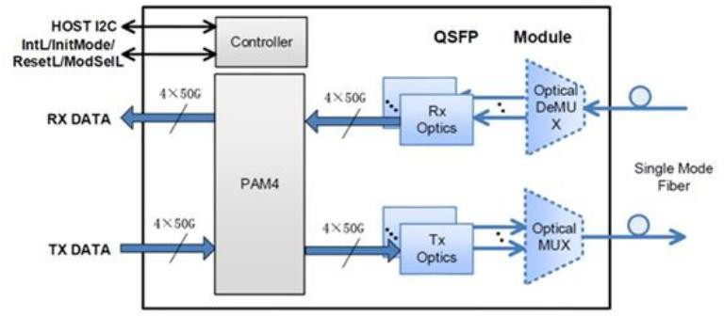
Block Diagram of Transceiver

Figure2
<Transmitter Section>: The JH-200G-QSFP56-FR4 converts 4-channel 53.125Gb/s electrical data to 4-channel 53.125Gb/s optical signals multiplexed for 212Gb/s optical transmission.
<Receiver Section>: Similarly, it optically de-multiplexes a 212.5 Gb/s input into 4-channel signals, and converts them to 4-channel electrical output data on the receiver side.

Recommended Interface Circuit

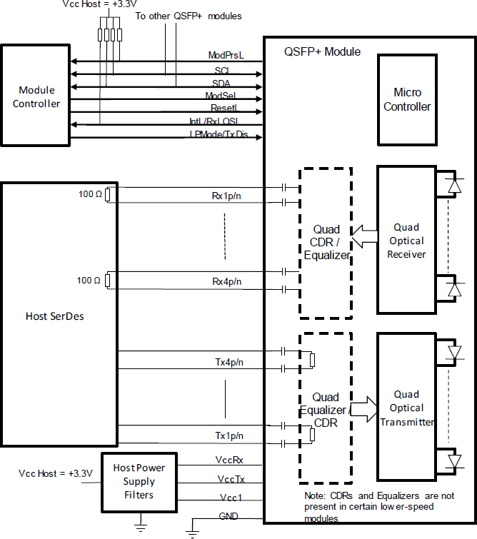
Figure3

Dimensions

Unit: mm

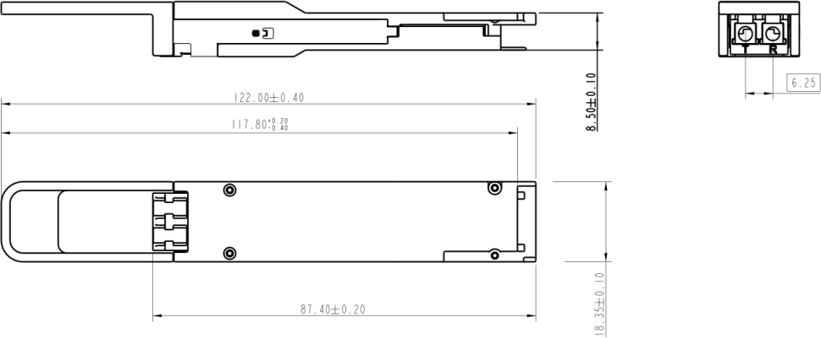

Figure4

Digital Diagnostic Memory Map

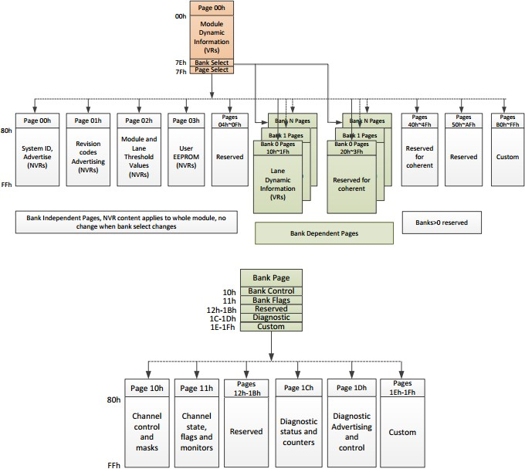

Ordering Information

Table10- Ordering Information
Part No | Specification |  |  |  |  |  |  |  |  | Application
Part No | Pack | Rate | Tx | Pout（per  lane） | Rx | Sen（OMA） | Top | Reach | Others | Application
JH-200G-QSFP56-FR4 | QSFP56 | 200G | CWDM  EA-DFB | -4.2 ~  4.7dBm | PIN | < -6dBm | 0~70℃ | 2Km | DDM/R  oHS | 200G FR4

