Product Specification
200G QSFP56 500m DR4 Transceivers

Features
l QSFP56 MSA compliant
l 4x53.125Gb/s PAM4 electrical interface (200GAUI-4)
l Maximum power consumption 9W
l MPO-12-APC connector
l Up to 500m transmission on single mode fiber
l Operating case temperature: 0℃~70℃
l Single 3.3V power supply
l RoHS-6 compliant

Applications
l 200G Ethernet
l Data Center Applications

Compliance
l QSFP56 MSA Rev2.1
l IEEE 802.3cn
l IEEE 802.3ck
l CMIS Rev5.2
l GR-468-CORE
l RoHS compliance

Description

The transceiver is a high performance, cost effective module for optical data communication applications supporting 200G Ethernet. The transceiver is designed to operate in switch and router applications supporting QSFP56 MSA / 200G DR4 compliant traffic for up to 500m links.

The transceiver can convert 4-channel
53.125Gb/s electrical data to 4-channel
53.125Gb/s optical signals. Similarly, it optically converts 4-channel 53.125Gb/s optical signals to 4-channel electrical data output on the receiver side. It has been designed to withstand the maximum range of external operating conditions including temperature, humidity and EMI. The module offers very high functionality and feature integration, accessible via a two-wire serial interface.

Absolute Maximum Ratings

Table1-Absolute Maximum Ratings

Parameter | Symbol | Min | Typical | Max | Unit | Notes
Storage Temperature | TSTG | -40 |  | 85 | ºC
Operating Relative Humidity | RH | 5 |  | 85 | % | Note1
Supply Voltage | VCC | -0.5 | 3.3 | 3.6 | V
Optical Input Power | PIN |  |  | 5 | dBm
Note:
[ 1] Non-condensing.

Recommended Operating Conditions

Table2-Recommended Operating Conditions

Parameter | Symbol | Min | Typical | Max | Unit | Notes
Case temperature | Tcase | 0 |  | 70 | ℃
Supply Voltage | VCC | 3.135 | 3.3 | 3.465 | V
Supply Current | ICC |  |  | 2871 | mA
Module Power Dissipation | P |  |  | 9 | W

Optical ，Electrical Characteristic

JH-200G-QSFP56-DR4
Tested under recommended operating conditions, unless otherwise noted
Table3-Transmitter Operating Characteristic-Optical ，Electrical

Parameter | Symbol | Min | Typical | Max | Units | Notes
Optical Data Rate, each Lane |  | 26.5625±100ppm |  |  | GBd
Modulation Format |  | PAM4
Line wavelengths | λ | 1304.5 | 1311 | 1317.5 | nm
Average Launch Power, each lane | PAVG | -2.9 |  | 4 | dBm
Optical Modulation Amplitude (OMA), each lane | OMA | -0.8 |  | 4.2 | dBm
Extinction Ratio | ER | 3.5 |  |  | dB
Side-Mode Suppression Ratio | SMSR | 30 |  |  | dB
Launch power in OMA minus TDECQ, each lane |  | -2.2 |  |  | dBm
Transmitter and Dispersion Eye Closure for PAM4, each Lane | TDECQ |  |  | 3.4 | dB
Optical Return Loss Tolerance |  |  |  | 21.4 | dB
Transmitter Reflectance |  |  |  | -26 | dB
Average Launch Power of OFF Transmitter, each Lane |  |  |  | -15 | dBm
Electrical Data Rate, each lane |  | 26.5625±100ppm |  |  | GBd
Differential pk-pk input Voltage tolerance | Vpp | 800 |  |  | mV
DC Common Mode Voltage | Vcm | -350 |  | 2850 | mV | Note1
Differential Termination  Resistance Mismatch |  | -10 |  | 10 | %
Effective return loss |  |  |  | 8.5 | dB
Differential to Common Mode Input Return Loss |  | IEEE 802.3-ck Equation (120G-2) |  |  | dB
Module Stressed Input Test |  | IEEE 802.3ck 120G.3.4.2 |  |  |  | Note2
Notes:
[ 1] DC common mode voltage generated by the host. Specification includes effects of ground offset voltage.
[2] BER specified in IEEE 802.3ck 120G.1.1.

Table4-Receiver Operating Characteristic-Optical ，Electrical

Parameter | Symbol | Min | Typical | Max |  | Units | Notes
Optical Data Rate, each Lane |  | 26.5625±100ppm |  |  |  | GBd
Modulation Format |  | PAM4
Damage Threshold, each lane |  | 5 |  |  |  | dBm
Line wavelengths | λ | 1304.5 | 1311 | 1317.5 |  | nm
Average receiver power, each lane |  | -5.9 |  | 4 |  | dBm
Receiver power, each lane (OMA) |  |  |  | 4.2 |  | dBm
Receiver Sensitivity  (OMAouter) , each lane |  |  |  | -4.4 |  | dBm
Stressed receiver sensitivity (OMAouter), each laned (max) |  |  |  | -1.9 |  | dBm
Receiver reflectance |  |  |  | -26 |  | dB
Electrical Data Rate, each lane |  | 26.5625±100ppm |  |  |  | GBd
Differential Termination Resistance Mismatch |  | -10 |  | 10 |  | %
Differential output Voltage pk-pk | Vpp |  |  | 845 |  | mV
DC Common Mode Voltage | Vcm | -350 |  | 2850 |  | mV | Note 1
Effective return loss |  | 8.5 |  |  |  | dB
Common to differential mode conversion return loss |  | IEEE 802.3-CK Equation (120G-1) |  |  |  | dB
Note:
[ 1] DC common mode voltage generated by the host. Specification includes effects of ground offset voltage.

Digital Diagnostic Functions and Control and Status I/O Timing Characteristics

Table5- Digital Diagnostic Functions

Parameter | Symbol | Min | Typical | Max | Units | Notes
Temperature monitor absolute error | DMI_Temp | -3 |  | 3 | ℃ | Note1
Supply voltage monitor absolute error | DMI_Vcc | -3% |  | 3% | V | Note2
Bias current monitor absolute error | DMI_Ibias | -10% |  | 10% | mA
Laser power monitor absolute error | DMI_Tx | -3 |  | 3 | dB
RX power monitor absolute error | DMI_Rx | -3 |  | 3 | dB
Notes:
[ 1] Temperature here is depending on module case around Max power dissipation. Temperature monitor is done over operating temperature.
[2] Supply voltage monitor is done over operating voltage.

Table6- Control and Status I/O Timing Characteristics

Parameter | Symbol | Min | Typical | Max | Units | Notes
MgmtInitDuration | Max MgmtInit  Duration |  |  | 2000 | ms | Note1
ResetL Assert Time | t_reset_init | 10 |  |  | µs | Note2
IntL Assert Time | ton_IntL |  |  | 200 | ms | Note3
IntL Deassert Time | toff_IntL |  |  | 500 | µs | Note4
Rx LOS Assert Time | ton_los |  |  | 100 | ms | Note5
Flag Assert Time | ton_flag |  |  | 200 | ms | Note6
Mask Assert Time | ton_mask |  |  | 100 | ms | Note7
Mask Deassert Time | toff_mask |  |  | 100 | ms | Note8
Notes:
[ 1] Time from power on, hot plug or rising edge of reset until completion of the MgmtInit State.
[2] Minimum pulse time on the ResetL signal to initiate a module reset.
[3] Time from occurrence of condition triggering IntL until Vout:IntL=Vol.
[4] Time from clear on read operation of associated flag until Vout:IntL=Voh.This includes deassert times for Rx LOS, Tx Fault and other flag bits.
[5] Time from Rx LOS state to Rx LOS bit set (value = 1b) and IntL asserted.
[6] Time from occurrence of condition triggering flag to associated flag bit set (value= 1b) and IntL asserted.
[7] Time from mask bit set (value= 1b) until associated IntL assertion is inhibited.
[8] Time from mask bit cleared (value=0b) until associated IntL operation resumes.

Table7- Surge Current Requirements

Parameter | Symbol | Min | Typical | Max | Units | Notes
VCC |  |  | 3.3 |  | V
Vcc set point accuracy |  | -5 |  | 5 | %
Power Supply Noise including ripple |  |  |  | 50 | mV
Module Maximum Current Inrush with LPMode Pin asserted |  |  |  | 0.55 | A
Module Maximum Current Inrush with LPMode Pin deasserted |  |  |  | 1.3 | A
Module Current Ramp Rate |  |  |  | 100 | mA/us
High Power Mode Power Class 8 module
Power Consumption | P_8 |  |  | 9 | W
Instantaneous peak current | Icc_ip_8 | - | - | 3600 | mA
Sustained peak current | Icc_sp_8 | - | - | 2970 | mA
Steady state current | Icc_8 |  |  | 2871 | mA | Note1
Notes:
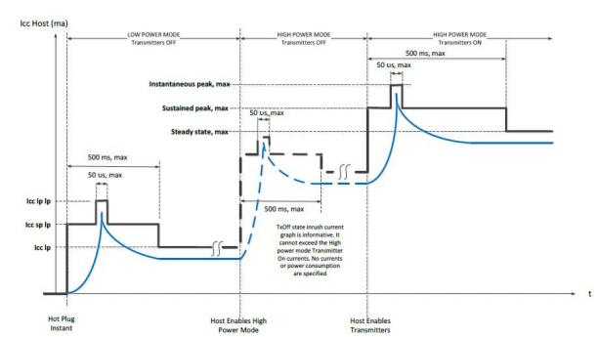
[ 1] The module must stay within its declared power class.

Figure1

Pin-out Definitions
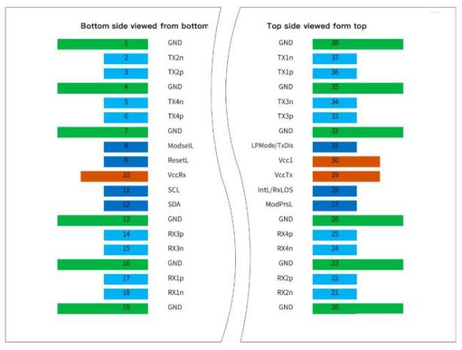

Figure2

Table8-Pin Function Definitions

Pin | Logic | Symbol | Description | Plug Sequence | Notes
1 |  | GND | Ground | 1B | Note1
2 | CML-I | Tx2n | Transmitter Inverted Data Input | 3B
3 | CML-I | Tx2p | Transmitter Non-Inverted Data Input | 3B
4 |  | GND | Ground | 1B | Note1
5 | CML-I | Tx4n | Transmitter Inverted Data Input | 3B
6 | CML-I | Tx4p | Transmitter Non-Inverted Data Input | 3B
7 |  | GND | Ground | 1B | Note1
8 | LVTTL-I | ModSelL | Module Select | 3B
9 | LVTTL-I | ResetL | Module Reset | 3B
10 |  | Vcc Rx | +3.3V Power Supply Receiver | 2B | Note2
11 | LVCMOS-I/O | SCL | 2-wire serial interface clock | 3B
12 | LVCMOS-I/O | SDA | 2-wire serial interface data | 3B
13 |  | GND | Ground | 1B | Note1
14 | CML-O | Rx3p | Receiver Non-Inverted Data Output | 3B
15 | CML-O | Rx3n | Receiver Inverted Data Output | 3B
16 |  | GND | Ground | 1B | Note1
17 | CML-O | Rx1p | Receiver Non-Inverted Data Output | 3B
18 | CML-O | Rx1n | Receiver Inverted Data Output | 3B
19 |  | GND | Ground | 1B | Note1
20 |  | GND | Ground | 1B | Note1
21 | CML-O | Rx2n | Receiver Inverted Data Output | 3B
22 | CML-O | Rx2p | Receiver Non-Inverted Data Output | 3B
23 |  | GND | Ground | 1B | Note1
24 | CML-O | Rx4n | Receiver Non-Inverted Data Output | 3B
25 | CML-O | Rx4p | Receiver Inverted Data Output | 3B
26 |  | GND | Ground | 1B | Note1
27 | LVTTL-I | ModPrsL | Module Present | 3B
28 | LVTTL-I | IntL/RxL  OS | Interrupt/optional RxLOS | 3B
29 |  | VccTx | +3.3V Power supply transmitter | 2B | Note2
30 |  | Vcc1 | +3.3V Power supply | 2B | Note2
31 | LVTTL-I | LPMode/  TxDis | Low Power Mode/optional TX Disable | 3B
32 |  | GND | Ground | 1B | Note1
33 | CML-I | Tx3p | Transmitter Non-Inverted Data Input | 3B
34 | CML-I | Tx3n | Transmitter Inverted Data Input | 3B
35 |  | GND | Ground | 1B | Note1
36 | CML-I | Tx1p | Transmitter Non-Inverted Data Input | 3B
37 | CML-I | Tx1n | Transmitter Inverted Data Input | 3B
38 |  | GND | Ground | 1B | Note1
Notes:
[ 1] GND is the symbol for signal and supply (power) common for the QSFP56 module. All are common within the QSFP56 module and all voltages are referenced to this potential unless otherwise noted. Connect these directly to the host board signal-common ground plane
[2] Vcc Rx, Vcc1 and Vcc Tx are the receiver and transmitter power supplies and shall be applied concurrently.
Requirements, defined for the host side of the Host Edge Card Connector, are listed in Table 4. Vcc Rx, Vcc1and Vcc Tx may be internally connected within the QSFP56 module in any combination. The connector pins are each rated for a maximum current of 1.5A (max. current of 2.0 A is required for high module power of 15-20W)

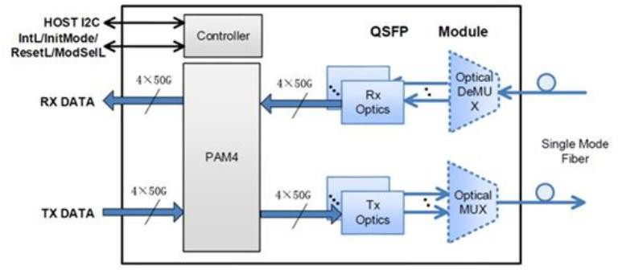
Block Diagram of Transceiver

Figure3

<Transmitter Section>: The 4-channel 53.125Gb/s electrical data to 4-channel 1310nm 53.125Gb/s optical signals for 200Gb/s optical transmission.

<Receiver Section>: Similarly, it optically converts 4-channel 1310nm 53.125Gb/s optical signals to 4-channel electrical data output on the receiver side.

Recommended Interface Circuit

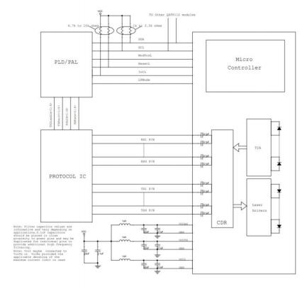
Figure4

Dimensions

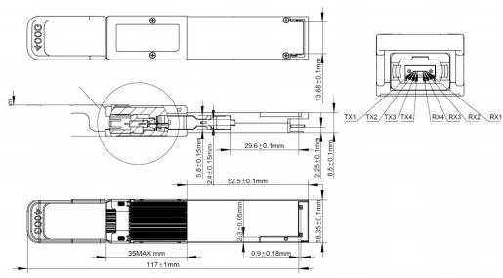
Figure5

Notes:
[ 1] Flatness: 0.05mm for the heat dissipation area and 0.075mm for the rest.
[2] Roughness: 0.8μm for the heat dissipation area and 1.6μm for the rest.

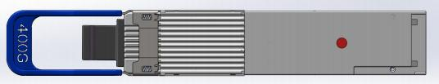
Figure7 Temperature measuring poin

Ordering Information
Table9- Ordering Information
Part No. | Specification |  |  |  |  |  |  |  |  | Application
Part No. | Pack | Soft | Tx | Pout | Rx | Sen | Top | Reach | Others | Application
JH-200G-QSFP56-DR4 | QSFP56 | CMIS  Res5.2 | 1311nm | -2.9 ~  4dBm | PIN | <-4.4 dBm | 0~70  ℃ | 500m | MPO12-APC | 200G DR4

