Product Specification
200Gb/s QSFP-DD 100m SR8 Transceivers

DESCRIPTION
JH-200G-QDD-SR8 is 200Gb/s QSFP-DD SR8 transceiver. It is an assembly of eight full-duplex lanes, where each lane is capable of transmitting data at rates up to 25.78Gb/s, providing an aggregated rate of 206.25 Gb/s. It is compliant to IEEE802.3bm, QSFP-DD MSA Rev5.0, and Common Management Interface Specification Rev5.0.

FEATURES
- Eight-channel full-duplex transceiver
- 25.78Gb/s data rate per channel
- Maximum link length of 70m on OM3(MMF),100m on OM4 (MMF)
- Power dissipation <4W
- Built-in digital diagnostic functions
- Support 10Gbps operation with CDR bypass mode
- 850nm VCSEL transmitter
- Good EMI performance
- Single 3.3V power supply
- RoHS compliant
- Operating case temperature: 0~+70°C

APPLICATION
- 2x100GBASE-SR4 Ethernet

Ordering information
Part Number | Product Description
JH-200G-QDD-SR8 | 200G QSFP-DD 850nm 100m SR8 Tranceivers, C temp，MPO16 APC

ABSOLUTE MAXIMUM RATINGS (TC=25°C, UNLESS OTHERWISE NOTED)
Stresses in excess of the absolute maximum ratings can cause permanent damage to the device. These are absolute stress ratings only. Functional operation of the device is not implied at these or any other conditions in excess of those given in the operational sections of the data sheet. Exposure to absolute maximum ratings will cause permanent damage and/or adversely affect device reliability.
Parameter | Symbol | Min | Typical | Max | Unit | Notes
Storage Temperature | TS | -40 | - | +85 | ºC
Maximum Supply Voltage | Vcc | -0.3 | - | 3.6 | V
Operating Relative Humidity | RH | 15 | - | +85 | %

RECOMMENDED OPERATING CONDITIONS
Parameter | Symbol | Min | Typical | Max | Unit | Notes
Data Rate | DR |  | 206.25 |  | Gb/s | 1
Bit Error Rate | BER |  |  | 5E-5 |  | 2
Operating Case Temperature | Tcase | 0 |  | 70 | ºC
Fiber Length on MMF(OM4) | L |  |  | 100 | m | 3
Notes:
[1] Supports 2x100GBASE-SR4 application.
[2] Tested with a 2³¹ – 1 PRBS.
[3] Requires FEC on the host to support maximum distance, per 100GBASE-SR4.

PIN DESCRIPTIONS
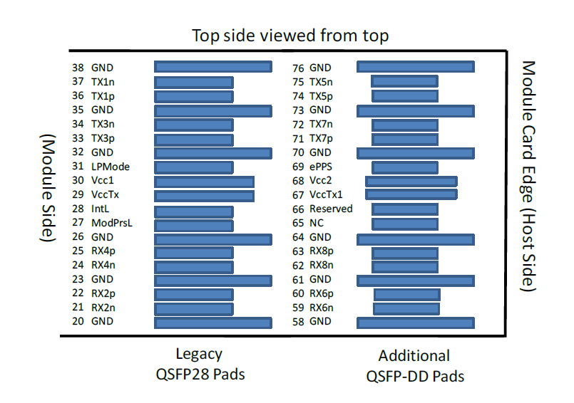
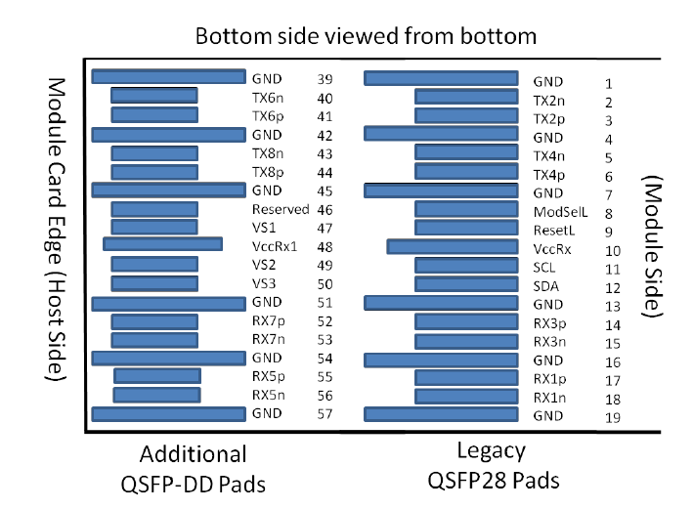
Figure 1 – Pin Definitions

Pad | Logic | Symbol | Description | Plug Seq⁴ | Notes
1 |  | GND | Ground | 1B | 1
2 | CML-I | Tx2n | Transmitter Inverted Data Input | 3B
3 | CML-I | Tx2p | Transmitter Non-Inverted Data Input | 3B
4 |  | GND | Ground | 1B | 1
5 | CML-I | Tx4n | Transmitter Inverted Data Input | 3B
6 | CML-I | Tx4p | Transmitter Non-Inverted Data Input | 3B
7 |  | GND | Ground | 1B | 1
8 | LVTTL-I | ModSelL | Module Select. | 3B
9 | LVTTL-I | ResetL | Module Reset. | 3B
10 |  | VccRx | +3.3V Power Supply Receiver | 2B | 2
11 | LVCMOS-I/O | SCL | 2-wire serial interface clock | 3B
12 | LVCMOS-I/O | SDA | 2-wire serial interface data | 3B
13 |  | GND | Ground | 1B | 1
14 | CML-O | Rx3p | Receiver Non-Inverted Data Output | 3B
15 | CML-O | Rx3n | Receiver Inverted Data Output | 3B
16 |  | GND | Ground | 1B | 1
17 | CML-O | Rx1p | Receiver Non-Inverted Data Output | 3B
18 | CML-O | Rx1n | Receiver Inverted Data Output | 3B
19 |  | GND | Ground | 1B | 1
20 |  | GND | Ground | 1B | 1
21 | CML-O | Rx2n | Receiver Inverted Data Output | 3B
22 | CML-O | Rx2p | Receiver Non-Inverted Data Output | 3B
23 |  | GND | Ground | 1B | 1
24 | CML-O | Rx4n | Receiver Inverted Data Output | 3B
25 | CML-O | Rx4p | Receiver Non-Inverted Data Output | 3B
26 |  | GND | Ground | 1B | 1
27 | LVTTL-O | ModPrsL | Module Present. | 3B
28 | LVTTL-O | IntL | Interrupt. | 3B
29 |  | VccTx | +3.3V Power supply transmitter | 2B | 2
30 |  | Vcc1 | +3.3V Power supply | 2B | 2
31 | LVTTL-I | LPMode | Low Power Mode | 3B
32 |  | GND | Ground | 1B | 1
33 | CML-I | Tx3p | Transmitter Non-Inverted Data Input | 3B
34 | CML-I | Tx3n | Transmitter Inverted Data Input | 3B
35 |  | GND | Ground | 1B | 1
36 | CML-I | Tx1p | Transmitter Non-Inverted Data Input | 3B
37 | CML-I | Tx1n | Transmitter Inverted Data Input | 3B
38 |  | GND | Ground | 1B | 1
39 |  | GND | Ground | 1A | 1
40 | CML-I | Tx6n | Transmitter Inverted Data Input | 3A
41 | CML-I | Tx6p | Transmitter Non-Inverted Data Input | 3A
42 |  | GND | Ground | 1A | 1
43 | CML-I | Tx8n | Transmitter Inverted Data Input | 3A
44 | CML-I | Tx8p | Transmitter Non-Inverted Data Input | 3A
45 |  | GND | Ground | 1A | 1
46 |  | Reserved | For future use | 3A | 3
47 |  | VS1 | Module Vendor Specific 1 | 3A | 3
48 |  | VccRx1 | 3.3V Power Supply | 2A | 2
49 |  | VS2 | Module Vendor Specific 2 | 3A
50 |  | VS3 | Module Vendor Specific 3 | 3A
51 |  | GND | Ground | 1A | 1
52 | CML-O | Rx7p | Receiver Non-Inverted Data Output | 3A
53 | CML-O | Rx7n | Receiver Inverted Data Output | 3A
54 |  | GND | Ground | 1A | 1
55 | CML-O | Rx5p | Receiver Non-Inverted Data Output | 3A
56 | CML-O | Rx5n | Receiver Inverted Data Output | 3A
57 |  | GND | Ground | 1A | 1
58 |  | GND | Ground | 1A | 1
59 | CML-O | Rx6n | Receiver Inverted Data Output | 3A
60 | CML-O | Rx6p | Receiver Non-Inverted Data Output | 3A
61 |  | GND | Ground | 1A | 1
62 | CML-O | Rx8n | Receiver Inverted Data Output | 3A
63 | CML-O | Rx8p | Receiver Non-Inverted Data Output | 3A
64 |  | GND | Ground | 1A | 1
65 |  | NC | No Connect | 3A | 3
66 |  | Reserved | For future use | 3A | 3
67 |  | VccTx1 | 3.3V Power Supply | 2A | 2
68 |  | Vcc2 | 3.3V Power Supply | 2A | 2
69 | LVTTL-I | ePPS | Precision Time Protocol (PTP) reference clock input | 3A | 3
70 |  | GND | Ground | 1A | 1
71 | CML-I | Tx7p | Transmitter Non-Inverted Data Input | 3A
72 | CML-I | Tx7n | Transmitter Inverted Data Input | 3A
73 |  | GND | Ground | 1A | 1
74 | CML-I | Tx5p | Transmitter Non-Inverted Data Input | 3A
75 | CML-I | Tx5n | Transmitter Inverted Data Input | 3A
76 |  | GND | Ground | 1A | 1

[1] QSFP-DD uses common ground (GND)for all signals and supply (power). All are common within the QSFP-DD module and all module voltages are referenced to this potential unless otherwise noted. Connect these directly to the host board signal-common ground plane.
[2] VccRx, VccRx1, Vcc1, Vcc2, VccTx and VccTx1 shall be applied concurrently. Requirements defined for the host side of the Host Card Edge Connector are listed in Table 7. VccRx, VccRx1, Vcc1, Vcc2, VccTx and VccTx1 may be internally connected within the module in any combination. The connector Vcc pins are each rated for a maximum current of 1000 mA.
[3] All Vendor Specific, Reserved, No Connect and ePPS (if not used) pins may be terminated with 50 Ohms to ground on the host. Pad 65 (No Connect) shall be left unconnected within the module. Vendor specific and Reserved pads shall have an impedance to GND that is greater than 10 kOhms and less than 100 pF.
[4] Plug Sequence specifies the mating sequence of the host connector and module. The sequence is 1A, 2A, 3A, 1B, 2B, 3B. (see Figure 2 for pad locations) Contact sequence A will make, then break contact with additional QSFP-DD pads. Sequence 1A,1B will then occur simultaneously, followed by 2A,2B,followed by 3A,3B.

LOW SPEED CONTROL AND SENSE SIGNALS
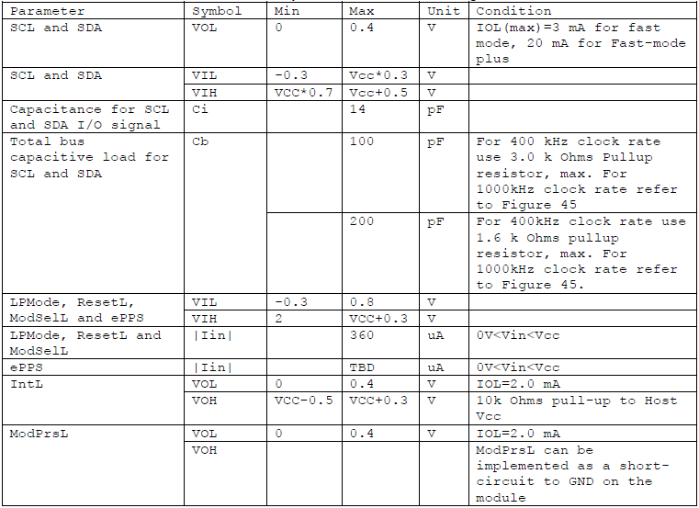
OPTICAL SPECIFICATION
Parameter | Symbol | Min | Typical | Max | Units | Notes
Transmitter
Signaling rate per lane |  | 25.78125±100ppm |  |  | Gb/s | 1
Center wavelength | λ | 840 | 850 | 860 | nm
RMS Spectral Width | SW |  |  | 0.6 | nm
Transmit Average Power per Lane | Pout | -8.4 |  | 2.4 | dBm
Optical Extinction Ratio | ER | 2 |  |  | dB
Average launch power of OFF transmitter, per lane |  |  |  | -30 | dBm
Receiver
Signaling rate per lane |  | 25.78125±100ppm |  |  | Gb/s | 1
Center wavelength | λ | 840 | 850 | 860 | nm
Average Receive Power per Lane | RXP | -7.2 |  | 2.4 | dBm | 2
LOS De-Assert | LOSD |  |  | -7.5 | dBm
LOS Assert | LOSA | -30 |  |  | dBm
LOS Hysteresis | LOSh | 0.5 |  |  | dB
Notes:
[1] Transmitter and Receiverconsists of 4 lasers and photodiode operating at 25.78Gb/s each.
[2] Average received power where the BER=5x10⁻⁵，measured with a PRBS 2³¹-1 teset pattern@25.78Gb/s.

Module Memory Map
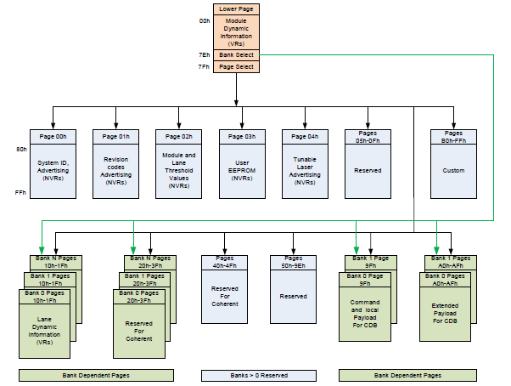
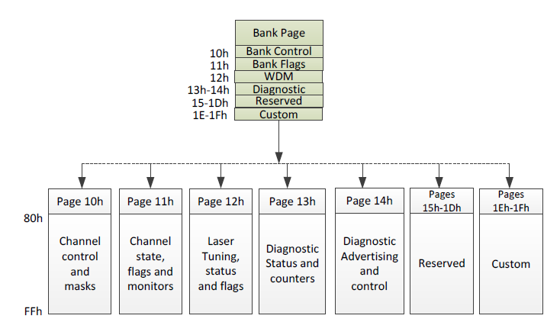
Figure 2 – QSFP-DD Memory Map

DIGITAL DIAGNOSTIC SPECIFICATION
Parameter | Symbol | Accuracy | Units | Notes
Transceiver Case Temperature | DMI_TEMP | ±3 | ℃ | Over operating temp
Supply voltage monitor absolute error | DMI _VCC | ±3% | V | Full operating range
Channel Bias current monitor | DMI_IBIAS | ±3% | mA | Per channel
Channel RX power monitor absolute error | DMI_RX | ±3 | dB | Per channel
Channel TX power monitor absolute error | DMI_TX | ±3 | dB | Per channel
OPTICAL INTERFACE LANES AND ASSIGNMENT
QSFP-DD optical interface port is a male MPO-16 APC receptacle

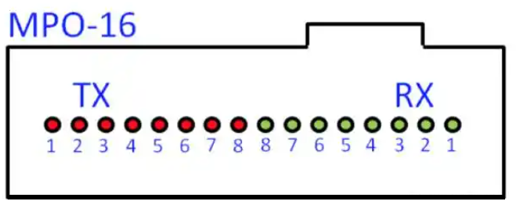
Figure 3 – QSFP-DD Optical lanes Assignment

MECHANICAL SPECIFICATIONS
unit：mm

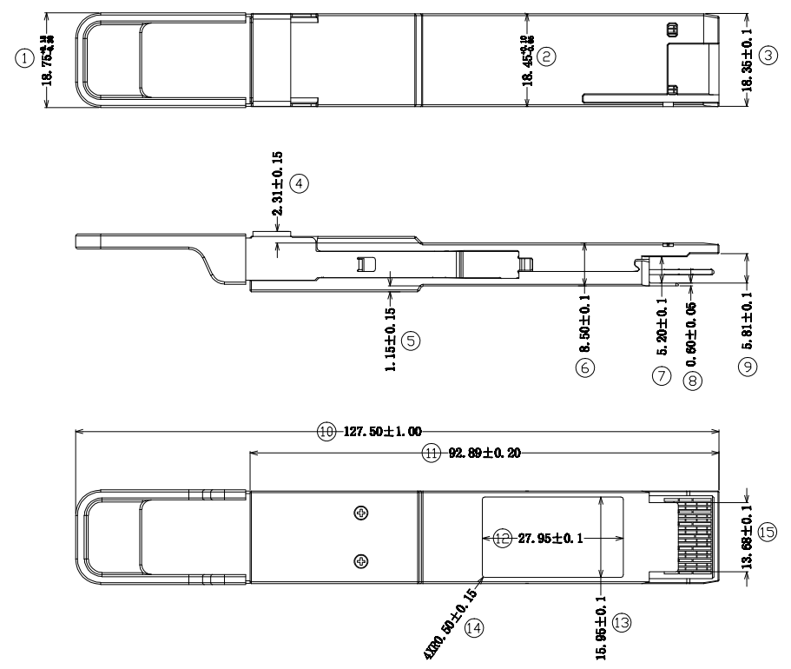

Figure 4 – QSFP-DD Mechanical Specifications

