Product Specification
200G QSFP56 SR4 DSP Transceivers
The 200G QSFP56 SR4 is a 4x 53.125Gbps multi mode fiber, hot pluggable optical transceiver. The module integrates four parallel lanes with baud rate at 26.5625GBd each lane. It can transmit up to 70m on fiber OM3 fiber or 100m on OM4 fiber with FEC.

FEATURES
- Compliant with 200G-SR4 optical specifications
- 4x53.125Gb/s electrical interface (200GAUI-4)
- Reach up to 70m on MMF(OM3)
- Reach up to 100m on MMF(OM4)
- Single +3.3V power supply
- Case temperature range: 0 ~ +70℃
- Maximum power consumption 4.5W
- Option：Single MPO12 connector APC / UPC
- RoHS complaint
- Hot pluggable
- DSP

APPLICATIONS

- 200G BASE-SR4 Ethernet links
- Data centers

Standards
- IEEE 802.3cd
- SFF 8679
- Option：SFF 8636 / CMIS 5.0

ABSOLUTE MAXIMUM RATINGS
Parameter | Symbol | Min | Max | Unit
Power Supply Voltage | Vcc | -0.3 | 3.6 | V
Input Voltage | Vin | -0.3 | Vcc+0.3 | V
Storage Temperature | Tst | -40 | 85 | ºC
Case Operating Temperature | Top | 0 | 70 | ºC
Humidity(non-condensing) | RH | 10 | 85 | %
Receiver Damage Threshold, each lane | Pin | 5 |  | dBm
Maximum Power Consumption | Pmax |  | 4.5 | W

RECOMMENDED OPERATING CONDITIONS
Parameter | Symbol | Min. | Typ. | Max. | Unit
Case Operating Temperature | Tcase | 0 | - | 70 | ºC
Power Supply Voltage | VCC | 3.135 | 3.3 | 3.465 | V

Transmitter characteristics
Parameter | Min | Typical | Max | Unit
Signaling Rate, each lane (range) | 26.5625±100ppm |  |  | GBd
Center Wavelength Range | 840 |  | 860 | nm
Modulation Format | PAM4
RMS spectral width |  |  | 0.6 | nm
Average launch power, each lane | -6.5 |  | 4 | dBm
Outer Optical Modulation Amplitude (OMAouter), each lane | -4.5 |  | 3 | dBm
Launch power in OMAouter minus TDECQ | -5.9 |  |  | dBm
Transmitter and dispersion eye closure for PAM4 (TDECQ), each lane |  |  | 4.5 | dB
Extinction ratio, each lane | 3 |  |  | dB
Optical return loss tolerance |  |  | 12 | dB

Receiver characteristics
Parameter | Min | Typical | Max | Unit
Signaling Rate, each lane (range) | 26.5625±100ppm |  |  | GBd
Center Wavelength Range | 840 |  | 860 | nm
Modulation Format | PAM4
Average receive power, each lane | -8.4 |  | 4 | dBm
Receive power, each lane (OMAouter) |  |  | 3 | dBm
Receiver reflectance |  |  | -12 | dB
Stressed receiver sensitivity (OMAouter), each lane |  |  | -3.4 | dBm
Receiver sensitivity (OMAouter), each lane | Max(-6.5, SECQ-7.9) |  |  | dBm
Stressed eye closure for PAM4 (SECQ), lane under test |  | 4.5 |  | dB
SECQ – 10log10(Ceq) (max), lane under test |  |  | 4.5 | dB

PIN ASSIGNMENT

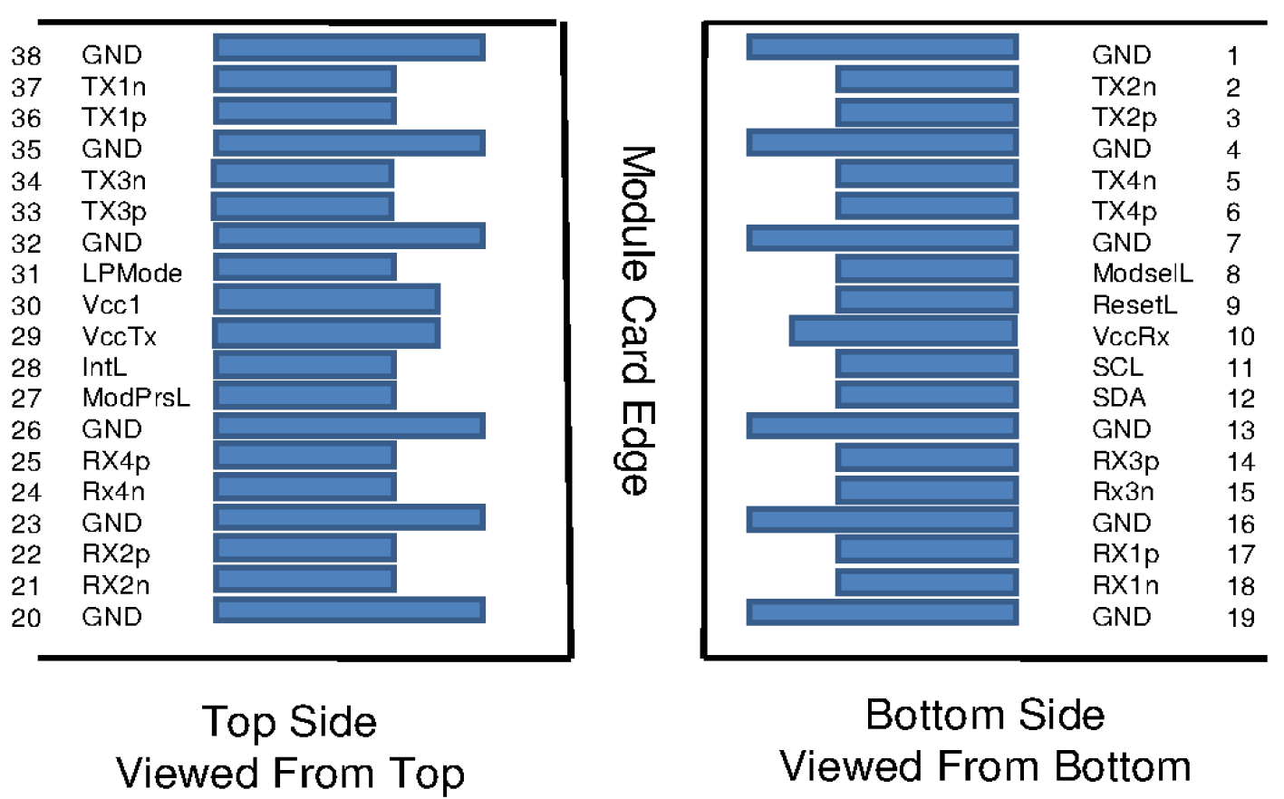

PIN DESCRIPTION

PIN | Logic | Symbol | Name/Description | Note
1 |  | GND | Ground
2 | CML-I | Tx2n | Transmitter Inverted Data Input
3 | CML-I | Tx2p | Transmitter Non-Inverted Data output
4 |  | GND | Ground
5 | CML-I | Tx4n | Transmitter Inverted Data Input
6 | CML-I | Tx4p | Transmitter Non-Inverted Data output
7 |  | GND | Ground
8 | LVTTL-I | ModSelL | Module Select
9 | LVTTL-I | ResetL | Module Reset
10 |  | VccRx | ﹢3.3V Power Supply Receiver
11 | LVCMOS-I/O | SCL | 2-Wire Serial Interface Clock
12 | LVCMOS-I/O | SDA | 2-Wire Serial Interface Data
13 |  | GND | Ground
14 | CML-O | Rx3p | Receiver Non-Inverted Data Output
15 | CML-O | Rx3n | Receiver Inverted Data Output
16 |  | GND | Ground
17 | CML-O | Rx1p | Receiver Non-Inverted Data Output
18 | CML-O | Rx1n | Receiver Inverted Data Output
19 |  | GND | Ground
20 |  | GND | Ground
21 | CML-O | Rx2n | Receiver Inverted Data Output
22 | CML-O | Rx2p | Receiver Non-Inverted Data Output
23 |  | GND | Ground
24 | CML-O | Rx4n | Receiver Inverted Data Output
25 | CML-O | Rx4p | Receiver Non-Inverted Data Output
26 |  | GND | Ground
27 | LVTTL-O | ModPrsL | Module Present
28 | LVTTL-O | IntL | Interrupt
29 |  | VccTx | +3.3 V Power Supply transmitter
30 |  | Vcc1 | +3.3 V Power Supply
31 | LVTTL-I | LPMode | Low Power Mode
32 |  | GND | Ground
33 | CML-I | Tx3p | Transmitter Non-Inverted Data Input
34 | CML-I | Tx3n | Transmitter Inverted Data Output
35 |  | GND | Ground
36 | CML-I | Tx1p | Transmitter Non-Inverted Data Input
37 | CML-I | Tx1n | Transmitter Inverted Data Output
38 |  | GND | Ground

Electrical Interface
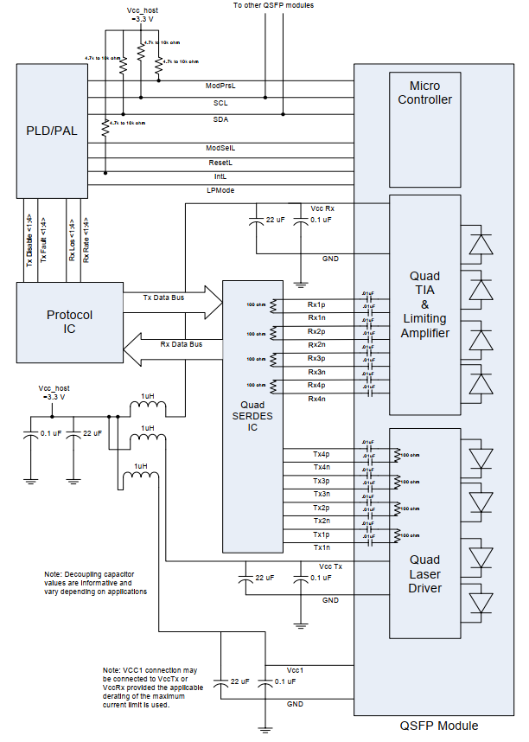

OUTLINE DIMENSIONS
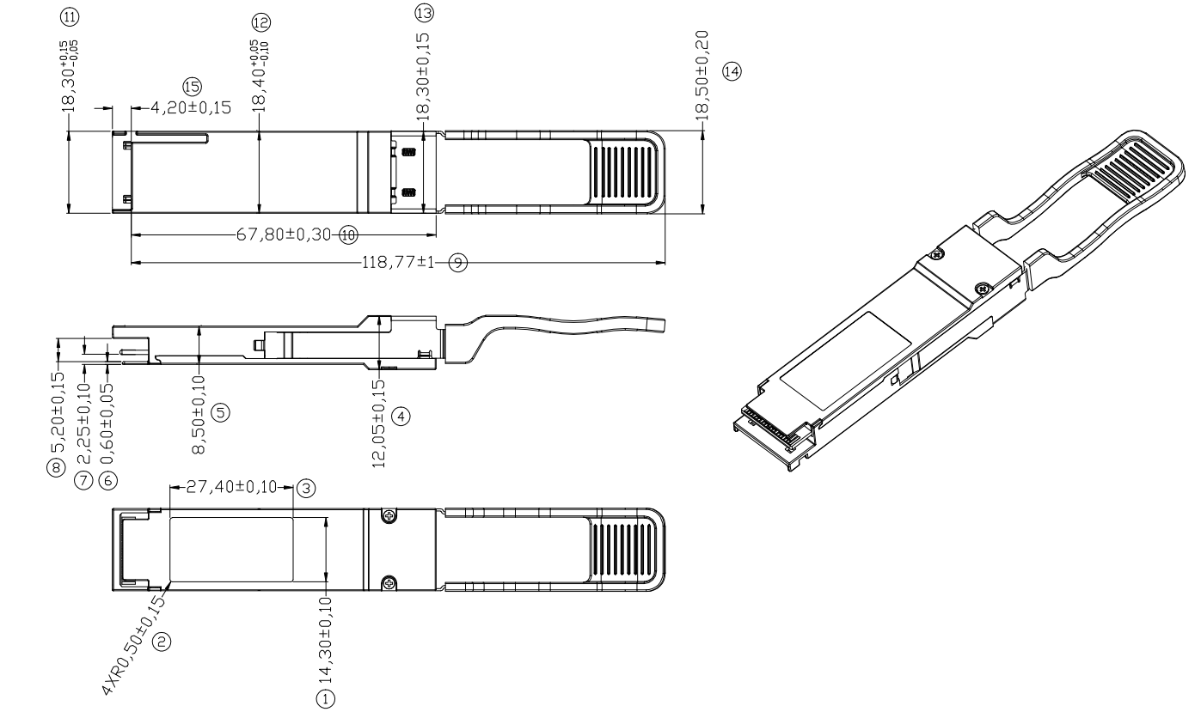

Unit mm

Digital Diagnostic Monitor Accuracy
The following characteristics are defined over recommended operating conditions

Parameter | Accuracy | Unit
Internally measured transceiver temperature | +/-3 | deg.C
Internally measured transceiver supply voltage | +/-3 | %
Measured Tx bias current | +/-10 | %
Measured Tx output power | +/-3 | dB
Measured Rx received average optical power | +/-3 | dB

