100Gb/s QSFP28 BIDI LR1 20km DDM Transceiver

PRODUCT FEATURES

- Lane signaling rate 106.25Gb/s with PAM4
- Up to 20km transmission on SMF
- EML Laser and PIN receiver
- 4x25.78Gb/s with NRZ electrical interface (CAUI-4)
- Support KP4 FEC inside the module
- High speed I/O electrical interface
- I2C interface with integrated Digital Diagnostic monitoring
- QSFP28 MSA package with simplex LC connector
- Single +3.3V power supply
- Power consumption <4W
- Operating case temperature: 0 to +70 °C
- Compliant to SFF-8636&SFF-8679 standard
- Compliant to 100G Lambda MSA 100G-LR1 Optical Specifications
- Complies with EU Directive 2015/863/EU

APPLICATIONS

- Data Center
- 100GBASE-LR BIDI

DESCRIPTIONS
The 100G QSFP28 LR1 BIDI is designed for 20km optical communication applications. It is intended for the service with single mode fiber in 100Gb/s high speed data communications. The optical signals are multiplexed to a single-mode fiber through commercial standard LC connector.
Module Block Diagram
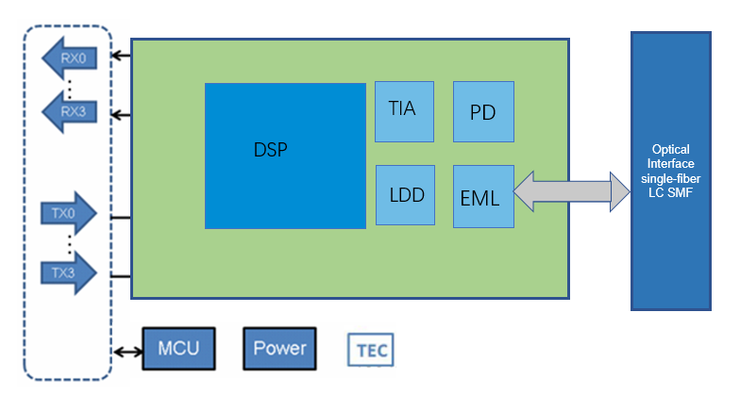

Ordering Information
Part No. | Data Rate(optical) | Laser | Fiber Type | Distance | Optical Interface | Temp | DDMI
JH-10G-WDM-A-20L-23 | 106.25Gbps | Tx1291/Rx1311 | SMF | 20km | LC | 0~70℃ | Yes
JH-10G-WDM-B-20L-32 | 106.25Gbps | Tx1311/Rx1291 | SMF | 20km | LC | 0~70℃ | Yes

Absolute Maximum Ratings
Parameter | Symbol | Min. | Typical | Max. | Unit | Notes
Storage Temperature | T_{S} | -40 | - | +85 | °C
Supply Voltage | V_{CC} | -0.5 | - | +4.0 | V
Operating Relative Humidity | RH | - | - | +85 | %

Recommended Operating Conditions
Parameter | Symbol | Min. | Typical | Max. | Unit | Notes
Operating Case Temperature | T_{C} | 0 | - | +70 | °C
Power Supply Voltage | V_{CC} | 3.13 | 3.3 | 3.47 | V
Power consumption | ICC |  |  | 4 | W
Transmission Distance | TD | - | - | 20 | km | Over SMF

Electrical Characteristics
Parameter | Symbol | Min. | Typical | Max. | Unit | Notes
Transmitter (Module Input)
Input Differential Impedance | Rin | - | 100 | - | Ohm
Differential Data Input Amplitude | V_{IN,P-P} |  | - | 900 | mVpp
Differential termination mismatch (max) | D-mismatch | - | - | 10 | %
DC common-mode input voltage |  | -0.3 | - | 2.8 | V
Transition time(20%~80%) | Tr Tf | 10 | - | - | ps
LPMode, Reset and ModSelL / Tx dis | V_{IL} | -0.3 | - | 0.8 | V
LPMode, Reset and ModSelL / Tx dis | V_{IH} | 2.0 | - | V_{CC}+0.3 | V
Receiver (Module Output)
Output Differential Impedance | Rout | - | 100 | - | Ohm
Differential Data Output Amplitude | V_{OUTP-P} | - | - | 900 | mVpp
Differential termination mismatch (max) | D-mismatch | - | - | 10 | %
Transition time, 20% to 80% | Tr Tf | 12 | - |  | ps
ModPrsL and IntL/ Rx los | V_{OL} | 0 | - | 0.4 | V
ModPrsL and IntL/ Rx los | V_{OH} | V_{CC}-0.5 | - | V_{CC+}0.3 | V

Optical and Characteristics
Parameter | Symbol | Min. | Typical | Max. | Unit | Notes
Transmitter
Center Wavelength | CW | 1284.5 | 1291 | 1297.5 | nm
Center Wavelength | CW | 1304.5 | 1311 | 1317.5 | nm
Signaling Rate | SR |  |  | 53.125 | GBd
Frequency Offset | Foffset | -100 |  | 100 | ppm
Average Launch Power | PTX | -1.4 | - | 4.5 | dBm | 1
Transmitter and dispersion eye closure for PAM4 (TDECQ) (max) | TDECQ | - | - | 3.6 | dBm
Average Output Power (Laser Turn off) | Poff | - | - | -30 | dBm
Side Mode Suppression Ratio | SMSR | 30 | - | - | dB
Extinction Ratio | ER | 3.5 | - | - | dB
RIN_OMA | RIN | - | - | -136 | dB/Hz
Transmitter reflectance | Tref | - | - | -26 | dB
Optical Return Loss Tolerance | ORLT | - | - | 15.6 | dB
Receiver
Center Wavelength | CW | 1284.5 | 1291 | 1297.5 | nm
Center Wavelength | CW | 1304.5 | 1311 | 1317.5 | nm
Damage threshold | Pdamage | 7.6 | - | - | dBm | 2
Average Rx Power | PRx | -10 | - | 6.6 | dBm | 3
Receive power _OMAouter | POMA | - | - | 6.8 | dBm
Receiver sensitivity _OMAouter  for TDECQ < 1.4 dB  for 1.4 dB ≤ TDECQ ≤ 3.4 dB | SEN _OMA | - | - | -7.6  –9 + TECQ | dBm | 4
Reflectance | Ref | - | - | -26 | dB
Los Assert | LosA | -26 | - |  | dBm
Los De-Assert | LosDA | - | - | -10 | dBm
Los Hysteresis | LosH | 0.5 | - | - | dB
Stressed receiver sensitivity _OMAouter | SRS | - | - | -5.4 | dBm | 5
Conditions of stressed receiver sensitivity teste :
Stressed eye closure for PAM4 (SECQ) |  |  |  | 3.6 | dB

Notes:
- The optical power is launched into SMF.
- The receiver shall be able to tolerate, without damage, continuous exposure to an optical input signal having this average power level. The receiver does not have to operate correctly at this input power.
- Average receive power, each lane (min) is informative and not the principal indicator of signal strength.
- Measured with conformance test signal at TP3 using the test pattern PRBS31Q or scrambled idle for stressed receiver sensitivity for the BER= 2.4x10-4.
- Measured with conformance test signal at TP3 (see3.11) for the BER specified in IEEE Std 802.3cu

Digital Diagnostics
Parameter | Range | Accuracy | Unit | Calibration
Temperature | 0 to 70 | ±3 | ºC | Internal
Voltage | 0 to Vcc | ±3% | V | Internal
Tx Bias Current | 0 to 100 | ±10% | mA | Internal
Tx Output Power | -0.2 to 6.8 | ±3 | dB | Internal
Rx Input Power | -10 to 6.6 | ±3 | dB | Internal

Communication Interface Timing Characteristics
Parameter | Symbol | Min | Max | Unit | Calibration | Notes
Initialization time | t_init |  | 10 | s | Time from power on or hot plug until the module is fully functional. This time applies to Power Class 2 or higher modules when LPMode is pulled low by the host, and to all Power Class 1 modules. | Room Temperature

Pin Diagram
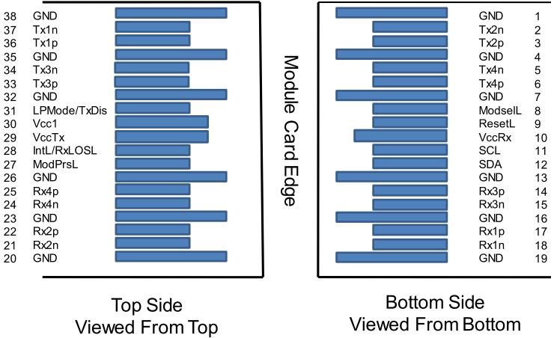

Pin Definitions
PIN | Logic | Symbol | Description | Plug  Seq. | Notes
1 |  | GND | Ground | 1 | 1
2 | CML-I | Tx2n | Transmitter Inverted Data Input | 3
3 | CML-I | Tx2p | Transmitter Non-Inverted Data output | 3
4 |  | GND | Ground | 1 | 1
5 | CML-I | Tx4n | Transmitter Inverted Data Input | 3
6 | CML-I | Tx4p | Transmitter Non-Inverted Data output | 3
7 |  | GND | Ground | 1 | 1
8 | LVTLL-I | ModSelL | Module Select | 3
9 | LVTLL-I | ResetL | Module Reset | 3
10 |  | VccRx | ﹢3.3V Power Supply Receiver | 2 | 2
11 | LVCMOS-I/O | SCL | 2-Wire Serial Interface Clock | 3
12 | LVCMOS-I/O | SDA | 2-Wire Serial Interface Data | 3
13 |  | GND | Ground | 1
14 | CML-O | Rx3p | Receiver Non-Inverted Data Output | 3
15 | CML-O | Rx3n | Receiver Inverted Data Output | 3
16 |  | GND | Ground | 1 | 1
17 | CML-O | Rx1p | Receiver Non-Inverted Data Output | 3
18 | CML-O | Rx1n | Receiver Inverted Data Output | 3
19 |  | GND | Ground | 1 | 1
20 |  | GND | Ground | 1 | 1
21 | CML-O | Rx2n | Receiver Inverted Data Output | 3
22 | CML-O | Rx2p | Receiver Non-Inverted Data Output | 3
23 |  | GND | Ground | 1 | 1
24 | CML-O | Rx4n | Receiver Inverted Data Output | 3 | 1
25 | CML-O | Rx4p | Receiver Non-Inverted Data Output | 3
26 |  | GND | Ground | 1 | 1
27 | LVTTL-O | ModPrsL | Module Present | 3
28 | LVTTL-O | IntL/Rx_LOS | Interrupt/Rx_LOS | 3 | 3
29 |  | VccTx | +3.3 V Power Supply transmitter | 2 | 2
30 |  | Vcc1 | +3.3 V Power Supply | 2 | 2
31 | LVTTL-I | LPMode/TxDIS | Low Power Mode/Tx_Disable | 3 | 3
32 |  | GND | Ground | 1 | 1
33 | CML-I | Tx3p | Transmitter Non-Inverted Data Input | 3
34 | CML-I | Tx3n | Transmitter Inverted Data Output | 3
35 |  | GND | Ground | 1 | 1
36 | CML-I | Tx1p | Transmitter Non-Inverted Data Input | 3
37 | CML-I | Tx1n | Transmitter Inverted Data Output | 3
38 |  | GND | Ground | 1 | 1
Notes:
- GND is the symbol for signal and supply (power) common for the QSFP28 module. All are common within the QSFP28 module and all module voltages are referenced to this potential unless otherwise noted. Connect these directly to the host board signal-common ground plane.
- Vcc Rx, Vcc1 and Vcc Tx are the receiver and transmitter power supplies and shall be applied concurrently. Requirements defined for the host side of the Host Edge Card Connector are listed in MSA. The connector pins are each rated for a maximum current of 1000 mA.
- Two Multi-Purpose Pin for supporting Tx_DIS and Rx_LOS function in the 100G QSFP28 LR1 BIDI module.

Recommended Interface Circuit

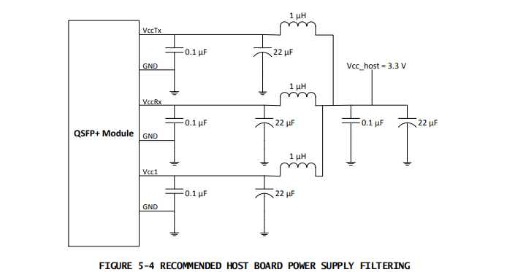

Mechanical Diagram

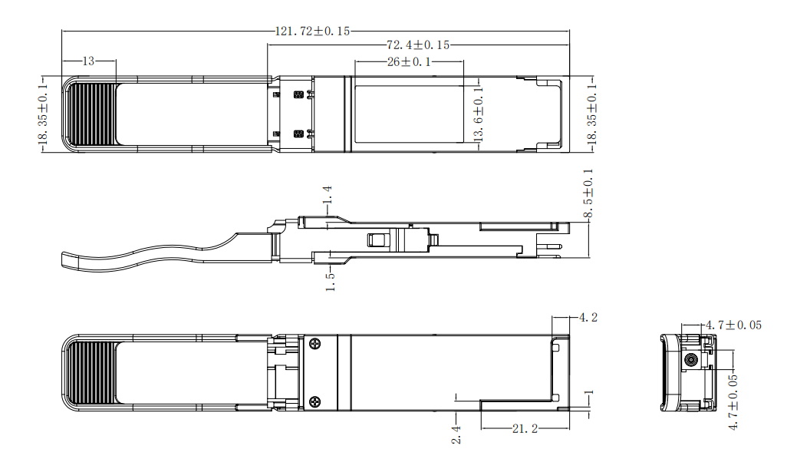

Revision History
Version No. | Date | Description
1.0 | FJHruary 4, 2022 | Preliminary datasheet
1.1 | Aug 20,2024 | Format change

