100G QSFP28 DR1 500M Optical Transceiver

Features
l Supports 100GBASE-DR1
l Optical port support 106.25Gb/s PAM4
l Electrical port support 4x26.5625Gb/s NRZ
l Up to 500m transmission on SMF
l EML Laser and PIN receiver
l High speed I/O electrical interface
l I2C interface with integrated Digital Diagnostic monitoring
l QSFP28 MSA package with simplex LC connector
l Single +3.3V power supply
l Maximum power consumption 4.5W
l Operating case temperature: 0 to +70 °C
l Compliant to 802.3cd
l Compliant to SFF-8636
l Complies to RoHS compliant

Applications
l 100GBASE-DR1
Absolute Maximum Ratings

Parameter | Symbol | Min | Max | Unit
Supply Voltage | Vcc | -0.5 | 4.0 | V
Storage Temperature | Tst | -40 | 85 | ºC
Humidity(non-condensing) | Rh | 5 | 85 | %
Recommended Operating Conditions

Parameter | Symbol | Min | Typical | Max | Unit | Notes
Operating Case Temperature | TC | 0 | - | +70 | °C
Power Supply Voltage | VCC | 3.13 | 3.3 | 3.47 | V
Power Supply Current | ICC | - | - | 1.43 | A
Maximum Power Dissipation | PD | - | - | 4.5 | W
Data Rate(optical) | DRo | - | 53.125 | - | GBd | PAM4
Transmission Distance | TD | - | - | 500 | m | Over SMF

Electrical Characteristics
High-Speed Signal: Compliant to CAUI-4 (IEEE 802.3cd)
Low-Speed Signal: Compliant to SFF-8679

Parameter | Symbol | Min. | Typical | Max. | Unit | Notes
Transmitter (Module Input)
Input Differential Impedance | Rin | - | 100 | - | Ohm
Differential Data Input Amplitude | VIN,P-P | 80 | - | 900 | mVpp
Differential termination mismatch  (max) | D-mismatch | - | - | 10 | %
DC common-mode input voltage |  | -0.3 | - | 2.8 | V
Transition time (20%~80%) | Tr Tf | 10 | - | - | ps
LPMode, Reset and ModSelL / Tx  dis | VIL | -0.3 | - | 0.8 | V
LPMode, Reset and ModSelL / Tx  dis | VIH | 2.0 | - | VCC+0.3 | V
Receiver (Module Output)
Output Differential Impedance | Rout | - | 100 | - | Ohm
Differential Data Output Amplitude | VOUT,P-P | - | - | 900 | mVpp
Differential termination mismatch  (max) | D-mismatch | - | - | 10 | %
Transition time, 20% to 80% | Tr Tf | 12 | - |  | ps
Mod PrsL and IntL/ Rx los | VOL | 0 | - | 0.4 | V
Mod PrsL and IntL/ Rx los | VOH | VCC-0.5 | - | VCC+0.3 | V

Optical Characteristics

Parameter | Symbol | Min. | Typical | Max. | Unit | Notes
Transmitter
Center Wavelength | CW | 1304.5 | - | 1317.5 | nm
Average Launch Power | PTX | -2.9 | - | 4 | dBm | 1
Outer Optical Modulation Amplitude | OMA | -0.8 | - | 4.2 | dBm | 1
Transmitter and dispersion eye closure for PAM4 (TDECQ) (max) | TDECQ | - | - | 3.4 | dB
Average Output Power (Laser Turn  off) | P0UT-OFF | - | - | -15 | dBm
Side Mode Suppression Ratio | SMSR | 30 | - | - | dB
Extinction Ratio | ER | 3.5 | - | - | dB
Receiver
Center Wavelength | CW | 1304.5 | - | 1317.5 | nm
Damage threshold | PDamage | 5 | - | - | dBm | 2
Average Rx Power | PRX | -5.9 | - | 4 | dBm | 3

Parameter | Symbol | Min. | Typical | Max. | Unit | Notes
Receive power_OMAouter | POMA | - | - | 4.2 | dBm
Los Assert | LosA | -26 | - | -9 | dBm
Los De-Assert | LosDA | - | - | -8.5 | dBm
Los Hysteresis | LosH | 0.5 | - | - | dB
Receiver sensitivity (OMAouter) | Sen |  |  | -3.9 | dBm
Notes:
1. The optical power is launched into SMF.
2 . The receiver shall be able to tolerate, without damage, continuous exposure to an optical input signal having this average power level. The receiver does not have to operate correctly at this input power.
3. Average receive power, each lane (min) is informative and not the principal indicator of signal strength.

Digital Diagnostics

Parameter | Accuracy | Unit | Calibration
Temperature | ±3 | ºC | Internal
Voltage | 0.1 | V | Internal
Tx Bias Current | 10% | mA | Internal
Tx Output Power | ±3 | dB | Internal
Rx Power | ±3 | dB | Internal

Pin Descriptions

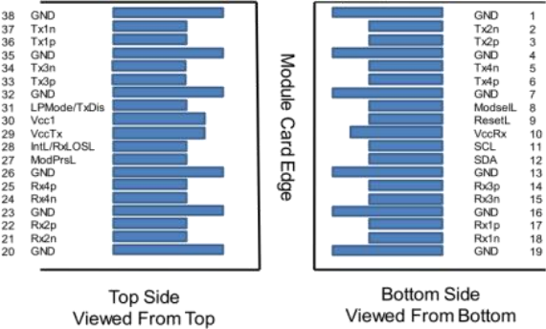
PIN | Logic | Symbol | Description | Plug Seq. | Notes
1 |  | GND | Ground | 1 | 1
2 | CML-I | Tx2n | Transmitter Inverted Data Input | 3
3 | CML-I | Tx2p | Transmitter Non-Inverted Data  output | 3
4 |  | GND | Ground | 1 | 1
5 |  | NC |  | 3
6 |  | NC |  | 3
7 |  | GND | Ground | 1 | 1
8 | LVTLL-I | ModSelL | Module Select | 3
9 | LVTLL-I | ResetL | Module Reset | 3
10 |  | VccRx | +3.3V Power Supply Receiver | 2 | 2
11 | LVCMOS-I/O | SCL | 2-Wire Serial Interface Clock | 3
12 | LVCMOS-I/O | SDA | 2-Wire Serial Interface Data | 3
13 |  | GND | Ground | 1
14 |  | NC |  | 3
15 |  | NC |  | 3
16 |  | GND | Ground | 1 | 1
17 | CML-O | Rx1p | Receiver Non-Inverted Data Output | 3
18 | CML-O | Rx1n | Receiver Inverted Data Output | 3
19 |  | GND | Ground | 1 | 1

PIN | Logic | Symbol | Description | Plug Seq. | Notes
20 |  | GND | Ground | 1 | 1
21 | CML-O | Rx2n | Receiver Inverted Data Output | 3
22 | CML-O | Rx2p | Receiver Non-Inverted Data Output | 3
23 |  | GND | Ground | 1 | 1
24 |  | NC |  | 3
25 |  | NC |  | 3
26 |  | GND | Ground | 1 | 1
27 | LVTTL-O | ModPrsL | Module Present | 3
28 | LVTTL-O | IntL | Interrupt | 3
29 |  | VccTx | +3.3 V Power Supply transmitter | 2 | 2
30 |  | Vcc1 | +3.3 V Power Supply | 2 | 2
31 | LVTTL-I | LPMode | Low Power Mode | 3
32 |  | GND | Ground | 1 | 1
33 |  | NC |  | 3
34 |  | NC |  | 3
35 |  | GND | Ground | 1 | 1
36 | CML-I | Tx1p | Transmitter Non-Inverted Data Input | 3
37 | CML-I | Tx1n | Transmitter Inverted Data Output | 3
38 |  | GND | Ground | 1 | 1
Note 1: GND is the symbol for signal and supply (power) common for the QSFP28 module. All are common within the QSFP28 module and all module voltages are referenced to this potential unless otherwise noted. Connect these directly to the host board signal-common ground plane .
Note 2: Vcc Rx, Vcc1 and Vcc Tx are the receiver and transmitter power supplies and shall be applied concurrently. Requirements defined for the host side of the Host Edge Card Connector are listed in MSA. The connector pins are each rated for a maximum current of 1000 mA.

Mechanical Dimensions
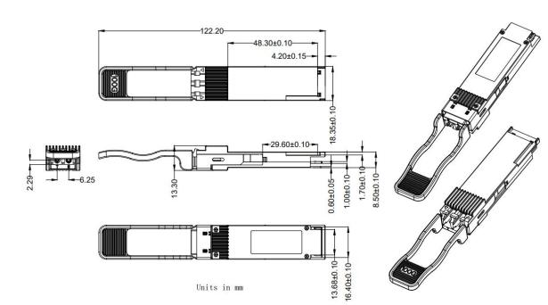

Contact:
Wuhan Jiuhong Optics Technology Co., Ltd.
TEL: 86-13476016116
E-mail：grace@jh-optics.com
Web：www.jh-optics.com
Address：
Building 1, 4th Floor, Yunqi Free Trade Innovation Port, Donghu Comprehensive Bonded Zone,
Donghu High-tech Zone, Wuhan City

