QSFP28-100G-CWDM4+
100G CWDM4+ QSFP28 Transceiver

DESCRIPTION
The CWDM4 QSFP28 optical transceivers are designed for a high-speed link at aggregated data rate of 103.13Gb/s with up to 10km transmission distance of single mode fiber. The transceiver integrates four lasers with center wavelengths of 1271nm, 1291nm, 1311nm and 1331nm to be multiplexed into a single mode fiber. Its receiver side uses an integrated optical demultiplexer to optically demultiplex four lanes of optical data streams. The transceiver is compliant to QSFP28 MSA, CWDM4 MSA and applicable portions of IEEE802.3bm.

FEATURES
- Hot-pluggable QSFP28 footprint
- Supports 25G Dual-Rate operation
- Supports 100G Dual Mode operation with CDR auto-bypass mode
- Built-in digital diagnostic functions
- 4x25Gb/s CWDM transmitters and PIN receivers
- Duplex LC optical connector
- 10km reach on single mode fiber
- Single +3.3V power supply
- Low power consumption <3.5W
- Operating case temperature: 0~+70°C

APPLICATION
- 100G CWDM4 applications with FEC
- High-density datacenter switches, routers

ABSOLUTE MAXIMUM RATINGS (TC=25°C, UNLESS OTHERWISE NOTED)
Stresses in excess of the absolute maximum ratings can cause permanent damage to the device. These are absolute stress ratings only. Functional operation of the device is not implied at these or any other conditions in excess of those given in the operational sections of the data sheet. Exposure to absolute maximum ratings will cause permanent damage and/or adversely affect device reliability.
Parameter | Symbol | Min | Typical | Max | Unit | Notes
Storage Temperature | TS | -40 | - | +85 | ºC
Maximum Supply Voltage | Vcc | -0.3 | - | 3.6 | V
Operating Relative Humidity | RH | 15 | - | +85 | %

RECOMMENDED OPERATING CONDITIONS
Parameter | Symbol | Min | Typical | Max | Unit | Notes
Data Rate | DR |  | 103.1 |  | Gb/s
Operating Case Temperature | Top | 0 |  | 70 | ºC
Bit Error Rate | BER |  |  | 5E-5
Fiber Length on SMF per G.652 | L |  |  | 2000 | m | 1
Loss budget over SMF per G.652 |  |  |  | 5 | dB
Supply Voltage | Vcc | 3.135 |  | 3.465 | V
Module Total Power | P |  |  | 3.5 | W
Notes:
1. Tested with PRBS31, 5dB loss budget with FEC on the host.

PIN DESCRIPTIONS
Pin | Symbol | Name/Description | Ref.
1 | GND | Ground | 1
2 | Tx2n | Transmitter Inverted Data Input
3 | Tx2p | Transmitter Non-Inverted Data Input
4 | GND | Ground | 1
5 | Tx4n | Transmitter Inverted Data Input
6 | Tx4p | Transmitter Non-Inverted Data Input
7 | GND | Ground | 1
8 | ModSelL | Module Select
9 | ResetL | Module Reset
10 | Vcc Rx | +3.3 V Power supply receiver
11 | SCL | 2-wire serial interface clock
12 | SDA | 2-wire serial interface data
13 | GND | Ground | 1
14 | Rx3p | Receiver Non-Inverted Data Output
15 | Rx3n | Receiver Inverted Data Output
16 | GND | Ground | 1
17 | Rx1p | Receiver Non-Inverted Data Output
18 | Rx1n | Receiver Inverted Data Output
19 | GND | Ground | 1
20 | GND | Ground | 1
21 | Rx2n | Receiver Inverted Data Output
22 | Rx2p | Receiver Non-Inverted Data Output
23 | GND | Ground | 1
24 | Rx4n | Receiver Inverted Data Output
25 | Rx4p | Receiver Non-Inverted Data Output
26 | GND | Ground | 1
27 | ModPrsL | Module Present
28 | IntL | Interrupt
29 | Vcc Tx | +3.3 V Power supply transmitter
30 | Vcc1 | +3.3 V Power Supply
31 | LPMode | Low Power Mode
32 | GND | Ground | 1
33 | Tx3p | Transmitter Non-Inverted Data Input
34 | Tx3n | Transmitter Inverted Data Input
35 | GND | Ground | 1
36 | Tx1p | Transmitter Non-Inverted Data Input
37 | Tx1n | Transmitter Inverted Data Input
38 | GND | Ground | 1
1. Circuit ground is internally isolated from chassis ground.
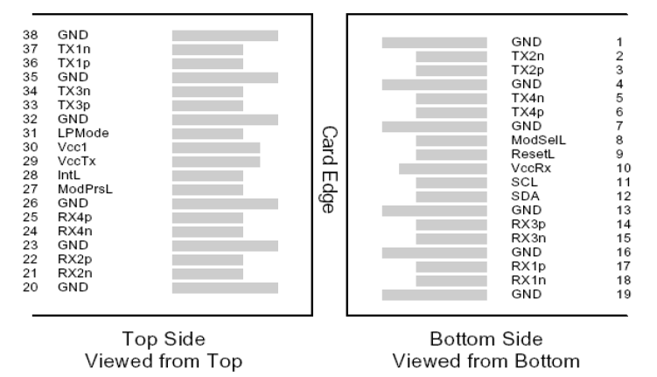
Figure 1 – QSFP28-Compliant 38-Pin Connector (Per SFF-8679)

ELECTRICAL SPECIFICATION
Parameter | Symbol | Min | Typical | Max | Units | Notes
Transmitter
Signaling rate per lane |  | 25.78125±100ppm |  |  | Gb/s
Differential input impedance | Zin |  | 100 |  | Ohm
Differential input voltage amplitude per lane | Vin | 100 |  | 1600 | mVp-p
Differential termination mismatch |  |  |  | 10 | %
Receiver
Signaling rate per lane |  | 25.78125±100ppm |  |  | Gb/s
Differential Output impedance | Zout |  | 100 |  | Ohm
Differential output voltage amplitude per lane | Vout | 100 |  | 400 | mVp-p | 1
Differential output voltage amplitude per lane | Vout | 300 |  | 600 | mVp-p | 1
Differential output voltage amplitude per lane | Vout | 400 |  | 800 | mVp-p | 1
Differential output voltage amplitude per lane | Vout | 600 |  | 1200 | mVp-p | 1
Eye width |  | 0.57 |  |  | UI
Vertical eye closure |  |  |  | 5.5 | dB
Differential termination mismatch |  |  |  | 10 | %

Notes:
1. Differential output voltage amplitude is adjustable through I2C bus. Default value of the differential output voltage amplitude per lane is 400 – 800 mV.

OPTICAL SPECIFICATION
Parameter | Symbol | Min |  | Typical |  | Max | Units | Notes
Transmitter
Signaling rate, each lane |  | 25.78125±100ppm |  |  |  |  | Gb/s
Line wavelengths (range) | λ | 1264.5 – 1277.5 |  |  |  |  | nm
Line wavelengths (range) | λ | 1284.5 – 1297.5 |  |  |  |  | nm
Line wavelengths (range) | λ | 1304.5 – 1317.5 |  |  |  |  | nm
Line wavelengths (range) | λ | 1324.5 – 1337.5 |  |  |  |  | nm
Side-mode Suppression ratio | SMSR | 30 |  |  |  |  | dB
Total average launch power |  |  |  |  | 8.5 |  | dBm
Average launch power, each lane |  | -4 |  |  | 2.5 |  | dBm
Transmit OMA, each lane | TXOMA1 | -4 |  |  | 2.5 |  | dBm
Launch Power (OMA-TDP), each lane | OMA-TDP | -5 |  |  |  |  | dBm
Optical Extinction Ratio | ER | 3.5 |  |  |  |  | dB
Transmitter and dispersion penalty, each lane | TDP |  |  |  | 3 |  | dB | 1
Average launch power of OFF transmitter, each lane |  |  |  |  | -30 |  | dBm
Transmitter Reflectance | RL |  |  |  | -12 |  | dB
Transmitter eye mask definition {X1, X2, X3, Y1, Y2, Y3} |  | {0.31, 0.4, 0.45, 0.34, 0.38, 0.4} |  |  |  |  | dB | 2
Receiver
Signaling rate, each lane |  | 25.78125±100ppm |  |  |  |  | Gb/s
Line wavelengths (range) | λ | 1264.5 – 1277.5 |  |  |  |  | nm
Line wavelengths (range) | λ | 1284.5 – 1297.5 |  |  |  |  | nm
Line wavelengths (range) | λ | 1304.5 – 1317.5 |  |  |  |  | nm
Line wavelengths (range) | λ | 1324.5 – 1337.5 |  |  |  |  | nm
Damage threshold, each lane |  | 3.5 |  |  |  |  | dBm
Average receive power, each lane |  | -11.5 |  |  | 2.5 |  | dBm
Unstressed Receiver Sensitivity (OMA), each lane | RXsens |  |  |  | -10 |  | dBm | 3
Stressed Receiver OMA Sensitivity | SRS |  |  |  | -12 |  | dBm | 4
Conditions of stressed receiver sensitivity test:
Vertical Eye Closure Penalty | VECP |  | 1.9 |  |  |  | dB
Stressed J2 Jitter, each lane | J2 |  | 0.33 |  |  |  | UI
Stressed J4 Jitter, each lane | J4 |  | 0.48 |  |  |  | UI
SRS eye mask definition {X1, X2, X3, Y1, Y2, Y3} |  |  | {0.39, 0.5, 0.5, 0.39, 0.39, 0.4} |  |  |  | dB
LOS De-Assert | LOSD |  |  |  | -12 |  | dBm
LOS Assert | LOSA |  | -30 |  |  |  | dBm
LOS Hysteresis | LOSH |  | 0.5 |  | 5 |  | dB

Notes:
1. TDP does not include a penalty for multi-path interference (MPI).
2. Hit ratio of 5E-5, per IEEE.
3. Sensitivity is specified at the BER of 5E-5.
4. Measured with CWDM4 MSA conformance test signal at TP3 for the BER of 5E-5.

DIGITAL DIAGNOSTIC FUNCTIONS

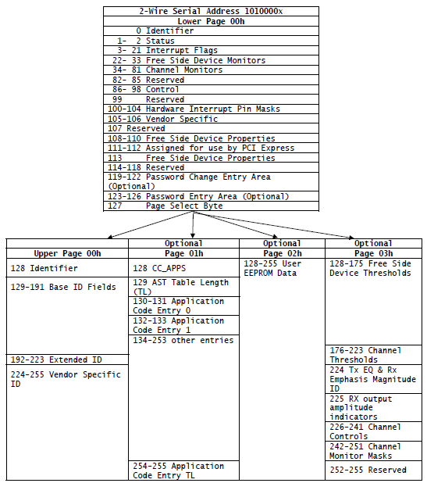
Figure 2 – Two-Wire Interface Fields

The operating and diagnostics information is monitored and reported by a Digital Diagnostics Transceiver Controller (DDTC) inside the transceiver, which is accessed through a 2-wire serial interface. The 2-wire serial interface shall consist of a master and slave. The fixed side shall be the master and the free side shall be the slave. Control and data are transferred serially. The master shall initiate all data transfers. Data can be transferred from the master to the slave and from the slave to the master. The 2-wire interface shall consist of clock (SCL) and data (SDA) signals. The master utilizes SCL to clock data and control information on the 2-wire bus. The master and slave shall latch the state of SDA on the positive transitioning edge of SCL. The SDA signal is bi-directional. During data transfer, the SDA signal shall transition when SCL is low. A transition on the SDA signal while SCL is high shall indicate a stop or start condition.

MECHANICAL SPECIFICATIONS
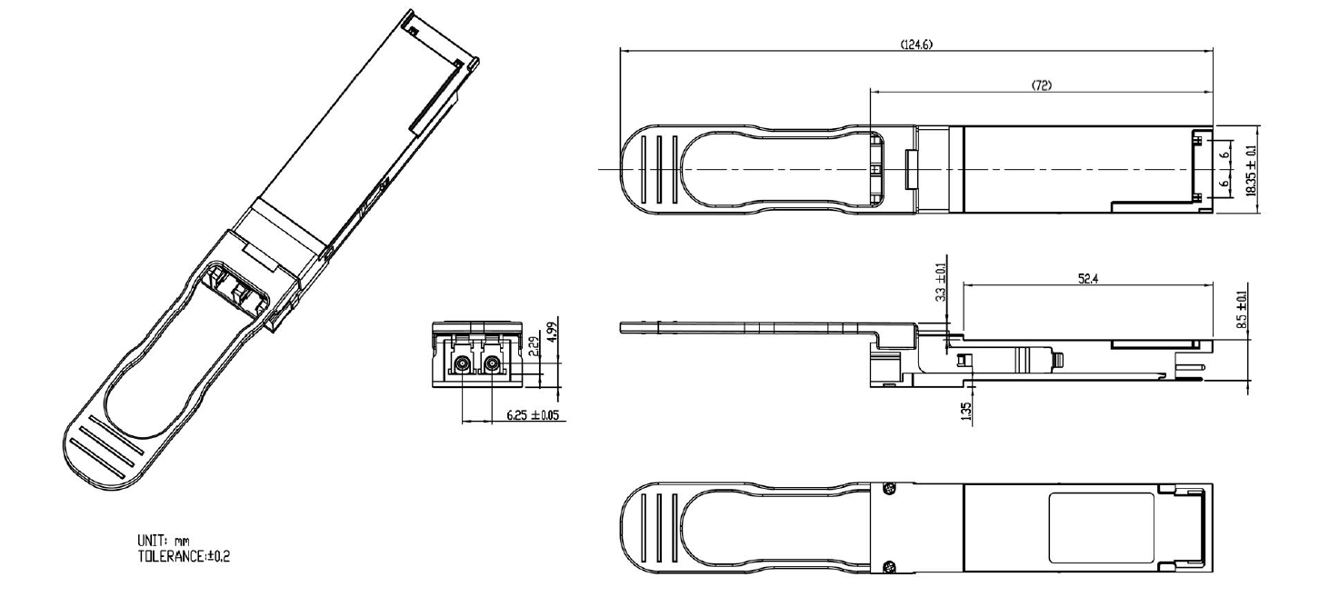

ORDERING INFORMATION
QSFP28-100G-CWDM4+

ESD SAFETY CAUTIONS
This transceiver is specified as ESD threshold 1KV for high speed data pins and 2KV for all others electrical input pins, tested per MIL-STD-883, Method 3015.4 /JESD22-A114-A (HBM). However, normal ESD precautions are still required during the handling of this module. This transceiver is shipped in ESD protective packaging. It should be removed from the packaging and handled only in an ESD protected environment.

Contact:
Wuhan Jiuhong Optics Technology Co., Ltd.
TEL: 86-13476016116
E-mail：grace@jh-optics.com
Web：www.jh-optics.com
Address：
Building 1, 4th Floor, Yunqi Free Trade Innovation Port, Donghu Comprehensive Bonded Zone,Donghu High-tech Zone, Wuhan City

