Product Specification
100G QSFP28 10km PLR4 Transceivers

The JH-100G-QSFP28-PLR4-10 QSFP28 optical transceiver is intended for up to 10km reach service with four-lane 25.78125G data rate. It is based on 3.3V DC power supply and operates in the commercial temperature range. It is compliant with QSFP MSA 、SFF-8436 、SFF-8636 and PSM4 MSA. Digital diagnostic functions are available via I2C interface，and the control functions can be achieved by LVTTL interfaces on the host，mainly including Module Select(ModSelL)、Module Reset(ResetL)、 Low Power Mode(LPMode). The transceiver incorporates a four-laser array which is usually DFB 、four-PIN diode array 、a high performance CDR integrated four drivers and TIAs IC separately. The differential AC coupled Tx and Rx data interfaces are CML compatible.

Applications
- 100G BASE Ethernet
- Infiniband EDR interconnects
- Enterprise networking

Features
- MPO12 optical interface
- Maximum link length up to 10km
- Up to 25.78125Gb/s data links per lane
- +3.3 V power supply
- QSFP MSA compliant package
- Hot Pluggable
- High performance singal mode DML transmitter
- High sensitivity PIN/TIA optical receiver
- Single Mode operation
- BER < 5E-5@-10.5dBm（OMA）
- Built-in CDR
- Case Operating temperature : 0 to 70ºC
- Data and Control Interfaces
- Tx Data CML/AC Coupled
- Rx Data CML/AC Coupled
- ModSelL LVTTL
- ResetL LVTTL
- ModPrsL LVTTL
- LPMode LVTTL
- 2-wire I2C communication bus
- RoHS 6 compliance

Ordering Code
Ordering Information
Part Number | Case Operating Temperature
JH-100G-QSFP28-PLR4-10 | 100G QSFP28 10km 0 to 70 ºC

Absolute maximum parameters

Absolute Maximum Ratings (EXCEEDING THESE RATINGS MAY CAUSE IRREVERSIBLE DAMAGE TO THE DEVICE)
Parameter | Symbol | Min | Max | Units | Notes
Storage Temperature | T_{stg} | -40 | +95 | ºC | Exceeding the absolute maximum ratings may cause irreversible damage to the device.  The device is not intended to be operated under the condition of simultaneous absolute maximum rat- ings, which may cause irreversible damage to the device.
Case Operating Temperature  (Commercial ) | T_{O} | 0 | +70 | ºC
Relative Humidity - Storage | R_{HS} | 0 | 95 | %
Relative Humidity - Operating | R_{HO} | 0 | 85 | %
Supply Voltage | VCC | -0.3 | 3.6 | V

Operating conditions

Recommended Operating Conditions
Parameter | Symbol | Min | Typ | Max | Units | Notes
Case Operating Temperature | T_{case} | 0 | - | +70 | ºC
DC Supply Voltage | VCC | 3.135 | - | 3.465 | V
Module Supply Current | I_{IN} | - | - | 1060 | mA

Electrical Characteristics

Transmitter Electrical Characteristics
Parameter | Symbol | Mi | Typ | Max | Units | Notes
Differential Data input Swing | V_{IN} | 180 | - | 900 | mV
Tx Differential Input Impendence | Z_{in} | 90 | 100 | 110 | Ω
Tx Differential Output Impendence | Z_{out} | 45 | 50 | 55 | Ω
ResetL Disable Voltage | V_{r} | 2.0 | - | Vcc+0.3 | V
ResetL Enable Voltage | V_{rEN} | 0 | - | 0.8 | V
ModSelL Disable Voltage | V_{m} | 2.0 | - | Vcc+0.3 | V
ModSelL Enable Voltage | V_{mEN} | 0 | - | 0.8 | V

Receiver Electrical Characteristics
Parameter | Symbol | Min | Typ | Max | Units | Notes
Differential Data Output Swing | V_{OUT} | 180 | - | 900 | mV
Rx Differential Output Impendence | Z_{OUT} | 90 | 100 | 110 | Ω
IntL Assert Voltage | V_{Int} | VCC-0.5 | - | VCC+0.3 | V
IntL De-assert Voltage | VD_{Int} | 0 | - | +0.4 | V

Optical Specification

Transmitter Optical Specification
Parameter | Symbol | Min | Typ | Max | Units | Notes
Signal Rate|_{Each Lane} |  |  | 25.78125±100ppm |  | Gbps
Lane Wavelength | L0 | 1295 | 1310 | 1325 | nm
Lane Wavelength | L1 | 1295 | 1310 | 1325 | nm
Lane Wavelength | L2 | 1295 | 1310 | 1325 | nm
Lane Wavelength | L3 | 1295 | 1310 | 1325 | nm
Side Mode Suppression Ratio | SMSR | 30 |  |  | dB
Total Average Launch Power | P_{tol} |  |  | 8.5 | dBm
Average Launch Power|_{Each Lane} | P_{avg} | -6 |  | 2.5 | dBm
Optical Modulation Amplitude|_{Each Lane} | OMA |  |  | 2.5 | dBm
Transmitter and dispersion penalty|_{Each Lane} | TDP |  |  | 2.2 | dB
Eye Mask coordinates:  X1, X2, X3, Y1, Y2, Y3 |  | {0.31, 0.4, 0.45, 0.34, 0.38, 0.4} |  |  |  | 1
Average launch power of OFF transmitter|_{Each Lane} |  |  |  | -30 | dBm
Extinction Ratio | ER | 3.5 |  |  | dB
Spectral Width|_{20dB} |  |  |  | 1 | nm
Transmitter Reflectance |  |  |  | -12 | dB
Optical return loss tolerance |  |  |  | 20 | dB

Note:
- Hit ratio of 5e-5, per IEEE.
Receiver Optical Specification
Parameter | Symbol | Min | Typ | Max | Units | Notes
Signal Speed Per Lane |  |  | 25.78125±100ppm |  | Gbps
Lane Wavelength | L0 | 1295 | 1310 | 1325 | nm
Lane Wavelength | L1 | 1295 | 1310 | 1325 | nm
Lane Wavelength | L2 | 1295 | 1310 | 1325 | nm
Lane Wavelength | L3 | 1295 | 1310 | 1325 | nm
Damage threshold|_{Each Lane} | THd |  |  | 3.0 | dBm | 1
Average Receive Power|_{Each Lane} |  | -10.6 |  | 2.5 | dBm | 2
Sensitivity OMA|_{Each Lane} | Sen |  |  | -10.5 | dBm | 2
Receiver reflectance |  |  |  | -26 | dB
LOS Assert | LOSA | -24
LOS Deassert | LOSD |  |  | -11.6
LOS Hysteresis | LOSH | 0.5 |  | 6

Note:
1. The receiver shall be able to tolerate, without damage, continuous exposure to a modulated optical input signal having this power level on one lane. The receiver does not have to operate correctly at this input power.
2. Measured with conformance test signal at receiver input for BER = 5e-5 BER.

PIN ASSIGNMENT

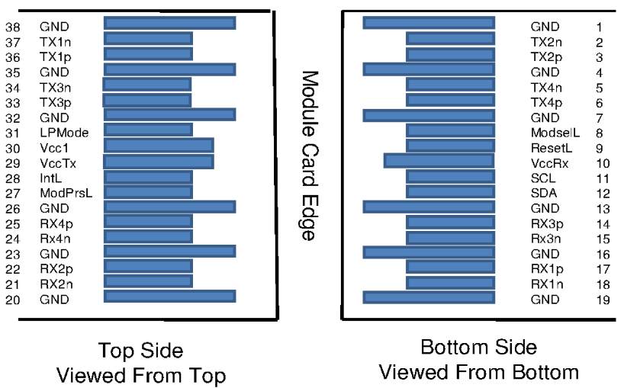

PIN DESCRIPTION

PIN | Logic | Symbol | Name/Description | Note
1 |  | GND | Ground
2 | CML-I | Tx2n | Transmitter Inverted Data Input
3 | CML-I | Tx2p | Transmitter Non-Inverted Data output
4 |  | GND | Ground
5 | CML-I | Tx4n | Transmitter Inverted Data Input
6 | CML-I | Tx4p | Transmitter Non-Inverted Data output
7 |  | GND | Ground
8 | LVTTL-I | ModSelL | Module Select
9 | LVTTL-I | ResetL | Module Reset
10 |  | VccRx | ﹢3.3V Power Supply Receiver
11 | LVCMOS-I/O | SCL | 2-Wire Serial Interface Clock
12 | LVCMOS-I/O | SDA | 2-Wire Serial Interface Data
13 |  | GND | Ground
14 | CML-O | Rx3p | Receiver Non-Inverted Data Output
15 | CML-O | Rx3n | Receiver Inverted Data Output
16 |  | GND | Ground
17 | CML-O | Rx1p | Receiver Non-Inverted Data Output
18 | CML-O | Rx1n | Receiver Inverted Data Output
19 |  | GND | Ground
20 |  | GND | Ground
21 | CML-O | Rx2n | Receiver Inverted Data Output
22 | CML-O | Rx2p | Receiver Non-Inverted Data Output
23 |  | GND | Ground
24 | CML-O | Rx4n | Receiver Inverted Data Output
25 | CML-O | Rx4p | Receiver Non-Inverted Data Output
26 |  | GND | Ground
27 | LVTTL-O | ModPrsL | Module Present
28 | LVTTL-O | IntL | Interrupt
29 |  | VccTx | +3.3 V Power Supply transmitter
30 |  | Vcc1 | +3.3 V Power Supply
31 | LVTTL-I | LPMode | Low Power Mode
32 |  | GND | Ground
33 | CML-I | Tx3p | Transmitter Non-Inverted Data Input
34 | CML-I | Tx3n | Transmitter Inverted Data Output
35 |  | GND | Ground
36 | CML-I | Tx1p | Transmitter Non-Inverted Data Input
37 | CML-I | Tx1n | Transmitter Inverted Data Output
38 |  | GND | Ground

OUTLINE DIMENSIONS

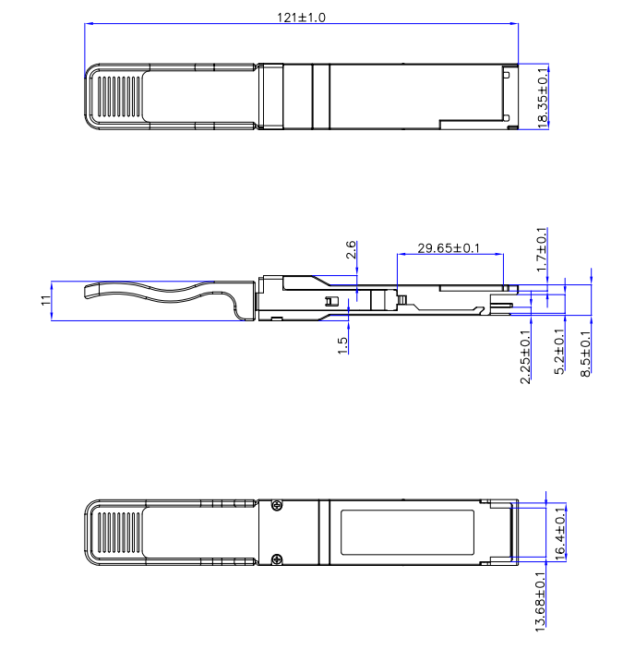
Notes:
1、Tolerance: +/-0.1mm.
2、Others according to SFF-8661 or customer spec .
3、Optical port according to fiber connector spec.

Digital Diagnostic Monitor Accuracy
The following characteristics are defined over recommended operating conditions

Parameter | Accuracy | Unit
Internally measured transceiver temperature | +/-3 | deg.C
Internally measured transceiver supply voltage | +/-3 | %
Measured Tx bias current | +/-10 | %
Measured Tx output power | +/-3 | dB
Measured Rx received average optical power | +/-3 | dB

