Product Specification
100G QSFP28 100m SR4 Transceivers

FEATURES
- Compliant with QSFP+ MSA Specification
- Wide Operating Temperature(0°C~70°C)
- 4x25Gbps 850nm VCSEL-based Transmitter
- Maximum Link Length of 100m via OM4 Multimode Fiber(MMF)

APPLICATIONS
- Data Center Backbone
- 100GBASE-SR4 100G Ethernet

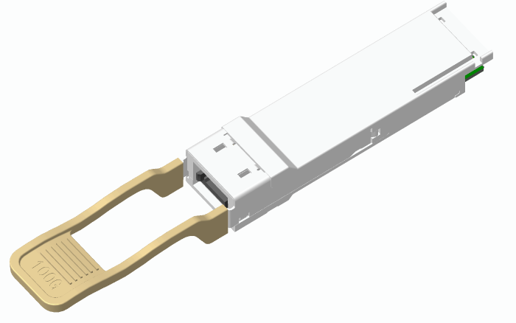

ABSOLUTE MAXIMUM RATINGS
Parameter | Symbol | Conditions | Min. | Max. | Unit
Storage Temperature | T_{Storage} |  | -40 | +85 | °C
Relative Humidity | RH |  | 0 | +85 | %

RECOMMENDED OPERATING CONDITIONS (Ta, unless noted)
Parameter | Symbol | Conditions | Min. | Typ. | Max. | Unit
Case Temperature | T_{C} |  | 0 |  | 70 | °C
Power Supply Voltage | V_{CC} |  | 3.135 | 3.3 | 3.465 | V
Signaling Rate each Channel |  |  |  | 25.78125 |  | Gbps
Supply Noise Rejection |  |  | --- | --- | 100 | mV
Receiver Differential Data Output |  |  | --- | 100 |  | Ohm
Operating Distance | D | @ OM3 MMF | --- | --- | 70 | m
Operating Distance | D | @ OM4 MMF |  |  | 100 | m

ELECTRICAL CHARACTERISTICS (Ta, unless noted)
Parameter | Symbol | Conditions | Min. | Typ. | Max. | Unit
Power Consumption |  |  |  |  | 3.5 | W
Supply Current | Icc |  |  |  | 1050 | mA

TRANSMITTER CHARACTERISTICS (T=25°C, unless noted)
Parameter | Symbol | Conditions | Min. | Typ. | Max. | Unit
Signaling rate, each lane (range) | GBb |  |  | 25.78125 |  | GBb
Center Wavelength | λ |  | 840 | 850 | 860 | nm
RMS Spectral Width | SW |  |  |  | 0.6 | nm
Average launch power, each lane | Pf |  | -8.4 |  | 2.4 | dBm
Optical Modulation Amplitude (OMA), each lane | TxOMA |  | -6.4 |  | 3 | dBm
Average launch power of OFF transmitter, each lane |  |  |  |  | -30 | dBm
Extinction ratio | ER |  | 3 |  |  | dB
Optical return loss tolerance |  |  |  |  | 12 | dB

RECEIVER CHARACTERISTICS (Ta, unless noted)
Parameter | Symbol | Conditions | Min. | Typ. | Max. | Unit
Signaling rate, each lane (range) | GBb |  |  | 25.78125 |  | GBb
Center Wavelength | λ |  | 840 |  | 860 | nm
Damage threshold |  |  | 3.4 |  |  | dBm
Average power at receiver input, each lane |  |  | -10.3 |  | 2.4 | dBm
Receive power, each lane (OMA) |  |  |  |  | 3 | dBm
Receiver sensitivity (OMA) | S_{OMA} | BER@5e-5 |  |  | -7.2 | dBm
Receiver reflectance |  |  |  |  | -12 | dB
LOS Assert | LOS_{A} |  | -30 |  |  | dBm
LOS De-Assert | LOS_{D} |  |  |  | -10.5 | dBm
LOS Hysteresis |  |  | 0.5 |  |  | dB

PIN ASSIGNMENT

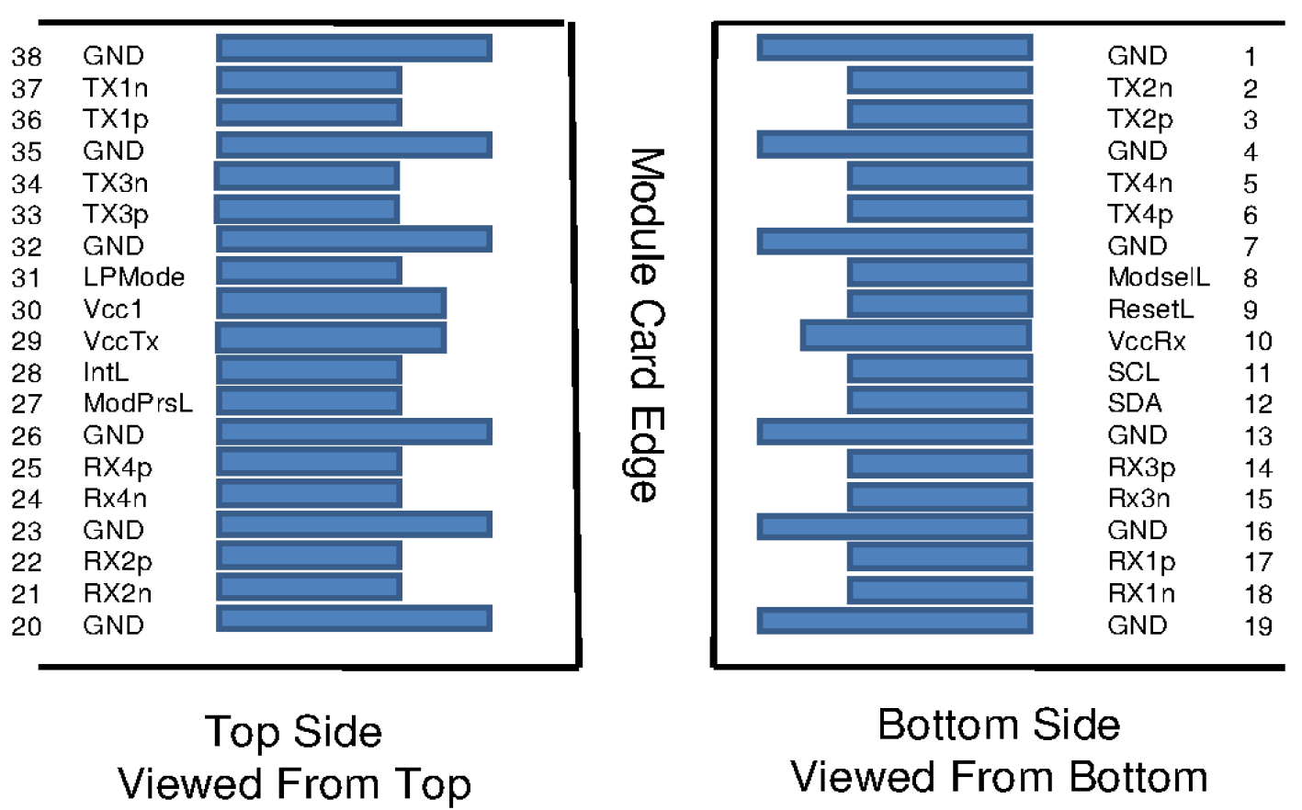

PIN DESCRIPTION

PIN | Logic | Symbol | Name/Description | Note
1 |  | GND | Ground
2 | CML-I | Tx2n | Transmitter Inverted Data Input
3 | CML-I | Tx2p | Transmitter Non-Inverted Data output
4 |  | GND | Ground
5 | CML-I | Tx4n | Transmitter Inverted Data Input
6 | CML-I | Tx4p | Transmitter Non-Inverted Data output
7 |  | GND | Ground
8 | LVTTL-I | ModSelL | Module Select
9 | LVTTL-I | ResetL | Module Reset
10 |  | VccRx | ﹢3.3V Power Supply Receiver
11 | LVCMOS-I/O | SCL | 2-Wire Serial Interface Clock
12 | LVCMOS-I/O | SDA | 2-Wire Serial Interface Data
13 |  | GND | Ground
14 | CML-O | Rx3p | Receiver Non-Inverted Data Output
15 | CML-O | Rx3n | Receiver Inverted Data Output
16 |  | GND | Ground
17 | CML-O | Rx1p | Receiver Non-Inverted Data Output
18 | CML-O | Rx1n | Receiver Inverted Data Output
19 |  | GND | Ground
20 |  | GND | Ground
21 | CML-O | Rx2n | Receiver Inverted Data Output
22 | CML-O | Rx2p | Receiver Non-Inverted Data Output
23 |  | GND | Ground
24 | CML-O | Rx4n | Receiver Inverted Data Output
25 | CML-O | Rx4p | Receiver Non-Inverted Data Output
26 |  | GND | Ground
27 | LVTTL-O | ModPrsL | Module Present
28 | LVTTL-O | IntL | Interrupt
29 |  | VccTx | +3.3 V Power Supply transmitter
30 |  | Vcc1 | +3.3 V Power Supply
31 | LVTTL-I | LPMode | Low Power Mode
32 |  | GND | Ground
33 | CML-I | Tx3p | Transmitter Non-Inverted Data Input
34 | CML-I | Tx3n | Transmitter Inverted Data Output
35 |  | GND | Ground
36 | CML-I | Tx1p | Transmitter Non-Inverted Data Input
37 | CML-I | Tx1n | Transmitter Inverted Data Output
38 |  | GND | Ground

Optical Interface Lanes and Assignment

The optical interface port is a male MPO connector .The four fiber positions on the left as shown in the below Figure, with the key up, are used for the optical transmit signals (Channel 1 through 4). The fiber positions on the right are used for the optical receive signals (Channel 4 through 1). The central four fibers are physically present.

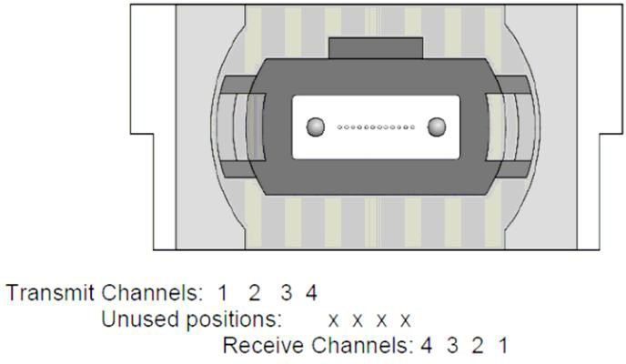

OUTLINE DIMENSIONS

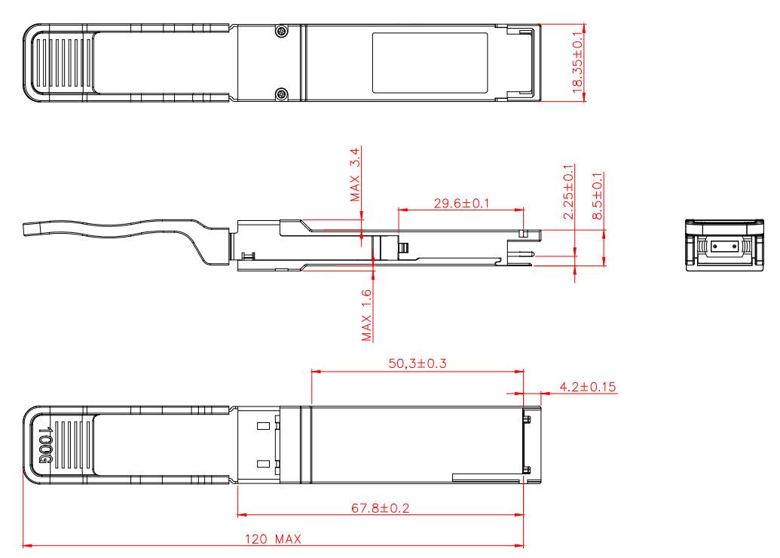

Digital Diagnostic Monitor Accuracy
The following characteristics are defined over recommended operating conditions

Parameter | Accuracy | Unit
Internally measured transceiver temperature | +/-3 | deg.C
Internally measured transceiver supply voltage | +/-3 | %
Measured Tx bias current | +/-10 | %
Measured Tx output power | +/-3 | dB
Measured Rx received average optical power | +/-3 | dB
Contact:
Wuhan Jiuhong Optics Technology Co., Ltd.
TEL: 86-13476016116
E-mail：grace@jh-optics.com
Web：www.jh-optics.com
Address：
Building 1, 4th Floor, Yunqi Free Trade Innovation Port, Donghu Comprehensive Bonded Zone,Donghu High-tech Zone, Wuhan City

