QSFP-40G-LR4

40 Gb/s QSFP+ LR4 Optical Transceiver

QSFP-40G-LR4 Overview

QSFP-40G-LR4 QSFP+ LR4 optical transceivers are based on the Ethernet IEEE P802.3ba standard and SFF 8436 standard. The QSFP+ transceiver converts 4 input channels of 10 Gb/s electrical data to 4 CWDM optical signals and multiplexes them into a single channel for 40 Gb/s optical transmission. On the receiver side, the module optically de-multiplexes a 40 Gb/s input into 4 CWDM channels of signals and converts them to 4 channel output electrical data. The central wavelengths of the 4 CWDM channels are 1271, 1291, 1311, and 1331 nm as members of the CWDM wavelength grid defined in ITU-T G694.2.

Product Features

- Uncooled 4x10Gb/s CWDM transmitter
- Up to 11.2 Gbps data rate per wavelength
- QSFP+ MSA compliant
- Duplex LC connector
- Built-in digital diagnostic functions
- Up to 20 km on SMF
- Maximum 3.5W operation power
- RoHS Compliant
- Operating temperature range: 0◦C to 75◦C

Applications

- 40G Ethernet
- Infiniband interconnects

General Specifications

Parameter | Symbol | Min | Typ | Max | Unit | Remarks
Bit Error Rate | BER |  |  | 10−12
Operating Temperature | TC | 0 |  | 75 | ◦C | 1
Storage Temperature | TSTO | -40 |  | 85 | ◦C | 2
Input Voltage | VCC | 3.14 | 3.3 | 3.46 | V
Maximum Voltage | VMAX | -0.5 |  | 3.6 | V | 3

Notes:
- Case temperature
- Ambient temperature
- For electrical power interface

Link Distances

Data Rate | Fiber Type | Distance Range (km)
40 Gb/s | 9/125um SMF | 20

Optical – Characteristics – Transmitter

Parameter | Symbol | Min | Typ | Max | Unit | Remarks
Total Output Optical Power | PT |  |  | 8.3 | dBm | 1
Average Launch Power (Each Lane) | PTX | -7 |  | 2.3 | dBm
Optical Center Wavelength (L0 Lane) | λ C | 1264.5 | 1271 | 1277.5 | nm
Optical Center Wavelength (L1 Lane) | λ C | 1284.5 | 1291 | 1297.5 | nm
Optical Center Wavelength (L2 Lane) | λ C | 1304.5 | 1311 | 1317.5 | nm
Optical Center Wavelength (L3 Lane) | λ C | 1324.5 | 1331 | 1337.5 | nm
Optical Modulation Amplitude | OMA | -4 |  | 3.5 | dB
Extinction Ratio | ER | 3.5 |  |  | dB
Spectral Width (-20 dB) | Δλ |  |  | 1 | nm
Side Mode Suppression Ratio | SMSR | 30 |  |  | dB
Relative Intensity Noise | RIN |  |  | -128 | dB/Hz
Transmitter Dispersion Penalty | TDP |  |  | 2.3 | dB
Optical Return Loss Tolerance | TOL |  |  | 20 | dB
Transmitter Eye Mask |  |  |  |  |  | 2
Launch Power of OFF Transmitter, per lane | POUT_OFF |  |  | -30 | dBm | 1

Notes:
- Average
- Compliant with IEEE 802.3ba

Optical – Characteristics – Receiver

Parameter | Symbol | Min | Typ | Max | Unit | Remarks
Optical Center Wavelength (L0 Lane) | λ C | 1264.5 | 1271 | 1277.5 | nm
Optical Center Wavelength (L1 Lane) | λ C | 1284.5 | 1291 | 1297.5 | nm
Optical Center Wavelength (L2 Lane) | λ C | 1304.5 | 1311 | 1317.5 | nm
Optical Center Wavelength (L3 Lane) | λ C | 1324.5 | 1331 | 1337.5 | nm
Optical Input Power (each lane) | PRX | -13.7 |  | 2.3 | dBm | 1
Damage Threshold (each lane) | P | 3.3 |  |  | dBm
Receiver Sensitivity (OMA) (each lane) | RX SEN1 |  |  | -11.5 | dBm
Receiver Reflectance | TRRX |  |  | -26 | dB
LOS Assert | LOSA | -28 |  |  | dBm
LOS De-Assert | LOSD |  |  | -15 | dBm
LOS Hysteresis | LOSH | 0.5 |  | 6 | dB

Notes:
1. Average, Informative

Electrical – Characteristics – Transmitter

Parameter | Symbol | Min | Typ | Max | Unit | Remarks
Input differential impedance | RIN |  | 100 |  | Ω
Differential data input swing | VIN PP | 120 |  | 1200 | mV
Transmit Disable Voltage | VD | VCC-1.3 |  | VCC | V
Transmit Enable Voltage | VEN | VEE |  | VEE+0.8 | V

Electrical – Characteristics – Receiver

Parameter | Symbol | Min | Typ | Max | Unit | Remarks
Differential data output swing | VOUT PP | 400 | 550 | 800 | mV
Data output rise/fall time (20%-80%) | tr/tf | 28 |  |  | ps
LOS Fault | VLOS A | VCC-1.3 |  | VCC HOST | V
LOS Normal | VLOS D | VEE |  | VEE+0.5 | V

Block Diagram of Transceiver
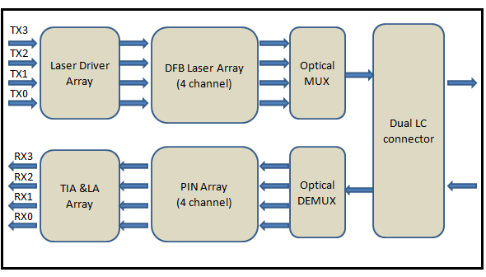

Functions Description

This product converts the 4-channel 10 Gb/s electrical input data into CWDM optical signals (light) by a driven 4-wavelength Distributed Feedback Laser (DFB) array. The light is combined by the MUX parts as 40 Gb/s data, propagating out of the transmitter module from the SMF. The receiver module accepts the 40 Gb/s CWDM optical signals input, and de-multiplexes it into 4 individual 10 Gb/s channels with different wavelengths. Each wavelength of light is collected by a discrete photodiode, and then outputted as electric data after amplified by a TIA.

Dimensions (mm)

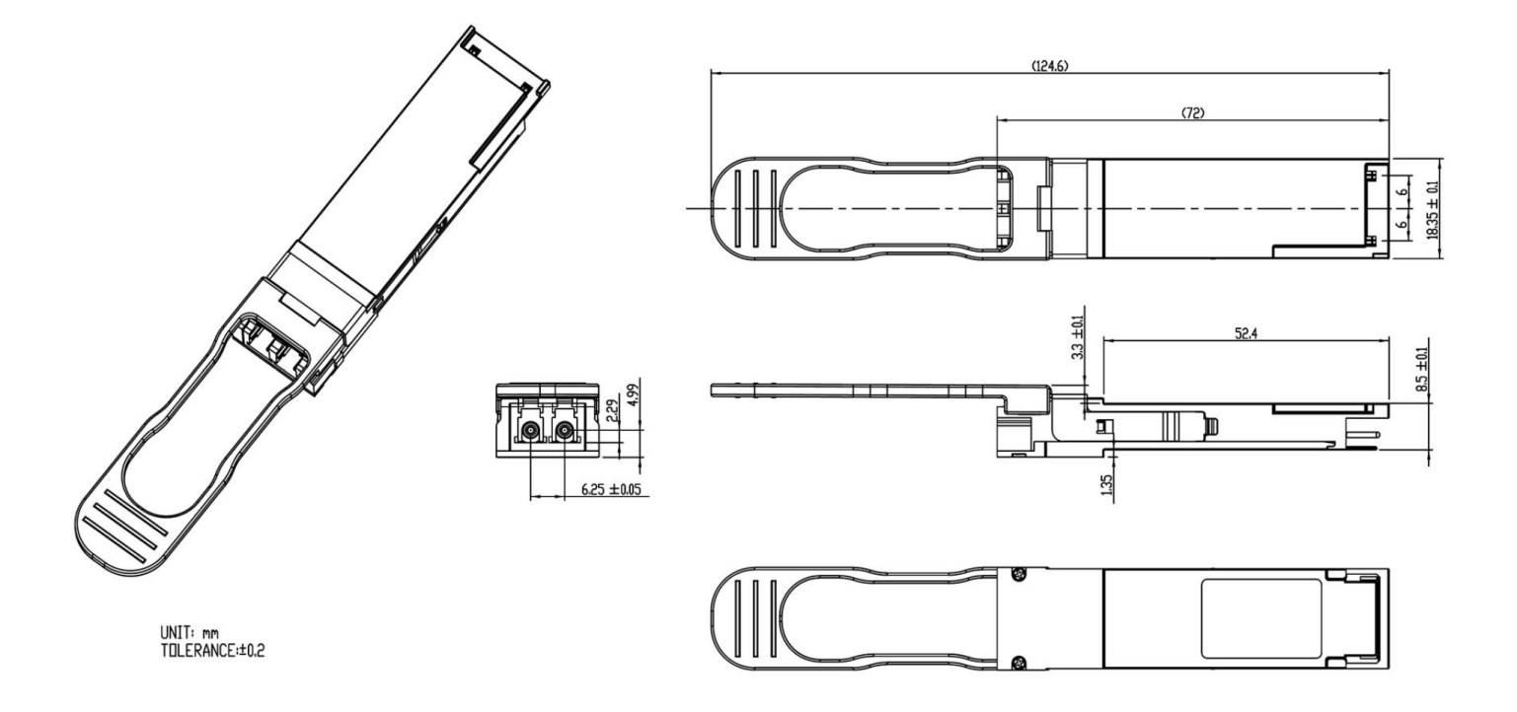

Electrical Pad Layout

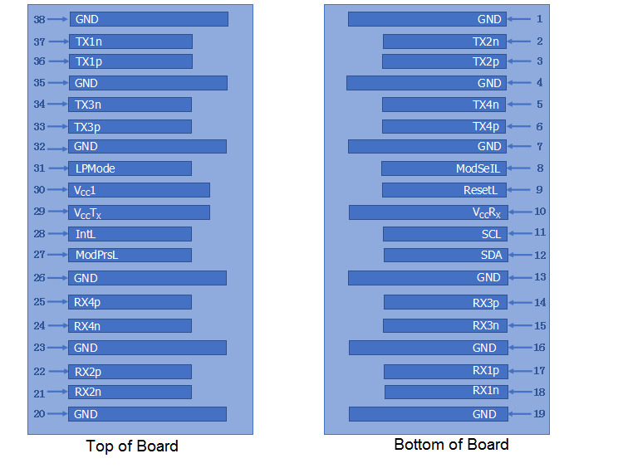

Pin Assignment

PIN # | Symbol | Description | Remarks
1 | GND | Ground | 5
2 | Tx2n | Transmitter Inverted Data Input, LAN2
3 | Tx2p | Transmitter Non-Inverted Data Input, LAN2
4 | GND | Ground | 5
5 | Tx4n | Transmitter Inverted Data Input, LAN4
6 | Tx4p | Transmitter Non-Inverted Data Input, LAN4
7 | GND | Ground | 5
8 | ModSelL | Module select pin; the module responds to two-wire serial communication when low level | 1
9 | Reset | Module Reset | 2
10 | VccRX | +3.3V Power Supply Receiver
11 | SCL | 2-wire serial interface clock
12 | SDA | 2-wire serial interface data
13 | GND | Ground | 5
14 | Rx3p | Receiver Non-Inverted Data Output, LAN3
15 | Rx3n | Receiver Inverted Data Output, LAN3
16 | GND | Ground | 5
17 | Rx1p | Receiver Non-Inverted Data Output, LAN1
18 | Rx1n | Receiver Inverted Data Output, LAN1
19 | GND | Ground | 5
20 | GND | Ground | 5
21 | Rx2n | Receiver Inverted Data Output, LAN2
22 | Rx2p | Receiver Non-Inverted Data Output, LAN2
23 | GND | Ground | 5
24 | Rx4n | Receiver Inverted Data Output, LAN4
25 | Rx4p | Receiver Non-Inverted Data Output, LAN4
26 | GND | Ground | 5
27 | ModPrsL | The module is inserted into the indicated pin and grounded in the module. | 3
28 | IntL | Interrupt | 4
29 | VccTX | +3.3V Power Supply transmitter
30 | Vcc1 | +3.3V Power Supply
31 | LP Mode | low power mode | 5
32 | GND | Ground | 5

33 | Tx3p | Transmitter Non-Inverted Data Input, LAN3
34 | Tx3n | Transmitter Inverted Data Input, LAN3
35 | GND | Ground | 5
36 | Tx1p | Transmitter Non-Inverted Data Input, LAN1
37 | Tx1n | Transmitter Inverted Data Input, LAN1
38 | GND | Ground | 5

Notes:
- ModSelL is the input pin. The module responds to 2-wire serial communication commands when it is held low by the host. ModSelL allows multiple QSFP modules to be used on a single 2-wire interface bus. If ModSelL is high, the module will not respond to any 2-wire interface communication from the host. Mouser has internal pull-up resistors in the module
- The module restart pin resets the module when the low level on the ResetL pin lasts longer than the minimum pulse length, restoring all user modules to their default state. When performing a reset device, the host should ignore all status bits. Until the module reset interrupt is completed, please note that during hot plugging, the module will issue this information to complete the reset interrupt without resetting
- This pin is active high, indicating that the module is running under a low power module.
- IntL is the output pin, which is an open-collector output and must be pulled up to Vcc on the motherboard. When it is low, it indicates that the module may malfunction. The host uses a 2-wire serial interface to identify the interrupt source
- The circuit ground is internally isolated from chassis ground.

