Product Specification
25Gb/s 80Km SFP28 BIDI Transceivers

PRODUCT FEATURES
- Support data rate up to 25.78125Gb/s
- Hot-Pluggable SFP Footprint and Single LC Connector
- Up to 80km reach for G.652 SMF
- EML TX and Integrated SOA & PIN TIA RX
- Temperature Range:
Commercial:0°C ~70°C
- Power consumption
Commercial:2.2W
- RoHS 6 compliance
- Compliant to IEEE 802.3cc, SFF-8472 and SFF-8419
- Complies with EU Directive 2015/863/EU

APPLICATIONS
- 25G Ethernet
- CPRI option 10

DESCRIPTIONS
The JH-25G-WDM-X series single mode transceiver is small form factor pluggable module for duplex optical data communications. The JH-25G-WDM-X-80 module is designed for single mode fiber and operates at a nominal wavelength of 1295.56nm or 1309.14nm; the transmitter section uses a multiple quantum well EML, which is class 1 laser compliant according to International Safety Standard IEC-60825.
The SFP28 80km module electrical interface is compliant to SFI electrical specifications. The transmitter input and receiver output impedance is 100 Ohms differential. Data lines are internally AC coupled. The module provides differential termination and reduce differential to common mode conversion for quality signal termination and low EMI.

Ordering Information
Part No. | Data Rate(optical) | Laser | Fiber Type | Distance | Optical Interface | Temp | DDMI
JH-25G-WDM-X-80 | 25.78Gbps | EML | SMF | 80km | LC | 0~70℃ | Y

Absolute Maximum Ratings
Parameter | Symbol | Min. | Typical | Max. | Unit | Notes
Storage Temperature | T_{stg} | -40 |  | +85 | °C
Case Operating Temperature | T_{O} | 0 |  | 70 | °C
Relative Humidity - Storage | R_{HS} | 5 |  | 95 | %
Relative Humidity - Operating | R_{HO} | 5 |  | 85 | %
DC Supply Voltage | V_{CC} | 0 |  | 3.6 | V

Recommended Operating Conditions
Parameter | Symbol | Min. | Typical | Max. | Unit | Notes
Case Operating Temperature | T_{op} | 0 | - | 70 | ℃ | Commercial
Power Supply Voltage | V_{CC} | 3.13 | 3.3 | 3.47 | V
Transmission Distance | TD | - | - | 80 | km | Over SMF

Electrical Characteristics
High-Speed Signal: Compliant to CEI-25G-VSR
Low-Speed Signal: Compliant to SFF-8431

Parameter |  | Symbol | Min. | Typical | Max. | Unit | Notes
Supply Voltage |  | V_{CC} | 3.135 |  | 3.465 | V
Supply Current |  | I_{CC} |  |  | 660 | mA | Commercial
 |  |  |  |  | 850 | mA | Industrial
Power Consumption |  | P |  |  | 2.2 | W | Commercial
 |  |  |  |  | 2.8 | W | Industrial
Transmitter (Module Input)
Differential Input Resistance |  | R_R_{din} | 90 | 100 | 110 | Ω
Input Differential Voltage |  | R_V_{diff} | - | - | 900 | mVpp
Tx_Disable | Normal Operation | V_{IL} | -0.3 | - | 0.8 | V
Tx_Disable | Laser Disable | V_{IH} | 2.0 | - | V_{CC}+0.3 | V
Receiver (Module Output)
Differential Resistance |  | T_R_{d} | 90 | 100 | 110 | Ohm
Output Differential Voltage |  | T_V_{diff} | - | - | 900 | mVpp
Differential Termination Resistance Mismatch |  | T_R_{dm} | - | - | 10 | %
Rx los | Normal Operation | V_{OL} | -0.3 | - | 0.4 | V
Rx los | Loss Signal | V_{OH} | 2 |  | VCCHOST | V

Optical and Characteristics
Parameter | Symbol | Min. | Typical | Max. | Unit | Notes
Transmitter
Average Output Power | POUT | 2 |  | 7 | dBm | 1
Average Output Power(Laser Off) | POFF |  |  | -30 | dBm
Wavelength | λ | 1294.53 | 1295.56 | 1296.59 | nm | JH-25G-WDM-A-80
Wavelength | λ | 1308.09 | 1309.14 | 1310.19 | nm | JH-25G-WDM-B-80
Spectrum Bandwidth @ -20dB | Δλ |  |  | 1 | nm
Side mode suppression ratio(SMSR) | SMSR | 30 |  |  | dB
Extinction ratio | ER | 8 |  |  | dB
RIN₂₀OMA | RIN |  |  | -128 | dB/Hz
Transmitter and dispersion penalty (TDP) |  |  |  | 2.7 | dB
Receiver
Wavelength | λ | 1308.09 | 1309.14 | 1310.19 | nm | JH-25G-WDM-A-80
Wavelength | λ | 1294.53 | 1295.56 | 1296.59 | nm | JH-25G-WDM-B-80
Received Sensitivity | P_{IN} |  |  | -27 | dBm | 1
Optical Power Overload | P_{IN}(SAT) | -4 |  |  | dBm
Damage threshold |  | 3 |  |  | dBm | 2
Rx_LOS of Signal Assert | P_{A} | -40 |  |  | dBm
Rx_LOS of Signal De-assert | P_{D} |  |  | -28 | dBm
Rx_LOS of Signal Hysteresis | PHy | 0.5 |  | 5 | dB
Optical Return Loss Tolerance | ORLT | 20 |  |  | dB

Notes:
- Test pattern: PRBS31. BER<5x10⁻⁵;
- The receiver shall be able to tolerate, without damage, continuous exposure to an optical input signal having this average power level. The receiver does not have to operate correctly at this input power.

Digital Diagnostics
Parameter | Range | Accuracy | Unit | Calibration
Temperature | 0 to 70 | ±3 | ºC | Internal
Voltage | 3.13-3.47 | ±3% | V | Internal
Tx Bias Current | 0 to 100 | ±10% | mA | Internal
Tx Output Power | 2 to 7 | ±3 | dB | Internal
Rx Input Power | -28 to -4 | ±3 | dB | Internal

Communication Interface Timing Characteristics
Parameter | Symbol | Min. | Typical | Max. | Unit | Notes
TX_Disable Assert Time | t_off |  |  | 100 | us
TX_Disable Negate Time | t_on |  |  | 2 | ms
Time to Initialize Include Reset of TX_FAULT | t_int |  |  | 300 | ms
TX_FAULT from Fault to Assertion | t_fault |  |  | 100 | us
TX_Disable Time to Start Reset | t_reset | 10 |  |  | us
Receiver Loss of Signal Assert Time | T_{A},RX_LOS |  |  | 100 | us
Receiver Loss of Signal Deassert Time | T_{d},RX_LOS |  |  | 100 | us
Rate-Select Chage Time | t_ratesel |  |  | 10 | us

Pin Diagram
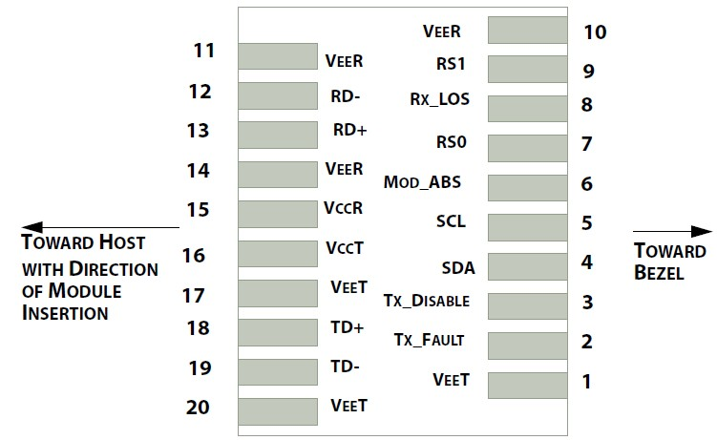

Pin Definitions
PIN # | Name | Function | Notes
1 | VeeT | Module transmitter ground | 1
2 | Tx Fault | Module transmitter fault | 2
3 | Tx Disable | Transmitter Disable; Turns off transmitter laser output | 3
4 | SDL | 2 wire serial interface data input/output (SDA) | 4
5 | SCL | 2 wire serial interface clock input (SCL) | 4
6 | MOD-ABS | Module Absent, connect to VeeR or VeeT in the module | 4
7 | RS0 | Rate select0, optionally control SFP+ receiver. When high, input data rate >4.5Gb/ s; when low, input data rate <=4.5Gb/s | 5
8 | LOS | Receiver Loss of Signal Indication | 6
9 | RS1 | Rate select0, optionally control SFP+ transmitter. When high, input data rate >4.5Gb/s; when low, input data rate <=4.5Gb/s | 1
10 | VeeR | Module receiver ground | 1
11 | VeeR | Module receiver ground | 1
12 | RD- | Receiver inverted data output
13 | RD+ | Receiver non-inverted data output
14 | VeeR | Module receiver ground | 1
15 | VccR | Module receiver 3.3V supply
16 | VccT | Module transmitter 3.3V supply
17 | VeeT | Module transmitter ground | 1
18 | TD+ | Transmitter inverted data output
19 | TD- | Transmitter non-inverted data output
20 | VeeT | Module transmitter ground | 1

Notes:
- Circuit ground is internally isolated from chassis ground
- Tx FAULT is an open collector/drain output, which should be pulled up with a 4.7k – 10k Ohms resistor on the host board if intended for use. Pull up voltage should be between 2.0V to Vcc + 0.3V.A high output indicates a transmitter fault caused by either the TX bias current or the TX output power exceeding the preset alarm thresholds. A low output indicates normal operation. In the low state, the output is pulled to <0.8V.
- Laser output disabled on Tx DIS >2.0V or open, enabled on Tx DIS <0.8V.
- Should be pulled up with 4.7kΩ- 10kΩ host board to a voltage between 2.0V and 3.6V. MOD_ABS pulls line low to indicate module is plugged in.
- Internally pulled down per SFF-8431 Rev 4.1.
- LOS is open collector output. It should be pulled up with 4.7kΩ – 10kΩ on host board to a voltage between 2.0V and 3.6V. Logic 0 indicates normal operation; logic 1 indicates loss of signal.

Recommended Interface Circuit
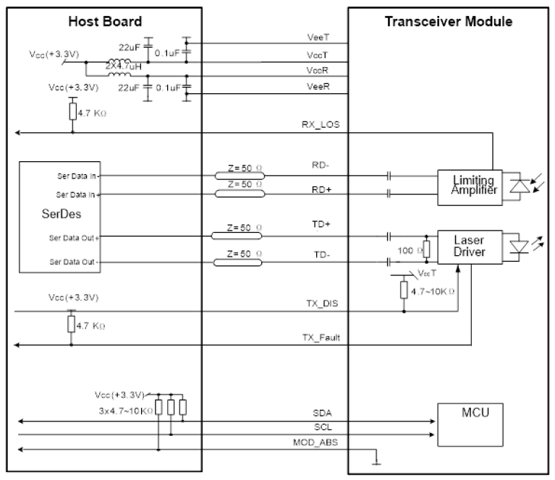

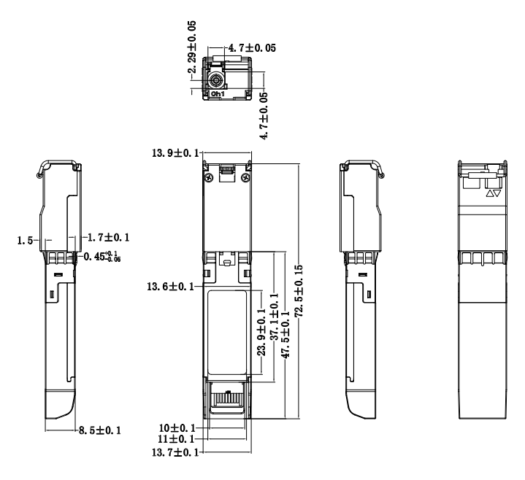
Mechanical Diagram

