Product Specification
25Gb/s 40Km SFP28 BIDI Transceivers

PRODUCT FEATURES
- Operating data rate up to 25.78Gbps
- Up to 40km transmission distance
- High sensitivity APD photodiode and TIA
- Rate Adaptation
- LC single connector
- Hot pluggable 20pin connector
- Low power consumption <1.5 W
- Single +3.3V±5% power supply
- Compliant with SFF-8472
- Fully RoHS Compliant
- Operating temperature range:
Commercial: 0°C to +70°C

Application
- 25GE BASE-LR Ethernet
- CPRI Option 10/eCPRI

- Ordering information
Part Number | Product Description
JH-25G-WDM-A-40L-23 | 25G SFP28 40km BIDI transceiver 1270 Tx/ 1330 Rx, C-TEMP
JH-25G-WDM-B-40L-32 | 25G SFP28 40km BIDI transceiver 1330 Tx/ 1270 Rx, C-TEMP

DESCRIPTION
The JH-25G-WDM-A/B-40L-XX Transceiver is intended for 40km reach service from 24.33Gb/s to 25.78Gb/s BI-direction single mode high-speed communications equipment where low-cost, extraordinary performance and reliability are essential. It consumes low power, operates base on 3.3V DC power supply and is offered in the commercial temperature range. They are compliant with SFP28 MSA, SFF-8431 and SFF-8432.
The low jitter and low bit error rate optical assembly features a DML laser transmitter and APD/TIA receiver. It utilizes internal clock and data recovery (CDR) units on transmitter and the receiver chains for low jitter compliance. The differential AC coupled Tx and Rx data interfaces are CML compatible. The device is Class I laser safety compliant.

Absolute Maximum Ratings
Parameter | Symbol | Unit | Min | Max
Storage Temperature Range | Ts | ºC | -40 | 85
Relative Humidity | RH | % | 0 | 85

Recommended Operating Conditions
Parameter | Symbol | Unit | Min | Typ | Max
Operating Case Temperature Range | Tc | ºC | 0 |  | 75
Power Supply Voltage | Vcc | V | 3.14 | 3.3 | 3.46
Bit Rate | BR | Gb/s |  | 25.78
Bit Error Ratio | BER |  |  |  | 5*10⁻⁵
Max Supported Link Length | L | Km |  |  | 40
Electric Ports Definition
Parameter | Symbol | Unit | Min | Typ | Max | Note
Transmitter
Input Differential Impedance | R_{IN} | Ω |  | 100
Single-ended Data Input Swing | V_{IN} | mVp-p | 90 |  | 450
Transmit Disable Voltage | V_{DIS} | V | 2 |  | V_{CCHOST}
Transmit Enable Voltage | V_{EN} | V | V_{EE} |  | V_{EE}+0.8
Transmit Fault Assert Voltage | V_{FA} | V | 2 |  | V_{CCHOST}
Transmit Fault De-Assert Voltage | V_{FDA} | V | V_{EE} |  | V_{EE}+0.4
Receiver
Single-ended Data Output Swing | V_{OD} | mVp-p | 200 |  | 450
LOS Fault | V_{LOSFT} | V | 2 |  | V_{CCHOST}
LOS Normal | V_{LOSNR} | V | V_{EE} |  | V_{EE}+0.4

Optical Characteristics (TA and Vcc= 3.14 to 3.46V)
Parameter | Symbol | Unit | Min | Typ | Max | Note
Transmitter
Center Wavelength  ( JH-25G-WDM-A-40L-23) | λ | nm | 1260 | 1270 | 1280
Center Wavelength ( JH-25G-WDM-B-40L-32) | λ | nm | 1320 | 1330 | 1340
Average Output Power | Pav | dBm | 0 |  | 6
Spectral Width (-20dB) | σ | nm |  |  | 1
Extinction Ratio | ER | dB | 3.5
Side Mode Suppression Ratio | SMSR | dB | 30
Average Launch Power of OFF Transmitter | POFF | dBm |  |  | -30
Relative Intensity Noise | RIN | dB/Hz |  |  | -128
Receiver
Center Wavelength ( JH-25G-WDM-A-40L-23) | λC | nm | 1320 | 1330 | 1340
Center Wavelength ( JH-25G-WDM-B-40L-32) | λC | nm | 1260 | 1270 | 1280
Receiver Sensitivity(OMA) | RSENSE | dBm |  |  | -19 | 1
Receiver Overload (OMA) | Pmax | dBm | -5
Receiver Reflectance |  | dB |  |  | -12
LOS Assert | LOSA | dBm | -35
LOS De-Assert LOS | LOSD | dBm |  |  | -21
LOS Hysteresis |  | dB | 0.5
Note1: Measured at 25.78125Gb/s, ER>3.5dBm, PRBS 2³¹-1 and BER better than or equal to 5E-5;

PIN Assignment

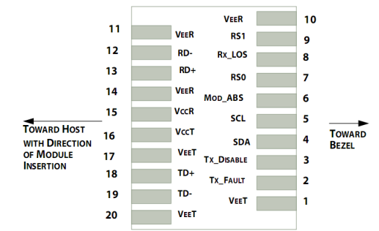

Figure 1.Pin function definitions

Table 1: Transceiver pin descriptions
Pin Number | Symbol | Name | Description
1,17,20 | VeeT | Transmitter Signal Ground | Connected to signal ground on the host board.
2 | TX Fault | Transmitter Fault Out (OC) | Module transmitter fault output.
3 | TX Disable | Transmitter Disable In (LVTTL) | Module transmitter disable control.
4 | SDA | Module Definition Identifiers | Serial ID with SFF 8472 Diagnostics  Module Definition pins should be pulled up to Host Vcc with 10 kΩ resistors.
5 | SCL | Module Definition Identifiers
6 | MOD-ABS | Module Definition Identifiers
7 | RS0 | Receiver Rate Select (LVTTL) Transmitter Rate Select (LVTTL) | Rate select 0(Rx):Low=CDR Bypass ; High=CDR Select  Rate select 1(Tx):Low=CDR Bypass ; High=CDR Select
9 | RS1 | Receiver Rate Select (LVTTL) Transmitter Rate Select (LVTTL)
8 | LOS | Loss of Signal Out (OC) | Receiver loss of signal.
10,11,14 | VeeR | Receiver Signal Ground | Connected to signal ground on the host board.
12 | RD- | Receiver Negative DATA Out (CML) | Receiver inverted data output, internally AC coupled and terminated
13 | RD+ | Receiver Positive DATA Out (CML) | Receiver non-inverted data output, internally AC coupled and terminated.
15 | VccR | Receiver Power Supply | Receiver Power 3.3V Supply.
16 | VccT | Transmitter Power Supply | Transmitter Power 3.3V Supply.
18 | TD+ | Transmitter Positive DATA In (CML) | Transmitter non-inverted data input, internally AC coupled and terminated.
19 | TD- | Transmitter Negative DATA In (CML) | Transmitter inverted data Input, internally AC coupled and terminated.

Recommended Interface Circuit
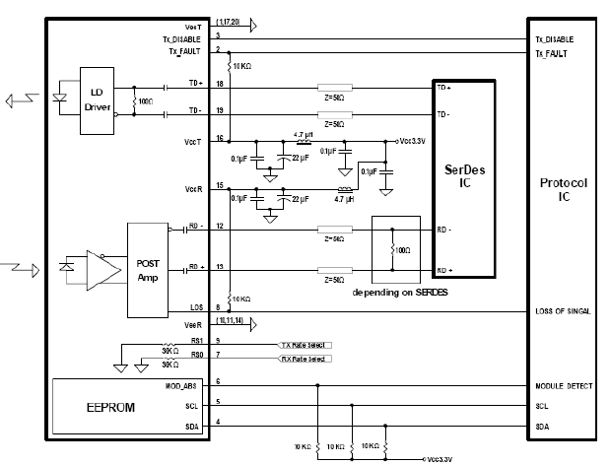
Figure 2. Typical application circuit

Mechanical Dimensions
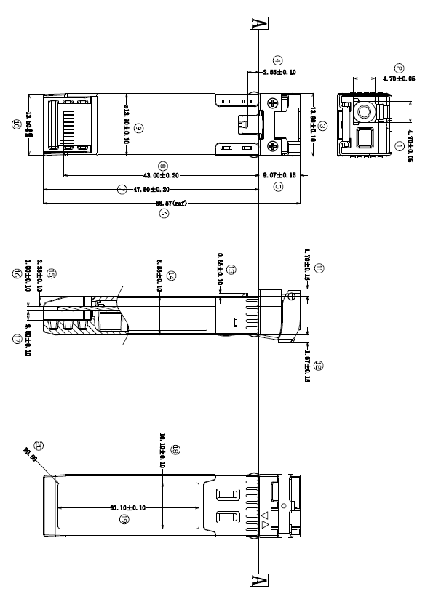
Figure 3. Module Mechanical Dimensions

Digital Diagnostics Functions
As defined by the SFF-8472, The SFP28 transceivers provide digital diagnostic functions via a 2-wire serial interface, which allows real-time access to the following operating parameters:
- Transceiver temperature
- Laser bias current
- Transmitted optical power
- Received optical power
- Transceiver supply voltage
It also provides a sophisticated system of alarm and warning flags, which may be used to alert end-users when particular operating parameters are outside of a factory-set normal range. The operating and diagnostics information is monitored and reported by a Digital Diagnostics Transceiver Controller (DDTC) inside the transceiver, which is accessed through the 2-wire serial interface. The memories are organized as a series of 8-bit data words that can be addressed individually or sequentially. The 2-wire serial interface provides sequential or random access to the 8 bit parameters, addressed from 0x00h to the maximum address of the memory. For more detailed information, including memory map definitions, please refer the SFF-8472 documentation.

Digital Diagnostic Monitor Accuracy
The following characteristics are defined over recommended operating conditions

Parameter | Accuracy | Unit
Internally measured transceiver temperature | +/-3 | deg.C
Internally measured transceiver supply voltage | +/-3 | %
Measured Tx bias current | +/-10 | %
Measured Tx output power | +/-3 | dB
Measured Rx received average optical power | +/-3 | dB

