Data Sheet
SFP28 25G SR
Features
- Supports 25.78Gb/s bit rate
- Transmission distance up to 70M (OM3),100M(OM4)
- LC optical cable connection
➢ +3.3V single power supply
- Low power consumption ＜1W
- Operating case temperature 0℃~70℃
- RoHS compliant Applications
- 25G Ethernet

Absolute Maximum Ratings
Parameters | Symbol | Min. | Max. | Unit
Storage Temperature | Tstg | -40 | 85 | ℃
Operating Humidity | RH | 5 | 85 | %
Supply Voltage | Vcc | 0 | 3.6 | V
- Optical transmitter Characteristics
Unless specified else, the specifications below are defined at TC=25±3℃
Parameters | Symbol | Min. | Typ. | Max. | Unit | Condition
Output Optical Power | Pf | -6 | --- | 2.4 | dBm | CW, Iop=6mA
Center Wavelength | λc | 840 | 850 | 860 | nm | CW, Iop=6mA
RMS Spectral Width | Δ λ | --- | --- | 0.65 | nm | CW, Iop=6mA
Extinction Ratio | ER | 2 | --- | --- | dB
Power Supply | Vcc | 3.14 | 3.3 | 3.47 | V | ---
Input Differential  Impedance | Zin | 90 | 100 | 110 | Ω | Tc=25℃

Differential Input  Voltage | Vppin | 200 | - | 900 | mV | Tc=25℃
Bit Rate | BR | - | 25.78 | - | Gbps

Optical Receiver Characteristics
Unless specified else, the specifications below are defined at TC=25±3℃
Parameters | Symbol | Min. | Typ. | Max. | Unit | Condition
Operating Wavelength | λ | 840 | 850 | 860 | nm | ---
Overload Input Optical  Power | Pin | 2.4 | --- | --- | dBm | ---
Sensitivity | Sen | --- | --- | -10.3 | dBm | PRBS31, BER=5E-  5, @25.78Gbps
Power Supply | Vcc | 3.14 | 3.3 | 3.47 | V | ---
Output Differential  Impedance | Zout | 90 | 100 | 110 | Ω | Tc=25℃
Differential Output  Voltage | Vppout | 200 | - | 900 | mV | Tc=25℃
Los Assert | Losa | -30 |  |  | dBm
Los De-Assert | Losd |  |  | -12 | dBm
Los Hysteresis | Losh | 0.5 |  |  | dB

Electrical Connections
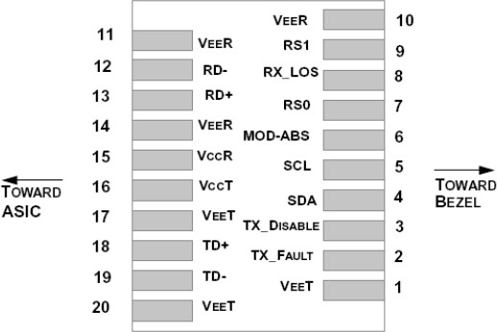

PIN Description
1 | VEET | Module Transmitter Ground
2 | TX_FAULT | Module Transmitter Fault
3 | TX_DISABLE | Transmitter Disable; Turns off transmitter laser output
4 | SDA | 2-Wire Serial Interface Data Line (MOD-DEF2)
5 | SCL | 2-Wire Serial Interface Clock (MOD-DEF1)
6 | MOD_ABS | ModuleAbsent, connected to VEET or VEER in the module
7 | RS0 | Rate Select 0, optionally controls SFP+ module receiver
8 | RX_LOS | Receiver Loss of Signal Indication (In FC designated as Rx_LOS  and in Ethernet designated as NOT Signal Detect)
9 | RS1 | Rate Select 1, optionally controls SFP+ module transmitter
10 | VEER | Module Receiver Ground
11 | VEER | Module Receiver Ground
12 | RD- | Receiver Inverted Data Output
13 | RD+ | Receiver Non-Inverted Data Output
14 | VEER | Module Receiver Ground
15 | VCCR | Module Receiver 3.3 V Supply
16 | VCCT | Module Transmitter 3.3 V Supply
17 | VEET | Module Transmitter Ground
18 | TD+ | Transmitter Non-Inverted Data Input
19 | TD- | Transmitter Inverted Data Input
20 | VEET | Module Transmitter Ground

Mechanical Outline Dimensions

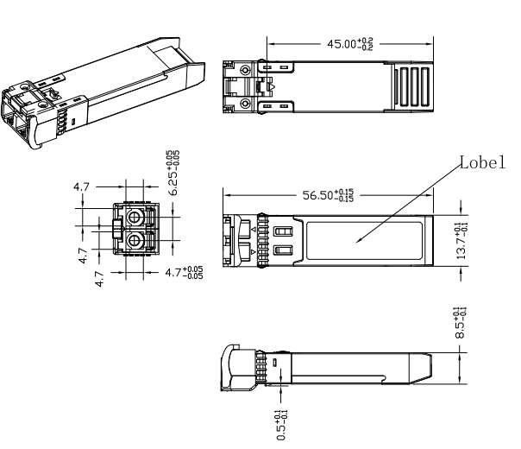

Contact:
Wuhan Jiuhong Optics Technology Co., Ltd.
TEL: 86-13476016116
E-mail：grace@jh-optics.com
Web：www.jh-optics.com
Address：
Building 1, 4th Floor, Yunqi Free Trade Innovation Port, Donghu Comprehensive Bonded Zone,
Donghu High-tech Zone, Wuhan City

